Lesson 8: Refusal Strategies
Overview: The lesson introduces the refusal skill strategy STOP (Say no; Tell why; Offer another option; Promptly leave). Students will describe each step of the refusal skill and apply the strategy in scenarios.

National Health Education Standards
Standard 1. Students will comprehend concepts related to health promotion and disease prevention to enhance health.
Standard 4. Students will demonstrate the ability to use interpersonal communication skills to enhance health and avoid or reduce health risks.
Healthy Behavior Outcomes (HBOs):
Alcohol and other drugs | HBO 1: Avoid misuse and abuse of over-the-counter and prescription drugs.
 | HBO 3. Avoid the use of alcohol.
 | HBO 4: Avoid the use of illegal drugs.
Tobacco | HBO 1: Avoid using or experimenting with any form of tobacco.
Lesson Objectives – Students will be able to:
Objective | Assessments
- Identify reasons, alternatives, and/or options instead of substance use. | Attachment 8.1b – Reasons
- Apply effective verbal and nonverbal communication skills to enhance health. | Attachment 8.1c – Refusal Skill Scenarios
- Demonstrate each step of the STOP strategy to refuse to engage in substance use. | Attachment 8.1c – Refusal Skill Scenarios
- State a health-enhancing position about being alcohol-, tobacco-, and other drug-free, supported with accurate information, evidence, and reasoning. | Attachment 8.2 – Advocacy Message
- Provide a message that persuades others to be alcohol-, tobacco-, and other drug-free. | Attachment 8.2 – Advocacy Message

Lesson Prerequisites or Assumptions:
- Lesson 8 assumes students have completed Lesson 7, which develops awareness of effective verbal and nonverbal communication as well as the characteristics of assertive communication.

Introduction:
- In Lesson 7, we developed our knowledge and skills to use verbal and nonverbal communication with assertiveness to deliver an effective message that enhances your health and prevents substance use. Today you are going to learn about refusal skills and the STOP strategy.
Teaching Steps:

Activity 1: Review decision-making and communication
- What is the tool we use to make healthy decisions?
  - Stop, Think, Choose
- If we have to say no or refuse to use substances, should we use passive, aggressive, or assertive communication?
- Can you remember the nonverbal communication cues to be sure our message is clearly communicated with our words and actions?
  - Remember that your eyes (eye contact), voice, and body language are important when communicating assertively. Is there a time when passive communication may be appropriate? (Give students time to think; do a think-pair-share if students need time to process.) What about aggressive communication?
- Today we are going to add a skill — refusal skills. Has anyone heard of refusal skills before? You have likely used refusal skills without realizing it.
  - Use the guided notes provided (hard copy or electronic). Refusal skills are strategies to say no when faced with whether to engage in a risky behavior or you need to remove yourself from a situation that is unhealthy, unsafe, or uncomfortable. Saying no can allow you to avoid risky peer pressure.
  - Let’s watch this video to learn more about refusal skills. Refusal Skills (3:18)
- This video shared strategies for refusing. We are going to use the STOP strategy to help with using refusal skills.
  - S = Say no in an assertive way (firm voice; eye contact; tone matches body language).
  - T = Tell why you are choosing to not engage with the substance(s).
  - “No, I am not going to smoke weed. I care about you as my friend, but I will not smoke weed with you. This does not interest me.”
  - O = Offer healthy alternatives.
  - “I want to continue to be your friend and hang out with you. We both enjoy skateboarding; would you like to go with me to the skate park instead?
  - P = Promptly go or plan how you will leave the situation.
- Text your older brother to pick you up from your friend’s home.
  - Cues: Say; Tell; Offer; Promptly go or create a plan for leaving.
- Let’s watch this video to see a realistic situation of peer pressure. As you are watching, write down examples of the resistor utilizing the STOP strategy. Refusal Skills (3:24)
  - After the video, discuss STOP examples as shown in the video.
- Assessment: Students work independently or in small groups to complete the graphic organizer (STOP).
  - Students work through characters from the case study (see Case Study Characters ).
  - Apply the STOP strategy to their character.
  - Alternative situation: You are riding the bus home, and your friend who sits across from you pulls out a container that has Benadryl in it. Your friend offers to give you two pills. Utilize the STOP strategy.
Activity 2: It’s important to make healthy choices.
- When you make healthy choices, you are a positive influence on others. In the next activity, we’ll create a message that can be seen by others. Students will create a social media advocacy campaign from an assigned perspective to raise awareness and state a health-enhancing position to influence others to make positive health choices.
  - Students should link an online valid resource in their post as well.
- Present a sample advocacy message (Attachment 8.1).
- Use the Advocacy Message Rubric (Attachment 8.2) to evaluate the sample message.
- Have students use the Advocacy Message Outline & Rubric (Attachment 8.3 to assess the elements of the message.
Closure:
- Today we learned about refusal skills and the STOP strategy. What does each letter of STOP mean? Why do you think STOP is a tool to help you make healthy choices? Can you give me an example of when you would use STOP?
- *Possibilities (if needed):
  - Students will work in pairs to come up with pressure lines one may use to encourage someone to use alcohol, tobacco, or another drug. Then, they come up with a great comeback for each of the listed pressure lines. Next, the pair will practice assertive communication skills refusing to consume alcohol. One partner will say the pressure line, and the other partner will respond with the comeback. Inspired by this activity: Pressure Lines and Great Comebacks (Alcohol)
Attachment 8.1a:
STRATEGY NOTES
Say NO in a firm voice.
- Use assertive verbal statements and strong body language to reinforce your drug-free choice.

Tell why you will not use drugs.
  - Identify reasons you are drug-free to strengthen your refusal skills.
  - Write statements using the I Will Not Use Drugs Because … practice sheet.
  - Possible answers:
    - I want to stay healthy.
    - I don’t want to hurt my relationships with the people I care about.
    - I want to do well in school.
    - I want to have a good career.
Offer other alternatives to drug use if you have the opportunity.
- Fun activities: Go to the movies, ride bikes, go swimming, take a walk in the park, volunteer in the community, go to a school-sponsored event, play sports at the YMCA, etc.
- Tell your friend you are not comfortable in this dangerous situation, and you would like to change the subject.

Promptly leave if the pressure continues.
- Text a trusted adult in your life to pick you up.
- Walk/ride your bike if it is safe.
- Call 911 or the police if the pressure become dangerous.

Attachment 8.1b
I Will Not Use Drugs Because …
Name:

Directions: Fill in the blanks with reasons you choose to stay drug-free.

- I will not use drugs because …

- I will not use drugs because …

- I will not use drugs because …

- I will not use drugs because …

Who is a trusted adult who can help you make healthy and safe choices to prevent substance use?

List three activities or alternatives to using substances like alcohol, tobacco, or other drugs.

Attachment 8.1c Refusal Skill Scenarios

Name:
REFUSAL SKILL SCENARIOS
Directions: Write a refusal skill that includes what you will do NONVERBALLY (eye contact, stand tall, head up, etc.) and what you would VERBALLY (assertive statement with reason to avoid drugs) say to avoid drug use for each scenario.
Scenario 1: Your friend offers you a prescription drug. She said it’s safe. Her mom got it from her doctor.
Say ________ in a firm voice.
Tell why you will not use drugs:

Offer an alternative:

Promptly leave or state how you will exit the situation.

Scenario 2: You are on the bus, and an older student offers you some chewing tobacco.
Say _________ in a firm voice.
Tell why you will not use drugs:

Offer an alternative:

Promptly leave or state how you will exit the situation

Scenario 3: You invited your friend to spend the night. After your parents go to bed, your friend says, “Let’s check out your parent’s liquor cabinet!”
Say _________ in a firm voice.
They continue to pressure you to check out your parent’s liquor cabinet.
Say _________ in a firm voice.
Tell why you will not use drugs:

Offer an alternative:

Promptly leave or state how you will exit the situation:
Attachment 8.2: Advocacy RAFT Template & Example
Create a message that encourages your peers or community to make healthy choices that prevent substance use. Choose your role (e.g., yourself, a teacher, etc.); audience (who the message is intended to reach); format (e.g., social media, video, poster/message board); and topic (the topic must target substance use prevention).

Role | Audience | Format | Topic

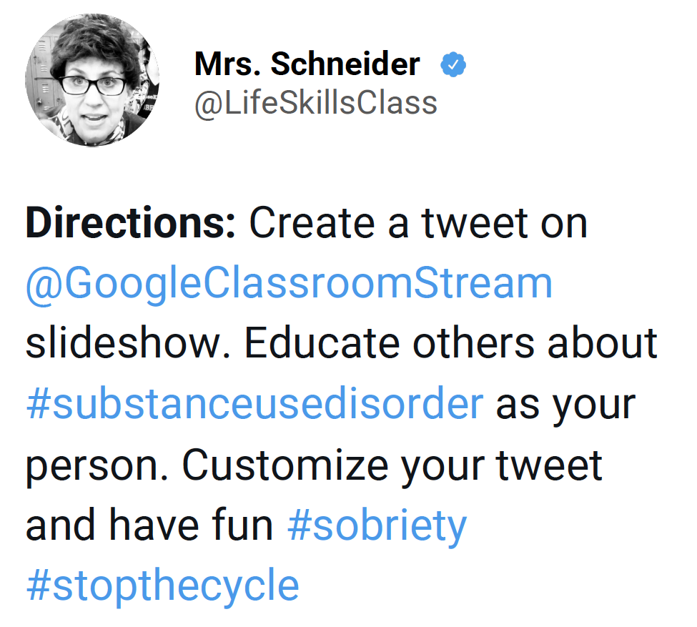

Attachment 8.2b: Advocacy Rubric
Category | 3 | 2 | 1
Message clarity | Provides clear, specific, and effective substance use prevention or health promotion statement | Provides an effective message. | The message is unclear or is not health-enhancing.
Message content | The message includes valid and reliable content that aligns with the substance use prevention principles. | The message includes valid and reliable content. | The message content does not include relevant content that is aligned with substance use prevention.
Target audience | Word choice, message, and graphics/pictures meet the target audience’s specific needs. | Word choice, message, and graphics/pictures meet the intended audience’s general needs. | Word choice, message, and graphics/pictures do not align with the audience’s needs or interests.
Resources | Identifies a health resource that would enhance healthy behaviors or promote substance use prevention for the targeted audience. | Identifies a health resource that would support healthy behaviors or substance use prevention for a general audience. | The health resource does not align with the goal of the message, is not a valid/reliable resource, or would not fit the situation or scenario.

