Lesson 2: Thoughtful Decision-Making Using Stop, Think, Choose

Overview: Students are introduced to the thoughtful decision-making process Stop, Think, Choose to make healthy choices that prevent substance use. This lesson targets the Stop component to determine when decisions require thoughtfulness, when help is needed from trusted adults, and when to consult health resources to support the decision.

National Health Education Standards
Standard 1: Students will comprehend concepts related to health promotion and disease prevention to enhance health.
Standard 5: Students will demonstrate the ability to use decision-making skills to enhance health.

Healthy Behavior Outcomes (HBOs):
Alcohol and other drugs | HBO 2: Avoid experimentation with alcohol and other drugs.
Tobacco | HBO 1: Avoid using or experimenting with any form of tobacco.

Lesson Objective – Students will be able to:
Objective | Assessments
- Determine situations that require thoughtful decision-making. | Attachment 2.2 – Thoughtful Decision-Making Worksheet
- Determine if a decision requires additional support of a trusted adult. | Attachment 2.2 – Thoughtful Decision-Making Worksheet
- Identify one trusted adult or resource to help support their decision-making process. | Attachment 2.2 – Thoughtful Decision-Making Worksheet
- Describe the Stop, Think, Choose decision-making process. | Attachment 2.3 – Exit Ticket

Lesson Prerequisites or Assumptions:
The students know who trusted adults are and have identified those individuals for themselves both at school and home.
Introduction:
- “In Lesson 1 we discussed how decisions can be considered healthy or unhealthy and how we determine those using the Know to NO! substance use prevention principles. Help me list the five principles:
- Substances such as tobacco, alcohol, and other drugs have harmful consequences on our health and well-being.
- Don’t touch, take, or taste; ask a trusted adult for help.
- Only take medicine as directed from a trusted adult.
- Never take someone else’s medicine.
- Properly store and dispose of medications.
- Today we are going to investigate the process of making thoughtful decisions to promote healthy choices and prevent substance use.
Teaching Steps:

Activity 1: Stop, Think, Choose
- Think-Pair-Share
  - Think – Make a list of decisions you made today.
    - After a minute, ask students to consider which of these decisions required little thought and which required more thought. (Thoughtfulness is thinking carefully about something.)
    - Have students share/discuss their ideas with a partner.
  - Pair - Once the pairs have had a chance to discuss their ideas, have students take turns sharing answers with the class to create a list on the whiteboard or poster paper. (Potential examples could include smoking, drinking, doing drugs, who to date, whether to lie about something, where to go to college, what job to get, etc.)
  - Let students take turns giving examples of decisions that require little to no thought.
- Share what decisions required more thought.
- Decisions can be organized into different types. They are organized by the consequences (short- or long-term) they would have on your health and well-being as well as others around you.
  - Everyday – don’t have long lasting or significant impact on life and health.
  - Impulsive – decisions made without thinking through the impact of the decision.
  - Thoughtful – decisions that need you to stop and think.
    - Can change your life
    - Could hurt you or someone else
    - Could result in serious consequences
- When we need to make thoughtful decisions, we need to Stop, Think, and Choose a healthy and safe choice. Using this process for every decision could be overwhelming, but today’s lesson will help you identify when to slow things down to Stop and Think.
- We’ll use Stop, Think, Choose to make challenging decisions. We will also use Stop, Think, Choose to think about how to make healthy choices to prevent substance use.
- We can also use Stop, Think, Choose to establish a healthy choice that we can then apply when confronted with the decision. Substance use is an example of where we can use Stop, Think, Choose to understand that we make healthy and safe choices. Then when we are in situations where we must make quick decisions can apply the Stop, Think, Choose decision to make a healthy choice.
- How can we make thoughtful decisions that have a positive impact on our health and well-being and be sure others impacted by the decision are safe and healthy?
- Pass out the Stop, Think, Choose graphic organizer. (Attachment 2.1)
- Let’s learn more about the steps of the Stop, Think, Choose decision-making model. In future lessons, we are going to apply Stop, Think, Choose to prevent substance use and make healthy choices.
- Stop
  - Recognize the situation.
  - Does it require a thoughtful decision?
  - Will it require the support of a trusted adult or additional resources?
  - Who can help you make a healthy and safe decision?
- Think
  - Think about your options
  - Think about the consequences of each option.
  - Think about the resources available to you.
  - (Lesson 3 spends more time thinking about options and consequences)
- Choose
  - Make the healthy and safe choice
- Let’s review the Stop step. Stop is the step where we recognize the problem or decision and determine whether we need help to make a healthy decision.
  - Type of decision: everyday, impulsive, or thoughtful?
  - Do I need help to make a decision?
  - What should I do if I need help taking medicine or recognize a substance such alcohol, tobacco, or other substances that are unhealthy or unsafe or that I am unsure about?
  - Reach out to a trusted adult for help.
    - Who are trusted adults? You can find them at home, at school, and in the community.
    - Why are trusted adults helpful?
      - They can help you make a healthy decision by providing information and rules and identifying potential consequences. They can also find additional help if needed.
    - How can a trusted adult influence you to make a healthy choice?
    - Trusted adults can help us identify our options and select a healthy and safe choice.
    - Trusted adults share rules and expectations that help us make the healthy, safe, and respectful choice.
    - Trusted adults can give us information or resources to make healthy choices. We’ll learn more about resources in future lessons.
  - We should rely on resources that are reliable, accurate, and up to date. We’ll learn more about influences and positive influences in Lesson 4.
    - Let’s make a list together. Can you name trusted adults at home, at school, or in the community?
    - Home – parents and grandparents
    - School – teachers and staff members
    - Community – professionals (e.g., doctors, nurses, police officers), helpers, coaches, club leaders
- We can use valid and reliable resources to provide additional information to support a healthy decision or consider additional options. (Refer to Lessons 3, 4, 5, and 6 for resources and supports for preventing substance use.)
- Pass out the Thoughtful Decision-Making worksheet (Attachment 2.1) and explain the directions.
  - Note – The scenarios include options that address alcohol, tobacco, medication safety, and other drugs. The scenarios also include other factors that influence decisions (e.g., peer pressure, stress, and feelings).
- Students will complete the scenarios. Then debrief your selected scenarios.
Closure:
- What model can you use to make thoughtful decisions? (Stop, Think, Choose)
- When do we use Stop, Think, Choose?
- How would Stop, Think, Choose help us with substance use prevention?
- When you Stop, what do you think about?
  - Is it a thoughtful decision?
  - Do I need help making this decision?
  - How could you use Stop, Think, Choose in your life?

Attachment 2.1: Stop, Think, Choose

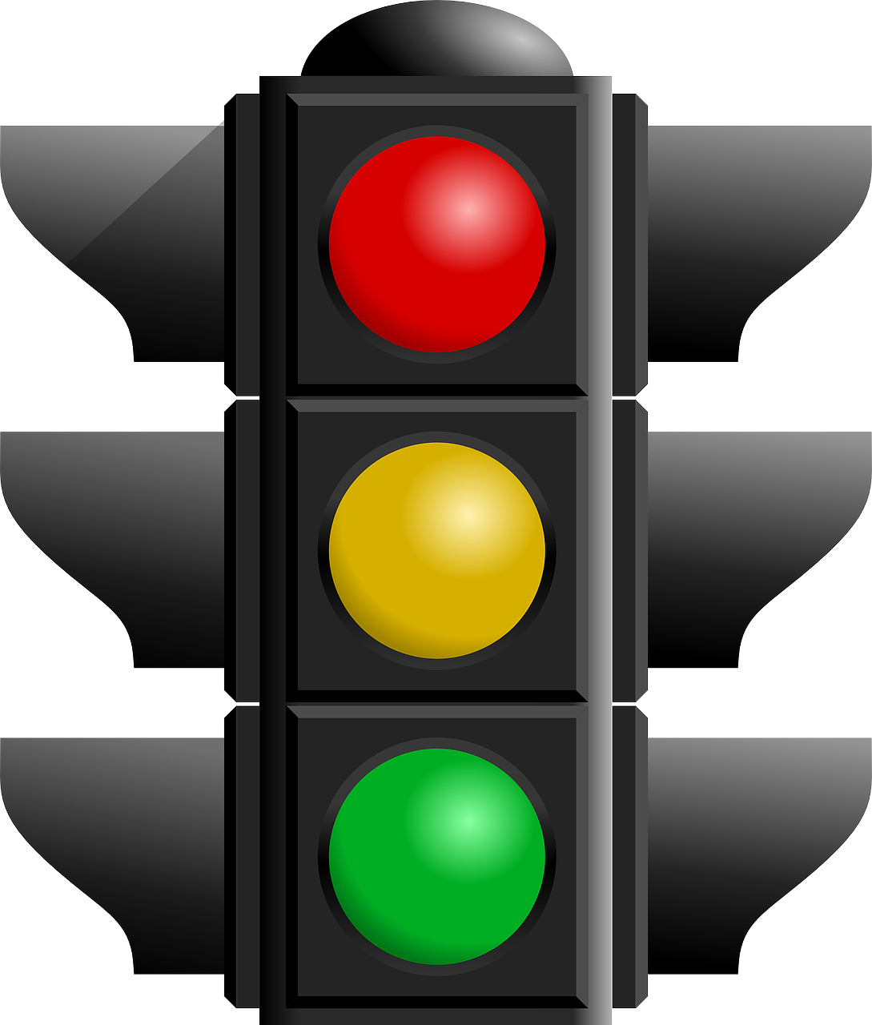 | Stop  - Recognize the problem.  - Does it require a thoughtful decision?  - Will it require the support of a trusted adult or additional resources?  - Who can help you make a healthy and safe decision?
Think
- Think about your options
- Think about the consequences of each option.
- Think about the resources that can help you.

Choose
- Make the healthy and safe choice.
- Reflect: How is it going? Do you still feel like this was the healthiest option, or is there another option to consider?

Attachment 2.2: Thoughtful Decision-Making
Directions: Read each scenario. Identify the decision that needs to be made; whether the decision requires thoughtfulness; and whether the decision requires outside help.

Scenario 1: After hurting her knee during a middle school basketball game, Maya was prescribed pain pills to help relieve her pain. Maya decides to take the pills exactly as they were prescribed by her doctor.
STOP  What is the situation? | Does it require thoughtfulness? | Does it require outside help?  Why or why not? | Who could help support Maya’s decision-making?
 | YES NO | YES NO
 | Why? | Why?
Scenario 2: Alex really likes hanging out with his older sister and her friends who all vape. To fit in, Alex decides to start vaping with them.
STOP  What is the situation? | Does it require thoughtfulness | Does it require outside help, why or why not? | Who could help support Alex’s decision-making?
 | YES NO | YES NO
 | Why? | Why?

Scenario 3: Aisha has a prescription for Adderall to help her concentrate better on her schoolwork. Feeling the pressure to get perfect grades from her family, she decides to start taking more of her Adderall than she is supposed to so she can focus even better.
STOP  What is the situation? | Does it require thoughtfulness? | Does it require outside help?  Why or why not? | Who could help support Aisha’s decision-making?
 | YES NO | YES NO
 | Why? | Why?

Scenario 4: Liam has been going through a lot lately with his family life. He has been feeling extremely sad and overwhelmed. Liam decides to start drinking alcohol at night before bed to help him not focus on all the negative feelings he is having.
STOP  What is the situation? | Does it require thoughtfulness? | Does it require outside help?  Why or why not? | Who could help support Liam’s decision-making?
 | YES NO | YES NO
 | Why? | Why?

Scenario 5: Sofia had a really bad experience at a party in middle school. It still causes her to feel very lonely and even have nightmares. Sofia has heard that marijuana can help her manage these intense feelings, so she decides to give it a try.
STOP  What is the situation? | Does it require thoughtfulness? | Does it require outside help?  Why or why not? | Who could help support Sofia’s decision-making?
 | YES NO | YES NO
 | Why? | Why?

Scenario 6: Ethan has been training really hard to make the varsity soccer team. His friend offers him some drugs to help him train even harder. Ethan decides not to take them because he is scared he will get in trouble if he gets caught.
STOP  What is the situation? | Does it require thoughtfulness? | Does it require outside help? Why or why not? | Who could help support Ethan’s decision-making?
 | YES NO | YES NO
 | Why? | Why?

Scenario 7: Jasmine is stung by a bee while playing outside. The bee sting begins to swell. A parent told them to take some Benadryl to help with the reaction. The parent helps Jasmine take the Benadryl as directed on the package just to be safe.
STOP  What is the situation? | Does it require thoughtfulness? | Does it require outside help? Why or why not? | Who could help support Jasmine’s decision-making?
 | YES NO | YES NO
 | Why? | Why?

Scenario 8: School is tough for Dylan, and he needs to try really hard to do well, unlike his older sister, who makes getting straight A’s look easy. To keep up with his older sister, Dylan decides to start taking caffeine pills and drinking energy drinks so he can study longer at night.
STOP  What is the situation? | Does it require thoughtfulness? | Does it require outside help? Why or why not? | Who could help support Dylan’s decision-making?
 | YES NO | YES NO
 | Why? | Why?

Attachment 2.3: Exit Ticket

I can use these three steps to make a healthy decision.

Step 1:

Step 2:

Step 3:

I am _________ that I can make healthy decisions.
- very confident
- somewhat confident
- not confident

List two people who can help you make healthy choices.

