Lesson 1: Making Healthy Choices: Know to NO!

Overview: Students will apply the substance use prevention principles to determine if a decision is healthy or unhealthy. Students will analyze scenarios to predict consequences, describe alternatives to substance use, and identify trusted adults who can support healthy choices.

National Health Education Standards
Standard 1. Students will comprehend concepts related to health promotion and disease prevention to enhance health.
Standard 5. Students will demonstrate the ability to use decision-making skills to enhance health.

Healthy Behavior Outcomes (HBOs):
Alcohol and other drugs | HBO 1: Avoid misuse and abuse of over-the-counter and prescription drugs.
 | HBO 2: Avoid experimentation with alcohol and other drugs.
 | HBO 3. Avoid the use of alcohol.
 | HBO 4: Avoid the use of illegal drugs.
Tobacco | HBO 1: Avoid using or experimenting with any form of tobacco.

Lesson Objectives – Students will be able to:
Objective | Assessments
- Predict individual short-term and long-term consequences from the substance use decision-making worksheet. | Attachment 1.1 – Making a Healthy Decision  Attachment 1.3 – Healthy or Unhealthy Decision
- Identify alternatives to substance use. | Attachment 1.1 – Making a Healthy Decision  Attachment 1.3 – Healthy or Unhealthy Decision
- Identify trusted adults at home, at school, and in the community who can support healthy decisions to prevent substance use. | Attachment 1.1 – Making a Healthy Decision
- Apply substance use prevention principles to distinguish between healthy and unhealthy decisions. | Attachment 1.2 – Can You Make a Healthy Choice?

Student Workbook Activities: Attachments 1.1, 1.2, 1.3

Lesson Prerequisites or Assumptions:
Lesson 1 was designed to introduce the substance use prevention unit for any middle school grade. The scenarios in Attachment 1.3 were designed to address alcohol, tobacco, medication safety, and other drugs. Select the scenarios that best fit your students’ needs.

Introduction:
- “Today we are going to begin learning about decision-making. We all make decisions every day, and a part of growing up is that we will make more decisions for ourselves. Who made a decision today? What was your decision?”
  - Discuss the various decisions students have made throughout the day. Possible answers may include what to wear, what to have for breakfast, etc.
  - Today we’ll learn about decisions and how they impact our health.
  - Remember during the substance use prevention lesson we’re going to apply recognize, reach out and use our resources and the substance use prevention principles to make healthy choices.
    - Recognize situations that require a thoughtful decision.
    - Reach out to resources that support healthy choices.
      - Trusted adults and health resources are here to help you make a healthy choice.
Teaching Steps:

Activity 1: Making Healthy Decisions
- Our health can be affected by our decisions. Have the class brainstorm decisions that we make that may impact our health (i.e., brushing our teeth, eating a healthy breakfast, smoking, exercising, staying up late and playing video games).
- Our decisions can be categorized as either healthy or unhealthy. Display the following definition:
  - Healthy decision: A health-related decision that will benefit ourselves, others, and the environment around us
  - Unhealthy decision: A health-related decision that could cause harm to ourselves, others, or the environment around us
- Complete Attachment 1.1: Making Healthy Decisions
- Ask students to explain how they made the decision: “What factors did you consider on whether something was a healthy decision or an unhealthy decision?” (Expect responses based around outcomes and/or consequences, i.e., I could get in trouble; it is bad for you; it will make me strong.)
- Share the key concepts and principles of substance use and misuse. Then display key terms and explain them.
  - Substance: alcohol, tobacco products, drugs, inhalants, medicines, and other chemicals that can be consumed, inhaled, injected, or otherwise absorbed into the body with possible dependence and other detrimental effects
  - Substance use: use of alcohol or illegal drugs or the misuse of prescription or over-the-counter drugs with negative consequences
  - Substance misuse: use of prescription and over-the-counter medications outside of the use prescribed by a doctor or as directed on the label
  - Substance use disorder: treatable, chronic disease characterized by a problematic pattern of use of a substance or substances, leading to impairments in health, social function, and control over substance use. It is a cluster of cognitive, behavioral, and physiological symptoms that accompany an individual’s continued substance use despite harmful consequences.
  - Addiction: severe and chronic substance use disorder
- Know to NO! principles: These can help us make healthy and safe choices. We’ll also learn skills to make healthy and safe choices.
  - 1a. Know to NO! Substance Use Prevention Principles
    - Substances such as tobacco, alcohol, and drugs have harmful consequences on our health and well-being.
    - Don’t touch, take or taste. Ask a trusted adult for help.
  - 1b. Know to NO! Medication Safety Principles
    - Only take medicine as directed from a trusted adult.
    - Trusted adults are people who are ready to help you; they will answer your questions kindly; they can help you make healthy choices and feel safe.
      - Trusted adults can be found at home, at school, and in the community.
    - Never take someone else’s medicine.
    - Properly store and dispose of medications.
- We make healthy choices using Stop, Think, Choose.
  - Recognize and reach out to resources to support healthy and safe choices.
  - Practice – Use Attachment 1.2 to practice applying the medication safety principles.
    - Picture 1 – Principle 2
    - Picture 2 – Application of principles 2, 3, 5
    - Picture 3 – Application of principles 1, 2, 3, 4, 5
    - Picture 4 – Application of principles 1, 2
    - Picture 5 – Application of principles 1, 2, 3, 4, 5
    - Picture 6 – Application of principles 1, 2, 3, 4, 5
- Now that we can apply the Know to NO! principles, we need to learn more about the positive and negative consequences of substance use. All decisions have consequences. Consequences can be positive or negative, short-term or long-term; they may affect only us or other people as well.
  - Consequence: the positive or negative outcome of a decision
  - Positive outcomes: healthy, safe results of a decision for self and others.
  - Negative outcomes: unhealthy, unsafe, and negative outcomes for self and others.
  - Short-term consequence: a positive or negative outcome of a decision that is going to impact us or those around us immediately
  - Long-term consequence: a positive or negative outcome of a decision that is going to take time to impact us or those around us
  - Let’s practice describing negative and positive outcomes. We’ll also think about short and long-term consequences. See Attachment 1.3.
- Discuss the consequences as a group.
  - Now that we see that our unhealthy decisions are most likely going to result in negative short- and long-term consequences, can we think of alternatives to these unhealthy decisions to help us avoid the negative consequences? Some ideas would be exercise/physical activity, mindfulness, creative activities, or hobbies. Display the term alternative to help students comprehend the concept.
    - Alternative: another option
  - Have students look at all the negative consequences on their sheet and decide if there is a positive alternative to them. For example: Vaping = negative consequence of getting in trouble with school. Alternative = do not vape and stay out of trouble
Activity 2: Healthy vs. Unhealthy Decisions Practice
- Let’s practice making decisions by analyzing decisions using our substance use prevention principles.
  - Select scenarios from Attachment 1.3 based on the students’ needs.
Closure:
- “As we have seen today, we are all making decisions every day. Some of them are going to improve our health, while others may not. In our next lesson, we are going to focus on making thoughtful decisions.”
- What are decisions?
- What makes it a healthy or unhealthy choice?
- Who can support you to make healthy and safe choices about substances?
- Can you tell me a healthy decision you would make involving substances?

Attachment 1.1: Making Healthy Decisions
Read the scenario and list the possible consequences. Circle if it is a healthy or unhealthy decision. If it is an unhealthy decision, then provide a healthy alternative.
 | Scenario | Possible consequences | Decision: Healthy or unhealthy? | If unhealthy, list a healthy alternative
1. | Eating a healthy breakfast. |  | Healthy
 |  |  | Unhealthy
2. | Taking a friend’s medication to help with a headache. |  | Healthy
 |  |  | Unhealthy
3. | Using a vape. |  | Healthy
 |  |  | Unhealthy
4. | Exercising or playing with friends for an hour. |  | Healthy
 |  |  | Unhealthy

List trusted adults you can talk to at home, at school, and in the community to help you make healthy choices.

Home | School/Community

Attachment 1.2: Can you make a healthy choice?
Circle your answer for each picture.
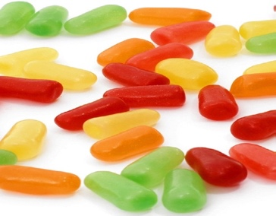 |  |  |  |  | 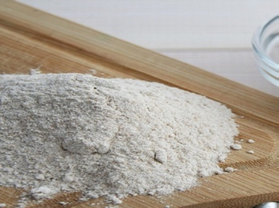 |  |  | 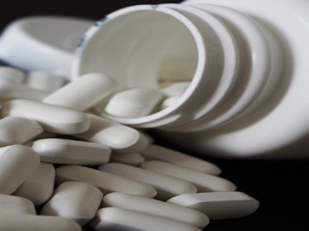
Healthy |  | 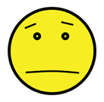Unsure |  | 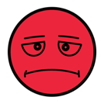Unhealthy | Healthy | Unsure | Unhealthy | Healthy | Unsure | Unhealthy
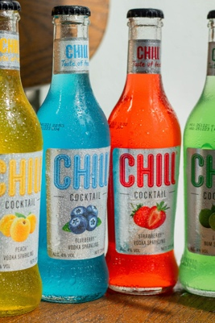 |  |  |  |  | 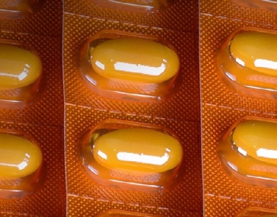 |  |  | 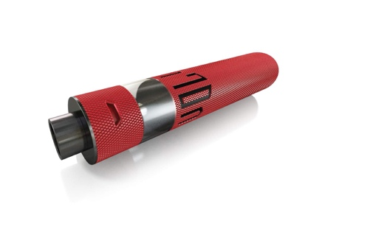
Healthy | Unsure |  | Unhealthy |  | Healthy | Unsure | Unhealthy | Healthy | Unsure | Unhealthy

If it is unhealthy , or unsure
- Don’t ________ it!
- Don’t _____ it!
- Don’t _____ it!

Only take medicine from a _____________________ adult

Attachment 1.3: Healthy vs. Unhealthy Decisions
Directions: Read each scenario and underline the part of the story that tells you if it is a healthy or unhealthy decision. Then write the number of the Know to NO! principle. Then describe the consequences and an alternative if it is unhealthy.
- Know to NO! Substance Use Prevention Principles
- Substances such as tobacco, alcohol, and drugs have harmful consequences on our health and well-being.
- Don’t touch, take, or taste. Ask a trusted adult for help.
- Know to NO! Medication Safety Principles
- Only take medicine as directed from a trusted adult.
- Never take someone else’s medicine.
- Properly store and dispose of medications.

Scenario 1: After hurting her knee during a middle school basketball game, Maya was prescribed pain pills to help relieve her pain. Maya decides to take the pills exactly as they were prescribed by her doctor.
Is the decision healthy or unhealthy? |  | Circle the Know to No! Principle that applies  - Substance Use Prevention Principles  - Substances such as tobacco, alcohol, and drugs have harmful consequences on our health and well-being.  - Don’t touch, take, or taste. Ask a trusted adult for help.  - Medication Safety Principles  - Only take medicine as directed from a trusted adult.  - Never take someone else’s medicine.  - Properly store and dispose of medications.
Healthy | Unhealthy

What are the possible consequences of this choice? | Describe a healthy alternative if it is unhealthy

Scenario 2: Alex really likes hanging out with his older sibling and their friends, but all of them vape. To fit in, Alex decides to start vaping with them.
Is the decision healthy or unhealthy? |  | Circle the Know to No! Principle that applies  - Substance Use Prevention Principles  - Substances such as tobacco, alcohol, and drugs have harmful consequences on our health and well-being.  - Don’t touch, take, or taste. Ask a trusted adult for help.  - Medication Safety Principles  - Only take medicine as directed from a trusted adult.  - Never take someone else’s medicine.  - Properly store and dispose of medications.
Healthy | Unhealthy

What are the possible consequences of this choice? | Describe a healthy alternative if it is unhealthy

Scenario 3: Kaidyn has a prescription for Adderall to help concentrate better on schoolwork. Feeling pressure to get better grades from family, they decide to start taking more Adderall than prescribed to try to improve their focus and attention.
Is the decision healthy or unhealthy? |  | Circle the Know to No! Principle that applies  - Substance Use Prevention Principles  - Substances such as tobacco, alcohol, and drugs have harmful consequences on our health and well-being.  - Don’t touch, take, or taste. Ask a trusted adult for help.  - Medication Safety Principles  - Only take medicine as directed from a trusted adult.  - Never take someone else’s medicine.  - Properly store and dispose of medications.
Healthy | Unhealthy

What are the possible consequences of this choice? | Describe a healthy alternative if it is unhealthy

Scenario 4: Liam has been going through a lot lately with their family life. They have been feeling extremely sad and overwhelmed. Liam decides to start drinking alcohol at night before bed to help not focus on all the negative feelings.
Is the decision healthy or unhealthy? |  | Circle the Know to No! Principle that applies  - Substance Use Prevention Principles  - Substances such as tobacco, alcohol, and drugs have harmful consequences on our health and well-being.  - Don’t touch, take, or taste. Ask a trusted adult for help.  - Medication Safety Principles  - Only take medicine as directed from a trusted adult.  - Never take someone else’s medicine.  - Properly store and dispose of medications.
Healthy | Unhealthy

What are the possible consequences of this choice? | Describe a healthy alternative if it is unhealthy

Scenario 5: Sofia had a really traumatic experience. It still causes anxious feelings and nightmares. Sofia has heard that marijuana can help manage these intense feelings, so she decides to give it a try.
Is the decision healthy or unhealthy? |  | Circle the Know to No! Principle that applies  - Substance Use Prevention Principles  - Substances such as tobacco, alcohol, and drugs have harmful consequences on our health and well-being.  - Don’t touch, take, or taste. Ask a trusted adult for help.  - Medication Safety Principles  - Only take medicine as directed from a trusted adult.  - Never take someone else’s medicine.  - Properly store and dispose of medications.
Healthy | Unhealthy

What are the possible consequences of this choice? | Describe a healthy alternative if it is unhealthy

Scenario 6: Ethan has been training hard to make the varsity soccer team. A classmate offers him some drugs to help him train even harder. Ethan decides not to take them because he is scared he will get in trouble if he gets caught.
Is the decision healthy or unhealthy? |  | Circle the Know to No! Principle that applies  - Substance Use Prevention Principles  - Substances such as tobacco, alcohol, and drugs have harmful consequences on our health and well-being.  - Don’t touch, take, or taste. Ask a trusted adult for help.  - Medication Safety Principles  - Only take medicine as directed from a trusted adult.  - Never take someone else’s medicine.  - Properly store and dispose of medications.
Healthy | Unhealthy

What are the possible consequences of this choice? | Describe a healthy alternative if it is unhealthy

Scenario 7: Jasmine is stung by a bee while playing outside. The bee sting begins to swell. A parent told them to take some Benadryl to help with the reaction. The parent helps Jasmine take the Benadryl as directed on the package just to be safe.
Is the decision healthy or unhealthy? |  | Circle the Know to No! Principle that applies  - Substance Use Prevention Principles  - Substances such as tobacco, alcohol, and drugs have harmful consequences on our health and well-being.  - Don’t touch, take, or taste. Ask a trusted adult for help.  - Medication Safety Principles  - Only take medicine as directed from a trusted adult.  - Never take someone else’s medicine.  - Properly store and dispose of medications.
Healthy | Unhealthy

What are the possible consequences of this choice? | Describe a healthy alternative if it is unhealthy

Scenario 8: School is tough for Dylan, and he needs to try really hard to do well, unlike his older sibling, who makes getting straight A’s look easy. To keep up with his older sibling, Dylan decides to start taking caffeine pills and drinking energy drinks so he can study longer at night.
Is the decision healthy or unhealthy? |  | Circle the Know to No! Principle that applies  - Substance Use Prevention Principles  - Substances such as tobacco, alcohol, and drugs have harmful consequences on our health and well-being.  - Don’t touch, take, or taste. Ask a trusted adult for help.  - Medication Safety Principles  - Only take medicine as directed from a trusted adult.  - Never take someone else’s medicine.  - Properly store and dispose of medications.
Healthy | Unhealthy

What are the possible consequences of this choice? | Describe a healthy alternative if it is unhealthy

