Lesson 3: Refusal Skills and Assertiveness
Overview: Students will develop communication skills and strategies to resist substance use. Verbal and nonverbal assertive communication will be practiced to support healthy choices that prevent substance use.

National Health Education Standards
Standard 1: Students will comprehend concepts related to health promotion and disease prevention to enhance health.
Standard 4: Students will demonstrate the ability to use interpersonal communication skills to enhance health and avoid or reduce health risks.

Healthy Behavior Outcomes (HBOs):
Alcohol and other drugs | HBO 2. Avoid misuse and abuse of over-the-counter and prescription drugs.
Alcohol and other drugs | HBO 3. Avoid the use of alcohol.
Alcohol and other drugs | HBO 4. Avoid the use of illegal drugs.
Tobacco | HBO 1. Avoid using or experimenting with any form of tobacco.

Lesson Objectives – Students will be able to:
Objective | Assessments
- Describe the elements of assertive communication. | Attachment 3.1 – Assertiveness T-Chart
- Apply medication safety and substance use prevention principles to prevent substance use. | Attachment 3.3 – Communication Skill Scenario
- Analyze a refusal message using the critical elements of assertiveness and refusal skills. | Attachment 3.3 – Communication Skill Scenario
- Write a refusal statement to prevent substance use. | Attachment 3.3 – Communication Skill Scenario
- Demonstrate assertive communication to refuse an unhealthy choice to prevent substance use in a situation or scenario. | Attachment 3.3 – Communication Skill Scenario
- Offer a healthy alternative to substance use. | Attachment 3.3 – Communication Skill Scenario

Introduction
- No is just a two-letter word: N-O. It seems simple enough to say, but saying the word is not all there is to refusing unhealthy substances. Today we’ll learn how to be assertive with our words and actions to say NO.
- Let’s review what we’ve learned so far:
- Can you remember our substance use prevention and medication safety principles to help us make healthy choices?
  - Rule 1: Substance use — including alcohol, tobacco, and drugs — is harmful to my health.
  - Rule 2: If you do not know what something is:
    - Don’t touch it!
    - Don’t take it!
    - Don’t taste it!
    - Reach out to a trusted adult for help to make healthy choices!
  - Rule 3: ONLY take medicine with the help of a trusted adult.
  - Rule 4: NEVER take someone else’s medicine.
- When we make a decision, what are the three steps we can use?
  - Stop, Think, Choose
- Today we’re going to give you one more tool to help you be healthy. We’re going to practice our communication skills — specifically, how to say NO.
  - How do we communicate? (With our words and nonverbal gestures.)
  - What can we communicate? (Ask for help and say thank you for helping)
    - Communicating a decision is sometimes challenging. For example, what if you are hesitant or a little afraid to say NO, especially to a friend? Are you concerned that you could be called names or that you may be left out of future activities? Are you concerned you may lose a friend? Indeed, saying NO is more than just sounding out two letters. It will take some practice to communicate clearly with our words and body language to share our healthy choice.
    - Saying NO will protect your health and well-being, and your real friends will accept your refusing to do something that is unhealthy or unsafe. Our big lesson today is how to say NO to unhealthy, unsafe situations.

Activity 1: Refusal Skills
- Decision-making helped you stop and think about the options before choosing a healthy and safe option to prevent substance use.
- You’ll need to communicate your decision to be sure you are healthy and safe. You might have to tell someone NO or refuse to do something that is unhealthy or unsafe. Using assertive communication will help you stand up for yourself and your decision.
- Today, we will practice refusal statements and assertive communication so you can be healthy and safe.
- To practice our refusal skill, we will complete an unfinished role-play with a partner. In the role-play, you will resist the peer pressure to use a substance. Let’s briefly learn more about refusal skills:
  - Refusal skills are ways to say NO to pressure.
- Why is it important to learn how to resist pressure and to learn refusal skills?
  - To tell others we don’t want to make an unhealthy choice
  - To make a healthy choice
- ALL REFUSAL SKILLS use assertiveness. Being assertive simply means standing up for yourself and for your health and safety.
  - What does assertiveness look like and sound like?
    - Stand up straight.
    - Look the other person in the eyes.
    - Calmly and politely state your position.
    - Be confident in voice and body. Your voice volume and tone should help the person hear you loud and clear.
  - Let’s practice being assertive with a partner. You’re at the park, and a friend brought a gummy they found at home. You don’t know what it is so you’re going to tell them NO.
- Give students an Assertiveness T-chart (Attachment 3.1). On one side, they will write what assertiveness LOOKS like; on the other side, they will write what assertiveness SOUNDS like.
  - When they are finished, briefly review their T-charts by drawing a similar T-chart on the board and recording their answers. Be sure to include any key parts of assertiveness students may have overlooked.
- One way of resisting pressure and making healthy decisions is to use refusal skills. Refusal skills are ways to say NO to pressure.

Activity 2: Modeling and Practicing Refusal Skills
- Why is it important to learn how to resist pressure and to learn refusal skills?
  - To tell others we don’t want to make that unhealthy choice
  - To make a healthy choice
- Refusal skills are both verbal and nonverbal. Today we will learn a specific type: “Three NOs and a Walk.”
  - What will you say? Three NOs and a Walk
  - No, I am not interested because want to stay healthy.
  - No, that’s not for me. I would rather go do something active.
  - No, I’ve made the choice to be healthy.
- How will you say it? Be assertive!
  - Look directly at the person.
  - Speak clearly, calmly, and confidently, and concisely (the three C’s)
  - No arguing
- How will your body look?
  - Stand straight up, shoulders back.
  - Body “says” I am confident.
- Let’s practice with a partner using Three NOs and a Walk
- Pair up with partner and use the assertiveness checklist to help you be assertive (Attachment 3.2).
Activity 3a: Refusal Skill Role-play
- Use the following role-play to demonstrate a refusal skill. Role-play with a partner is recommended, but you could have student write what they would say.
  - In role-play No. 1 (Attachment 3.2), the teacher will model the refusal skill for the students.
    - The teacher plays the role of refuser. A student volunteer plays the role of the friend.
    - During the role-play, the class will use the checklist for Three Nos and a Walk (Attachment 3.3) to determine if the refuser was effective in this scenario.
    - Discuss what occurred in the role-play.
      - Did I say no?
      - Did I say no three times?
      - Did I walk away from the situation?
      - How did Three Nos and a Walk help me communicate the healthy decision?

Activity 3b: Provide an Alternative
- Another refusal skill strategy is to provide an alternative. When someone is pressuring you to use a substance, simply offer an idea about something else that the two of you could do (see Attachment 3.3).
  - Charlie: Hey Takuma — let’s go try this vape pen.
  - Takuma: NO. I’ve got another idea. Let’s bike down to the ice cream shop and get a shake.
    - ASK: What was the alternative Takuma offered? (Biking to get a milkshake)
- EXPLAIN: By offering an alternative, Takuma took the focus off the substance use situation. But what if Charlie doesn’t want to get a shake?
  - Let’s return to the situation:
  - Charlie: I do not want to bike to get a milkshake. I want to try this vape pen.
  - Takuma: See you later, Charlie. If you change your mind, I’ll be at the ice cream shop.
- EXPLAIN: There is no point in arguing with Charlie about the vape pen. When someone begins to argue, they are just trying to get you to change your mind. You already told Charlie what you wanted to do, so it is time to do what matches YOUR values and beliefs.
- GIVE pairs of students the unfinished role-play and ask them to complete it using the Charlie/Takuma example as a guide. They should not use the same alternative as the one used by Takuma. They should think of their own alternatives.
  - Charlie: Hey, let’s go try this vape pen.
  - You: (Provide an alternative to vaping with Charlie.)
  - Charlie: I do not want to. I want to vape.
  - You: (Write a goodbye statement.)
- ASK: After a few minutes, ask students to share their role-plays with the class. Before they begin sharing, remind them of the chart you wrote on the board about what assertiveness looks and sounds like.
- After each role-play, use the Assert Yourself: Offer an Alternative checklist (see Attachment 3.3) to provide feedback. (Give each student a copy of this checklist or display it on the front board.)
Activity 3c: Ask for Help
- If you need to reach out to a trusted adult, you can be assertive and remember to:
  - Ask: “Can you help me?”
  - Tell what is happening. Be clear and specific
  - Listen to what you are told to do.
  - Thank you!
- Practice with your partner to ask for help.
Closure:
- What do we use when someone wants you to do something that is not healthy or safe?
  - Refusal skills
- What does a refusal skill look and sound like?
  - We use verbal and nonverbal communication to say no.
- What is a strategy you can use to say no?
  - Three NOs and a Walk
Attachment 3.1: Assertiveness T-Chart

Assertiveness looks like: | When I use my words, assertiveness sounds like:

Attachment 3.2a: I Am Assertive! Checklist
- Say NO and give a reason.
- No, I am not interested because I want to stay healthy.
- No, that’s not for me. I would rather go do something active.
- No, I’ve made the choice to be healthy.
After three NOs, you walk away.
- Be assertive! Say it with your words and actions.
- Look directly at person.
- Speak clearly, calmly, confidently, and concisely (the four C’s)
- Stand straight up, shoulders back.
- Body conveys, “I am confident.”
- No arguing; walk away if you need to.

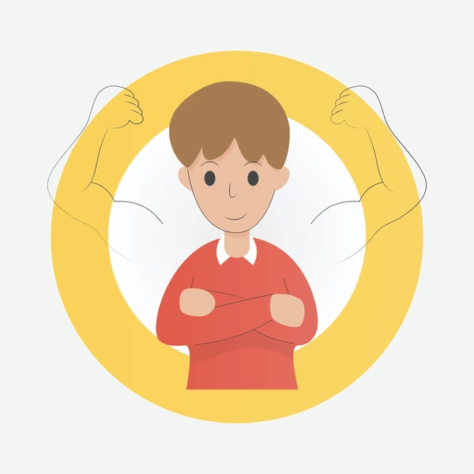

Attachment 3.2b: Asking for help
Find a trusted adult
- Ask, “Can you help me?”
- Tell what is happening.
- Listen to what you are told to do.
- Thank you!

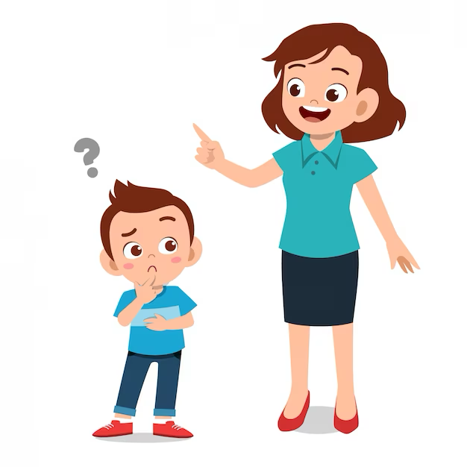

Attachment 3.3: Communication Skill Scenario
Part I. Refusal Message: Saying NO
Scenario: Gracyn – Hey Sevyn, let’s go try this vape.
- Is trying a vape a safe and healthy choice?
  - YES
  - NO
- What is your reason?
- It is a healthy choice.
- It is unhealthy, so I won’t take, touch, or taste it.
- We never share or take someone else’s medicine
- I don’t think it will hurt to try it.
- After you say NO! ______ times, you must walk away.
  - 1
  - 2
  - 3
  - 7
- Write a healthy alternative to vaping.
Gracyn: Hey Sevyn, let’s go try this vape.
Sevyn:
Sevyn needs to ask a trusted adult for help. Try out your statement with a classmate.
- Who is a trusted adult you can turn to when you need help?

Part II. Write how Sevyn would ask for help from a trusted adult.
- Ask

- Tell what is happening.

- Listen to what you are told to do.

- Thank you!

