Lesson 1: Making Healthy Choices: Know to NO!

Overview: This lesson targets the Know to NO! principles to make healthy choices about substance use. Students will analyze situations, apply substance use prevention principles, and identify when to seek additional information or support to make a healthy choice.

National Health Education Standards
Standard 1: Students will comprehend concepts related to health promotion and disease prevention to enhance health.
Standard 3: Students will demonstrate the ability to access valid information, products, and services to enhance health.

Healthy Behavior Outcomes (HBOs):
Alcohol and other drugs | HBO 2. Avoid misuse and abuse of over-the-counter and prescription drugs.
 | HBO 3. Avoid the use of alcohol.
 | HBO 4. Avoid the use of illegal drugs.
Tobacco | HBO 1. Avoid using or experimenting with any form of tobacco.

Lesson Objectives – Students will be able to:
Objective | Assessments
- Describe how substances including medicines, tobacco, alcohol, and drugs can have harmful and unhealthy consequences. | Attachment 1.1 – What Do You know?  Attachment 1.3 – Show What You Know!
- Apply Know to NO! substance use principles to determine if a choice is healthy or unhealthy. | Attachment 1.1 – Know to NO!  Attachment 1.3 – Quest Cards
- Identify trusted adults and resources that can support a healthy decision. | Attachment 1.3 – Show What You Know!

Introduction:
- STATE: We are going to begin today’s lesson with a story. Please listen carefully.
- READ story: Joyellen, a fifth grader, heard a few things about this new device called a vape or a vape pen. She had seen a few adults and a couple of high school students using a vape. The high school kids told her it was just water vapor that was inhaled and then blown out, and it wouldn’t hurt. In fact, they said it was harmless but made them look cool. Joyellen decided there wasn’t any harm in trying it. She began using the vape pen a few days a week, then felt the urge to use it more, and after a month or so, she developed continual wheezing and a bad cough. One day she woke up and was struggling to breathe. She became scared and told her mom what she had been doing. Joyellen’s mom took her to the doctor, where she learned the truth about vaping.
- Ask the students:
  - Did Joyellen make a healthy and safe choice when she tried the vape pen?
  - Why is it an unhealthy and unsafe choice?
  - What could help Joyellen make a healthy decision?
Teaching Steps:

Activity 1: Know to NO! Substance Use Prevention
- This is our first lesson about substance use prevention. Substances include alcohol, tobacco, medications, and other drugs. Substances can also include medicines and substances such as poisons and chemicals that are harmful. Our focus is on making healthy choices to prevent substance use. There are four key Know to NO! principles to remember to make healthy choices that enhance our health and prevent substance use:
  - Rule 1: Substance use — including alcohol, tobacco, and other drugs — is harmful to my health.
  - Rule 2: If you do not know what something is:
    - Don’t touch it!
    - Don’t take it!
    - Don’t taste it!
    - Reach out to a trusted adult for help to make healthy choices!
  - Rule 3: ONLY take medicine with the help of a trusted adult
  - Rule 4: NEVER take someone else’s medicine.
- Let’s apply the Know to NO! to Joyellen’s story. Give thumbs up if you agree or thumbs down if you disagree or thumbs in the middle if you’re unsure.
  - Is using the vape harmful to Joyellen’s health?
    - Yes, it is harmful and unhealthy. (Rule 1)
  - Did Joyellen touch, take, or taste something that was unhealthy or unsafe, or was she unsure? Did Joyellen reach out to a trusted adult for help?
    - Yes, she did, and it was unhealthy to touch, take or taste. (Rule 2)
    - No, Joyellen did not reach out to a trusted adult. (Rule 2)
- We’ll apply the Know to NO! principles for any substance. Substances include alcohol, tobacco, medicines, and drugs.
  - Conduct a THINK-PAIR-SHARE to process their answers. You will THINK about each question, pair up with a partner to discuss your answers, and SHARE your answers with the whole class or another group.
- What do you know about substances?
  - Students will share a range of answers. Be sure to provide a safe, supportive environment where you are listening to what students know and would like to know.
  - Make the connection between substances and drugs, alcohol, medicine, and other harmful substances like poison.
- What do you need to know about substances?
- Can you make a list of substances that would be unhealthy or unsafe or that you are unsure about?
  - We need to make healthy choices with alcohol, tobacco, drugs, and medicines.
  - After the last question, review the Know to NO! principles.
- What should we do if we encounter any of these substances?
  - Don’t touch, take, or taste! Tell a trusted adult.
Activity 2: Identifying Trusted Adults
- What should I do if I need help taking medicine or recognize a substance such as alcohol, tobacco, or other drugs that are unhealthy or unsafe or that I am unsure about?
  - Reach out to a trusted adult for help.
  - Who are trusted adults? You can find them at home, at school, and in the community.
  - Why are trusted adults helpful?
    - They can help you make a healthy decision by providing information and rules and identifying potential consequences. They can also find additional help if needed.
  - How can a trusted adult influence you to make a healthy choice?
  - Trusted adults can help us identify our options and select a healthy and safe choice.
  - Trusted adults share rules and expectations that help us make the healthy, safe and respectful choice.
  - Trusted adults can give us information or resources for more information to make healthy choices. We’ll learn more about resources in future lessons.
    - We should rely on resources that are reliable, accurate, and up to date. We’ll learn more about influences and positive influences in Lesson 4.
- Let’s make a list together. Name trusted adults at home, at school, or in the community:
  - Home – parents and grandparents
  - School – teachers and staff members
  - Community – professionals (e.g., doctor, nurse, police officer), helpers, coaches, club leaders)
- Complete Attachment 1.1 – Just What Do You Know?
Activity 3: What’s the Message?
- EXPLAIN that students will be completing a quest to decipher the message using our knowledge about healthy choices about substances.
- Decide if your students will be divided into teams, pairs, or individuals. Students can travel to each station or have their collection of cards at their desk/table.
- Attachments:
  - Attachment 1.2a – Student copy of coded message.
  - Attachment 1.2b – Teacher copy of coded message.
  - Attachment 1.3a – Question side of quest cards.
  - Attachment 1.3b – Quest card answer side. Number represents the space the letter goes in the coded message. Example: 2 = T. The letter T would go in each square marked 2.
  - Notes: Attachments 1.3a and 1.3b should be copied double sided, cut, and shared with each team. Teachers could also use the lesson presentation slides to ask each question and supply the coded letter after each response.
- ASK these questions when all students are finished:
  - What was the message? (I can make healthy choices)
  - How can you make healthy choices?
    - Know to NO! Reach out to trusted adults. Never share or take someone else’s medicine.

Attachment 1.1: Just What Do You Know?
- Circle the substances that are unhealthy or unsafe.
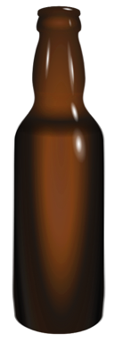 | 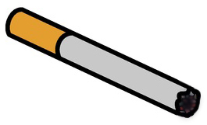 | 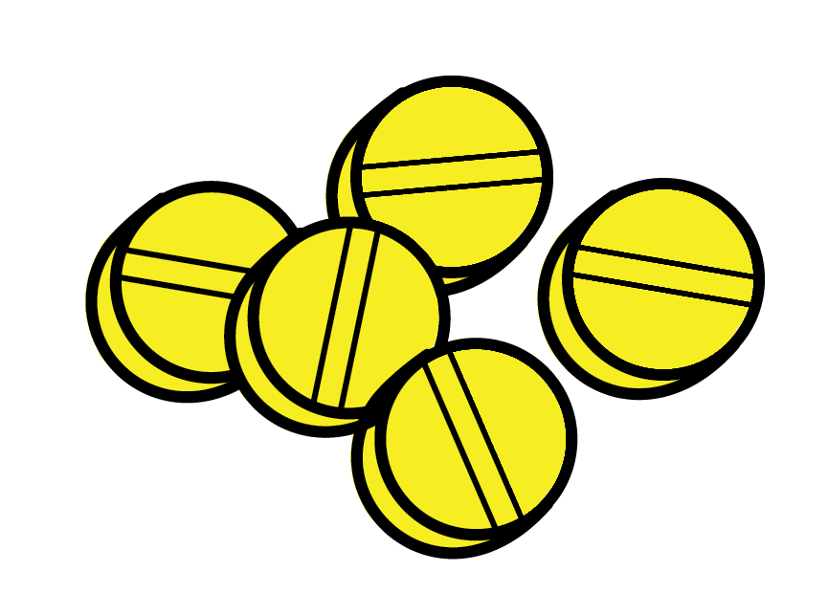 | 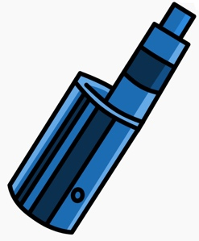
Alcohol | Tobacco | Opioids | Marijuana
- Fill in the blank: I can make ____________choices because my health is important to me.
- Know to NO! Using tobacco has ____________ consequences for my health.
    - Positive
    - Negative
- Fill in the blanks: If I recognize a substance that is unhealthy or unsafe, or if I’m unsure, don’t _____________, touch, or _______________. Reach out and ask a __________________ adult or resource for help to make a healthy decision.
- List a trusted resource to reach out to when you need help making a healthy choice.

Attachment 1.2a: Quest Message
Answer each question to earn letters to complete your Quest for Healthy Choices
(3) | (6) | A | (4) | (2) | (3) | (7) | !
(8) | (3) | O | (1) | (8) | (6) | (5)

Attachment 1.2b: Quest Answers
I can make …
H  (3) | E  (6) | A | L  (4) | T  (2) | H  (3) | Y  (7) | !
C  (8) | H  (3) | O | I  (1) | C  (8) | E  (6) | S  (5)

Attachment 1.3a: Quest Cards (Question Side)

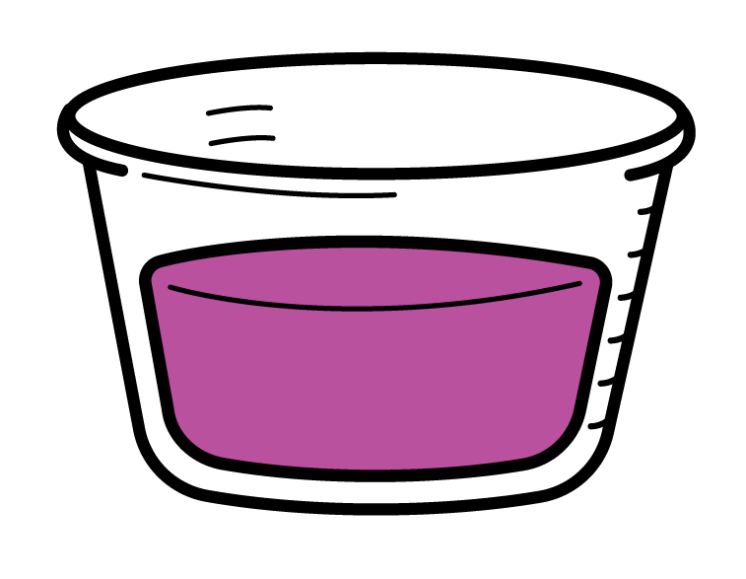  Healthy choice?  (1) | 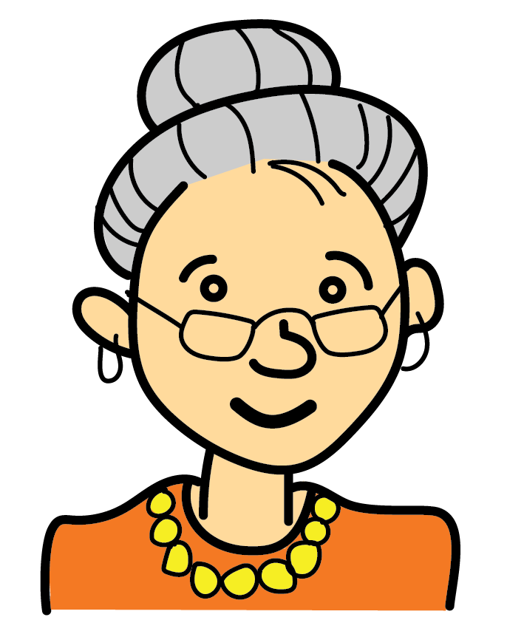  Trusted adult?  (2) | 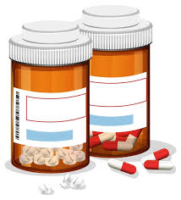  If you see this, do NOT _____, _____, or ____.  (3) | 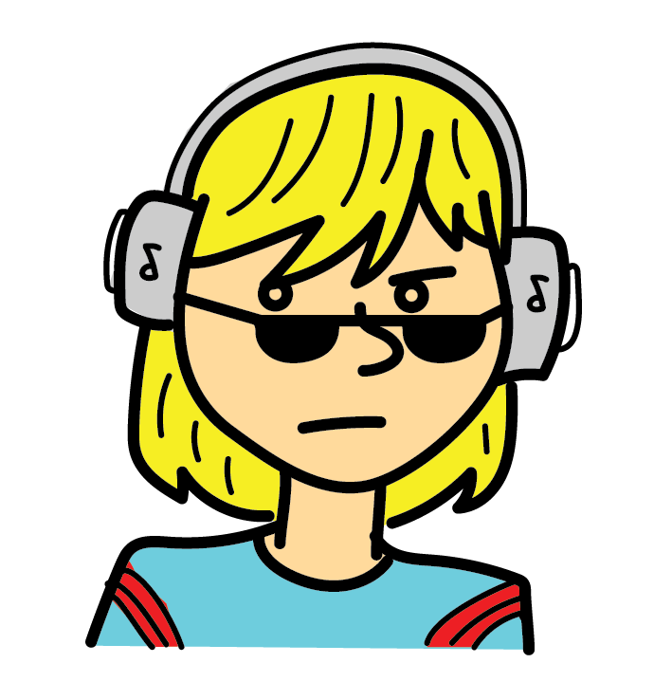  Trusted adult?  (4)
Who can help you take medicine?  (5) |   Healthy Choice?  (6) | 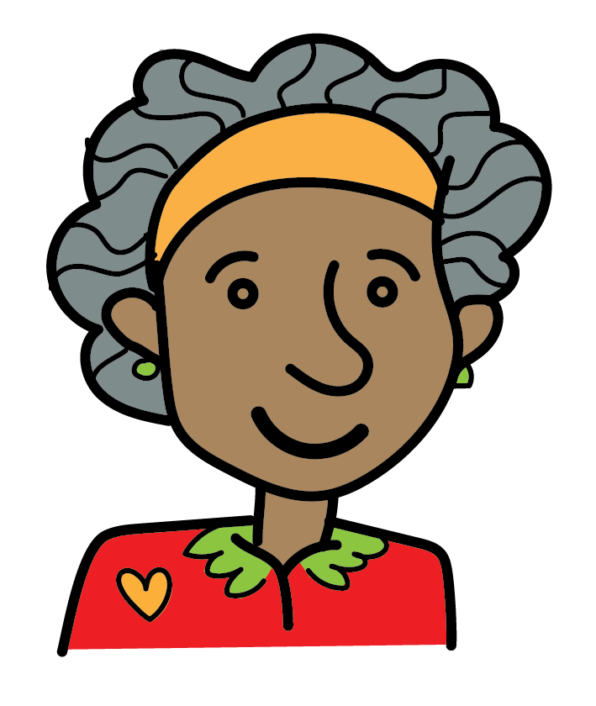  Trusted adult?  (7) | 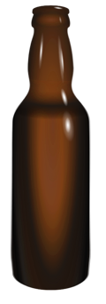  Healthy Choice?  (8)

Attachment 1.3b: Quest Cards (Code Side)

NO!  (1 = I) | YES  (2 = T) | Take, Touch or Taste  (3 = H) | NO!  (4 = L)
Trusted Adults  (5 = S) | NO!  (6 = E) | Yes!  (7 = Y) | NO!  (8 = C)

