Lesson 4: Positive Influences and Healthy Choices
Overview: Students will describe influences and how to be a positive influence to make healthy choices. Lesson activities will also differentiate between positive and negative influences at home, at school, and in the community that can support healthy choices.

National Health Education Standards
Standard 1: Students will comprehend concepts related to health promotion and disease prevention to enhance health.
Standard 2: Students will analyze the influence of family, peers, culture, media, technology, and other factors on health behaviors.

Healthy Behavior Outcomes (HBOs):
Alcohol and other drugs | HBO 2. Avoid misuse and abuse of over-the-counter and prescription drugs.
 | HBO 3. Avoid the use of alcohol.
 | HBO 4. Avoid the use of illegal drugs.
Tobacco | HBO 1. Avoid using or experimenting with any form of tobacco.

Lesson Objectives – Students will be able to:
Objective | Assessments
- Differentiate between positive and negative influences. | Attachment 4.1 – Recognize the Positive Influences
- Describe harmful consequences of substance use. | Attachments 4.2a, 4.2b, 4.2c – Show What You Know
- Apply medication safety and substance use prevention principles to promote healthy choices and avoid substance use. | Attachments 4.2a, 4.2b, 4.2c – Show What You Know
- Identify resources and influences that can support healthy choices. | Attachments 4.2a, 4.2b, 4.2c – Show What You Know
- Identify positive influences and resources that can promote healthy choices that prevent substance use. | Attachment 4.3 – Positive Influences in My Life
Introduction (Hook):
- WRITE on front board:
  - The power of influence
- ASK:
  - What does it mean to influence? How can you influence or be influenced?
    - Influence can change our how we act, think, and feel.
- In this lesson, we’re going think about how decisions about substances including alcohol, drugs, and medicines can be influenced. After this lesson, you will be able to spot positive and negative influences.
- You’ll learn the power of positive influences to help you make healthy choices and how we can be a positive influence to help others make healthy choices.
Teaching Steps:

Activity 1: Positive and Negative Influences
- REVIEW influences and differences between positive and negative influences.
- Explain that influences are people or things that can affect whether you make a healthy or unhealthy choice.
  - A positive influence is one that can lead to a healthy and safe choice. Positive influences protect our health.
  - A negative influence is one that can lead to an unhealthy or unsafe choice. Negative influences could put our health at risk.
  - Influences include people, rules, activities, and messages. There are lots of influences, but we’re going to use positive influences to make healthy choices.
- Let’s practice together identifying a positive or negative influence.
  - Your cousin asks you to run across the road with her before looking both ways.
    - Ask: Is this a positive or negative influence? (Negative)
Why? (Unhealthy, unsafe)
  - Your friend shares his apple slices with you.
    - Ask: Is this a positive or negative influence? (Positive)
Why? (Healthy)
  - Your fourth grade neighbor asks you if you want to take some medicine because you have a headache.
    - Ask: Is this a positive or negative influence? (Negative)
Why? (Unhealthy, Unsafe)
- STATE: Let’s practice spotting positive and negative influences and substance use (see Attachment 4.1).
- READ the following story about influences:
  - Malachi got a new bicycle for his birthday. The other day at the park, Malachi’s friends said they were not going to wear their bike helmets because it doesn’t look cool, and it feels too tight on their head. They said Malachi should not wear a helmet either. Malachi begins to wonder what it would feel like to ride without his helmet. Then Malachi thinks about what his parents told him, “Malachi, we trust you to wear your bike helmet whenever you are riding your bike. You know it is unsafe and unhealthy to ride without a helmet.” Malachi remembered telling his parents he would always ride with his helmet securely on his head. Malachi has to think about what to do. (Influences are italicized for the teacher.)
- STATE: There is a negative influence in this story, and there is a positive influence.
  - A positive influence could lead to a h______, s_____ choice.
  - A negative influence could lead to an unh________, uns______ choice.
  - Ask these processing questions:
    - What is the negative influence? How did you know?
    - What is the positive influence? How did you know?
    - When Malachi’s parents said, “Malachi we trust you …,” what did they mean?
    - Are there rules about wearing a helmet while riding a bike?
    - Which influence would you tell Malachi to listen to: his friends or his parents? Why?
- READ: Continue with Malachi’s bike story.
  - Malachi’s parents took him to a bike shop to get a water bottle for his bike. While there, Mr. Johnson, the bike shop manager, asked Malachi if he always wore his helmet. Mr. Johnson told Malachi the helmet would help protect his head if he fell from his bike or got in an accident. Mr. Johnson gave Malachi a biking magazine that had interesting stories, a list of nearby bike trails, and lots of pictures of children and adults riding their bikes and wearing helmets.
    - Did you recognize any negative influences?
    - Did you recognize any positive influences?
    - What did Mr. Johnson tell Malachi?
    - How were the pictures in the biking magazine a positive influence?
    - What or who is a positive influence in your life? Why?
Activity 2: Avoid the Negative Influence
- Your friends found a jar of cinnamon and dare you to take a challenge.
  - Why would some people be influenced by a negative influence?
    - Want to fit in
    - Easier to go along with the group
    - Curious to try what the others are doing because they think everyone is trying it
    - Miss the signs to recognize a negative influence
- Why is it important to avoid negative influences?
  - They could influence, push, or lead you to make an unhealthy or unsafe choice.
  - Positive influences help you make healthy choices.
- Tools to say NO to a negative influence
  - Know to NO! Trust your knowledge and feelings that you know what is healthy, safe, and right.
  - Use Stop, Think, Choose to recognize the situation, think about your options, and make a healthy choice.
  - Find a positive influence: Have friends that can help you make healthy choices.
  - Reach out for help or advice from a trusted adult.
  - Use protective factors: These are ways we protect our health. They are activities we do (e.g., physical activities and hobbies), people who help us make healthy choices (e.g., friends, family, or trusted adults who encourage healthy choices), or places that are healthy and safe (e.g., school). Can you think of three ways your health is protected?
  - Be a positive influence: Help a friend make a healthy choice to be a positive influence. Get other friends to go along with you.
  - Walk away.
- Do you remember how to say NO?
  - Be assertive and clearly say NO with your words and actions.
  - Use a strategy like “Three NOs and a Walk.”
  - Just walk away.
  - Give an alternative.
Activity 3 – Show What You Know!
- Use Attachments 4.2a (tobacco), 4.2b (medicine and drugs) and 4.2c (alcohol) to practice identifying influences and making healthy choices. Use the scenario(s) that best meet your students’ needs. Use the other scenarios for additional practice.
Activity 4: I Am a Positive Influence!
- In our final activity. We’re going to show and tell how we make healthy choices and will be a positive influence on others to be sure we’re healthy and safe.
- Use sticky notes or small pieces of paper or another method to collect your students’ ideas into a word wall.
- Give your students a prompt: I will be a positive influence and make healthy choices by …
- Once all of the notes are on the wall, have students share how they are positive influences.
Closure:
- How can we make healthy choices?
  - Know to NO!
  - Use Stop, Think, Choose to make healthy choices.
  - Use our communication skills to say no.
  - Be a positive influence.
  - Reach out to trusted adults to help you make healthy choices.
Attachment 4.1: Recognize the Positive Influences
Label with a + if it is positive influence on your health. Label with a – if it is negative influence on your health.
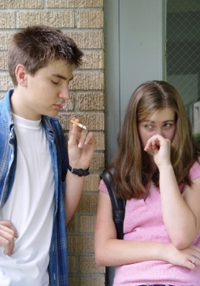  Another kid smoking |   My family playing a game with me
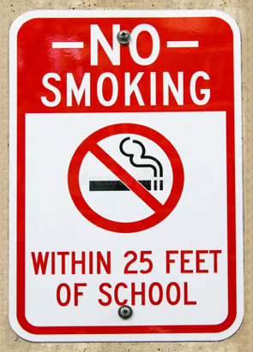  A sign on the outside door of  a school that states, “No Smoking  in this Building” | 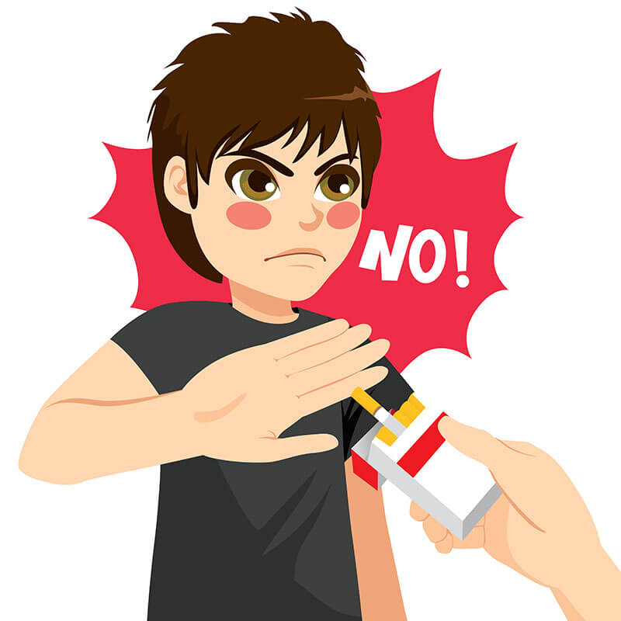  A friend saying “No” to an unhealthy choice
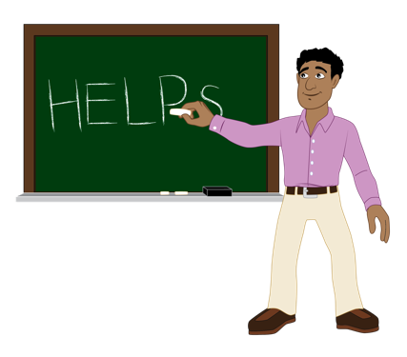  Know to No!  Teacher pointing to  “Know to NO! sign | 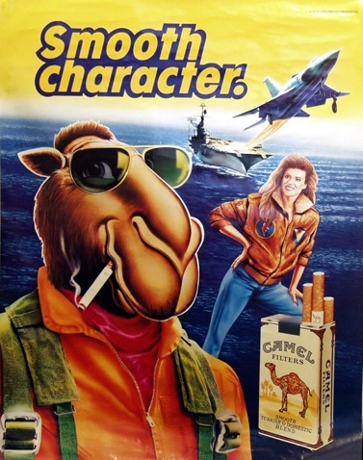  Tobacco advertisement in a store

Attachment 4.2a: Show What You Know: Tobacco
Circle the tobacco products | Circle the organs hurt by tobacco use
Cigarettes | Heart
E-cigarettes and vape | Lungs
Vape cartridge | Brain
Cigar | Teeth

Situation: A group of friends are hanging out skateboarding and riding scooters. One kid found a vape at home and tells you to try it because their older sibling used it.
- Is the kid with the vape a positive or negative influence?
- Positive
- Negative
- Should you try vaping?
- Yes
- No
- Circle any substance use prevention principle(s) that may fit this situation.
- I know vaping and using tobacco is dangerous and could harm my health.
- I don’t know what it is, but I’m not going to take, touch, or taste this.
- I’m going to ask a trusted adult for help.
- You want more information or support. Who or what could help?
- Older sibling
- Older friends
- A parent
- A TikTok or YouTube video
- How confident are you that you can make healthy choices that prevent substance use?
- Very
- Some
- Not at all

Attachment 4.2b: Show What You Know: Medicine and Drugs
Circle the answers that correctly complete the sentence below.
Unhealthy choices about drugs or medicine could hurt my (Check all that apply):
Heart
Lungs
Brain
Muscles
Situation: A group of friends are hanging out skateboarding and riding scooters. One kid found a plastic sandwich bag of pills at home. He tells you to try one because he’s seen his older sibling take them. Is the kid with the pills a positive or negative influence?
- Positive
- Negative
- Should you take the pill?
- Yes
- No
- Circle any medication safety or substance use prevention principle(s) that may fit this situation.
- Know to NO! I don’t know what this is. Don’t take, touch, or taste.
- Only take medicine from a trusted adult.
- Never share or take someone else’s medicine
- Ask a trusted adult for help.
- You want more information or support. Who or what could help?
- Older sibling
- Older friends
- A parent
- A TikTok or YouTube video
- How confident are you that you can make healthy choices that prevent substance use?
- Very
- Some
- Not at all

Attachment 4.2c: Show What You Know: Alcohol
Using alcohol is healthy or unhealthy?
- Healthy
- Unhealthy
Situation: A group of friends are hanging out skateboarding and riding scooters. You are thirsty, so your friend goes to the fridge and finds a can of beer. She dares you to try it.
- Is the kid with the beer a positive or negative influence?
- Positive
- Negative
- Should you drink the beer?
- Yes
- No
- Circle any medication safety or substance use prevention principle(s) that may fit this situation.
- Know to NO! I don’t know what this is. Don’t take, touch, or taste.
- Only take medicine from a trusted adult.
- Never share or take someone else’s medicine
- Ask a trusted adult for help.
- You want more information or support. Who or what could help?
- Older sibling
- Older friends
- A parent
- A TikTok or YouTube video
- How confident are you that you can make healthy choices that prevent substance use?
- Very
- Some
- Not at al
Attachment 4.3: Positive Influences in My Life
Directions: List three activities you do that are healthy and safe. List two trusted adults. List one reason you will make healthy choices that prevent substance use.
Know to NO! | Activities | People
- Rule 1: Substance use — including alcohol, tobacco, and other drugs — is harmful to my health.  - Rule 2: If you do not know what something is  - Don’t touch it! Don’t take it! Don’t taste it!  - Reach out to a trusted adult  - Rule 3: ONLY take medicine with the help of a trusted adult.  - Rule 4: NEVER take or share someone else’s medicine. | 1.  2.  3. | 1.  2.
I will make healthy choices because….
