Lesson 2: Decision-Making
Overview: Students will train to become Astronomical Astronauts for a journey to the planet Choosewell. Astronauts must be certified in the Stop, Think, Choose decision-making strategy to be a healthy decision-maker and fly the mission to Choosewell.

National Health Education Standards
Standard 1: Students will comprehend concepts related to health promotion and disease prevention to enhance health.
Standard 5: Students will demonstrate the ability to use decision-making skills to enhance health.

Healthy Behavior Outcomes (HBOs):
Alcohol and other drugs | HBO 2. Avoid misuse and abuse of over-the-counter and prescription drugs.
 | HBO 3. Avoid the use of alcohol.
 | HBO 4. Avoid the use of illegal drugs.
Tobacco | HBO 1. Avoid using or experimenting with any form of tobacco.

Lesson Objectives – Students will be able to:
Objective | Assessments
- Apply the medication safety and substance use prevention principles to identify a healthy or unhealthy choice. | Attachment 2.1 – Astronaut Screening
- Identify trusted adults and resources that could support healthy choices. | Attachment 2.1 – Astronaut Screening
- Identify substance use situations that need a thoughtful decision with Stop, Think, Choose. | Attachment 2.3 - Stop, Think, Choose
- Recognize when help is needed from a trusted adult to prevent substance use. | Attachment 2.3 - Stop, Think, Choose
- Identify options and their potential outcomes when making a decision related to alcohol. | Attachment 2.3 - Stop, Think, Choose
- Choose a healthy option when making a decision about medicines or alcohol. | Attachment 2.3 - Stop, Think, Choose

Introduction:
- Today we are going on an adventure into outer space!
- What is an adventure?
- How do you feel about going on an adventure into space? Would you like to hear more about your upcoming journey to the planet Choosewell? Choosewell requires each astronaut to be certified in the Stop, Think, Choose decision-making model before they make the trip.
Teaching Steps:

Activity 1: Know to NO! Review
- Before our journey, let’s review our substance use prevention principles to help make a healthy choice.
  - Rule 1: If you do not know (use motions with arms to show “X”):
    - Don’t touch it! (Touch pointer finger to palm for “touch.”)
    - Don’t take it! (Make grabbing motion for “take.”)
    - Don’t taste it! (Point to lips for “taste.”)
    - Reach out to a trusted adult for help to make healthy choices! If you don't know what something is, get the help of a trusted adult.
  - Rule 2: ONLY take medicine with the help of a trusted adult.
  - Rule 3: NEVER take someone else’s medicine.
  - Substance use — including alcohol, tobacco, and other drugs — is harmful to my health.
- Who can you ask for help?
  - Trusted adults: Who are trusted adults at home, at school, and in the community?
- Why is it important to make healthy choices about substances?
- Could you think of how using a substance like tobacco, alcohol, or other drugs could be harmful?
  - If needed, prompt how it could impact multiple dimensions of health and well-being.
  - You could use a chart to make a list of positive consequences of healthy choices and negative consequences of substance use.
Activity 2: Astronaut Screening: Do You Know to NO? (Attachment 2.1)
- Show the pictures. A healthy choice gets a thumbs up. An unhealthy choice gets a thumbs down.
  - Scenario 1: You need to take your medicine, so you ask your teacher if you can go to the school nurse to take it.
    - What rule was followed? (Ask a trusted adult for help.)
- Scenario 2: You see a cigarette or vape.
  - What rule should you follow? (Don’t touch it. Ask a trusted adult for help.)
- Scenario 3: You notice an open pill bottle and pills spilled on the counter. You decide to clean up the mess.
  - What rule was not followed? (Don’t touch it.)
- Scenario 4: Your friend thinks it will be fun to try a quick drink from a can of alcohol they found in the garage refrigerator.
  - Don’t take, touch, or taste it. Alcohol, tobacco, and other drugs are unhealthy and unsafe.
- Remind students that any time they feel unsafe or unsure, they should seek the help of a trusted adult.
Activity 3: Stop, Think, Choose
- For our trip, we have to be sure we are ready to make healthy choices on Choosewell. We’re going to learn to use our decision-making tool – Stop, Think, Choose.
  - STOP (Put your hand up to show STOP.)
    - Recognize the situation. What is happening?
    - Do I need to think about the decision?
    - Do I need help from a trusted adult? If yes, reach out to a trusted adult.
    - Trusted adults are ready to help and will answer your questions and help you make safe and healthy choices.
- THINK (Put your finger next to your head.)
  - What are the possible choices I could make?
  - For each choice, ask these questions:
    - Is this choice healthy to you and others?
    - Is this choice safe?
    - Is this choice respectful?
  - If you’re unsure, ask a trusted adult for help.
- CHOOSE (Point to your heart.)
  - Choose what is best for you. Is it healthy, safe, and respectful
  - Why is this the best choice?
  - (See the questions above: Is it healthy? Is it safe? Is it respectful?)
  - Model – Stop, Think, Choose (Attachments 2.2a, 2.2b, 2.2c)
- Choose one of the scenarios to model the skill. Use the remaining scenarios to practice Stop, Think, Choose. Attachments are: 2.2a (tobacco), 2.2b (medicines/drugs), 2.2c (alcohol).
- To model the skill, you will complete each step of Stop, Think, Choose with your students. Explaining the decision-making process.
- Practice – Stop, Think, Choose on Choosewell (Attachment 2.2a, b, c)
  - Use the remaining scenarios to practice Stop, Think, Choose.
  - Review each scenario and answer the questions.
  - Reinforce asking a trusted adult for help if it’s an important decision or you’re unsure what to do.
  - Task 1: Students read Choosewell’s Planet Guidebook. (Attachment 2.1b - Planet Guidebook.)
  - Task 2: Students will read trusted and true alcohol information listed on the Attachment 2.1b - Astronomical Astronaut’s Alcohol Files.
    - Instruct students to record key alcohol information on Attachment 2.2: Choosewell Mission Document.
    - Students should list the risks the teen aliens are facing with alcohol use.
    - Students should list the benefits of being alcohol-free.
  - Task 3: REVIEW with students the STOP, THINK, CHOOSE decision-making process in preparation for the Choosewell decision-making training mission.
Closure:
- You’ve completed your first mission. Debrief the mission with the mission commander. Share what you’ve learned on the mission.
- What tool can help you make healthy choices?
  - Stop, Think, Choose
- What should you do when you STOP?
  - Recognize the situation
  - Determine if you need help from a trusted adult.
- What will you THINK about?
  - What are my options? Is it healthy, safe, and respectful?
- What should you CHOOSE?
  - Choose the healthiest option; ask a trusted adult for help.

Attachment 2.1: Astronaut Screening – Show What you Know

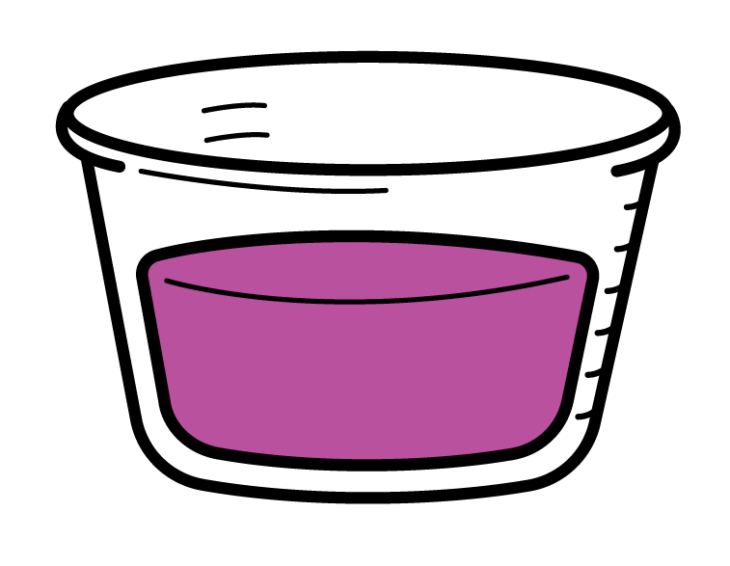 | 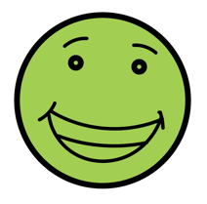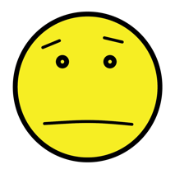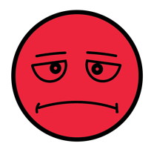
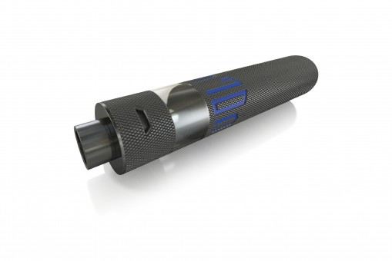
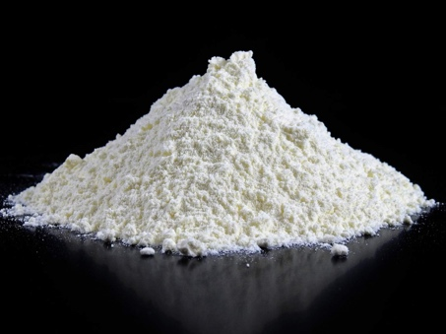
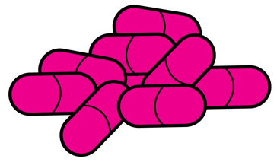

Who is a trusted resource to reach out to when you need help making a healthy choice?
Attachment 2.2a: Stop, Think, Choose Assessment (Tobacco)
Directions: Read the scenario below and complete the questions to determine the best choice.
Scenario: You were walking home from school and found what looks like a flash drive. You can’t tell if it is a vape cartridge or pod.
- STOP
  - Recognize the situation. What is happening?
  - Do I need to use Stop, Think, Choose? YES or NO
  - Do I need help from a trusted adult? YES or NO
- THINK
  - What are two possible choices you could make?
 | Choice 1: Pick it up | Choice 2: Don’t touch it
Is this choice HEALTHY? | YES NO | YES NO
Is this choice SAFE? | YES NO | YES NO
Is this choice HELPFUL? | YES NO | YES NO
Do I need the help of a trusted adult? | YES NO | YES NO
  - Who is a trusted adult who could help in this situation?
- CHOOSE
  - What is the BEST CHOICE (healthiest, safest, most helpful)?
Choice 1 Choice 2
  - Why is this the healthiest safest, most helpful choice?

Attachment 2.2b: Choosewell’s Stop, Think, Choose Assessment (Medicine)
Directions: Read the scenario below and complete the questions to determine the best choice.
Scenario: You are spending the night with your friend Jerika. You cannot sleep. Jerika says her mom takes sleeping pills that help her get to sleep quickly. She offers to get you one of her mom’s sleeping pills.
- STOP
  - Recognize the situation. What is happening?
  - Do I need to use Stop, Think, Choose? YES or NO
  - Do I need help from a trusted adult? YES or NO
- THINK
  - What are two possible choices you could make?
 | Choice 1: Take it | Choice 2: Don’t touch, take, or taste it
Is this choice HEALTHY? | YES NO | YES NO
Is this choice SAFE? | YES NO | YES NO
Is this choice HELPFUL? | YES NO | YES NO
Do I need the help of a trusted adult? | YES NO | YES NO
  - Who is a trusted adult who could help in this situation?
- CHOOSE
  - What is the BEST CHOICE (healthiest, safest, most helpful)?
    - Take it.
    - Don’t touch, take, or taste it.
  - Why is this the healthiest safest, most helpful choice?

Attachment 2.2c: Stop, Think, Choose Assessment (Alcohol)
Directions: Read the scenario below and complete the questions to determine the best choice.
Scenario: You and your friend find a bottle of vodka in the house. Your friend wants to you to try some with him.
- STOP
  - Recognize the situation. What is happening?
  - Do I need to use Stop, Think, Choose? YES or NO
  - Do I need help from a trusted adult? YES or NO
- THINK
  - What are two possible choices you could make?
 | Choice 1: Try it | Choice 2: Say NO
Is this choice HEALTHY? | YES NO | YES NO
Is this choice SAFE? | YES NO | YES NO
Is this choice HELPFUL? | YES NO | YES NO
Do I need the help of a trusted adult? | YES NO | YES NO
  - Who is a trusted adult who could help in this situation?

- CHOOSE
  - What is the BEST CHOICE (healthiest, safest, most helpful)?
Choice 1 Choice 2
  - Why is this the healthiest safest, most helpful choice?

