Lesson 1: Making Healthy Choices
Overview: Students will use the Know to NO! principles and trusted adults to make healthy choices. Students will analyze situations, determine the risks and consequences of substance use, and make the healthy, safe, and respectful choice.

National Health Education Standards
Standard 1: Students will comprehend concepts related to health promotion and disease prevention to enhance health.
Standard 3: Students will demonstrate the ability to access valid information, products, and services to enhance health.

Healthy Behavior Outcomes (HBOs):
Alcohol and other drugs | HBO 2. Avoid misuse and abuse of over-the-counter and prescription drugs.
 | HBO 3. Avoid the use of alcohol.
 | HBO 4. Avoid the use of illegal drugs.
Tobacco | HBO 1. Avoid using or experimenting with any form of tobacco.

Lesson Objectives – Students will be able to:
Objective | Assessments
Identify substances (alcohol, tobacco, and other drugs) that are unhealthy and unsafe. | Attachment 1.1 – What Do You Know?
Apply medication safety and substance use prevention principles to determine if a choice is healthy or unhealthy. | Attachment 1.1 – What Do You Know?  Attachment 1.2 – I Can Make Healthy Choices
Locate trusted adults and health information using the characteristics of trusted health information. | Attachment 1.3 – Reaching Out to Trusted Adults and Resources

Introduction
- DRAW a large question mark on the front board.
- What is a healthy choice?
- What do you need to make a healthy choice?
- We’ll be learning about preventing substance use. We’ll learn to use tools to make healthy choices.
Teaching Steps:

Activity 1 - Maria Wants Answers
- STATE: I am going to read a story about Maria, who wants to make healthy choices about prescription medication. Listen carefully so you will be ready to discuss the story when I finish reading it to you.
- Maria had a friend who recently was prescribed medicine to help with a health condition. Her friend said the doctor was very clear about the importance of following medication safety principles. She still remembers what the doctor said that we should remember the “Know to NO!” rules. (Additional video available at the Ohio Department of Public Safety — https://publicsafety.ohio.gov/404.html):
  - Rule 1: Substance use — including alcohol, tobacco, and other drugs — is harmful to my health.
  - Rule 2: If you do not know what something is:
    - Don’t touch it!
    - Don’t take it!
    - Don’t taste it!
    - Reach out to a trusted adult for help to make healthy choices!
  - Rule 3: ONLY take medicine with the help of a trusted adult.
  - Rule 4: NEVER take someone else’s medicine.
- Maria’s friend shared that she always must go to the school nurse to take her medication at school, and her parent(s) help her before and after school.
- Is Maria’s friend following the substance use prevention principles to make a healthy choice?
  - (YES. She is only taking medicine with the help of a trusted adult.)
- When we are making a choice, it is important to be sure the choice:
  - Protects my health.
  - Helps me be safe.
  - Shows respect for myself, parents, guardians, rules, and other trusted adults.
- Let’s see what you know and practice making healthy choices (Attachment 1.1).
- Try three additional scenarios to apply substance use prevention principles (Attachment 1.2).
  - You’re playing at a friend’s house. You see a plastic looking square. You don’t really know what it is, so you ask your friend. Your friend says it is a vape. You don’t really know what it is, but you heard it has tobacco in it like a cigarette. Is vaping a healthy or unhealthy choice?
    - Identify the Know to NO! Rules – Rules 1 and 2.
  - A classmate brought some gummy candies to school. They want you to try one. Would trying a gummy you can’t identify be a healthy or unhealthy choice?
    - Identify the Know to NO! Rules – Rules 2, 3, and 4.
  - You see a group of high schoolers on your way to school. They put something near their mouths, and then you see white clouds that look like smoke. Are they making a healthy or unhealthy choice?
    - Identify the Know to NO! Rules – Rules 1 & 2.
Activity 2 – Trusted Adults & Resources
- In the first scenario, Maria recognized that prescription medication requires reaching out to a trusted adult.
- Who is a trusted adult who can help you with medication or if you need help to make a healthy choice?
  - You can also reach out to trusted adults as a resource any other time you need help to be healthy and safe.
  - A trusted adult:
    - Gives good advice when you want and ask for it.
    - Allows you to talk freely about your feelings and emotions without judging, teasing, or criticizing.
    - Helps you figure out what to do the next time a difficult situation comes up.
    - You can find trusted adults at home, at school, and in the community.
- Other resources:
  - Health professionals: school counselor, school nurse, and your doctor
  - School resources: teachers, school counselors, school nurse, principals, school resource officers, and other staff
  - Community resources: Police officers, doctors, nurses, and counselors
  - Emergencies: 911
- Key point: If you recognize a situation that is unhealthy or unsafe for yourself or others, reach out and talk with someone. A trusted adult or resource can listen to your concerns and connect you with additional resources if needed.
- Let’s practice identifying trusted adults (Attachment 1.3).
- Let’s practice recognizing situations and identifying resources for Maria.
  - Maria wants to learn more about prescription medicines. She always thought prescription medicines were safe because a doctor prescribes them, and these medicines come with directions. First, she asks her 12-year-old brother, who tells her to Google prescription medicines. When she does this, she finds all kinds of conflicting information.
  - Maria is now more confused than ever. While thinking about where else she could find an answer to her question, she remembers her teacher talking about asking trusted adults when you need help. She decides to ask the teacher, Mr. Miles, who she considers a trusted adult because he cares about students and listens carefully, and Maria feels comfortable and safe around him.
    - Ask the following questions:
      - What information did Maria seek?
        - Learn more about medicine.
      - Who was her trusted adult?
        - Teacher
      - Why did she decide to ask Mr. Miles, her teacher?
        - A teacher is a trusted adult.
      - Did Maria get the information she needed to make healthy choices?
        - Yes
- DISCUSS: Information is available from many sources. You could get information from your friends, online, and trusted adults.
  - Some information is accurate/truthful; some is inaccurate or untruthful.
  - Some of the information is unhealthy and potentially harmful.
  - With so much information, we need to learn how to find accurate/truthful information.
  - Sometimes our friends give us information that might not be accurate, trustworthy, or truthful.
- ASK: Why do we need true and accurate information?
  - Trusted adults can help us locate information and help us make healthy choices.
Activity 3: Skill Practice & Feedback (Attachment 1.3)
- Kellen was hanging out with their older sibling and friends at the park. One of the teenagers showed the group an e-cigarette or a vape pen. Kellen doesn’t know what a vape pen or an e-cigarette is. What would you do if you were Kellen? (Refer to Attachment 1.3.)
- Should Kellen try vaping?
  - Yes
  - No
- Which medication safety or substance use prevention principle applies?
  - Tobacco is dangerous and could harm my health.
  - I don’t know what it is, so I’m not going to take, touch, or taste it.
  - I’m going to ask a trusted adult for help.
- Kellen wants more information or support. Who could they reach out to for more help?
  - Older sibling
  - Older friends
  - A parent
  - A teacher or other school staff member
  - A TikTok or YouTube video
Closure:
- Always ask if the decision is healthy, safe, and respectful.
- If you recognize a situation, you should reach out to a ________ adult or resource.
- Why is it important to reach out to a trusted adult?
Attachment 1.1: What Do You Know?
- Circle the substances that are unhealthy or unsafe
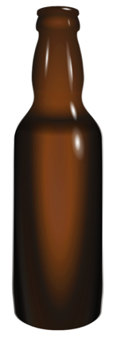 | 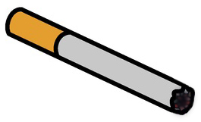 | 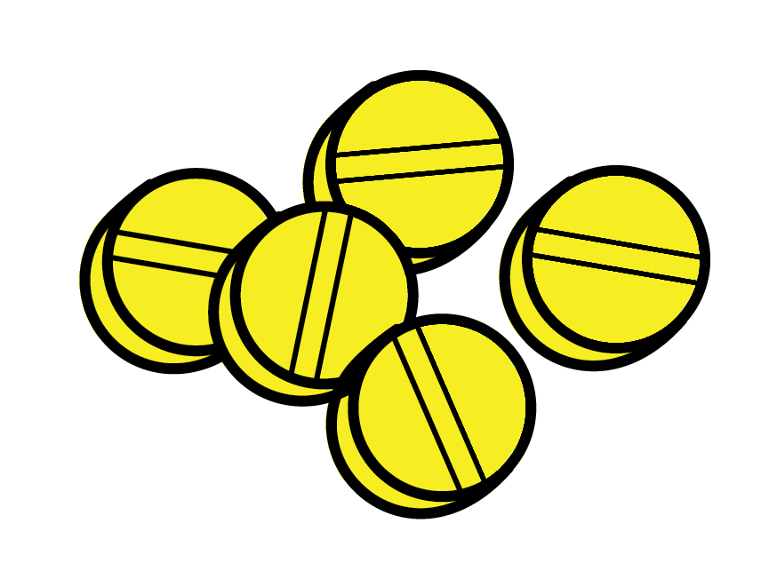 | 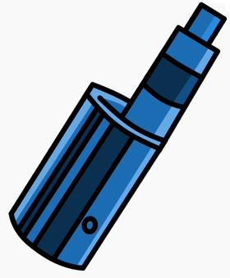
Alcohol | Tobacco | Opioids | Marijuana
- I can make _________ choices because my health is important to me.
  - Healthy
  - Unhealthy
- Know to NO! Using tobacco has _________consequences to my health.
- Positive
- Negative
- Fill in the blanks:
If I recognize a substance that is unhealthy or unsafe, or if I’m unsure,
don’t _________________, touch, or _________________ it.
- Reach out and ask a _______________ adult or resource for help to make a healthy decision.
- List a trusted resource to reach out to when you need help making a healthy choice:

Attachment 1.2: I Can Make Healthy Choices
Scenario 1: Maria has a friend who recently was prescribed medicine to help with a health condition. Her friend said the doctor was very clear about the importance of following medication safety principles. She always goes to the school nurse to take her medication at school, and her parents help her at home. | Check if YES
- Is Maria’s friend following principles to help keep her safe?
- Are the safety principles protecting her health?
- Does her behavior show respect for herself, parents, guardians,
rules, and other trusted adults?
Is this a healthy choice?

Scenario 2: You’re playing at a friend’s house. You see a vape pen on the table. You don’t really know what it is, so you ask your friend. Your friend says it is a vape pen. You decide to try it. Is this a healthy or unhealthy choice? | Check if YES
- Helps me be safe
- Protects my health
- Shows respect for myself, parents, guardians, rules, and other trusted adults
Is this a healthy choice?

Scenario 3: A classmate brought some gummy candies to school. They want you to try one. Would trying a gummy you can’t identify be a healthy or unhealthy choice? | Check if YES
- Helps me be safe
- Protects my health
- Shows respect for myself, parents, guardians, rules, and other trusted adults
Is this a healthy choice?

Scenario 4: You see a group of high schoolers on your way to school. They put something in their mouths, and then you see white clouds that look like smoke. Do you think they are making a healthy or unhealthy choice? | Check if YES
- Helps them be safe
- Protects their health
- Shows respect for themselves, parents, guardians, rules, and other trusted adults
Is this a healthy choice?

Attachment 1.3: Reaching Out to Resources
List a trusted adult who can help you make healthy choices about substances.
Home | School | Community

Skill Practice
Kellen was hanging out with his older sibling and friends at the park. One of the teenagers showed the group an e-cigarette or a vape pen. Kellen doesn’t know what a vape pen or an e-cigarette is. What would you do if you were Kellen?
- ______ Should Kellen try vaping?
  - Yes
  - No
- ______ Which substance use prevention principle applies:
  - Tobacco is dangerous and could harm my health.
  - I don’t know what it is, but I’m not going to take, touch, or taste it.
  - I’m going to ask a trusted adult for help.
  - All of the above.
- ______ Kellen wants more information or support. Who or what could help?
  - An older sibling who 15 years old
  - A classmate
  - A parent
  - A teacher or other school staff member
  - A TikTok or YouTube video

