Lesson 1: Know to NO!

Overview: Students will learn to use substance use prevention principles to make healthy choices.

National Health Education Standards
Standard 1: Students will comprehend concepts related to health promotion and disease prevention to enhance health.
Standard 3: Students will demonstrate the ability to access valid information, products, and services to enhance health.
Healthy Behavior Outcomes (HBOs):
Alcohol and other drugs | HBO 2. Avoid misuse and abuse of over the counter and prescription drugs.
Alcohol and other drugs | HBO 3. Avoid the use of alcohol.
Alcohol and other drugs | HBO 4. Avoid the use of illegal drugs.
Tobacco | HBO 1. Avoid using or experimenting with any form of tobacco.

Lesson Objectives – Students will be able to:
Objective | Assessments
- Explain how substances including medicines, tobacco, alcohol, and vapes can be harmful. | Attachment 1.1 – Know to NO! Making Healthy Choices
- Differentiate between a healthy choice and an unhealthy choice. | Attachment 1.1 – Know to NO! Making Healthy Choices
- Apply medication safety and substance use prevention principles to make healthy choices. | Attachment 1.1 – Know to NO! Making Healthy Choices  Attachment 1.2 – Make a Healthy Choice
- Identify trusted adults at home and school who can support substance use prevention and healthy behaviors. | Attachment 1.1 – Know to NO! Making Healthy Choices

Introduction:
- Show a large question mark on the front board.
- What is a healthy choice?
- What do you need to make healthy choices?
- We’ll be learning about preventing substance use. We’ll learn to use tools to make healthy choices.
Teaching Steps:

Activity 1: Making Healthy Choices
- We always must ask ourselves, “What is a healthy choice?”
  - Healthy choices have positive consequences because they are helping my body and mind be healthy and safe.
- Whenever we make a choice, we need to look at the positive consequences that could happen as well as the negative or unhealthy consequences.
- Draw two large boxes on the front board. Label one POSITIVE CONSEQUENCES (Healthy, Safe, Good) and the other NEGATIVE CONSEQUENCES (Unhealthy, Unsafe, Bad).
- Present a choice for your students (e.g., eat an apple; have a handful of M&M’s; take a walk). Brainstorm the possible consequence as positive (healthy) or negative (unhealthy).
- Whenever we look at healthy and safe choices, we can also look at the consequences on our health. First, let’s review those three types of health: Physical (your body), social (your relationships with others), and emotional (your feelings).
  - Add the categories of physical, social, and emotional to your boxes.
  - With your students’ help, give examples of each of these words OR sort your previous answers into physical, social, and emotional health.
Activity 2: Know to NO! Substance Use Prevention
- Introduce rules for substance use prevention
  - We’re going to learn how to make healthy choices that prevent substance use. Substances include alcohol, tobacco, drugs, and medicines. We need to use our Know to NO! tips to make healthy choices. Healthy choices will have positive consequences on our health.
  - Rule 1: Substance use — including alcohol, tobacco, and other drugs — is harmful to my health.
  - Rule 2: If you do not know what something is (use motions with arms to show “X”)
    - Don’t touch it! (Touch pointer finger to palm for “touch.”)
    - Don’t take it! (Use grabbing motion for “take.”)
    - Don’t taste it! (Point to lips for “taste.”)
      - Reach out to a trusted adult for help to make healthy choices!
  - Rule 3: ONLY take medicine with the help of a trusted adult.
  - Rule 4: NEVER take or share someone else’s medicine.
- Let’s practice making a healthy choice in a situation (Attachment 1.1)
- Why is it important to follow the medication safety rules?
  - Substances including medicines, drugs, tobacco/vapes, alcohol, and poisons can have negative consequences. They can be harmful and unhealthy.
    - Add to your positive and negative consequences. Think about what could happen if you make unhealthy choices about drugs, alcohol, or tobacco. Notice how unhealthy choices to use drugs, alcohol, and tobacco lead to negative consequences on our physical, social, and emotional health.
  - These lessons will help you learn how to make healthy choices, identify trusted adults who can help us, and use our communication skills to be healthy and safe.
Activity 3: Trusted Adults and Healthy Choices
- Who is a trusted adult who can help you with medication or if you recognize a situation where you need help to make a healthy choice?
- You can reach out to trusted adults when you need help to make healthy and safe choices or any other time you need help to be healthy and safe.
- A trusted adult:
  - Is ready to help.
  - Will answer your questions and give good advice when you want and ask for it.
  - Helps you make a healthy choice and feel safe.
  - Is someone you can talk freely to about your feelings and emotions without them judging, teasing, or criticizing.
  - Helps you figure out what to do the next time a difficult situation comes up.
- You can find trusted adults at home, at school, and in the community.
- Let’s brainstorm a list of trusted adults at home, at school, or in the community who can help us make healthy choices.
  - Parents and grandparents, teachers, bus drivers, school counselor, school nurse.
  - Community resources: For emergencies, you can call 911 or seek help from a police officer or other health professional like a doctor, nurse, or counselor.
  - Key point: If you recognize a situation that is unhealthy or unsafe for yourself or others, reach out and talk with someone. A trusted adult or resource can listen to your concerns and connect you with additional resources if needed.
  - Complete Attachment 1.1 – Question 2
Activity 4: Know to NO! Practice
- Explain: We are going to practice making healthy choices. We’ll read story, apply our Know to NO! rules, and talk about the consequences. Remember: Positive consequences keep us healthy and safe. Negative consequences are unhealthy or unsafe. We will decide if the choice is healthy and safe. If it is unhealthy, we will … (answer: ask a trusted adult). (Use Attachment 1.2)
- Situation 1: A stranger approaches you and offers you candy. You love sweets and decide to take the candy from the stranger. Is this a healthy choice or unhealthy choice? Let’s talk about it.
  - What is the Know to NO! rule?
    - Don’t take, touch or taste. Tell a trusted adult.
  - How do we know this is unhealthy and unsafe? Briefly discuss possible consequences.
    - You could become ill. (Negative: unhealthy, bad)
    - When I move closer to the see what the stranger is holding, the stranger grabs me and pushes me into his car. (Negative: unsafe, unhealthy, dangerous)
    - My friends’ parents do not want my friends to play with me any longer because they do not trust me. (Negative: unhealthy, unsafe)
    - (Teacher: Sort or write the consequences into the correct positive or negative consequences box.)
- Situation 1 debrief:
  - Was this a healthy choice to take the candy from the stranger?
  - What do we need to remember to make healthy choices? Remember our rules for medicines.
    - Don’t know or unsure: Don’t touch. Don’t taste. Don’t take. Tell a Trusted Adult.
    - Only take medicines from a trusted adult.
    - Never share or take someone else’s medicine.
    - Store medicines in a locked area away from children.
  - What should you do in this situation?
- Situation 2 (if time is available)
  - Mary is over at her friend’s house. Her friend is in the family room talking on her cell phone. Mary is really thirsty, so she walks into the kitchen and finds a glass with a blue liquid inside. She decides to drink it. Healthy choice or unhealthy choice? Is this safe or not safe to do? What could happen to Mary? (Use new set of consequence boxes.)
  - Let’s use the same situation, but a different choice: You choose not to drink what is in the glass and go find your friend’s parent to ask for something to drink.
Closure:
- Can you remember our Know to NO! Tips?
  - Rule 1: Substance use is harmful to my health.
  - Rule 2: If you do not know what something is (use motions with arms to show “X”):
    - Don’t touch it! (Touch pointer finger to palm for “touch.”)
    - Don’t take it! (Use grabbing motion for “take.”)
    - Don’t taste it! (Point to lips for “taste.”)
    - Reach out to a trusted adult.
  - Rule 3: ONLY take medicine with the help of a trusted adult.
  - Rule 4: NEVER take or share someone else’s medicine.
- Why are healthy choices important?
  - They have positive consequences on our health.
- Now what will you do when you have to make a choice?
  - I will choose healthy and safe choices.

Attachment 1.1: Know to NO! Making Healthy Choices
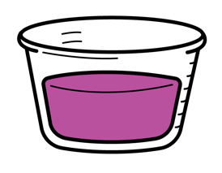 | 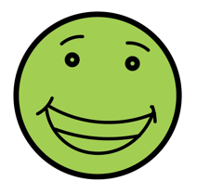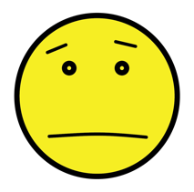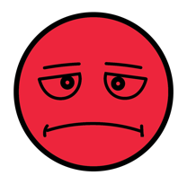


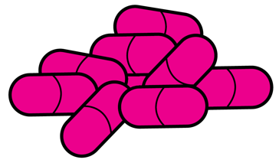

2. Circle the trusted adults in the picture.
Attachment 1.2: Make a Healthy Choice

Situation 1: A stranger approaches you and offers you candy. You love sweets and decide to take the candy from the stranger. Is this a healthy choice or unhealthy choice? Let’s talk about it.

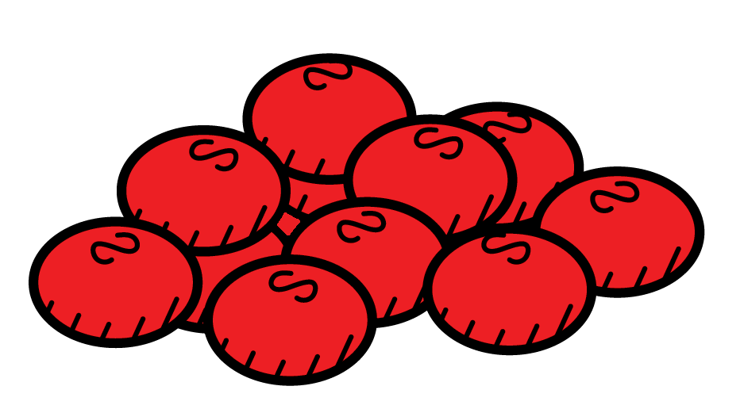

- Helps me be safe | YES | NO
- Protects my health | YES | NO
- Shows respect for myself, parents, guardians, rules, and other trusted adults | YES | NO
Is this a safe and healthy choice? | YES | NO

Scenario 2: Mary is over at her friend’s house. Her friend is in the family room talking on her cell phone. Mary is really thirsty, so she walks into the kitchen and finds a glass with a purple liquid inside. She decides to drink it.
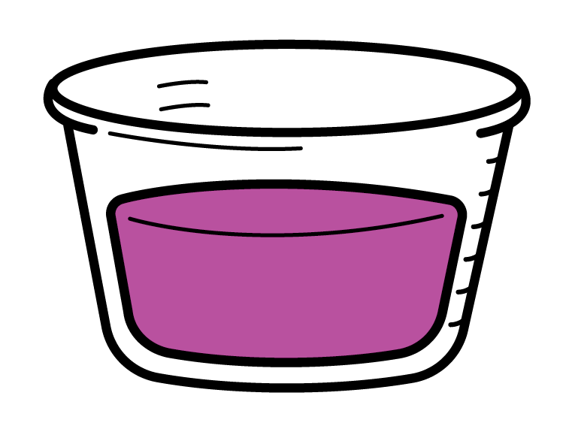
- Helps me be safe | YES | NO
- Protects my health | YES | NO
- Shows respect for myself, parents, guardians, rules, and other trusted adults | YES | NO
Is this a safe and healthy choice? | YES | NO

