**Lesson 4: I am a Positive Influence!**

**Overview:** The lesson introduces positive and negative influences on decision-making. Students will identify positive influences in their lives and how they can be positive influences and promote healthy choices about substances.

National Health Education Standards

**Standard 1:** Students will comprehend concepts related to health promotion and disease prevention to enhance health.

**Standard 2:** Students will analyze the influence of family, peers, culture, media, technology, and other factors on health behaviors.

Healthy Behavior Outcomes (HBOs):

|  |  |
| --- | --- |
| **Alcohol and other drugs** | HBO 2. Avoid misuse and abuse of over-the-counter and prescription drugs. |
| HBO 3. Avoid the use of alcohol. |
| HBO 4. Avoid the use of illegal drugs. |
| **Tobacco** | HBO 1. Avoid using or experimenting with any form of tobacco. |

Lesson Objectives – Students will be able to:

|  |  |
| --- | --- |
| **Objective** | **Assessments** |
| 1. Recall the Know to NO! principles for substance use prevention and medication safety. | Attachment 4.1 – Wheel of Influences |
| 1. Determine whether an influence would be positive or negative on substance use and/or medication safety. | Attachment 4.2 – Influences Checkup |
| 1. Identify positive influences. | Attachment 4.3 – My Wheel of Positive Influences |
| 1. Apply the substance use prevention principles and tools to make healthy choices. | Attachment 4.4 – Show What You Know |

Introduction:

* ASK: Today we are going to talk about positive and negative influences.
  + What do you think the term “influence” means?
* Let’s role-play a situation where someone will try to influence me.
  + Role-play: Pick a student to “influence” the teacher to go against a classroom or school expectation/rule. Some examples are having an ice cream party, movie time instead of math, field trip to the park for the rest of the day. The student needs to convince the teacher by using pressure or “influence.”
* What does it mean to influence? In this situation was the influence helping me be your teacher today?
* We’ve practiced making healthy choices. In this lesson, we’ll practice identifying positive and negative influences on our health.

Teaching Steps:

Activity 1: Know to No Review (use Attachment 4.1)

* STATE: Before we get started talking about influences, let’s review the rules of medicines.
* ASK students to fill in the missing words *(write on board or project on screen):*
  + If you do not know what something is:
  + Don’t t__ __ __ __ h it! (Touch)
  + Don’t t __ __ e it! (Take)
  + Don’t t __ __ t e It! (Taste)
  + ONLY take medicine with the help of a t__________ a_______ (*trusted adult*)
* If we need to make a choice:
  + STOP: Recognize what is happening.
  + THINK: Do I need help? Who can help me?
  + ASK a trusted adult for help.

Activity 2: What are influences?

* An influence is something or someone that tries to get us to do something
  + Positive influences help you make healthy choice.
  + Negative influences try to get you to make an unhealthy choice.
    - A negative influence could try to get you to do something that is unhealthy, like not following one of the rules of medicine or taking a substance like alcohol, tobacco, or drugs.
  + REMEMBER: When someone is trying to get us to do something, that person is an influence.
* Ask: Which kind of influence is trying to get us to do something unhealthy or unsafe? (*Negative)*
* Which kind of influence is trying to get us to do something healthy and safe? *(Positive)*
* Which kind of influence do we need to listen to make healthy and safe choices? *(Positive)*
* Positive influences could be rules, people, and activities.
  + Our Know to No! rules are a positive influence.
  + Trusted adults are positive influences.
  + Activities that keep us healthy like games, sports, and activities can also be positive influences.
* Which kind of influence do we need to either ignore or say NO to? *(Negative)*
* EXPLAIN: We need to know how to detect when someone is trying to get us to do something. Let’s practice using the Influence Checkup
  + *Teacher – two options.* You can read these statements and have the students respond with a thumbs up (positive), down (negative), or middle (unsure). To incorporate movement in the classroom, you could have negative and positive be a different movement (e.g., squat, tree pose).
* Statements
  + The school nurse came to our class and taught us the rules of taking medicine.
  + A family member smokes.
  + When I am sick, my parents always help me take my medicine.
  + A neighbor kid is mean to other students at the bus stop.
  + An uncle told me to take his medicine for my headache.
  + My teacher sent me to the school nurse when I was not feeling well.
  + All my family wears bike helmets.
* Use your positive influences to make healthy choices. If you spot a negative influence, make a healthy choice and ask a trusted adult for help.

Activity 3: My Wheel of Positive Influences

* *Who or what are POSITIVE influences in your life*? The class will brainstorm a list of positive influences; they can be people (e.g., family, friends, teacher, nurse), media, rules, or places.
* On My Wheel of Influences (Attachment 4.3), students will add four positive influences that help them make healthy choices. (Teacher can determine whether students will cut and paste pictures provided or whether they can draw their own influences.)

Closure:

* REVIEW students’ answers and discuss why an influence is positive or negative.
  + Reinforce: Positive and negative INFLUENCES are determined by a person’s WORDS or ACTIONS — not by who a person is.
  + Positive influences can help us make healthy and safe choices.
  + Negative Influences could lead to unhealthy and unsafe choices.

We will be positive influences because we make healthy choices, ask trusted adults for help, and follow our safety principles.Attachment 4.1: Healthy Choices Review

Fill in the blanks.

* + ONLY take medicine with the help of a t__________ a_________ (*trusted adult*)
  + If you do not know what something is:
    - Don’t T__ __ __ __ h it! (touch)
    - Don’t T __ __ e it! (take)
    - Don’t T __ __ t e it! (taste)
    - NEVER share or take someone else’s m __ __ __ __ __ __ e.
  + If we need to make a choice:
    - **STOP:** ______________ what is happening.
    - **THINK:** Do I need _____? Who can help me?
    - **ASK** A trusted adult for help.

Attachment 4.2: Influences Checkup

Circle positive or negative.

1. The school nurse came to our class and taught us the rules of taking medicine.
   1. Positive
   2. Negative
2. A family member smokes.
   1. Positive
   2. Negative
3. When I am sick, my parents always help me take my medicine.
   1. Positive
   2. Negative
4. A neighbor kid is mean to other students at the bus stop.
   1. Positive
   2. Negative
5. An uncle told me to take his medicine for my headache.
   1. Positive
   2. Negative
6. My teacher sent me to the school nurse when I was not feeling well.
   1. Positive
   2. Negative
7. All my family wears bike helmets.
   1. Positive
   2. Negative

Attachment 4.3: Show What You Know!

1. _____You see an open medicine bottle on the counter. You decide to touch it. Which rule was broken?
2. *ONLY take medicine with the help of a trusted adult.*
3. *If you do not know what something is or where it came from:* ***Don’t touch it!******Don’t take it! Don’t taste it!***
4. *NEVER take someone else’s medicine.*
5. *All of the above*
6. _____What are the three steps to use to make a decision

1. Stop, Think, Ask

2. Try it, taste it, and take it

3. Stop, try it, ask for help

1. _____Helping a friend make a healthy choice is being a _________ influence.
2. Positive
3. Negative
4. Circle the trusted adults in the pictures.

|  |  |  |  |  |  |  |  |
| --- | --- | --- | --- | --- | --- | --- | --- |
|  | | |  | | |  |  |
| 1. **I can make healthy choices.** | | | | | |
| A green smiley face with black background  Description automatically generated  Yes | | A yellow face with black background  Description automatically generatedMaybe | A red face with black lines  Description automatically generated  No | |
| 1. **I know a trusted adult.** | | | | | |
| A green smiley face with black background  Description automatically generated  Yes | | A yellow face with black background  Description automatically generatedMaybe | A red face with black lines  Description automatically generated  No | |
| 1. **I can use Stop, Think, Ask.** | | | | | |
| A green smiley face with black background  Description automatically generated  Yes | | A yellow face with black background  Description automatically generatedMaybe | A red face with black lines  Description automatically generated  No | |

Attachment 4.4: My Positive Influences

* Draw or glue pictures of positive influences that promote healthy and safe (OR draw or write) choices.

**WHEEL OF INFLUENCE**

1. Write your name in the center of the wheel.

1. In each section of the wheel, write who or what influences what you may choose to do.

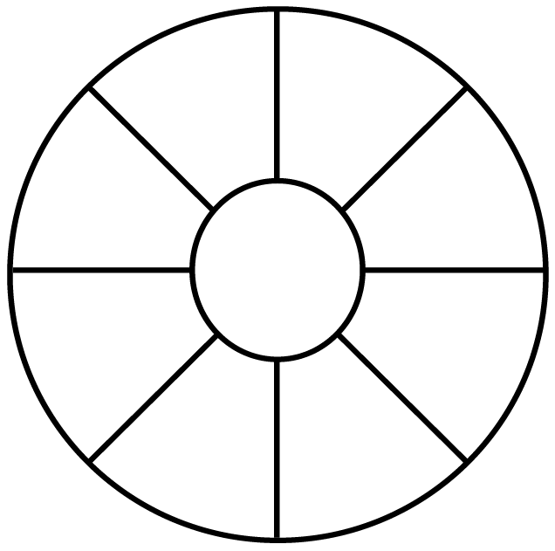

I am a positive influence because I will:

1. Only take medicine with the help of a trusted adult.
2. Don’t take, touch, or taste if something is unhealthy or unsafe or if I am unsure what something is or where it came from.
3. Ask a trusted adult for help.