Lesson 9: Strengthening ME Health– Boundaries for Screen Time, Social Media and Technology
Overview: Students will set boundaries to using screen time, social media, and technology. Lesson activities will focus on positive and negative consequences of social media and technology use. Students will practice applying boundaries and refusal skills for screen time, social media, and technology in ways that promote ME health.
National Health Education Standards
Standard 1: Students comprehend functional health knowledge to enhance health.
Standard 2: Students analyze the influence of family, peers, culture, social media, technology, and other determinants on health behaviors.
Healthy Behavior Outcome (HBO):
Use self-control and impulse-control strategies to promote health.
Lesson Objectives – Students will be able to:
Objective | Assessments
- Explain three ways technology and social media use could benefit ME (mental and emotional) health. | Attachment 9.1 – Boundaries for Social Media and Technology
- Explain three ways technology and social media use could negatively impact ME health. | Attachment 9.1 – Boundaries for Social Media and Technology
- Describe personal boundaries for technology and social media use to support mental and emotional health. | Attachment 9.1 – Boundaries for Social Media and Technology
- Identify situations that are inside or outside of the technology and social media use boundaries | Attachment 9.1 – Boundaries for Social Media and Technology

Lesson Prerequisites or Assumptions:
- Behavioral HELPs lessons complement lessons on internet and technology safety. This lesson only addresses the boundaries for use that could impact mental and emotional health. The lesson does not address the knowledge and skills associated with internet safety.
- The lesson assumes your students have completed Lesson 7 (Boundaries).

Introduction
- Use the Feelings Index (Attachment 8.1) to brainstorm a list of feelings you have when using social media or technology. Sort the words into positive and negative.
Teaching Steps

Activity 1: My Love and Hate for Social Media and Technology
- Divide the whiteboard into two columns. The right column should be titled “What I love about screen time, social media, and technology”; the left column should be titled “What I hate about screen time, social media, and technology.”
- Have students identify one thing for each column.
- Consider using a strategy to allow students to respond anonymously like crumbled paper; pair and share; Padlet, etc.
  - Round 1: Student perspective
  - Round 2: Perspective – pretend you are a parent, teacher, adult, etc. What do they love and hate about social media and technology?
- Once you have a variety of responses, go over them and have students elaborate. Start with what students love about social media, then discuss what they hate about it.
  - Screen time, social media, and technology can help kids:
    - Stay connected with friends and family
    - Interact with a more diverse group of kids
    - Volunteer or get involved with a campaign, nonprofit, or charity
    - Enhance their creativity by sharing ideas, music, and art
    - Meet other people who have similar interests
    - Communicate with educators and fellow students
    - Find health information
    - Learn about current events
    - Get support when they feel sad or anxious
    - Screen time, social media, and technology can also have a negative implications:
    - Cyberbullying
    - Privacy and safety
    - Damage reputations
    - Increased anxiety and depression can accompany excessive social media use.
    - Inappropriate or harmful content
    - Drains your free time
- We need boundaries for social media and technology use:
  - Put it down and limit your use – is it taking time from activities, friends, family, or responsibilities?
  - Be nice!
  - Be careful what you share – avoid posting personal information, location, and other information that could violate your privacy.
  - Don’t friend strangers.
  - Be aware of what you share – only share what would make parents, family, or teachers proud.
- Display this prompt for the students to think about. “Social media has benefits and disadvantages. We are more connected than ever right now, but we are also experiencing worse mental health. Do you think these could be related?” Allow time for reflection and discussion.
Activity 2: Boundaries for Social Media and Technology for ME Health
- Review Lesson 7 to reinforce what boundaries are; the importance of setting boundaries; and how boundaries can help us be safe and healthy.
- Explain to students that they are going to be researchers for the rest of the class to investigate how social media impacts our health.
- Use the resources on Page 1 of Lesson 9. Choose the topics that best meet your students’ needs.
- Complete Attachment 9.2.
- Debrief about their findings. What kind of boundaries should be set for social media and technology? What are the benefits of setting these boundaries? Think about a first step you will take to set boundaries for social media use.
Closure:
- Social media is going to be a part of our lives, and that will most likely not change. It is important to pay attention to how much we use social media and how it is impacting our mental health. For homework, the students will complete the writing assignment reflecting on their current social media use.

Additional resources:
- Social media
  - https://kidshealth.org/en/parents/social-media-smarts.html
  - https://kids.britannica.com/students/article/social-media/635756
  - https://www.safesearchkids.com/a-teens-guide-to-social-media-safety/
- Screen time and technology:
  - https://kidshealth.org/en/teens/reboot.html
  - https://www.nhlbi.nih.gov/health/educational/wecan/downloads/reduce-screen-time.pdf
  - https://www.nhlbi.nih.gov/health/educational/wecan/downloads/tip_screen_time.pdf

Attachment 9.1: Feelings Index
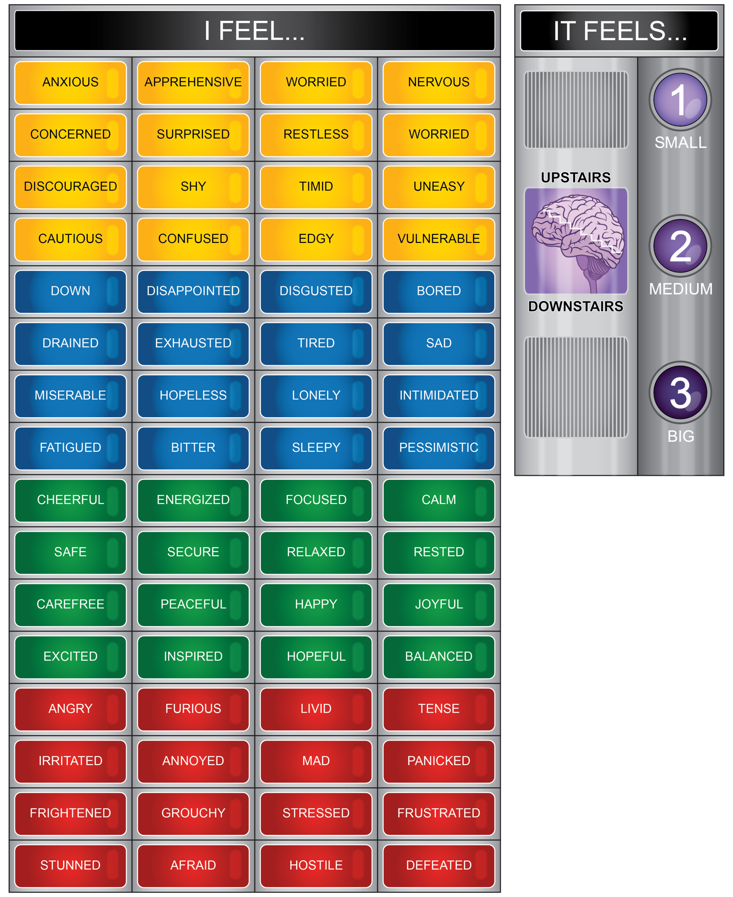

Attachment 9.2: Boundaries for ME Health: Screen time, Social Media and Technology
- What are three ways screen time, social media, and technology can help our mental health?

- What are three ways screen time, social media, and technology can harm our mental health?

- List two tips you could use for using screen time, social media, and technology in a safe way.

Inside or outside of the boundaries for ME health?
- Sage has been playing a game online for the past three hours. It’s been fun, but they haven’t even had anything to drink or eat since they have started playing.
Inside Outside
- Jamie created a social media account without permission from their parents. They used a profile name and haven’t posted any personal information.
Inside Outside
- Shae woke up at 1 a.m. and stayed up playing on their phone all night long. They are really tired the next morning.
Inside Outside
- Kai created a video with pictures and video from all their friends and posted it on YouTube.
Inside Outside
- There is an anonymous social media account for your school that is making fun of teachers and students.
Inside Outside



Boundaries for screen time, social media, and technology
Directions: Describe a boundary for each category and a strategy or helper to maintain the boundary.

Boundary | Strategy
Time
Interactions
Activities

What are signs that you have exceeded your boundaries for social media/technology use?

Instead of spending time in front of a screen, I can …



