**Lesson 2: Emotions, Feelings, and ME Health**

**Overview:** The lesson helps students identify and describe emotions and feelings; recognize big emotions, overwhelming feelings, and urgent signs; understand how emotions and feelings are expressed in healthy and unhealthy ways; and identify and practice strategies to think and act in healthy ways. Activities will help students recognize feelings, reach out, and use resources to support mental health.

National Health Education Standards:

Standard 1: Students comprehend functional health knowledge to enhance health.

Standard 2: Students analyze the influence of family, peers, culture, social media, technology, and other determinants on health behaviors.

**Healthy Behavior Outcomes (HBOs):**

|  |
| --- |
| Identify and express emotions appropriately. |
| Engage in activities that are mentally and emotionally healthy. |

**Lesson Objectives –** Students will be able to:

|  |  |
| --- | --- |
| **Objective** | **Assessments** |
| 1. Describe emotions and feelings. | Attachment 2.2 – Emotions, Feelings, Mood |
| 1. Describe big emotions, overwhelming feelings, and urgent signs of a mental health concern. | Attachment 2.2 – Emotions, Feelings, Mood |
| 1. Recognize feelings in self and others. | Attachment 2.2 – Emotions, Feelings, Mood |
| 1. Describe how to recognize feelings and think and act in healthy ways using resources and supports. | Attachment 2.2 – Emotions, Feelings, Mood |
| 1. Identify trusted adults and health resources who can support emotions and feelings. | Attachment 2.2 – Emotions, Feelings, Mood |
| 1. Describe a resource or support that can support thinking and acting in healthy and safe ways. | Attachment 2.2 – Emotions, Feelings, Mood |

**Lesson Prerequisites or Assumptions:**

* This lesson examines emotions, feelings, and actions. Connect with your school’s behavioral health services and resources to identify how students can reach out to those services and resources. It is also helpful to share parent education resources (see HELPs Parent Education Handout) for when students identify overwhelming feelings.
* This lesson aligns with the concept of “overwhelming and everyday” feelings from Erika’s Lighthouse (<https://www.erikaslighthouse.org/portal/>). We suggest using Erika’s Lighthouse to support your students as part of a whole school, whole community approach to providing a safe, supportive culture around mental health.

Introduction:

* Today, we will practice recognizing feelings and how they influence how we think and act. When our emotions and feelings are strong or become heightened, they can impact our thoughts and actions. Self-regulation — the ability to manage emotions and behavior in a manner that fits the situation — helps us think and act in healthy and safe ways. Once we can recognize our feelings, we can reach out and use resources to support our health. We also will learn to identify personal strategies for emotional, behavioral, and cognitive self-regulation in challenging situations.

Teaching Steps:

Activity 1: Recognizing Feelings and Emotions

* In Lesson 1, we reviewed how we can recognize and talk about emotions and feelings.
* Use our Feelings Index (Attachment 2.1) to identify a word that describes how we are feeling. If you can’t find the exact word, pick one within the same color/category. Then you can rate the size of your feelings by how strong they are from small, medium, or strong
* Whether you are speaking about emotions, feelings, or moods we can share using the same technique:
* I feel ______ because______. I will ______ to think and act in healthy and safe ways.
  + Find a word to describe a feeling you have had recently and WHY you felt that way.  (The goal is to continue this each lesson; once they have identified feelings in all four quadrants, they will have learned how to identify a feeling at any given time).
  + Use the Feelings Index to help identify feelings. If you’re struggling to find the right word, use the color until you find a word that describes your feelings. Green – happy, strong, safe; blue – sad, down, tired; yellow – unsure, confused, anxious; red – angry, hostile, frustrated.
  + Feelings and moods can change throughout the day. For example: You had a great bus ride into school and were in the green zone. Then you find out your friends are all going to a trampoline park after school, and you weren’t invited. Your feeling/mood may change to blue because you’re feeling sad or yellow because you’re confused. It is important for us to recognize our emotions so we can think and act in healthy and safe ways.
  + We can also **recognize** “how it feels” or how strong or intense those feelings might feel to us.
  + What should we do if recognize our mental and emotional health is not at its best, we’re not feeling OK, or we might act in a way that is unhealthy or unsafe?
    - **Recognize** your feelings.
    - **Reach out** to a trusted adult.
    - Use your **resources** like trusted adults, friends, and mental health professionals. Resources can also be tools and strategies like those we will learn through our mental health lessons. We can also use activities or strategies to support our own ME health. In our ME health lessons, we call them “recharge” or “strengthen ME” activities.
  + When we can recognize emotions and feelings, we can also be supportive of others. The basics to support ME health are to:
    - Be kind and empathetic; reach out; listen; and let them know you care. There are resources and supports who can help.
    - Review question: What are the three steps to support ME health? (Recognize, reach out and use resources.)
* **Recognize:** Everyday feelings come and go and are a normal reaction to what happens in our daily lives. **Overwhelming feelings** hang around for a long time, change the way we feel and behave, and may stop us from doing what we enjoy.
  + When we have **strong** emotions (Level 3) or feelings, we have difficulty controlling or regulating the emotion. When we have **small** feelings (Level 1), we still feel in control of our thoughts and actions.
    - It is important to recognize big emotions because big emotions are managed by the downstairs brain. The downstairs brain is good at regulating your body but not for dealing with strong feelings. Our upstairs brain is thoughtful and can process information to think and act in healthy ways. We want to manage our emotions so we can use our upstairs brain to think and act in healthy ways.
  + **Overwhelming feelings** hang around for a long time, change the way we feel and behave, and may stop us from doing what we enjoy.
  + **URGENT warning signs** are observable changes, behaviors, or statements that directly or indirectly signal an individual is contemplating suicide or violence toward others ([Wisconsin, Lesson 2](https://dpi.wi.gov/sites/default/files/imce/sspw/pdf/spcurriculumgrades7-12.pdf)). If you notice, see, hear, or recognize any of the following URGENT warning signs, talk with a trusted adult right away, call 911, and seek immediate help from a mental health provider:
    - Someone is threatening to hurt or kill themselves.
    - Someone is looking for ways to kill themselves, such as seeking access to pills, weapons, or other means.
    - Someone is talking or writing about death, dying, or suicide in a way that is not “typical” for them.
  + You should also reach out to a trusted adult if you need help or support with your everyday feelings or big emotions.
  + **We always reach out to a trusted adult when you recognize overwhelming feelings in yourself or others, threats or actions that could hurt or injure themselves or someone else.**
  + Practice using Attachment 2.2 to recognize everyday, big, or overwhelming feelings or urgent signs.

Activity 2: Feel, Think, and Act in Healthy Ways

* Mental and emotional health is how we feel, think, and act. We learned that everyday feelings could range from small to big. Today, we are learning how our feelings can influence how we think and act. Use the Feelings Index to identify feelings in each color category, then stop and think about how you could think and act in healthy and unhealthy ways.
* We can reach out and use our resources to support ME health. For each emotion, think of a resource that could influence or support you to think and act in healthy and safe ways.
* When we have strong or intense feelings, we need to manage our strategies using our resources. Resources include reaching out to a trusted adult and/or using tools and strategies to think and act in healthy ways. Manage also means to regulate. Today we’re going to learn how to regulate our emotions and feelings so we can express them in healthy ways.
* Self-regulation is a set of skills and strategies to manage emotions and behavior. It can be learned through practice and instruction. Let’s learn about techniques and strategies to regulate our emotions and behavior.
  + Let’s imagine we’re in math class, and there is a really difficult problem. How would you describe your emotions or feelings? How might you behave when you’re feeling this way? What could be a positive or negative way to manage this situation? Let’s think about a couple of resources or strategies to manage our emotions when we’re feeling frustrated.
    - Ask for help and support for the problem.
    - Calm yourself and relax – take a breath or find a calming space.
    - Think and be positive – take on the challenge.
    - Distract – doodle, fidget, color.
    - Move – stand up and move around.
* Another strategy is to use resources. Depending on the situation, emotions, and feelings, you can use a variety of resources including reaching out to a trusted adult, professionals, friends, or a community resource.
* Model the activity (Attachment 2.2), then have students complete the remaining sections for each color of the Feelings Index (Attachment 2.1).

Closure:

* What are the three steps to support your mental health? (Recognize, reach out, and use your resources)
* Why is it important to recognize your emotions and feelings? (So you can recognize your feelings and how strong they might be or if they are overwhelming feelings or urgent signs. If you recognize overwhelming or urgent signs, reach out to a trusted adult.)
* It is also important because you can recognize when you are in your downstairs brain and need to use your resources to think and act in healthy ways.
* Can you think of a resource that can help you think and act in a healthy way?

Attachment 2.1: Feelings Index

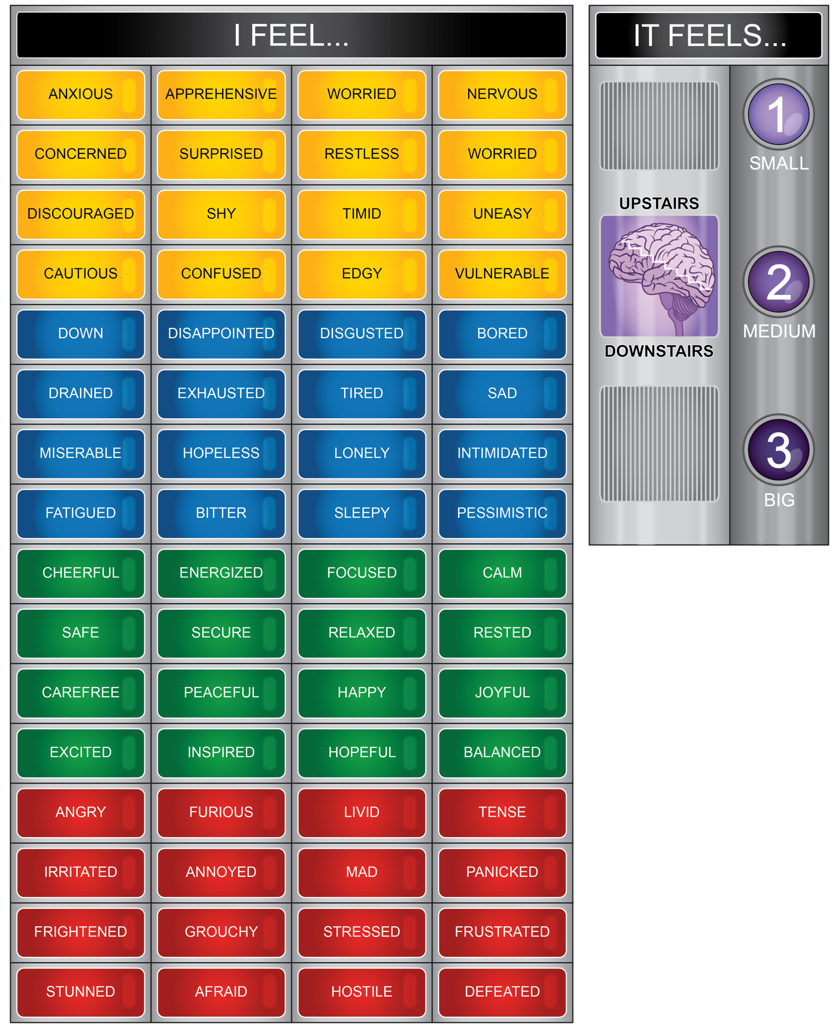

**Attachment 2.2: Recognize Feelings and Urgent Signs**

Directions: *Read the situation and recognize the feeling. Circle if it is an everyday, overwhelming feeling, or an urgent sign. If it is an everyday feeling, then determine how it feels (1-small, 2- medium, or 3-strong) and whether your upstairs or downstairs brain is in control.*

|  |  |  |  |  |
| --- | --- | --- | --- | --- |
| Situation | Feeling | Type  (Circle) | It feels…  (Circle) | Brain |
| I got a new game that I can’t wait to play. |  | Everyday |  |  |
| Overwhelming |
| Urgent |
| A friend said they’re just tired of everything and wish they were not here anymore. |  | Everyday |  |  |
| Overwhelming |
| Urgent |
| Another student in your class is calling you hurtful names and has threatened to hit you. |  | Everyday |  |  |
| Overwhelming |
| Urgent |
| I didn’t sleep much last night. |  | Everyday |  |  |
| Overwhelming |
| Urgent |

Part II. List a trusted adult who can support mental health:

|  |  |  |
| --- | --- | --- |
| **Home** | **School** | **Community or Health Resource** |
|  |  |  |

**Attachment 2.3: Manage Emotions and Express Them in Healthy Ways**

Directions: Choose one feeling word from each color of the Feelings Index. Write one unhealthy action and one healthy action for when you feel this way. Think of a resource that would help you think and act in healthy ways.

|  |  |  |  |  |
| --- | --- | --- | --- | --- |
| **Feeling** | **Think and Act Unhealthy** | | **Think and Act Healthy** | **Resource to Support a Healthy Choice** |
| **Example:** I feel…  Frustrated (red) | Skip school | | Share my frustrations with my best friend during lunch. | My PE teacher. |
| **Red** |  |  | |  |
|  |
| **Blue** |  | |  |  |
|  |
| **Yellow** |  | |  |  |
|  |
| **Green** |  | |  |  |
|  |