Lesson 1: What Is Mental and Emotional (ME) Health?

Overview: Students will describe the characteristics of mental and emotional (ME) health as how we feel, think, and act. Students will understand the interrelationship with other dimensions of wellness. Students will practice identifying feelings as well as strategies and additional activities that promote ME health.

National Health Education Standards:
Standard 1: Students comprehend functional health knowledge to enhance health.
Standard 7: Students demonstrate observable health and safety practices.
Healthy Behavior Outcome (HBO):
Students will engage in activities that are mentally and emotionally healthy.
Lesson Objectives – Students will be able to:
Objective | Assessments
Describe characteristics of mental and emotional health. | Attachment 1.1: Getting to Know ME
Describe how mental and emotional health is connected to and influenced by other aspects of health. | Attachment 1.1: Getting to Know ME
Describe how to recognize, reach out, and use resources to support mental and emotional health. | Attachment 1.1: Getting to Know ME
Describe feelings and the reasons for them. | Attachment 1.1: Getting to Know ME
Identify a trusted adult who can support mental and emotional health. | Attachment 1.1: Getting to Know ME
Demonstrate a practice or strategy that enhances mental and emotional health. | Attachment 1.2: Mental Health Strategies

Lesson Prerequisites or Assumptions:
- This lesson examines emotions, feelings, and actions. Connect with your school’s behavioral health services and resources to identify how students can reach out to those services and resources. It is also helpful to share parent and family education resources (see HELPs Parent Education Handout) so trusted adults are more aware of how they can support mental and emotional health.
- Ensure that school mental health staff is aware of the Behavioral HELPs lesson. Build a connection with school behavioral health staff so they are ready and available to support students’ who experience strong feelings or need additional supports/resources.

Introduction
- Today’s lesson addresses mental and emotional health. If you are having feelings, emotions, or thoughts you should feel comfortable to reach out to me or a trusted adult at school. (Remind students of your procedures if students need to use a regulation or mindfulness tool or strategy.)
- Reminder students of your classroom expectations and norms to create a safe supportive environment. (INSERT your procedures here)
Teaching Steps:

Activity 1: ME Activity
- Start with a mindfulness strategy of box breathing.
  - Step 1: Breathe in, counting to four slowly. Feel the air enter your lungs.
  - Step 2: Hold your breath for four seconds.
  - Step 3: Slowly exhale through your mouth for four seconds.
  - Step 4: Repeat until you feel centered.
- Practice this breathing for one to two minutes. How do you feel when you are using box breathing? Write down this sentence: I feel _________ because ___________.
- Box breathing is one of many breathing techniques to use when feeling stressed or anxious or when you need to slow down and think for a minute. Did you recognize anything about how your mind and body felt before, during and after the activity?
Activity 2: Getting to Know ME: Defining Mental and Emotional (ME) Health (Attachment 1.1)
- What is mental and emotional health?
  - ME health is how we feel, think, and act. It helps determine how we handle stress, relate to others, and make choices.
  - Mental health is important at every stage of life from childhood and adolescence through adulthood. ME health includes our emotional, psychological, and social well-being. Your mental and emotional health impacts your thinking, mood, and physical health; it can also affect behavior.
  - Mental and emotional health is about your strengths, abilities, talents, and needs.
  - To enhance and support our mental and emotional health, we will recognize, reach out, and use our resources.
    - Recognize our feelings and emotions and how they influence how we think and act.
    - Reach out to trusted adults and mental health resources to support how we feel, think, and act.
    - Use resources including trusted adults and mental health resources and strategies.
- Our ME health is the foundation for all other health behaviors. Our ME health can have a positive or negative impact on other aspects of health. Other aspects of our health and wellness can impact ME. Let’s brainstorm a list of examples of the relationship between ME and other aspects of health and wellness.
  - There are times when we recognize our health and wellness are not optimal. What do we do when our physical health is not OK?
    - Reach out and seek help from a trusted adult, doctor, or other professional who can support me.
  - What should we do if our mental and emotional health is not OK?
    - Reach out and seek help from a trusted adult, doctor, or other professional who can support me.
    - We can also take steps to support ME. These might be activities or specific strategies for ME. In our ME lessons, we call them “recharge” or “activities that strengthen ME.”
  - How could we help someone who isn’t feeling the best about their mental and emotional health?
    - Reach out, listen, and demonstrate empathy. Be kind, nonjudgmental, and supportive.
  - We can also use this relationship to enhance our health. For example, we can use physical activity to enhance our physical health and in turn enhance our mental health. We can talk to friends to support our mental health. Ask students to think and share other examples.
- Part I - Recognize ME: What Are Your Feelings and Emotions
  - Our mental and emotional health is how we think, feel, and act (Wisconsin, Lesson 2).
  - Feelings and emotions
    - Everyone experiences emotions, but how we experience them and respond to them is different for each person.
    - People experience a wide range of feelings and emotions.
    - Feelings are not good or bad or positive or negative, but feelings give us information that we can pay attention to so we can think and act in healthy and safe ways.
    - It’s important to understand emotions and feelings because they can impact how we act. We want to be sure we act in ways that are healthy and safe.
  - Thoughts occur when our brain is at work to process information to help us learn and make decisions
  - Actions are behaviors or decisions using our minds and bodies.
  - Lessons 2 and 3 will address thoughts and actions. Lesson 1 targets how we talk about our mental health, particularly our feelings and emotions.
- Part II – Recognize Feelings and Emotions
  - Let’s practice identifying and describing different emotions. The Feelings Index (Attachment 1.2) will help us describe our feelings. Describing our feelings and emotions will help us talk about them and make us aware of how people around us are feeling.
  - Step 1: Recognize feelings
    - When we recognize feelings, we use a word from our feeling’s vocabulary in the Feelings Index (Attachment 1.2) and then use an adjective to describe the strength of the feeling.
    - It is also helpful to recognize what might be causing you to feel this way.
    - Example – I’m feeling really (Level 3) tired because I stayed up late to ______.
    - Sometimes we can’t find exactly the right word to share our emotions or feelings; that’s why the wheel organizes them into categories
    - Green – I’m ready to go. I feel calm, ready, and focused.
    - Blue – I’m feeling sad or moving slowly; I need some help to get going.
    - Yellow – I’m feeling cautious or worried. I also need some help to accomplish what I want or need to do.
    - Red – I’m feeling frustrated or angry. I don’t feel in control, and I need some help getting control.
  - Step 2: Describing Feelings
    - We can use a scale to describe the strength or size of our emotions. The range is between 1 and 3. Level 1 feelings are smaller, so I can think and act in healthy and safe ways using my upstairs brain. At the top of the scale is 3, or big feelings. Big feelings are when I am unable to control how I think and act because I’m using my downstairs brain. When I’m at Level 2, I should watch my feelings and use my tools, strategies, and resources to think and act in healthy and safe ways. In Level 2, I need the support of my tools and can reach out for help or support if needed.
  - When we are describing feelings, we use the following steps (See Attachment 1.1, Part III)
    - I feel ________ (feeling word). This feels (small, medium, or big).
    - I feel this way because _____________.
    - Think about what tools or people could help you think and act in healthy ways.
  - Practice describing how you would feel for each situation (See Attachment 1.1, Part III):
    - A referee makes a wrong call, and it costs the team the game.
    - You have a test coming up, and you are unsure how you will do.
    - You missed your alarm, and now you’re late for school.
    - You had the highest score on the quiz.
- Part III – How I feel.
  - Take a moment to choose one feeling word for each color, then describe the situations and the reason you might feel this way. Example: I am feeling happy because it is Friday, and I have big plans for this weekend.
  - There are times when we recognize our mental and emotional health is not at its best, or we need help to think and act in ways that are healthy and safe.
  - What do you do when you need help with your physical health or when you need help making healthy choices?
    - Reach out and seek help from a trusted adult, doctor, or other professional who can support me. (Refer to Behavioral HELPs Substance Use Prevention Lessons; we will address resources in Lessons 3 and 4)
  - What should we do if we recognize our feelings and thinking or our mental and emotional health is not at its best, we’re not feeling OK, or we might act in a way that is unhealthy or unsafe?
    - Reach out to a trusted adult, doctor, or another professional who can support ME.
    - Use our resources to support our mental health.
      - Resources can be trusted adult, doctor, or another professional who can support ME health.
  - Our resources could be a trusted adult, a friend, a mental health professional, or tools that help us manage our feelings so we can think and act in healthy ways.
    - If you recognize that you need support or help with your mental health, you can reach out and use your resources.
    - We will learn how to support and advocate for mental health. We’ll learn to be kind and reach out, listen, and let them know a trusted adult can help them.
Activity 3: Activities for ME – How Does It Feel?
- Use Attachment 1.3 for mental health strategies. The goal of this activity is to practice recognizing feelings and create awareness of activities that can strengthen mental health. Remind your students they will have the opportunity to practice some self-care activities. Share your procedures for completing each station and how to rotate to the next station.
  - At each station, describe how you feel and rate its usefulness to enhancing your health. If it is not your favorite, give it a try; maybe you will like the next one better. As you move from station to station, keep notes on Attachment 1.3.
  - Divide students into groups based upon the number of strategies available.
  - After completing each station, reflect and write down three strategies for ME.
Closure:
- Let’s review – Mental and Emotional Health is how we feel, think, and act. What can we do to support mental and emotional health? We can recognize, reach out, and use our resources to support and enhance mental health.
Attachment 1.1: Getting to Know Mental and Emotional (ME) Health
Part I.
- In your own words, how would you describe mental and emotional health?

- What is one example of how mental health might impact your overall health?

- List the three “R” activities that support mental and emotional health.

- What is one activity you do (or could do) to enhance your mental and emotional health?

- What is one thing you want to learn about or a question you have about mental and emotional health?

Part II. Directions: Complete each statement to recognize the color, feeling, and reason. Look at the Feelings Index to determine the color and feeling. In the “Because” column, add the reason you would feel this way.
- A referee makes the wrong call that costs the team the game.
Color | Feeling | Because…
 | I am feeling ________________________
- You have a test coming up, and you are unsure how you will do.
Color | Feeling | Because…
 | I am feeling ________________________
- You missed your alarm, and now you’re late for school.
Color | Feeling | Because…
 | I am feeling ________________________
- You had the highest score on the quiz.
Color | Feeling | Because…
 | I am feeling ________________________

Part. III – Sharing How I Feel

Directions. Use your Feelings Index to practice describing how you are feeling. Choose an emotion in each color category and write it in the first column. In the next column, use the statement provided to describe situation that would make you feel this way.

Color  Happy | I am feeling ________________ because ________________.  I am feeling happy because it is Friday, and I have big plans for this weekend.
Red
Blue
Yellow
Green

Attachment 1.2: Feelings Index

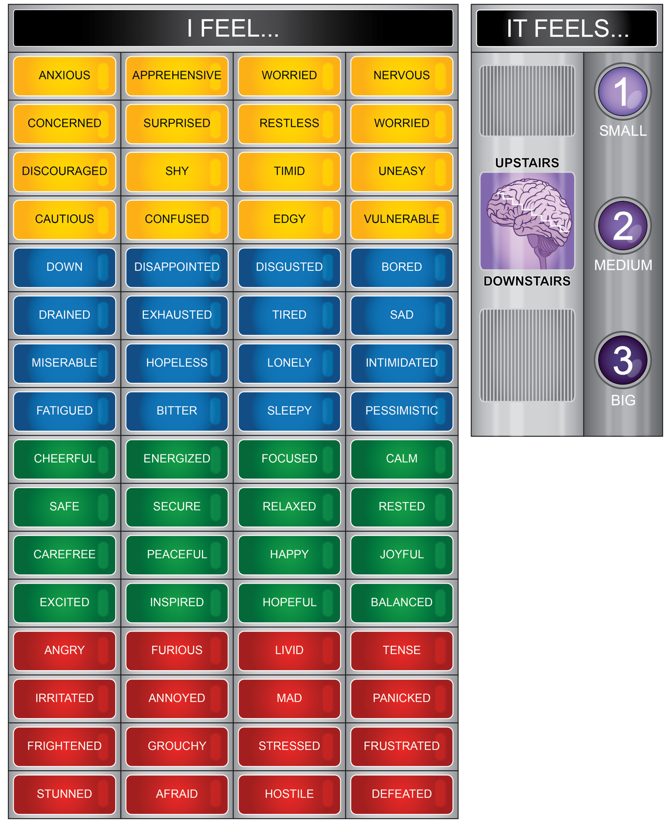

Attachment 1.3a: Mental Health Resilience Strategies Worksheet
Directions:
Write the name of the station in the shaded box above each section. Then answer the three questions for each station. You can use a feeling word or color to best describe how you felt.
When you finish the stations, identify three activities you can use to support ME health.

Station 1: |  | Station 2:
I feel _______ when using this station. |  | I feel _______ when using this station.
I would use this station feeling….. |  | I would use this station feeling…..
I would use this station again. | Yes | I would use this station again. | Yes
 | No |  | No
Station 3: |  | Station 4:
I feel _______ when using this station. |  | I feel _______ when using this station.
I would use this station feeling….. |  | I would use this station feeling…..
I would use this station again. | Yes | I would use this station again. | Yes
 | No |  | No
Station 5: |  | Station 6:
I feel _______ when using this station. |  | I feel _______ when using this station.
I would use this station feeling….. |  | I would use this station feeling…..
I would use this station again. | Yes | I would use this station again. | Yes
 | No |  | No

List three activities you would use for your ME health.
When I am feeling …  (List feeling) | I will …  (List activity)

Who is a trusted adult you can talk about your feelings and mental health?
Attachment 1.3b: Mental Health Resilience Strategies
TECHNIQUE | HOW TO DO IT | HOW HELPFUL?
POSITIVE PLAYLIST   | Make a music playlist that brings your spirits up and motivates you. These should be uplifting, positive songs. Listen to this playlist when you’re feeling down! | 3  Very
2
Some
1
None
ROUTINES  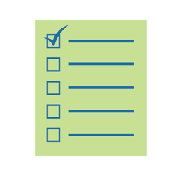 | Try to keep to regular daily routines. This will help things seem normal and productive. It will also help your sleeping patterns and make sure you eat regularly. Example: “I will wake up at 8 a.m. and eat breakfast. At 2 p.m., I will take an exercise break. My bedtime will be 10 p.m.” Make a list of routines you want to follow and check off when complete. | 3  Very
2
Some
1
None
REGULAR EXERCISE   | Exercise benefits the body, but it also can relieve mild to moderate symptoms of depression and anxiety. Even brisk walking can lift your mood, release calming chemicals in your brain, reduce physical and emotional pain, promote memory and learning, and distract you from things that are bothering you. | 3  Very
2
Some
1
None
MANTRA or “ONE WORD”  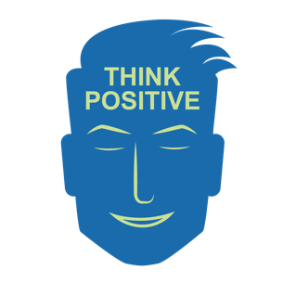 | Choose some encouraging phrases such as, “It might be tough, but you’ve got this,” or, “You are stronger than you know.” Some people even choose one word to focus on such as “calm” or “confident” or “peace.” Focus on that word or phrase and repeat it inside your head. Some people even close their eyes and imagine that word or phrase being typed or handwritten. Or, post it somewhere in your room. | 3  Very
2
Some
1
None
GRATITUDE WALL  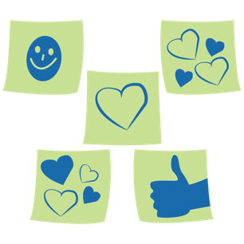 | This could be a personal or family activity. It is a dedicated space to reflect on things you are thankful for and remember them visually: printed photos, words cut out from magazines, lists, drawings, cards from loved ones, and mementos. | 3  Very
2
Some
1
None
DEFINE YOUR FEARS  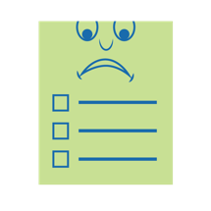 | Write or type out a list of your worries. Sometimes just getting them out of your head and onto paper can be helpful. Decide how much is within your control and make note of what you can do to help the situation or help you feel better. Then, make a choice to let it go. Some people even like to tear up their worry list into tiny pieces and throw it away. Worrying keeps you from fully experiencing joys in life. | 3  Very
2
Some
1
None
PERSPECTIVE   | Make a list of the things you HAVE that are not being affected by difficult situations. When you’re feeling frustrated by things that have changed or that you can’t have right now, look back at this list and try to add one item. Bonus: Think of things you could do to help others who have less than you. | 3  Very
2
Some
1
None
JOURNAL   | Write out your thoughts or make a video journal to help you think through your challenges and discover patterns and solutions. Questions you might ask yourself include: What were the highlights of my day? What did I struggle with? How did I feel? What did I do to cope, or what could I try next time? What might I do differently tomorrow? What am I looking forward to? What have I learned about myself? | 3  Very
2
Some
1
None
SLEEP PRACTICE  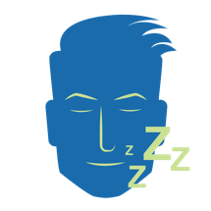 | During the day, expose yourself to as much natural light as possible and avoid spending time in your bed. Practice feeling awake — teeth brushed, daytime clothes, up and moving. Set a specific bedtime and turn off all electronics an hour in advance. Plan a bedtime routine including hygiene and a quiet activity like reading or listening to relaxing music. At night, practice winding down and feeling sleepy. You should get eight to 10 hours of sleep each night. | 3  Very
2
Some
1
None
GROWTH MINDSET   | Try to look at challenges as opportunities to grow and expand your brain. If something hasn’t gone well, see how others are doing it well, ask questions to learn more, and keep trying. | 3  Very
2
Some
1
None
MUSCLE RELAXATION  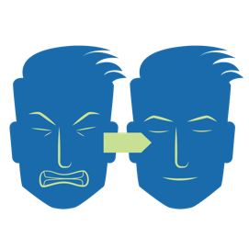 | Link to the document with directions. Learn to relax by muscle relaxing. Follow these steps when you feel yourself getting angry or upset. | 3  Very
2
Some
1
None

TECHNIQUE | HOW TO DO IT | HOW HELPFUL?
REFRAME   | Challenge your brain to find a different way of looking at your situation. For example, replace, “I have to stay at home instead of hanging out with my friends,” with, “I’m learning some ways to have fun with my family, and I can still reach out to my friends in other ways.” Another example: Replace, “There’s nothing to do,” with, “Now I have time to learn new skills like cooking/baking.” | 3  Very
2
Some
1
None
TIME MANAGEMENT  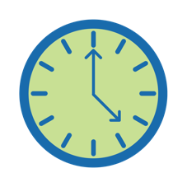 | Set limits on activities that could waste your day or make you less productive, such as video games, TV, and social media. Make time to work on assignments and chores so you are not overwhelmed with lots of things to do later. | 3  Very
2
Some
1
None
HEALTHY EATING   | Try to cut sugar out of your daily meals and cut back on snacking. Half of your daily food intake should come from vegetables and fruits. Stay away from fatty foods and caffeine. Try some “good mood” foods such as fish, bananas, or nuts, which can boost overall brain health and energy levels. | 3  Very
2
Some
1
None
COUNSELING  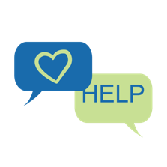 | If you’re not feeling better after self-care and talking out your feelings with loved ones, you could reach out to a guidance counselor at school. You might also consider asking a parent about professional counseling. The NAMI website has additional resources. | 3  Very
2
Some
1
None
GIVE YOURSELF GRACE   | Everyone has bad days. Take some extra time for self-care and try again tomorrow! | 3  Very
2
Some
1
None
5-4-3-2-1 STRATEGY   | Grounding Strategy: Name five things you can SEE; four things you can TOUCH; three things you can HEAR; two things you can SMELL; and one thing you can TASTE. | 3  Very
2
Some
1
None
Additional Strategies:
- 4-6-8 breathing, belly breathing, square breathing, tapping
- Crunching on fruit or veggies
- Visualization
- Meditation
- Gratitude (write down what you are grateful for)
- Music, mindfulness, meditation, yoga, stretching, bath
- Nature, walking
- Stress ball
- Reading
- Coloring
- Hobbies – for example, knitting/sewing
- Talking to a friend
- Funny TV or videos
- Pet an animal or watch fish
- Taking a break; power nap; mantras; positive self-talk
- Dancing
