**Lesson 3: Recognize, Reach Out, and Use Resources**

**Overview**: Students will apply recognize, reach out and use resources to support mental health. The lesson will practice recognizing big feelings, overwhelming feelings, and urgent signs of a mental health concern.

National Health Education Standards:

**Standard 1:** Students comprehend functional health knowledge to enhance health.

**Standard 3:** Students demonstrate health literacy by accessing valid and reliable health information, products, and services to enhance health.

Healthy Behavior Outcome (HBO):

|  |
| --- |
| Students will demonstrate emotional self-regulation techniques to cope with big feelings. |

**Lesson Objectives** - Students will be able to:

|  |  |
| --- | --- |
| **Objective** | **Assessment** |
| Recognize emotions, big emotions, overwhelming feelings, and urgent signs of a mental health concern. | Attachment 3.2: Recognizing Emotions & Feelings Notes |
| Use recognize, reach out and use resources to support mental and emotional health. | Attachment 3.2: Recognizing Emotions & Feelings Notes |
| Identify trusted adults and mental health resources to support mental and emotional health. | Attachment 3.2: Recognizing Emotions & Feelings Notes |

Introduction:

* Let’s check in to recognize how you are feeling. Complete the sentence based using a feeling that occurred today. I feel _________ because ___________.
* Today we’re going to review how to recognize, reach out, and use resources. Today’s lesson will focus on recognizing feelings and connecting to resources that can support your ME health.

Teaching Steps:

* This lesson is important because we can all support good mental health in ourselves and others by recognizing, reaching out, and using resources.
* Review classroom norms and expectations and remind students that they can connect with you or school staff to support their mental and emotional (ME) health.
* Emphasize that the goal of this lesson is not to diagnose mental health conditions. Students will learn to recognize or notice and then reach out to resources including a trusted adult or mental health resource.

Activity 1: Recognize, Reach Out, and Use Resources – Guided Notes

* What is mental health? It is how we **feel, think**, and **act**.
* What can we do to support our mental health? What should we do if we **recognize** feelings, thoughts, or actions that are not our best and might cause us to think and act in ways that are unhealthy or unsafe?
  + **Reach out** and seek help from a **resource**.
    - Resources include people like trusted adults, friends, and mental health professionals who can support ME health. Resources can also be tools and strategies. We can also take steps to support ME through activities or specific strategies. We call them “recharge” or “strengthen ME” activities.
* Recognize feelings and emotions
  + Everyday feelings come and go and are a normal reaction to what happens in our daily lives. We use I feel _______ because _______ to describe our feelings. Use Attachment 3.1 to review feelings.
  + Use it “It feels….” to recognize the size or intensity of the feelings and to recognize signs help is needed.
  + **Big emotions** (Level 3) or feelings are when we have difficulty controlling or regulating the emotion. When we have small feelings (Level 1), we still feel in control of our thoughts and actions. Use the “It Feels” section to describe your feelings. “It feels like a big emotion,” or “It feels like a small emotion,” can help you recognize the next step to reach out and use resources to support ME health.
  + **Overwhelming feelings** hang around for a long time, change the way we feel and behave, and may stop us from doing what we enjoy.
  + **URGENT warning signs** are observable changes, behaviors, or statements that directly or indirectly signal an individual is contemplating suicide or violence toward others ([Wisconsin, Lesson 2](https://dpi.wi.gov/sites/default/files/imce/sspw/pdf/spcurriculumgrades7-12.pdf)). If you notice, see, hear, or recognize these URGENT warning signs, talk with a trusted adult right away, call 911, and seek immediate help from a mental health provider. Some examples of urgent warning signs:
    - Someone is threatening to hurt or kill themselves.
    - Someone is looking for ways to kill themselves, such as seeking access to pills, weapons, or other means.
    - Someone is talking or writing about death, dying, or suicide in a way that is not “typical” for them.
    - **Reach out to a trusted adult or a mental health resource when you recognize feelings, threats, or actions in yourself or others that could hurt or injure someone. You should also reach out to a trusted adult if you need help or support for your everyday feelings or big emotions.**

Activity 2: Reach Out and Use Resources

* If you notice or recognize big emotions, overwhelming feelings, or urgent signs, reach out and use resources to support mental and emotional health. (Use Attachment 3.1)
* Why is it important to reach out? We want to think and act in ways that are healthy and safe. We can be helpful to ourselves and others by reaching out and using resources.
  + Asking for help and support for the problem from a trusted adult, health professional, or mental health resources.
* If you notice or recognize a signal about your own mental health, you can reach out to a trusted adult or resource by sharing what you noticed and ask for help and support. For example, “I noticed I’m feeling very anxious. Can I talk to you more about this?”
* If you notice a signal in a friend, family member, or another person, you could say something like, “I noticed you seem a little upset. Would you like to talk about it?”
* If you notice a signal in someone else but don’t feel comfortable talking to that person, reach out to a trusted adult to share your concern. “I’ve noticed something different in Jade, and I’m concerned. What should I do to help?”
  + The trusted adult can help by listening to your concern as well as reaching out to supports that could help that person.
  + Lesson 4 will provide additional information about valid and reliable mental health resources and supports.
* Another way to get help is by talking to someone you trust. Trusted adults can be found at home, at school, and in the community. This could be a parent, family member, teacher, school counselor, spiritual leader, or another trusted adult who:
  + Gives good advice when you want and ask for it.
  + Respects your need for privacy.
  + Does not judge, tease, or criticize when you talk freely about your feelings and emotions.
  + Helps you figure out what to do the next time a difficult situation comes up.
* Mental health resources:
  + Community resources – 988 and others (add your local resources)
  + Health professionals at your school and in the community including a school counselor, a school nurse, and your doctor.
    - Any person on this list can listen to your concerns and connect you with additional resources if needed.
    - We will practice reaching out to resources in Lesson 5 but here are three cues to remember. These steps can be used to ask for help for yourself or someone else.
      * Share what you recognized in a caring and empathetic way.
      * Be nonjudgmental.
      * Ask for help (or ask to help if you are helping a friend)
        + “I recognize ______. Can you help me?”
* You can also reach out and use resources like the self-regulation tools from Lesson 1 and 2. We practiced some of these tools in Lesson 1. These tools are useful to manage small and medium feelings to stay in your upstairs brain
* Tools
  + Calm yourself and relax – take a breath or find a calming space.
  + Think and be positive – take on the challenge.
  + Distract – doodle, fidget, or color.
  + Move – stand up and move around.
  + Talk – share how your feeling with someone.
* Remember if you recognize your feelings or emotions need additional support you should reach out to trusted adults and resources to support your ME health.
* Have students complete the first two questions of Attachment 3.2 to identify tools and resources that could support ME health. Then Part II (Scenario practice) to model Recognize, Reach Out, and use Resources.

Activity 3: Practice Situation

* **Practice task (Attachment 3.3):** Model the first scenario then have students practice applying recognize, reach out and resources. Reinforce big emotions, overwhelming feelings, and urgent signs of a mental health concern. The activity will ask students to recognize and reach out to a resource.

Closure:

* What can you do to support your mental health and the mental health of others?
  + Use the three R’s: recognize, reach out, and use resources
* What should you do if you recognize or notice something that makes you think you should speak to someone about how you are feeling or how someone is making you feel?
  + Reach out to a trusted adult.
* List an example of a resource that could help in this situation.

Attachment 3.1: Feelings Wheel

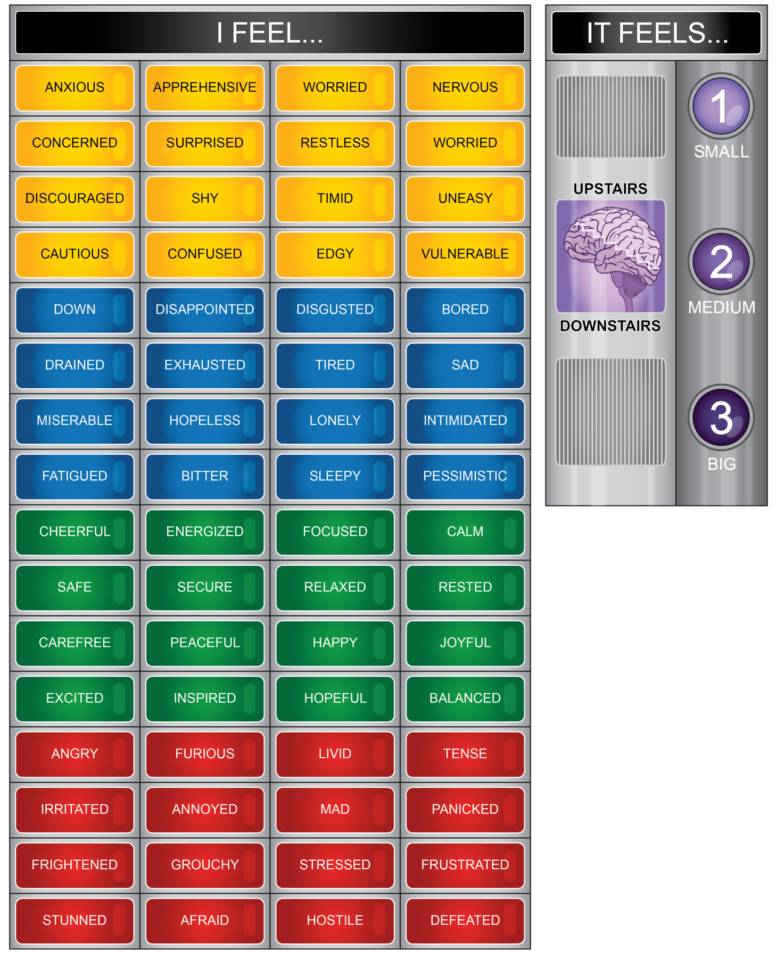

**Attachment 3.2**

Write a sentence about how you feel today using: **I feel _________ because ___________________________.**

**List or describe three tools, resources, or strategies or self-regulation techniques you can use to support ME health.**

**List resources that include trusted adults, mental health resources, and health professionals.**

|  |  |  |
| --- | --- | --- |
| **Trusted Adults** | **Mental Health Resources** | **Health Professionals** |
|  |  |  |
|  |  |  |
|  |  |  |

*Part II. Scenario Practice*

You have noticed your friend Rae has been acting a little different since their parents’ divorce. Rae has been skipping basketball practice, not turning in homework assignments, and wearing long sleeves even when it is 90 degrees outside to hide their arms and wrists. You went up to check in, and they lashed out at you and yelled, “Mind your own business.”

1. List two things you recognized about Rae or the situation.
2. _____I should you do?
3. Ignore it. It isn’t a big deal.
4. Reach out to Rae and show support. Tell a trusted adult.
5. Confront Rae and tell them to get it together.
6. List a resource you could reach out to in this situation.

Attachment 3.3 – Recognize, Reach Out and use Resources

|  |  |  |  |  |  |  |
| --- | --- | --- | --- | --- | --- | --- |
| **Situation** | **I feel…** | **It feels…** | **My brain is…** | **Is it…** | **Reach out to resources** | **Resources that can help** |
| You were not cast for the part you wanted in the school play. |  |  |  | Big |  |  |
| Overwhelming |
| Urgent |
| You found out you earned an academic college scholarship. |  |  |  | Big |  |  |
| Overwhelming |
| Urgent |
| Your best friend is moving to another state. |  |  |  | Big |  |  |
| Overwhelming |
| Urgent |
| You bowled your highest game. |  |  |  | Big |  |  |
| Overwhelming |
| Urgent |
| Your friend posted a picture of you on social media that you told her not to share. |  |  |  | Big |  |  |
| Overwhelming |
| Urgent |