Lesson 2: Emotions, Feelings, and ME Health

Overview: The lesson highlights the connections between emotions and feelings and how we think and act. Students will practice recognizing emotions and reaching out to use resources to think and act in healthy safe ways.

National Health Education Standards:
Standard 1: Students comprehend functional health knowledge to enhance health.
Standard 2: Students analyze the influence of family, peers, culture, social media, technology, and other determinants on health behaviors.
Healthy Behavior Outcome (HBO):
Students will identify factors that influence their ability to self-regulate.
Lesson Objectives - Students will be able to:
Objective | Assessment
- Describe everyday feelings, overwhelming feelings, and urgent signs. | Attachment 2.1- Recognize Emotions and Feelings
- Recognize emotions and emotions would impact thoughts and actions. | Attachment 2.1- Recognize Emotions and Feelings
- Define emotions, feelings, and moods and the relationships between them. | Attachment 2.1- Recognize Emotions and Feelings
- Define self-regulation and provide examples of emotional, behavioral, and cognitive self-regulation. | Attachment 2.1- Recognize Emotions and Feelings
- Identify influences that impact our ability to self-regulate. | Attachment 2.1- Recognize Emotions and Feelings
- Identify self-regulating tools that they can implement for different feelings, emotions or moods. | Attachment 2.1- Recognize Emotions and Feelings

Lesson Prerequisites or Assumptions:
- This lesson examines emotions, feelings, and actions. Connect with your school’s behavioral health services and resources to identify how students can reach out to those services and resources. It is also helpful to share parent education resources (see HELPs Parent Education Handout) for when students identify overwhelming feelings.
- This lesson aligns with the concept of “overwhelming and everyday” feelings from Erika’s Lighthouse (https://www.erikaslighthouse.org/portal/). We suggest using Erika’s Lighthouse to support your students as part of a whole school, whole community approach to providing a safe, supportive culture around mental health.
Introduction:
- Today, we will practice recognizing feelings and how they influence how we think and act. When our emotions and feelings are strong or become heightened, they can impact our thoughts and actions. Self-regulation — the ability to manage emotions and behavior in a manner that fits the situation — helps us think and act in healthy and safe ways. Once we can recognize our feelings, we can reach out and use resources to support thinking and acting in healthy ways. We also will learn to identify personal strategies for emotional, behavioral, and cognitive self-regulation in challenging situations.
Teaching Steps:

Activity 1: Recognize, Reach Out and use Resources
- Distribute Attachment 2.1 – Awareness of ME Notes.
- Review what is Mental Health? Mental health is how we feel, think and act. Today we’ll learn more about our emotions, feelings, and mood so we can recognize, reach out and use our resources to support our ME Health.
- In Lesson 1, we reviewed how we can recognize and talk about emotions and feelings. We can use recognize, reach out and resources to support our ME health. We can use it when our ME health is not at its best, we’re not feeling OK, or when we want to improve our health.
  - Recognize your feelings.
  - Reach out to a trusted adult.
  - Use your resources like trusted adults, friends, and mental health professionals. Resources can also be tools and strategies like those we will learn through our mental health lessons. We can also use activities or strategies to support our own ME health. In our ME health lessons, we call them “recharge” or “strengthen ME” activities.
    - When we can recognize emotions and feelings, we can reach out and use resources to be supportive of others.
- Review question: What are the three steps to support ME health? (Recognize, reach out and use resources.)
Activity 2: Recognize Review
- Whether you are speaking about emotions, feelings, or moods we can share using the same technique:
  - I feel ______ because______. It feels (small, medium, strong). I will ______ to think and act in healthy and safe ways.
- Model the “I feel” sentence for your students. Student can then write their own feeling statement on Attachment 2.1.
- Learning how to recognize our feelings will help us describe and understand our feelings. Sharing our feelings also help us reach out to support mental health.
- Use the Feelings Index (Attachment 2.1) to identify a word that describes how we are feeling. If you’re struggling to find the right word, use the color until you find a word that describes your feelings. Green – happy, strong, safe; blue – sad, down, tired; yellow – unsure, confused, anxious; red – angry, hostile, frustrated.
- Then you can rate the size of your feelings or “How it feels” by how strong they are from small (Level 1), medium, or strong (Level 3).
- We need to be aware of big emotions, overwhelming feelings, and urgent signs so we can support and enhance ME health.
  - Big emotions (Level 3) or feelings are when we have difficulty controlling or regulating the emotion. Small emotions (Level 1) are still important feelings, but we still feel in control of our thoughts and actions.
  - Overwhelming Feelings - hang around for a long time, change the way we feel and behave, and may stop us from doing what we enjoy.
  - URGENT warning signs that are observable changes, behaviors or statements that directly or indirectly signal an individual is contemplating suicide or violence towards others (Wisconsin, Lesson 2). If notice, see, hear, or recognize these URGENT warning signs you must talk with a trusted adult right away, call 911, and seek immediate help from a mental health provider:
    - Someone is threatening to hurt or kill themselves.
    - Someone is looking for ways to kill themselves: seeking access to pills, weapons, or other means.
    - Someone is talking or writing about death, dying, or suicide in a way that is not “typical” for them.
  - Always reach out to a trusted adult when you recognize overwhelming feelings in yourself or others, threats or actions that could hurt or injure themselves or someone else. Reach out to resources like a trusted adult or health professional if your everyday feelings or big emotions need help or support.
- Resources include people like trusted adults, friends, and mental health professional who can support ME.
- Resources can also be tools and strategies like those we will learn through our mental health lessons. We can also take steps to support ME. These might be activities or specific strategies for me. In our ME lessons we call them recharge or strengthen ME activities.
- Complete Attachment 2.1 to assess students’ knowledge of big emotions, overwhelming feelings and urgent signs. Debrief the answers to reinforce recognize and reach out to resources.
  - We will learn more about recognize, reach out and use resources in Lessons 3 and 4.
Activity 3: Recognize – How feelings influence how we think and act.
- ME health is how we feel, think and act. Our feelings can influence how we think and act. We are going to learn more about our emotions, feelings, and moods. Then we’ll learn more about how we can recognize our feelings, reach out and use resources to think and act in healthy and safe ways.
- Part I. Emotions, Feelings, and Moods
  - Emotions are our response to external stimuli. Feelings are then generated from our thoughts or interpretations about those emotions. A mood is a state of mind or feeling that can influence our thoughts, behaviors, and actions. Moods are generally less intense than emotions and not necessarily caused by an event or trigger; it is how a person feels over time and influenced by the environment, diet, exercise, physical health, and what we choose to think about.
  - Feelings and moods can change throughout the day. For example: You had a great bus ride into school and were in the green zone. Then you find out your friends are all going to a trampoline park after school, and you weren’t invited. Your feeling/mood may change to blue because you’re feeling sad or yellow because you’re confused. It is important for us to recognize our emotions so we can think and act in healthy and safe ways.
  - We can use our feeling index to recognize how we feel. We can use this word to better understand how we are feeling and to share our feelings with others when we need help or support.
  - We support mental health when we share our feelings with others. It can help improve our mental health but it can also help others feel safe and supportive to share their feelings or seek support for mental health. We’ll learn more about supporting mental health in Lesson 5 and 6.
- Part II. Feel, Think and Act: Upstairs or Downstairs Brain
  - We have described our feelings using I feel and also describe how “it feels” by rating our feeling as small, medium or big. Why is it important to recognize big feelings.
  - Big emotions are difficult to manage how we think and act. If we can recognize the size of our feelings we can reach out and use our resources to think and act in healthy ways.
  - Let’s learn more about how our brain works when we have big emotions.
    - One of the functions of the limbic system within our brain is to process information and regulate emotions. Our upstairs brain in the frontal lobe just behind the forehead is responsible for our executive function. This is where we process information, focus, plan, prioritize, and make thoughtful decisions. In our upstairs brain we are more self-aware and socially aware (awareness of others and their emotions).
    - Our downstairs brain is the brain’s limbic system that keeps us breathing and regulates heart rate, as well as regulate our response to stimuli and emotions. Our downstairs brains maintain these functions without much thought or control. Our downstairs brain takes over when we encounter a stressful, dangerous, and threatening situation.
    - Our upstairs and downstairs brain has a set of stairs that send information back and forth via neurons and synapses. We try our best to stay in our upstairs brain to make thoughtful decisions as well as think and act in healthy and safe ways. The way we think and act can be impacted by our feelings, emotions, and mood.
  - Our ME health is how we feel, think and act. To be sure we are thinking and acting in ways that are safe and healthy we can use self-regulation to manage emotions and feelings.
  - Self-regulation can be defined as the act of managing thoughts and feelings to enable goal directed actions, including a variety of actions necessary for success in school, relationships, and the workplace. Self-regulation develops and is learned through interaction with caregivers and the broader environment over an extended period from birth through young adulthood (and beyond) (Murray, D. & Rosanbalm, K. 2017).
    - Simply put, it is control of oneself. For example, you could go to the movies with your friends, but you have a social studies research project that you need to get done for Monday. Making the decision to delay gratification (doing what you want to do, like going to the movies with your friends) or what you need to do (finishing your research project) is an example of behavioral self-regulation.
  - There are three different types of self-regulation:
    - Emotional self-regulation involves actively managing strong and unpleasant feelings and results in adaptive functioning in emotionally arousing situations. It requires awareness and understanding of feelings and involves self-calming strategies and tolerance or management of internal distress. It also supports empathy and compassion for self and others.
      - If you had ever talked yourself out of a bad mood or calmed yourself down when you were angry, you were displaying effective emotional self-regulation.
    - Behavioral self-regulation includes following rules, delay of gratification, persistence, impulse control, conflict resolution, enactment of active coping strategies (e.g., doing something like physical activity, deep breathing, or seeking support), and goal-oriented behaviors (e.g., organizing time to complete tasks). Lack of self-regulation may result in a range of mental health difficulties; in children and youth it is most observable in impulsive, aggressive behavior, attentional difficulties, withdrawal, self-harm, and engagement in risk behaviors such as substance use.
      - Behavioral self-regulation is “the ability to act in your long-term best interest, consistent with your deepest values” (Stosny, 2011). It is what allows us to feel one way but act another.
      - If you’ve ever dreaded getting up and going to school in the morning but convinced yourself to do it anyway after remembering your goals (e.g., good grades, a possible scholarship) or your basic needs (e.g., diploma to get a job and make money for food, shelter, etc.), you displayed effective behavioral self-regulation.
    - Cognitive self-regulation includes focused attention, executive functioning (i.e., cognitive flexibility, mental shifting), goal setting, self-monitoring, attributions and appraisals, problem solving, perspective taking (i.e., theory of mind and future orientation), and decision-making.
      - Complete Attachment 2.3 to identify self-regulation strategies you might use to think and act in healthy and safe ways for at least one feeling for each color of the Feelings Index.
      - Complete Attachment 2.4 scenarios to practice recognize and reach out to think and act in healthy ways.
  - Ask Students - What do you think influences our ability to self-regulate?
    - Have students share answers.
      - Possible Answers – how we are as a person; skills we learn from opportunities we have; people in our life; our environment; social media; barriers like time, money, and confidence to use the strategies; etc.
  - Ask Students - What influences in your life have contributed to your ability to self-regulate?
    - Students will list these influences in Attachment #1 - Self-regulation Notes.
    - Possible student answers may include - the role modeling from my parents; wanting to do well in school and in sports; my intrinsic motivation to do well; etc.
Closure:
- Mental health is how we…. (Feel, Think and Act)
- So, what can you do if you recognize feelings or emotions that might influence how you think and act?
  - We can reach out and use our resources.
- Now what resources can help you self-regulate?
  - Trusted adults and mental health professionals
  - Resources and tools
  - Regulation
  - Move, think, or calming activities.

Lesson Resources:
- These are additional materials outside of the Behavioral HELP Mental Emotional Health (MEH) Curriculum that provide information that supports the development or implementation of the lesson.
- https://dakotafamilyservices.org/resources/blog/archive/moods-feelings-emotions/#:~:text=While%20emotions%20start%20as%20sensations,both%20physical%20and%20emotional%20states.
- https://fpg.unc.edu/sites/fpg.unc.edu/files/resources/reports-and-policy-briefs/Promoting%20Self-Regulation%20in%20Adolescents%20and%20Young%20Adults.pdf
- https://www.acf.hhs.gov/sites/default/files/documents/acf_report_4_final_rev_11182016_b5082_0.pdf
- https://positivepsychology.com/self-regulation/

Attachment 2.1a: Feelings Index
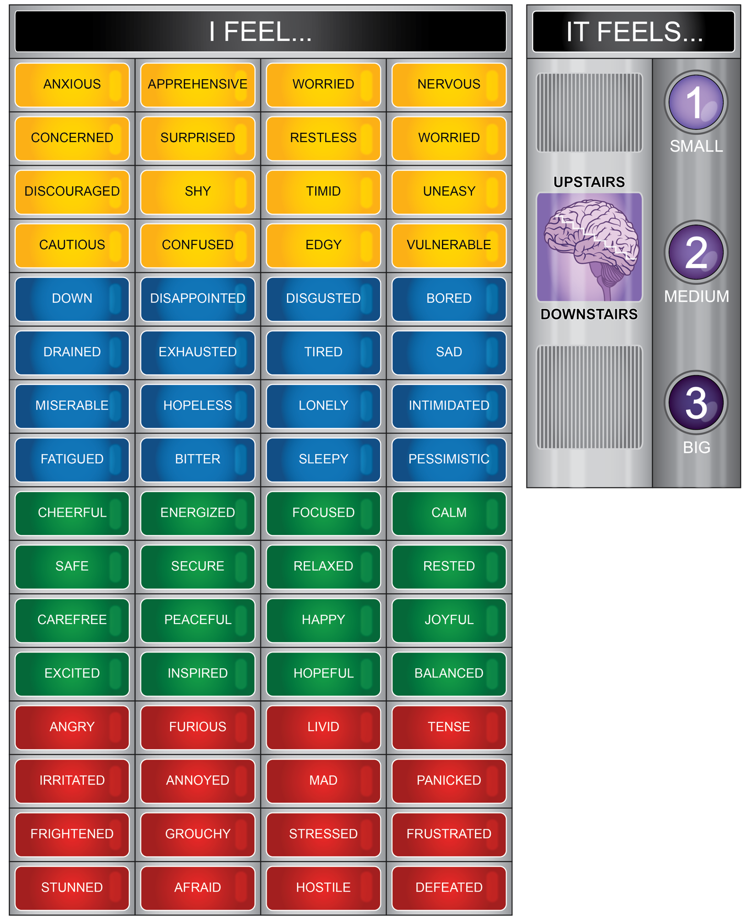

Attachment 2.1b: Recognizing Emotions and Feelings
Part I. Can your recognize big, overwhelming feelings, and urgent warning signs

1. ____ Is the part of the brain that is regulated and can execute thoughtful decisions and actions.
- Upstairs
- Downstairs
2. The ________ brain is activated when we experience a big emotions or overwhelming feeling.
- Upstairs
- Downstairs
3. ______Feelings that are difficult to control or regulate that might lead to thinking or acting in unhealthy or unsafe ways.
- Big emotions
- Overwhelming feelings
- Urgent warning signs
4. ______Feelings that hang around for a long time and change the way we feel and act.
- Big emotions
- Overwhelming feelings
- Urgent warning signs
5.______Someone is trying to hurt, injure or kill themselves
- Big emotions
- Overwhelming feelings
- Urgent warning signs
6.______Feelings that change the way we act for an extended period of time
- Big emotions
- Overwhelming feelings
- Urgent warning signs
7._____ When you recognize urgent warning signs you MUST….
- Tell a trusted adult
- A behavioral health professional
- Call 911
- Any of the above would be appropriate.
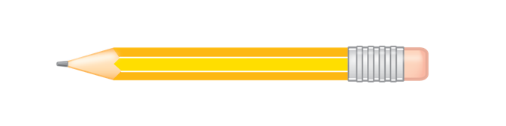

Part II. Identify the feeling for each situation and if you recognize a big, overwhelming or urgent sign.
Situation | Feel (I feel ____ because) | Recognize | Reach Out
- You just found out you were not cast for the part you wanted in the school play. |  | Big | Trusted Adult  Resource
 |  | Overwhelming
 |  | Urgent
- A classmate seems to be very upset lately. They lashed out and you and today you saw them crying by their locker. |  | Big | Trusted Adult  Resource
 |  | Overwhelming
 |  | Urgent

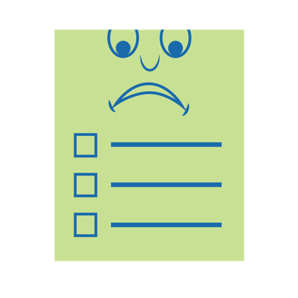

Attachment 2.2: Awareness of ME Notes
Part I. Emotions, Feelings, and Mood
 | Emotions | Feelings | Mood
Duration | Short (seconds) | Moderate (minutes)
Intensity |  | Moderate
Causes | Specific response to external stimuli (events or objects) |  | General and unclear at times
Effects

Part II. Recognize Big Emotions, Overwhelming Feelings, and Urgent Signs
 | Big Emotions | Overwhelming | Urgent Warning Signs
Description
How to get help? | Reach out and use resources:  - Talk with a trusted adult  - Practice self-care  - Use health information and resources | Seek help of a trusted adult or mental health professional | Call 911 and seek the help of a trusted adult or medical professional immediately

Attachment 2.3: Regulation Tools and Strategies
Define each category of self-regulation and give an example.
Emotional self-regulation | Define
 | Example
Behavioral self-regulation | Define
 | Example
Cognitive self-regulation | Define
 | Example

Self-Regulation for ME
Directions. List a feeling word from Attachment 2.1 for each color. Describe a regulation strategy, tool or resource you would use if you had a strong feeling for that feeling for that color or word.
 | I feel…. | Self-Regulation Strategy
Red
Blue
Yellow
Green

Attachment 2.4: Feel, Think and Act Scenarios
Situation | Feeling | Type  (Circle) | Brain | Think and Act
 |  |  |  | Unhealthy | HEALTHY
I got a new game that I can’t wait to play. |  | Everyday | 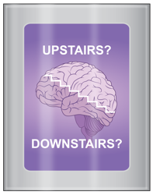
 |  | Overwhelming
 |  | Urgent
A friend said they’re just tired of everything and wish they were not here anymore. |  | Everyday
 |  | Overwhelming
 |  | Urgent
Another student in your class is calling you hurtful names and has threatened to hit you. |  | Everyday
 |  | Overwhelming
 |  | Urgent
I didn’t sleep much last night. |  | Everyday
 |  | Overwhelming
 |  | Urgent

