**Lesson 1: What Is Mental and Emotional (ME) Health?**

**Overview:** Students will describe the characteristics of mental and emotional (ME) health as how we feel, think, and act. Students will understand the interrelationship with other dimensions of wellness. Students will practice identifying feelings as well as strategies and additional activities that promote ME health.

National Health Education Standards:

**Standard 1:** Students comprehend functional health knowledge to enhance health.

**Standard 7:** Students demonstrate observable health and safety practices.

Healthy Behavior Outcome (HBO):

|  |
| --- |
| Students will demonstrate observable health and safety practices to strengthen their mental health. |

**Lesson Objectives** - Students will be able to:

|  |  |
| --- | --- |
| **Objective** | **Assessments** |
| 1. Define mental and emotional (ME) health and the interrelationship among other components of health (physical, social, intellectual, and overall well-being). | Attachment 1.1 – MEH Notes |
| 1. Describe feelings and emotions and how they relate to how we think and feel. | Attachment 1.1 – MEH Notes |
| 1. Identify activities and strategies that strengthen and promote ME health when faced with a challenge. | Attachment 1.1 – MEH Notes  Attachment 1.3 – Strategies for ME |
| 1. Demonstrate a practice or strategy that enhances mental and emotional health. | Attachment 1.3 – Strategies for ME |

Lesson Prerequisites or Assumptions:

* This lesson examines emotions, feelings, and actions. Connect with your school’s behavioral health services and resources to identify how students can reach out to those services and resources. Ensure that school mental health staff is aware of the Behavioral HELPs lessons.
* Build a connection with school behavioral health staff so they are ready and available to support students’ who experience strong feelings or need additional supports/resources.
* It is also helpful to share parent and family education resources (see HELPs Parent Education Handout) so trusted adults are more aware of how they can support mental and emotional health.

Introduction:

* Today’s lesson addresses mental and emotional health. If you are having feelings, emotions, or thoughts you should feel comfortable to reach out to me or a trusted adult at school. (Remind students of your procedures if students need to use a regulation or mindfulness tool or strategy.)
* Reminder students of your classroom expectations and norms to create a safe supportive environment. (INSERT your procedures here)
* Today we will be defining mental and emotional (ME) health; looking at ME health and the interrelationships among other components of health; and demonstrating self-care activities that strengthen our ME health. Our goal in each lesson is to develop the tools and skills to strengthen our ME health. We will showcase our work in Lesson 10 when we create a ME Health Toolkit.
* How would you define ME health?
  + Have students share their answers.

Teaching Steps

Activity 1 – What is ME Health

* Distribute Attachment #1 - ME Health Notes
* What is mental and emotional health?
  + Formal definition from ([SAMHSA, 2023](https://www.samhsa.gov/mental-health)) - ME health includes our emotional, psychological, and social well-being. It affects how we think, feel, and act, and helps determine how we handle stress, relate to others, and make choices.
  + Mental health is important at every stage of life, from childhood and adolescence through adulthood. Over the course of your life, if you experience mental health problems, your thinking, mood, and behavior could be affected.
  + A user-friendly definition is that mental health is how we feel, think and act ([Wisconsin, 2023](https://dpi.wi.gov/sites/default/files/imce/sspw/pdf/Suicide_Prevention_Curriculum_9_12.pdf)). It helps determine how we handle stress, relate to others, and make choices.
  + Mental health is important at every stage of life from childhood and adolescence through adulthood. ME health includes our emotional, psychological, and social well-being. Your mental and emotional health impacts your thinking, mood, and physical health; it can also affect behavior.
  + Mental and emotional health is about your strengths, abilities, talents, and needs.
  + To enhance and support our mental and emotional health, we will recognize, reach out, and use our resources.
    - Recognize our feelings and emotions and how they influence how we think and act.
    - Reach out to trusted adults and mental health resources to support how we feel, think, and act.
    - Use resources including trusted adults and mental health resources and strategies.
    - There are times when we recognize our health and wellness are not optimal. What do we do when our physical health is not OK?
    - Reach out and seek help from a trusted adult, doctor, or other professional who can support me.
  + What should we do if our mental and emotional health is not OK?
    - Reach out and seek help from a trusted adult, doctor, or other professional who can support me.
    - We can also take steps to support ME. These might be activities or specific strategies for ME. In our ME lessons, we call them “recharge” or “activities that strengthen ME.”
  + How could we help someone who isn’t feeling the best about their mental and emotional health?
    - Reach out, listen, and demonstrate empathy. Be kind, nonjudgmental, and supportive.
    - We can also use this relationship to enhance our health. For example, we can use physical activity to enhance our physical health and in turn enhance our mental health. We can talk to friends to support our mental health. Ask students to think and share other examples.
  + How does our ME health impact other components (e.g. physical, social, intellectual) and overall health and wellbeing?
    - Our ME health is the foundation for all other health behaviors. Our ME health can have a positive or negative impact on other aspects of health. Other aspects of our health and wellness can impact ME. Let’s brainstorm a list of examples of the relationship between ME and other aspects of health and wellness.
  + Can you share how an emotion or feeling that would influence how we think or act?Example(s)
    - A referee makes the wrong call that costs the team the game.
    - Someone is sharing a rumor about you.
    - You found out a friend is moving to another school.
    - You had the highest score on the quiz.
  + Discuss the answers of feel, think, and act. Then ask what you could do to be sure to do to think and act in healthy and safe ways:
    - Recognize when we need support of others.
    - Reach out and talk to someone.
    - Resources – connect to resources like trusted adults, teachers, counselors, and community resources like 988, text and help lines.
    - Recharge – try an activity that enhances ME!

*Activity 2:* Recognize ME: What are your Feelings & Emotions

* Our mental and emotional health is how we think, feel and act ([Wisconsin, 2023](https://dpi.wi.gov/sites/default/files/imce/sspw/pdf/Suicide_Prevention_Curriculum_9_12.pdf)).
  + *Feelings and emotions* are
    - Everyone experiences emotions but how we experience them and respond to them are up to each person.
    - People experience a wide range of feelings and emotions.
    - Feelings are not good or bad or positive or negative, but feelings give us information that we can pay attention to so we can think and act in health and safe ways.
    - It’s important to understand emotions and feelings because they can impact how we act. We want to be sure we act in ways that are healthy and safe.
  + *Thoughts* occur when our brain is at work to process information to help us learn, progress, and navigate life and its decisions.
  + *Actions* are behaviors or decisions using our mind and bodies.
* Lessons 2 and 3 will address thoughts and actions. Lesson 1 will target how we talk about our mental health, particularly our feelings and emotions.
* Let’s practice identifying and describing different emotions. The Feelings Index (Attachment 1.2) will help us describe our feelings. Describing our feelings and emotions will help us talk about them and make us aware of how people around us are feeling.
  + Step 1: Recognize feelings
    - When we recognize feelings, we use a word from our feelings vocabulary in the Feelings Index (Attachment 1.2) and then use an adjective to describe the strength of the feeling.
    - It is also helpful to recognize what might be causing you to feel this way.
    - *Example –* I’m feeling really (Level 3) tired because I stayed up late to ______.
  + Sometimes we can’t find exactly the right word to share our emotions or feelings; that’s why the wheel organizes them into categories
    - Green – I’m ready to go. I feel calm, ready, and focused.
    - Blue – I’m feeling sad or moving slowly; I need some help to get going.
    - Yellow – I’m feeling cautious or worried. I also need some help to accomplish what I want or need to do.
    - Red – I’m feeling frustrated or angry. I don’t feel in control, and I need some help getting control.
  + Step 2: Describing Feelings
    - We can use a scale to describe the strength or size of our emotions. The range is between 1 and 3. Level 1 feelings are smaller, so I can think and act in healthy and safe ways using my upstairs brain. At the top of the scale is 3, or big feelings. Big feelings are when I am unable to control how I think and act because I’m using my downstairs brain. When I’m at Level 2, I should watch my feelings and use my tools, strategies, and resources to think and act in healthy and safe ways. In Level 2, I need the support of my tools and can reach out for help or support if needed.
  + When we are describing feelings, we use the following steps (See Attachment 1.1, Part III)
    - I feel ________ (feeling word). This feels (small, medium, or strong)
    - I feel this way because _____________.
      * Think about what tools or people could help you think and act in healthy ways.
      * Practice describing how you would feel for each situation (See Attachment 1.1, Part III):
        + A referee makes a wrong call, and it costs the team the game.
        + You have a test coming up, and you are unsure how you will do.
        + You missed your alarm, and now you’re late for school.
        + You had the highest score on the quiz.
  + There are times when we recognize our feelings or health are not at their best or we need help to think and act in ways that are healthy and safe.
  + What do we do when we need help with our physical health or when we need help making healthy choices? (refer to Behavioral HELPs Substance Use Prevention Lessons)
    - Reach out and seek help from a trusted adult, doctor, or other professional who can support me.
    - What should we do if recognize our feelings and thinking or our mental and emotional health is not at its best, we’re not feeling ok, or we might act in a way that is unhealthy or unsafe?
    - Reach out and use our Resources to support our mental health.
      * Our resources could be a trusted adult, a friend, mental health professional or even tools that help us manage our feelings so we can think and act in healthy ways.
      * In our future lessons we’ll learn more about how to reach out and use a variety of resources to support ME (our mental and emotional health). We will also learn more about overwhelming feelings and urgent signs that someone needs support for their mental health. Remember, if you recognize you feel you need support or help with your mental health you can reach out and use your resources.
    - We will also learn how to support and advocate for mental health. We’ll learn to be kind and reach out, listen, and let them know a trusted adult can help them.

Activity 2: Around the Room - Practice ME Health Activities

* We can also take steps to support ME health. These activities are all tools, strategies, and resources that help to enhance our health. They can be called self-care activity and in our ME health lessons we call them recharge or strengthen ME activities.
* Today you will have the opportunity to practice some self-care activities that you may find helpful or not so helpful. You will not stay at an activity for more than 5 minutes, during that time you will describe how you feel during the activity and rate its usefulness to enhancing your health. So, if it is not your favorite, give it a try and the next station will hopefully be one you like better.
* Explain and model your ME health activities.
* Share Attachment 1.3 and explain how to complete the worksheet.
* Name the station. Complete the station activity. Then answer the three questions for each station.
* When you finish the stations be sure to identify three activities you can use to support ME health. They can be activities you used today or any activities that support ME.
* Brainstorm/Journal activity – Can you think of feeling you had and how you used an activity or resource to help you think and act in healthy ways?
  + I was really upset this morning, but I listened to my favorite music, and I felt a little calmer.
  + I was nervous about the test, but I took a deep breath, and I felt a little more relaxed.
  + *Other answers might be* Ask for help; talk to trusted adults, such as a parent/guardian, counselor, coach, faith leader, teacher, etc. Positive self-talk/mindset, belief in yourself, exercise, proper nutrition, mindfulness activities (ex. deep breathing), self-care activities, adequate sleep, setting goals, staying connected with others, building and strengthening relationships, showing gratitude, participating in acts of kindness, exploring sense of purpose, prosocial (doing something to benefit, help or care for someone else because you believe that other people’s feelings and experiences are important) behaviors such as, showing kindness by speaking gently to someone or considering their feelings, comforting someone who’s sad or hurt, sharing with others, donating money, volunteering time, offering to help someone, cooperating with other people in a game or task, showing care for animals and the environment, etc.

Closure:

* Give each student a post it note and have them write which strategy they will put into action this week to strengthen their MEH. Have students share the strategies on the board.
* Ask Students - *What are examples of self-care activities?* 
  + Possible Answers - activities you enjoy like listening to music, painting your nails, talking with friends, exercise, cooking, coloring, journaling, reading, etc.
* Ask Students - *Why are self-care activities important?*
  + Possible Answers - Self-care activities provide a sense of calm; helps us to refocus; alleviates anxiety; helps to redirect thoughts; allows us to be present in the moment; etc.
  + *Note.* [*Erika’s Lighthouse Self Care Video*](https://vimeo.com/564760627/1649a8d75b) *- In addition to teens talking about the self-care activities they participate in; this video clip also references depression and provides suicide prevention resources.*
* What did you feel during the MH activities?
* Did you feel any different after the activities?
* So why would it be important to use activities, tools, and resources for ME health?
* Now what activities would you use to enhance ME health?

**Lesson Resources:** These are additional materials outside of the Behavioral HELP Mental Emotional Health (MEH) Curriculum that provide information that supports the development or implementation of the lesson.

* + [Mental Health Journal](https://www.erikaslighthouse.org/wp-content/uploads/2020/07/ELH-Intro-to-Mental-Health_Journal.pdf)
  + [Glitter Jar](https://blissfulkids.com/mindfulness-kids-teens-calming-glitter-jar-aka-mind-jar/)
  + <https://www.samhsa.gov/mental-health>
  + <https://www.samhsa.gov/mental-health/how-to-talk/people-with-mental-health-problems>
  + <https://copingskillsforkids.com/blog/using-shapes-to-teach-deep-breathing>

Attachment 1.1: Mental Emotional Health (MEH) Notes

1. Define three elements of ME health.
2. Describe how ME health impacts another component of health and wellness.
3. List three “R” activities that can enhance mental and emotional health.

**Directions:** Complete each statement to recognize the color, feeling, and reason. Look at the Feelings Index to determine the color and feeling. In the “Because” column, add the reason you would feel this way.

1. A referee makes the wrong call that costs the team the game.

|  |  |  |
| --- | --- | --- |
| **Color** | **Feeling** | **Because…** |
|  | I am feeling ________________________ |  |

1. You have a test coming up, and you are unsure how you will do.

|  |  |  |
| --- | --- | --- |
| **Color** | **Feeling** | **Because…** |
|  | I am feeling ________________________ |  |

1. You missed your alarm, and now you’re late for school.

|  |  |  |
| --- | --- | --- |
| **Color** | **Feeling** | **Because…** |
|  | I am feeling ________________________ |  |

1. You had the highest score on the quiz.

|  |  |  |
| --- | --- | --- |
| **Color** | **Feeling** | **Because…** |
|  | I am feeling ________________________ |  |

**Directions.** Use your Feelings Index to practice describing how you are feeling. Choose an emotion in each color category and write it in the first column. In the next column, use the statement provided to describe situation that would make you feel this way.

|  |  |
| --- | --- |
| **Color**  Happy | I am feeling ________________because ________________.  *I am feeling happy because it is Friday, and I have big plans for this weekend.* |
| **Red** |  |
|  |
| **Blue** |  |
|  |
| **Yellow** |  |
|  |
| **Green** |  |
|  |

Attachment 1.2a: Feelings Index

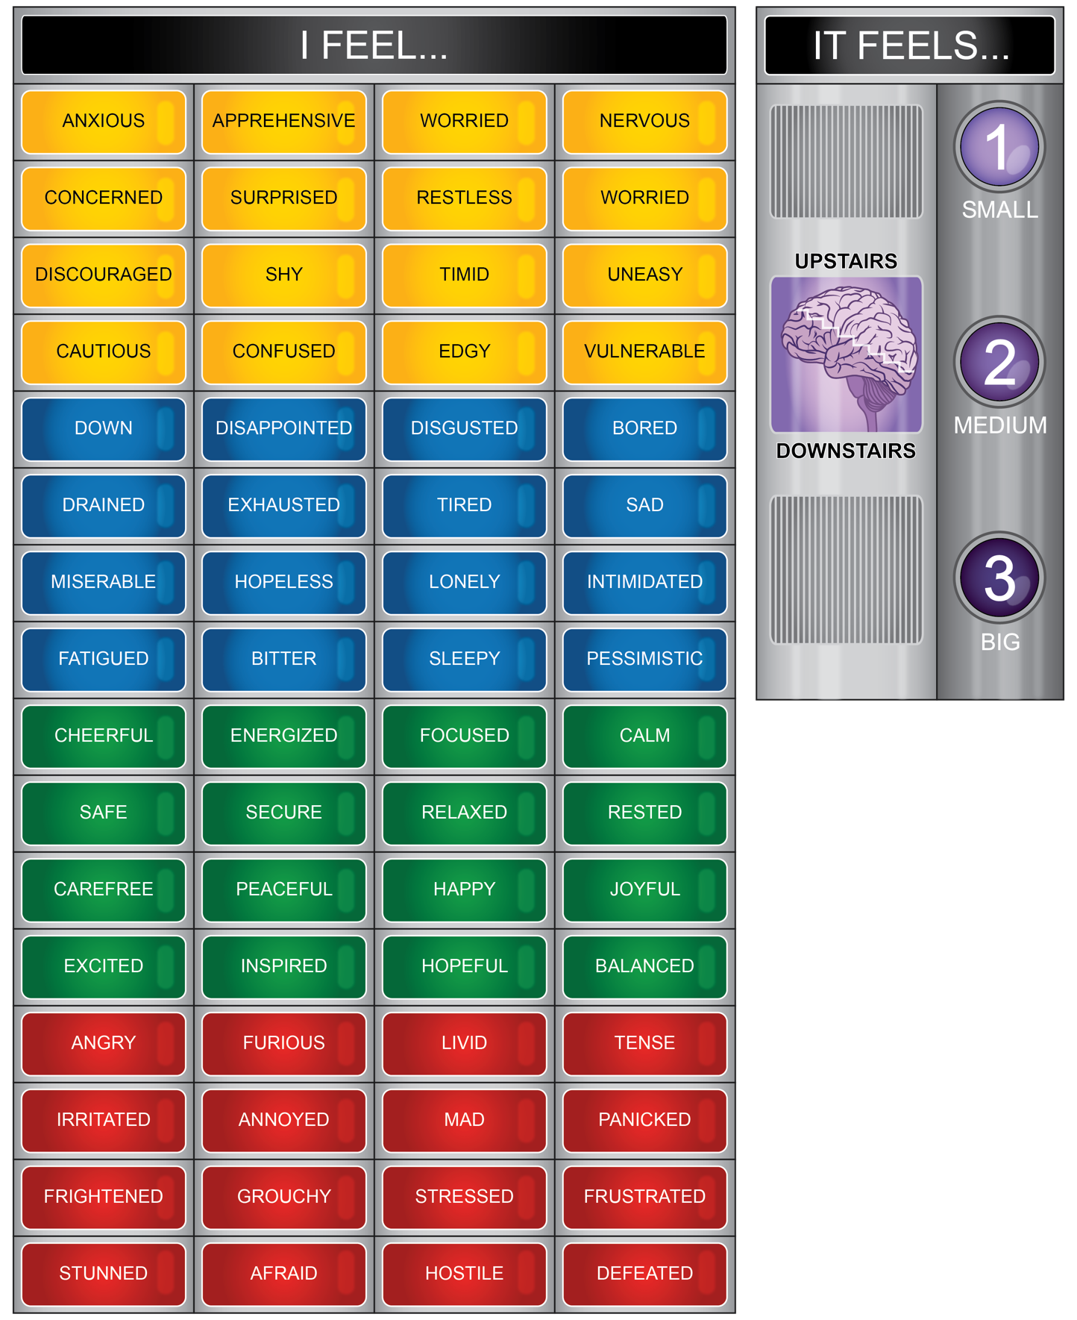

Attachment 1.3a: Mental Health Resilience Strategies Worksheet

**Directions:**

*Write the name of the station in the shaded box above each section. Then answer the three questions for each station. You can use a feeling word or color to best describe how you felt.*

*When you finish the stations, identify three activities you can use to support ME health.*

|  |  |  |  |
| --- | --- | --- | --- |
| **Station 1:** | | **Station 2:** | |
| I feel _______ when using this station. | | I feel _______ when using this station. | |
| I would use this station feeling….. | | I would use this station feeling….. | |
| I would use this station again. | Yes | I would use this station again. | Yes |
| No | No |
| **Station 3:** | | **Station 4:** | |
| I feel _______ when using this station. | | I feel _______ when using this station. | |
| I would use this station feeling….. | | I would use this station feeling….. | |
| I would use this station again. | Yes | I would use this station again. | Yes |
| No | No |
| **Station 5:** | | **Station 6:** | |
| I feel _______ when using this station. | | I feel _______ when using this station. | |
| I would use this station feeling….. | | I would use this station feeling….. | |
| I would use this station again. | Yes | I would use this station again. | Yes |
| No | No |

*List three activities you would use for your ME health.*

|  |  |
| --- | --- |
| **When I am feeling …**  (List feeling) | **I will …**  (List activity) |
|  |  |
|  |  |
|  |  |

Who is a trusted adult you can talk about your feelings and mental health?

**Attachment 1.4a: Favorite Song List**

Make a music playlist that brings your spirits up and motivates you. These should be uplifting, positive songs. Listen to this playlist when you’re feeling down!

|  |
| --- |
|  |
|  |
|  |
|  |
|  |
|  |
|  |
|  |
|  |

Attachment 1.4b: Writing Prompts

**Directions:** *Pick a writing prompt below to journal or you can do your own free writing. This journal does not have to be turned in.*

Writing Prompts:

* What makes you happy in the morning?
* Write down 3 things you love most about yourself.
* Where do you see yourself 5, 10, or 15 years from now?
* Write down things you would like to improve in your life and what action you can take to improve each one.
* Write down things you should cut back on in your life. For example, junk food, binge-watching TV, amount of time spent on social media, etc.
* Write about one of the happiest moments in your life.
* Who are the people that make you feel happy? What is it about them that brings joy to your life?
* Describe what a perfect day looks like to you.
* When was the last time you did something that made you feel good? What was the action you took that brought you these positive feelings?
* When was the last time you did something kind for someone else? What was the act of kindness you did for them?
* **Journal** – Write your reflection below; you can use the space on the back of the paper as well.

Attachment 1.4c: *Yoga Pose Ideas*

**Safety Tips** - The pose should not cause pain or tension; only try poses you feel comfortable doing. If a pose shows one side of the body being used, remember to do the other side as well. Remember to breathe in and out during each pose you participate in.

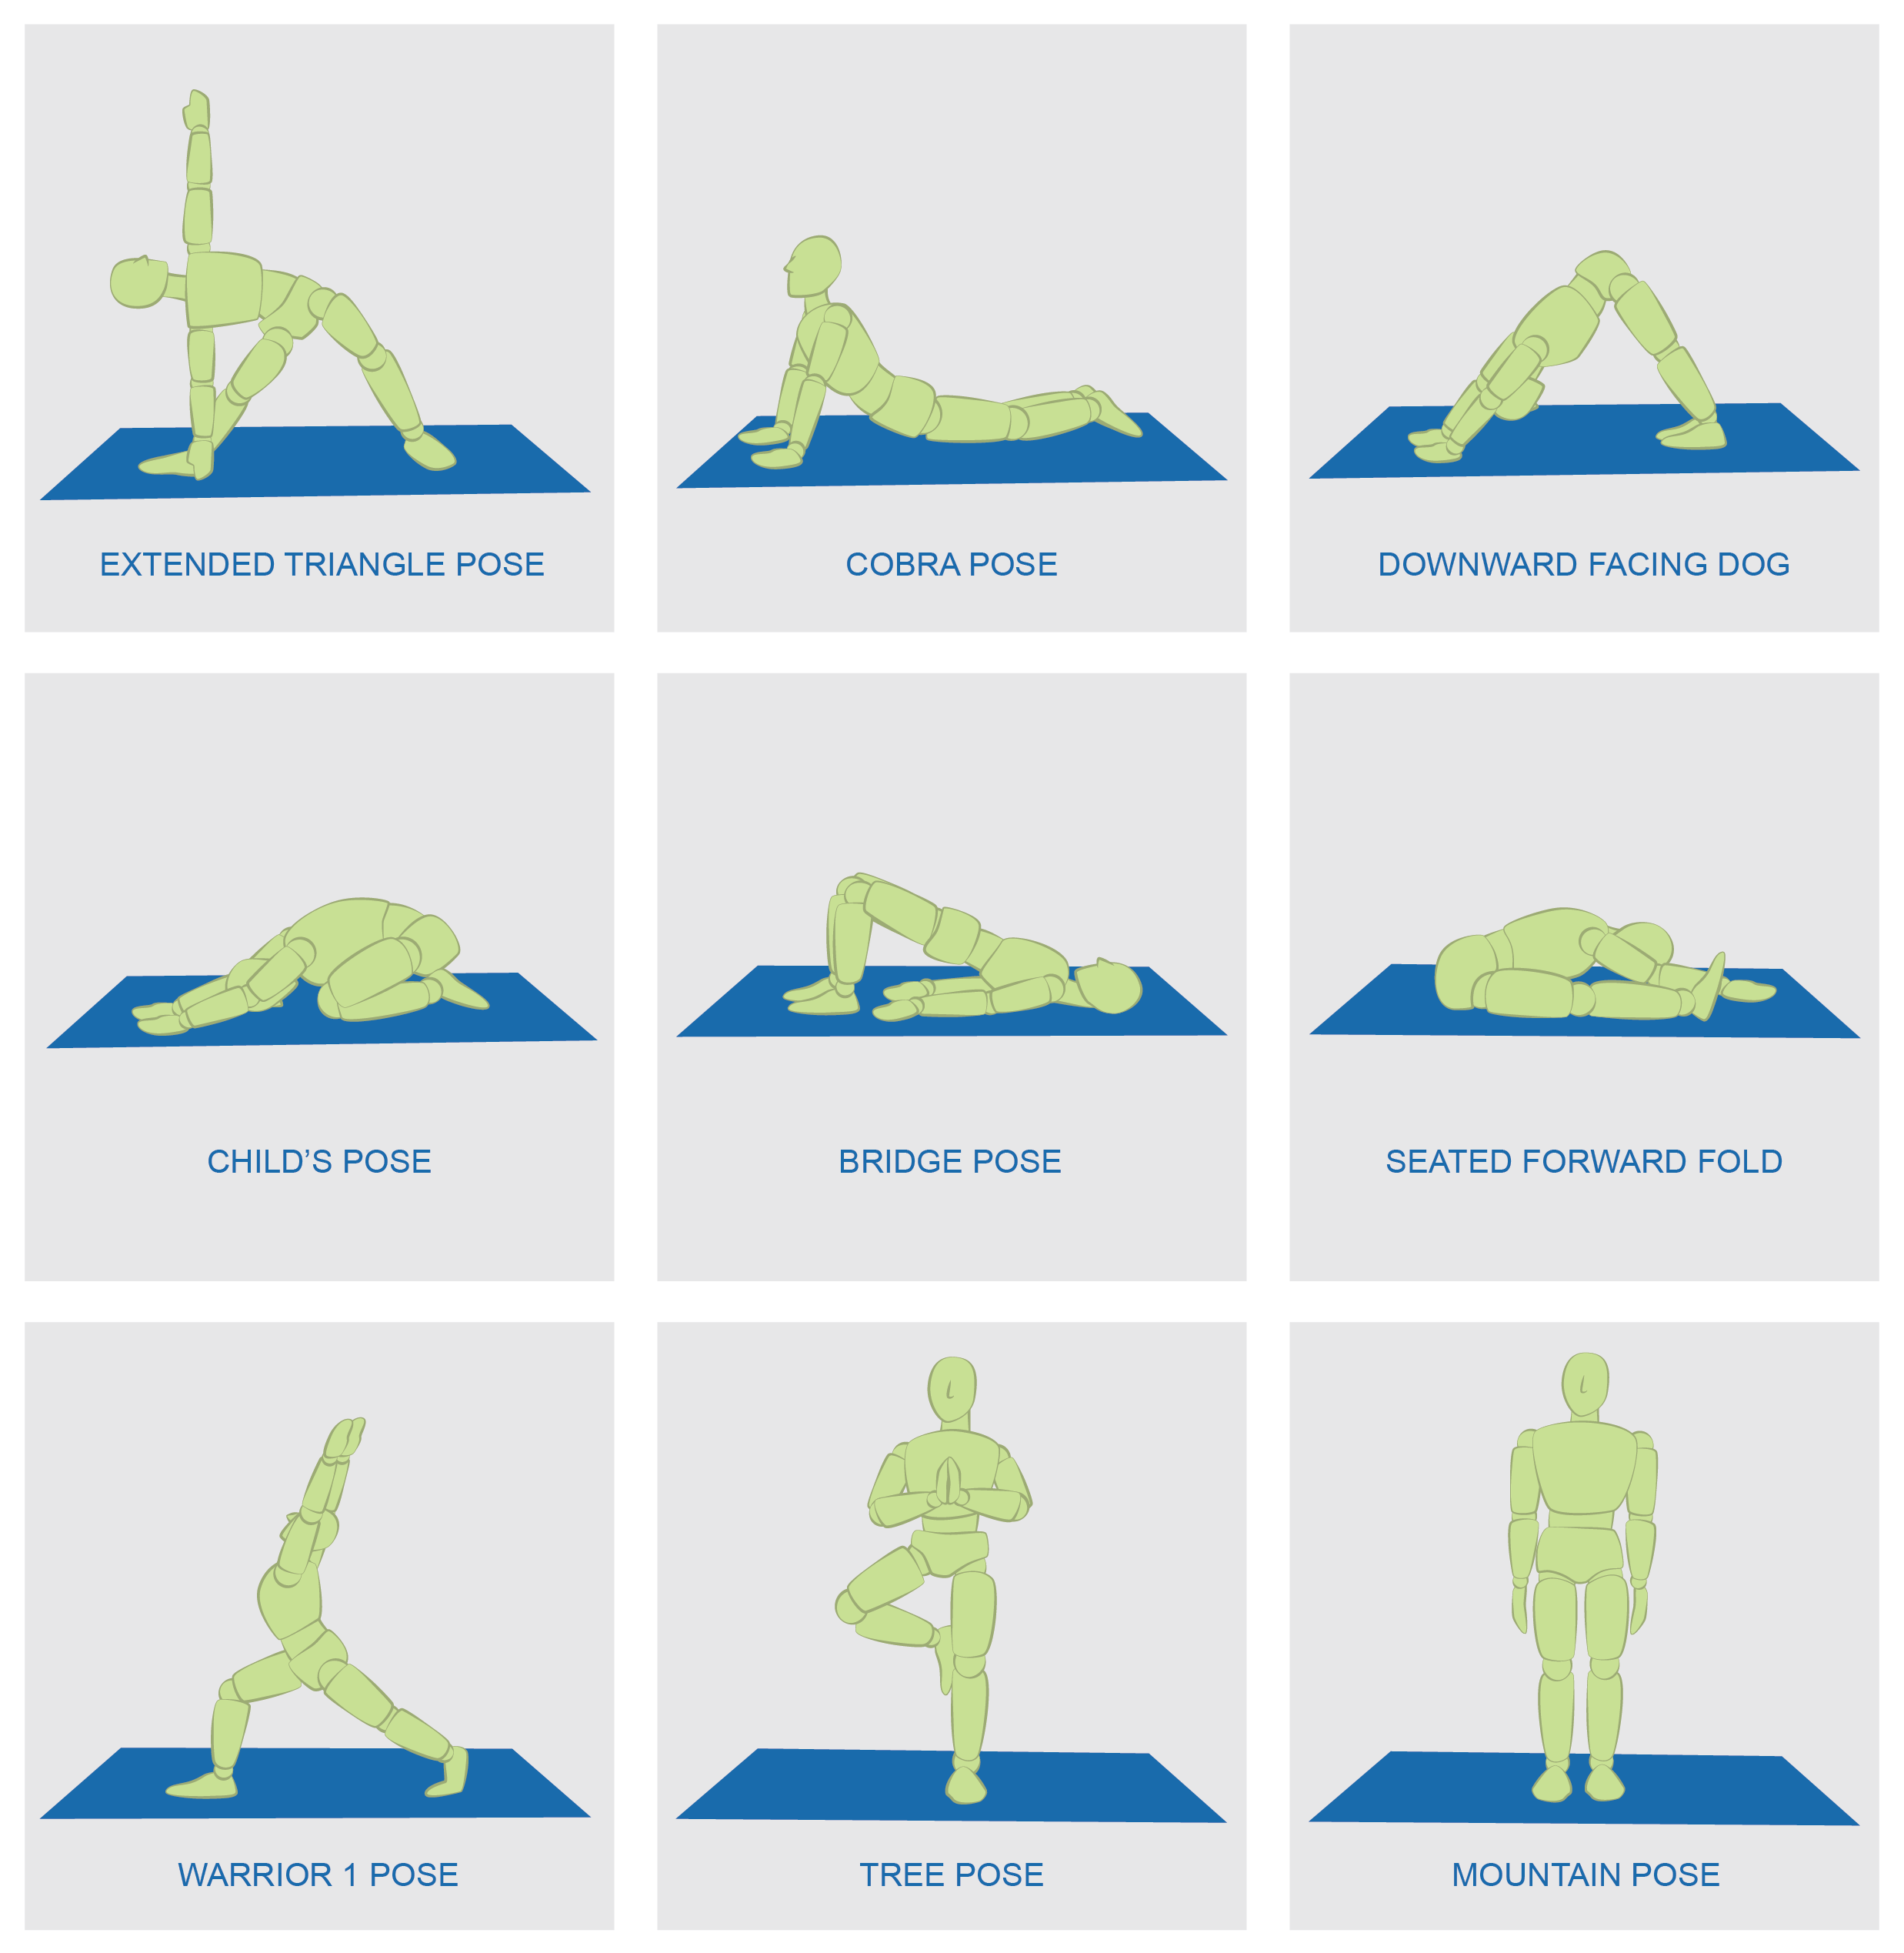

Attachment 1.4d: Discussion Topics

* What’s been the best part of your day so far?
* What book are you reading right now? If they haven’t had time for reading lately, ask them to share the last great book they read or what titles are on their list for the future.
* What’s the last thing you bought online that you really loved?
* What would be your perfect weekend?
* What’s something (besides your phone) that you take with you everywhere?
* What’s the last great show you binged?
* If you started a business, what kind would it be?
* What’s your favorite season and why?
* What’s your hidden talent?
* What’s your favorite restaurant or favorite food?
* Who is your favorite singer/actor/sports personality?
* What’s the best birthday gift you’ve ever received?
* What would be your dream vacation?
* What person in your life brings you the most joy?
* What is your favorite subject in school?

Attachment 1.4e: My Positive Action

**Directions:** For each of the statements below, describe a positive action you would take to keep your mental emotional health balanced.

1. If someone hurt my feelings, I would…
2. If I was thinking about joining an after-school activity, I would…
3. If I failed a test, I would…
4. If my partner broke up with me, I would…
5. If I experienced troublesome feelings (anxious, depressed, upset, overwhelmed, etc.), I would…
6. If I was starting my first job, I would…

**Attachment 1.4f: Breathing Exercises**

* Start at the bottom left of the triangle.
* Breathe in for three counts as you trace the first side of the triangle.
* Hold your breath for three counts as you trace the second side of the triangle.
* Breathe out for three counts as you trace the final side of the triangle. You have just completed one deep breath.

[**https://copingskillsforkids.com/blog/using-shapes-to-teach-deep-breathing**](https://copingskillsforkids.com/blog/using-shapes-to-teach-deep-breathing)

* Start at the bottom right of the square.
* Breathe in for four counts as you trace the first side of the square.
* Hold your breath for four counts as you trace the second side of the square.
* Breathe out for four counts as you trace the third side of the square.
* Hold your breath for four counts as you trace the final side of the square.

* Start at any “Breathe In” side on the star.
* Trace your finger over the breath inside of the point.
* Hold your breath when your finger gets to the tip of the point.
* Breathe out as you trace your finger over the other side of the point.
* Keep going until you reach where you started.
* When you trace the whole star, you will have completed 5 deep breaths.

* Start with the 8 on its side and start in the middle.
* Go up to the left and trace the left part of the 8 with your finger while you breathe in.
* When you get to the middle of the 8 again, breathe out while you trace the right part of the 8 with your finger.