Lesson 4: It’s ME

Overview: Students will apply what they’ve learned in the first three lessons to share and awareness of ME, activities that strengthen ME, skills recognize, reach out and use resources that support ME.
National Health Education Standards
Standard 1: Students will comprehend concepts related to health promotion and disease prevention to enhance health.
Standard 4: Students will demonstrate the ability to use interpersonal communication skills to enhance health and avoid or reduce health risks.
Healthy Behavior Outcome (HBO):
MEH HBO 2 | Engage in activities that are mentally and emotionally healthy.

Lesson Objective- Students will be able to:
Objective | Assessments
- Use positivity to enhance emotions and feelings. | Attachment 4.1: Activity for ME Check-in
- Recognize different emotions and feelings | Attachment 4.2: Toolkit for ME  Attachment 4.3: Show What you Know
- Identify trusted adults that can support mental and emotional health. | Attachment 4.2: Show What you Know
- Identify a useful strategy when experiencing a big emotion. | Attachment 4.2 Toolkit for ME

ME Activity:
- Explain: “We are going to practice use another tool to promote ME – Positivity. First, I will show you what the tool looks like, then we will do it together and finally you will show me how to do it. Be slow and calm as we practice this tool.”
- Be Positive! helps kids to gain confidence, contributes to a growth mindset, helps kids to truly believe in themselves, and helps you to be positive. Looking to the positive, even when faced with a challenge, can help ME health.
- Let’s practice being positive by saying something positive instead of negative. Instead of “I can’t.” You can say….
- We can also use positivity to take a negative thought and change them into a positive. Let’s practice it in a new situation can you take this statement and make it positive?
- I can’t do that it looks to hard… try to say, “It looks really hard, but I’ll do my best.”
- Great job of being positive! We’ll keep working on being positive and in this lesson, we’ll also practice using communication to enhance our mental health.
Introduction:
- We’ve developed an awareness of ME; how to strengthen ME by using strategies to enhance ME or regulating our emotions and behaviors; how to support ME by recognizing, reaching out, and using resources to help ME. Today’s lesson will apply what you’ve learned so far.
Teaching Steps:
Activity 1: “Tools for ME”
- We’re going to collect the tools we’ve learned during our lessons into a toolkit we can use to strengthen our mental and emotional health. Our toolkit has four sections:
- Recognize – One tool is to recognize my thoughts, feelings, and emotions. There is also a tool that helps me recognize everyday and overwhelming feelings.
  - Add two feelings you recognize for each color (e.g. green – happy, calm).
  - Choose one feeling word and complete this sentence. I feel ___ because….
  - Students can choose any feeling but thing about a situation or reason you felt that way.
    - I feel happy because I played with my friends.
- Resources – These tools can be activities or people who can help me. These tools are activities that can help me be positive, recharge my mental health or resources who can help me at home, school, and in the community with my mental health.
  - We learned to:
    - Calm, Move, Think, and Distract.
    - Students can write a color under each one of those actions.

- Reach Out – These tools help to ask for help from trusted adults and resources who can help me.
  - I have to read a sentence to the entire school today for our assembly.
    - I feel ____________.
    - Recognize - Is this an emotion, everyday feeling, or overwhelming feeling?
    - Think: What can I do to support me? Choose a strategy or activity that might help.
    - Who would you talk to if you needed help with how you are feeling?
    - Choose a healthy way to respond to this situation. Remember your resources that include tools, skills, and trusted adults.
Activity 2: Show what you know about ME health
- Complete the knowledge check-in first and then review the answers.
- Then have students complete the Skill check. Remind them this is how confident they feel about each statement.
  - Review the answers.
Closure:
- What is mental and emotional health?
  - It is how we feel, think, and act.
- Why is mental and emotional health important to me?
  - It impacts our health and well-being. It is how we feel, think, and act.
- How can you support your mental and emotional health?
  - Know about mental and emotional health including our feelings and emotions. Use activities that strengthen mental and emotional health. Recognize and reach out to resources to support mental and emotional health.

Attachment 4.1: Activity for ME Self-Assessment
___ can ___ positive. | 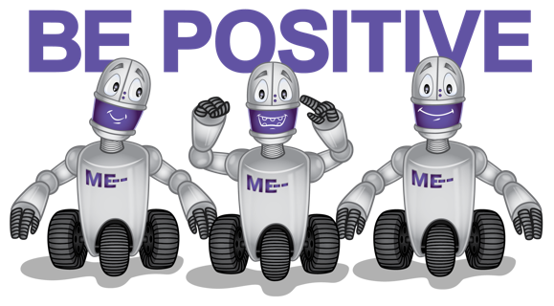

Instead of | I will say…
I can’t | __ can
I am not good enough

When I am positive, I feel _________
Green | Yellow | Blue | Red
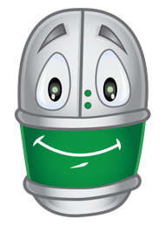 | 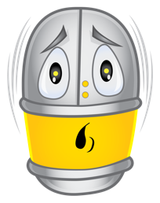 | 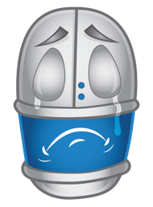 | 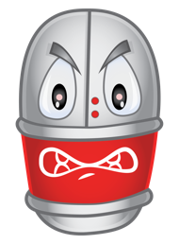

Attachment 4.2: Toolkit for me.
When I have big feeling, I can…. (Circle your answers)
Take a Deep Breath | Move | Distract | Ask for help
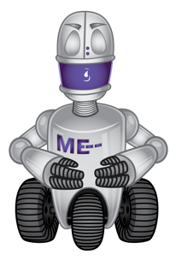 | 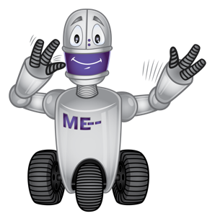 | 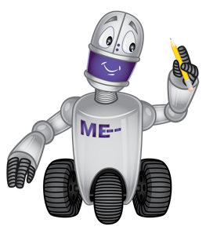 | 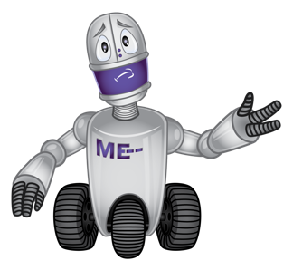

Draw or write the name of a trusted adult who can help you.

Attachment 4.3: Show what you Know
Part I. Knowledge Check
Circle your answer.
- True or False. Everyone has emotions and feelings.

- True or False All emotions and feelings are okay.

What color is each robot feeling?
1 = Red
2 = Blue
3 = Yellow
4 = Green
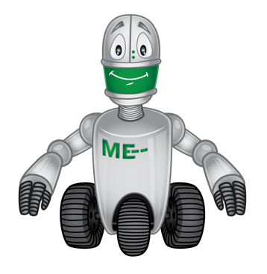 | 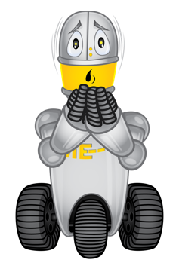 | 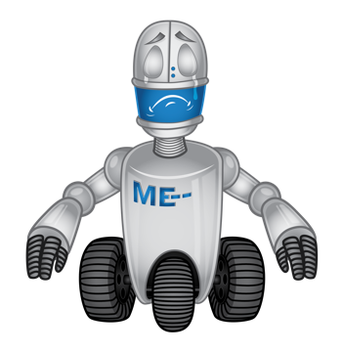 | 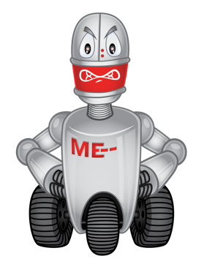
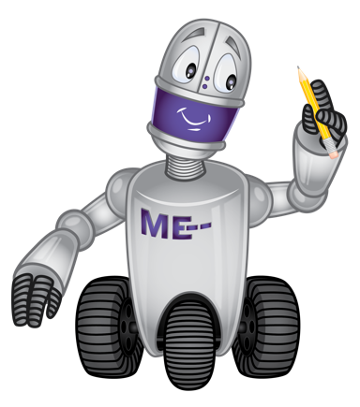

Part 2. Skills Check
I can…. | Always | Sometime | Never
Recognize my feelings. |   Yes |   Maybe |   No
Reach out and share how I feel. | Yes | Maybe | No
Reach out and ask for help. | Yes | Maybe | No
I know a trusted adult who can help me. | Yes | Maybe | No

