**Lesson 2: It’s ME: Feel, Think, & Act**

**Overview:** Students apply their knowledge of feelings and emotions to recognize feeling and understand how feelings are linked to how we think and act. When we recognize big feelings and emotions, we can reach out to resources to be sure we think and act in healthy ways.

National Health Education Standards

**Standard 1:** Students comprehend functional health knowledge to enhance health.

**Standard 3:** Students demonstrate health literacy by accessing valid and reliable health information, products, and services to enhance health.

**Standard 7:** Students demonstrate observable health and safety practices.

Healthy Behavior Outcome (HBO):

Students will engage in activities that are mentally and emotionally healthy.

Lesson Objective – Students will be able to:

|  |  |
| --- | --- |
| **Objective** | **Assessments** |
| 1. Describe emotions and feelings. | Attachment 2.2 – How Do You Feel, Think, and Act? |
| 1. Recognize when help is needed with emotions and feelings. | Attachment 2.2 – How Do You Feel, Think, and Act? |
| 1. Analyze whether emotions and feelings are expressed with healthy or unhealthy actions. | Attachment 2.2 – How Do You Feel, Think, and Act? |
| 1. Identify trusted adults who can help with emotions and feelings. | Attachment 2.2 – How Do You Feel, Think, and Act? |
| 1. Demonstrate a strategy that enhances mental health and recognize the feelings after completing the skill. | Attachment 2.3 – The Big Squeeze |

Behavioral HELPs Reminders

This lesson examines emotions, feelings, and actions. Connect with your school’s behavioral health services and resources to identify how students can connect to those services and resources. It is also helpful to share parent education resources (see HELPs Parent Education Handout in the Teacher Guide) for when students identify overwhelming feelings.

ME Activity:

* **EXPLAIN:** “We are going to practice a calming or regulating activity to calm body and brain/mind. First, I will **show** you what the tool looks like. Then we will **do** it together, and then you will **show me** how to do it. Be slow and calm as we practice this tool.”
* **The Big Squeeze (Attachment 2.3)**
* Choose one muscle group to squeeze. It could be your making your fingers into a fist or curling your toes. We’re going to squeeze, count to five, and then release.
* How does your body feel when you squeeze? What’s the feeling when you let go of the squeeze? Remember to use “I feel _______ because ______________.”
* Let’s try it three more times. If you want, you can try another muscle group. Sometimes I work from my toes up.
* Can you describe how you feel after using this activity?
  + I feel __________ because _____________.
* When might you use this activity?
  + We might use it when we’re feeling anxious or stressed. It’s a good activity to feel the release of tension.

Teaching Steps:

Activity 1: Recognize, Reach Out, and Use Resources

* Review mental and emotional health. Mental and emotional health is how we **feel, think**, and **act.**
* Everyone experiences feelings and emotions, but how we experience them and respond to them is different for each person. People experience a wide range of feelings and emotions.
* **Feelings** give us information that we can pay attention to and learn more about a situation. Feelings are not good or bad or positive or negative.
  + It’s important to recognize and understand emotions and feelings because they can impact how we think and act. We want to be sure we act in ways that are healthy and safe.
* **Thinking** is the work our brains do to help us learn and make good decisions.
* **Actions** are when we make decisions or are how we behave. We need to act in ways that are healthy and safe to help our minds and bodies.
* We’re going to learn how to **recognize** our emotions, **reach out** for help when needed, and use **resources** to help us think and act in healthy and safe ways.
* Let’s review the Feelings Wheel and practice recognizing emotions (see Attachment 2.1).

*Part 1:* Recognize Emotions and Feelings

* (Use Attachment 2.1). Show the emoji and have the students tell you what color then use a feelings vocabulary word. Teacher model how to share feelings – “I feel_____.
* Option – You can integrate math by rolling a dice then counting the numbers together and then sharing the robot emoji.
* Emotions are not always easy to label or recognize with a vocabulary word and you might not know what/why you are feeling a certain way. If you can’t find the feeling word, then you can use the color (e.g. red, blue, yellow or green). We can also use the scale to describe how strong it feels. The scale includes Level 1 (small), Level 2 (watch), Level 3 (big feelings). Sometimes feelings are big when they seem to be difficult to control and might feel like you are unable to think or act in healthy and safe ways.

*Part 2: How do you feel, think and act?*

* Now we’re going to practice recognizing how feelings and emotions impact how we think and act.
* Our brain has an upstairs and downstairs. Our upstairs brain is when our brain is in control, and we can think and play. When our downstairs brain controls our body functions like breathing and heart rate without thinking. The downstairs brain takes over when we experience big emotions so we might not be in control, or we must work to think and act in healthy ways.
  + We can rate our feelings from big (3) to small (1). Big feelings mean we are usually in our downstairs brain, while in a Level 1 we are in our upstairs brain.
  + Some feeling and colors are more likely to feel big like red and blue.
* Complete the remaining column(s) of Attachment 2.2 to determine if the action was healthy or unhealthy and if you need help from a trusted adult (Yes/No).
  + Think about whether your upstairs or downstairs brain would be at work. Give a thumbs up if it is healthy or thumbs down if unhealthy.
    - Example 1 – You lost a video game right before winning the level. You slam the controller down.
    - Example 2 – You are playing tag. You didn’t feel the tag, but the tagger said it they tagged you. You’re frustrated but you say “ok, I’ll be it.”
  + When we are in our upstairs brain, we can control how we think and act.
  + How can I think and act in healthy ways? Can I manage and express my emotions?
    - I can take a breath and think about how we can compromise.
    - I can move my body
    - I can doodle, draw or use a fidget to distract how I’m feeling.
    - I can share how I am feeling.
* Who can help you?
  + Trusted adults. Trusted adults are adults who care about you and are willing to help you. Some of the Trusted Adults in our building include teachers, school counselor, and many others. There are also health professionals like a doctor, nurse and counselor who are trained and ready to help you be healthy and safe.

Closure:

* Great job today recognizing your emotions, thinking about how we can act in healthy and safe ways. Let’s review our zones and the feelings in each color. You can use the robot cards or slides.
* Let’s try our ME activity to see if you can recognize how you feel after using the activity.
  + Squeeze and let go. How do you feel?
* What part of your brain is working when you have big feelings?
  + Downstairs. Why it is important to know your upstairs and downstairs brain?
    - So I can use my upstairs to think and act in healthy ways.
* Think about what you can do to act in healthy ways?
  + I can stop and think, then reach out and use resources.
* What are resources you can use?
  + Move, breath, distract, or think.
  + I can also ask a trusted adult for help

Attachment 2.1: Feelings Wheel

Attachment 2.2: Name that feeling

Directions: Roll two dice and count the number. Show the robot. Students respond with the color, then the word.

|  |  |  |
| --- | --- | --- |
| 1 | 2 | 3 |
| 4 | 5 | 6 |

Show these robots

|  |  |  |
| --- | --- | --- |
| 1 | 2 | 3 |
| 4 | 5 | 6 |

Answer Key:

|  |  |  |
| --- | --- | --- |
| Angry (1) | Confused (2) | Scared (3) |
| Happy (4) | Nervous (5) | Sad (6) |

Attachment 2.3: How do you feel?

|  |  |  |  |  |  |  |
| --- | --- | --- | --- | --- | --- | --- |
| **Story** | **Feeling** | | | | **Size** | **Upstairs or Downstairs** |
| **Column 1** | **2** | | | | **3** | **4** |
| **Green** | **Yellow** | **Blue** | **Red** |
| My birthday is today. |  |  |  |  |  |  |
| I spent recess arguing with my friends about what game to play. |  |  |  |  |  |  |
| I forgot my lunch on the bus. |  |  |  |  |  |  |

Draw or write the name of a trusted adult who can help you be healthy and safe.

Attachment 2.4: Activity for ME: Self-Assessment

I can demonstrate the “Big Squeeze.”

|  |  |
| --- | --- |
| **Critical Elements** | **Check if Yes** |
| Squeeze |  |
|  |  |
| Release |  |

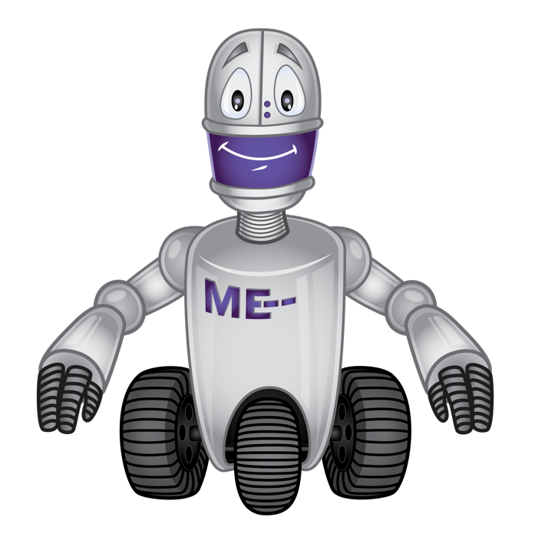

Circle how you feel when you do the Big Squeeze?

|  |  |  |  |
| --- | --- | --- | --- |
| **Green** | **Yellow** | **Blue** | **Red** |
|  |  |  |  |

Would you use this activity again?

|  |  |  |
| --- | --- | --- |
|   **Yes** |   **Maybe** |   **No** |