**Lesson 1: Me and My Feelings**

**Overview:** Students learn how all people experience a variety of emotions every day. Given several different situations, students will identify different feelings. Students learn that we can recognize our feelings, reach out to share our feelings and use resources to support how we feel, think, and act.

National Health Education Standards

**Standard 1:** Students comprehend functional health knowledge to enhance health.

**Standard 7**: Students demonstrate observable health and safety practices.

Healthy Behavior Outcome (HBO):

Students will engage in activities that are mentally and emotionally healthy.

Lesson Objective - Students will be able to:

|  |  |
| --- | --- |
| Objective | Assessments |
| 1. Describe different emotions and feelings. | Attachment 1.2 – Recognize Feelings |
| 1. Demonstrate an activity that promotes mental and emotional health. | Attachment 1.3 – Activity for ME |

Behavioral HELPs Introduction:

* This lesson examines emotions, feelings, and actions. Connect with your school’s behavioral health services and resources to understand how students can connect to those services and resources. Ensure school mental health staff has set time aside to manage student self-referrals and any uncomfortable feelings students may have after this lesson.
* It is also helpful to share parent education resources (see HELPs Parent Education Handout) to have resources and support available when students identify overwhelming feelings.
* This lesson aligns with the concept of “feelings from Erika’s Lighthouse (<https://www.erikaslighthouse.org/portal/>). We suggest using Erika’s Lighthouse to support your students as part of a whole school, whole community approach to provide a safe, supportive culture around mental health.

Lesson Introduction:

* Today’s lesson addresses mental and emotional health. If you are recognize feelings, emotions, or thoughts that you think need help or support, you can reach out to me or a trusted adult at school. (Remind students of your procedures if students need to use a regulation or mindfulness tool or strategy.)
* Remind students of your classroom expectations and norms to create a safe, supportive environment. (INSERT your procedures here)

ME Activity: Dragon Breathing

We’re starting a series of mental and emotional health lessons. You’ll hear me call these ME lessons, which stands for **mental** and **emotional** health, but it’s also because mental and emotional health is about ME. You’ll learn about what ME health is and how it connects to all aspects of your health. You’ll also learn strategies and activities that can enhance ME and your health. Each lesson about ME will have an activity or practice you can use to strengthen your own ME health. Today’s activity is a breathing skill that will help us have a calm body and brain. First, I will **show** you what the tool looks like. Then we will **do** it together, and finally you will **show me** how to do it. Be slow and calm as we practice this tool.

Dragon Breathing ([LINK](https://www.yoremikids.com/news/july-strike-a-pose-dragon-breathing)) Teaching Steps:

* Sit with your legs crisscrossed
* Breathe in through your nose
* Breath out like a dragon but whisper your roar. You can also open your eyes and mouth wide.

Teaching Steps:

**Activity 1**: Getting to know ME: Defining Mental & Emotional (ME) Health

* What is mental and emotional health?
  + ME health is how we think, feel, and act.
  + ME health helps us be happy, healthy, and productive. ME health impacts our overall health. It is also connected to our physical health and social health.
  + Think of mental health as taking care of our minds; think of physical health as taking care of our bodies; think of social health as taking care of relationships with family, friends, peers, and others in your community.
  + ME Health is just as important as physical health. Just as we take care of our bodies by brushing our teeth, being physically active, and eating healthy, we’ll learn how to take care of mental health. Your mental and emotional health impacts not only your thinking and mood; it can also affect your physical health and behavior.
  + While we get to know more about ME health, you’ll learn more about your strengths, abilities, talents, and activities that support ME.

**Activity 2:** Matching Emotions

* Our mental and emotional health is how we feel, think, and act.
  + *Feelings and emotions* are within or inside us.
    - Everyone experiences emotions, but how we experience them and respond to them are up to each person.
    - People experience a wide range of feelings and emotions. Feelings are not good or bad, positive, or negative, but they can give us information that we can pay attention to.
    - Feelings change; they don’t remain the same for too long.
    - It’s important to understand emotions and feelings because they can impact how we act. We want to be sure we act in ways that are healthy and safe.
  + *Thinking* occurs when our brain is working and processing information to help us learn and make decisions.
  + *Actions* are behaviors.
* If we can recognize how we’re feeling it can help us manage those feelings and think about how we can act in ways that are healthy and safe.
  + We’re going to practice matching feelings with words. Show students the Feelings Wheel (Attachment 1.1). Read through the feelings listed on the Feelings Wheel. If you cannot find the exact word, it can be helpful to share what color or category you are feeling.
  + Step 1: Recognize feelings – Students can spread out their robot emoji cards. Share a feeling word (Attachment 1.2b). Students show what robot feeling they recognize. Sort the cards by the feelings you recognized on the right side of your desk and the ones you did not recognize on the left.
  + Extension - You can also do the reverse, show a word, and have the students draw a corresponding emoji face. What are three emotions or feelings you have experienced recently.
  + There are lots of different feelings, but you can see the wheel organizes them into categories. The categories are helpful if we cannot find the exact word to match how we are feeling.
  + Green – I’m ready to go. I’m feeling calm, ready, and focused.
  + Blue – I’m feeling sad, moving slowly, or need some help to get going.
  + Yellow – I’m feeling cautious or worried. I need some help to accomplish what I want or need to do.
  + Red – I’m feeling frustrated or angry. I don’t feel in control, and I need some help getting control.
  + Let’s try to organize the feeling cards into each category. If you are unsure, we’ll collect those into a pile then work together.
  + It’s helpful to talk about our feelings. It can help us feel better and can help us ask for help to feel
  + Step 2: Describing my feelings
    - To help you share your feelings we will use this sentence: “I am feeling ___________. (Show a robot card and share the feeling word.)
    - You can also just use the word or a color from the wheel.
    - Let’s try to see if we can recognize the feelings and then practice sharing how you feel.
    - Show slides with robot emotions. After each slide allow students to color the square. Then practice saying the answer. I feel __________.
* Debrief
  + What are some feelings you recognized? (Show Feelings Wheel or the List from Attachment 1)
  + How can you share your feelings?
    - I feel ___________ because…..
  + Why is it important to recognize feelings?
    - So, we can reach out or use resources if we need support for our feelings.

**Activity 4:** ME Activity: Dragon Breathing

* Now that we’ve learned more about our mental health by learning about feelings. We’re going to try our breathing activity again this time I want you to think about……
* When I take a dragon breath, I feel __________ (vocabulary and descriptor) because ____________.
* Would you use this activity again? (Yes, Maybe, or No)

**Closure:**

* What do you know about mental health?
  + (Our feelings, thoughts, and actions)
* Why is mental and emotional health important?
  + (Our feelings and thoughts connect to our health. ME health can also influence how we act.)
* How can you share your feelings?
  + I feel ___________.

Attachment 1.1: Feelings Wheel

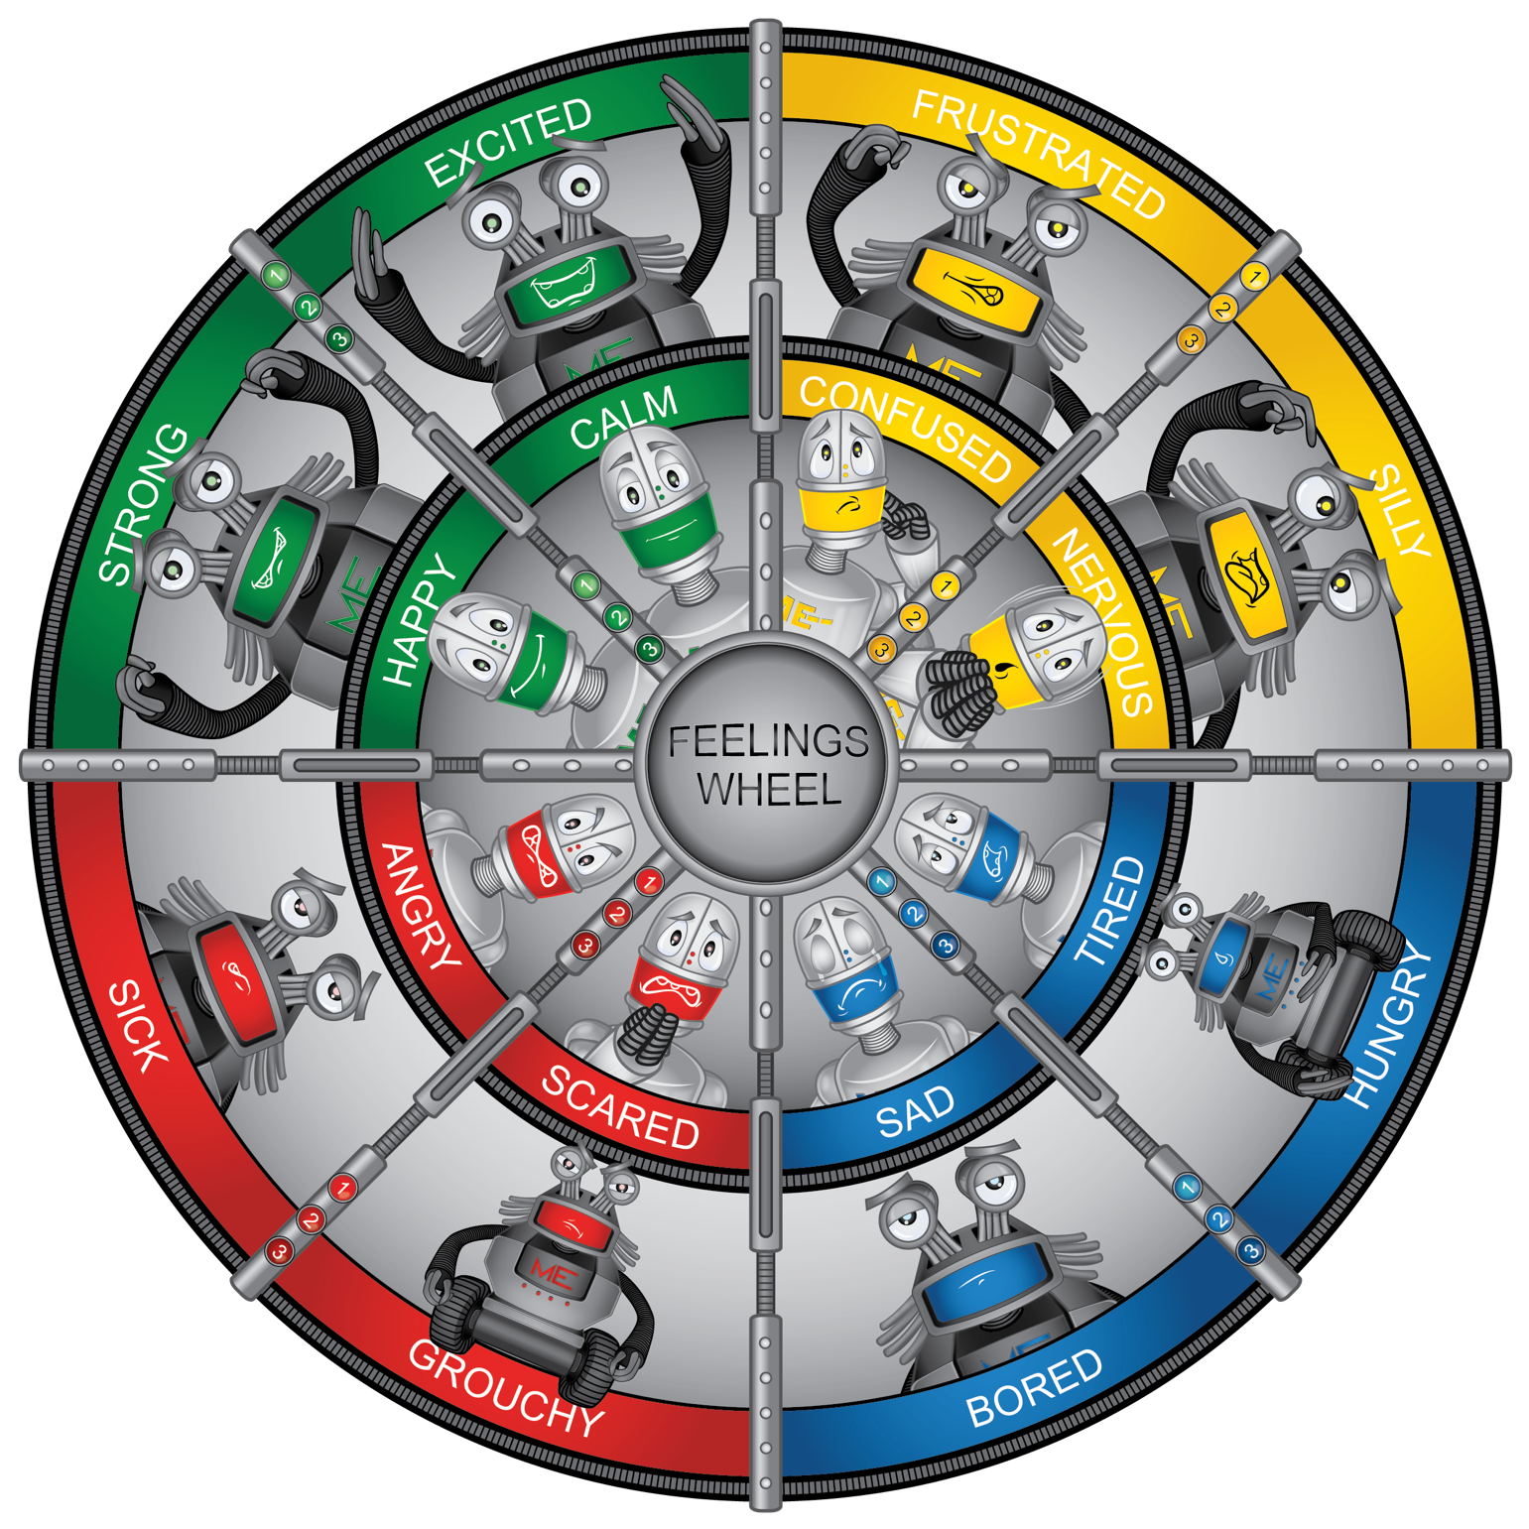

Attachment 1.2a: Robot Feelings

Attachment 1.2b: Feelings Cards

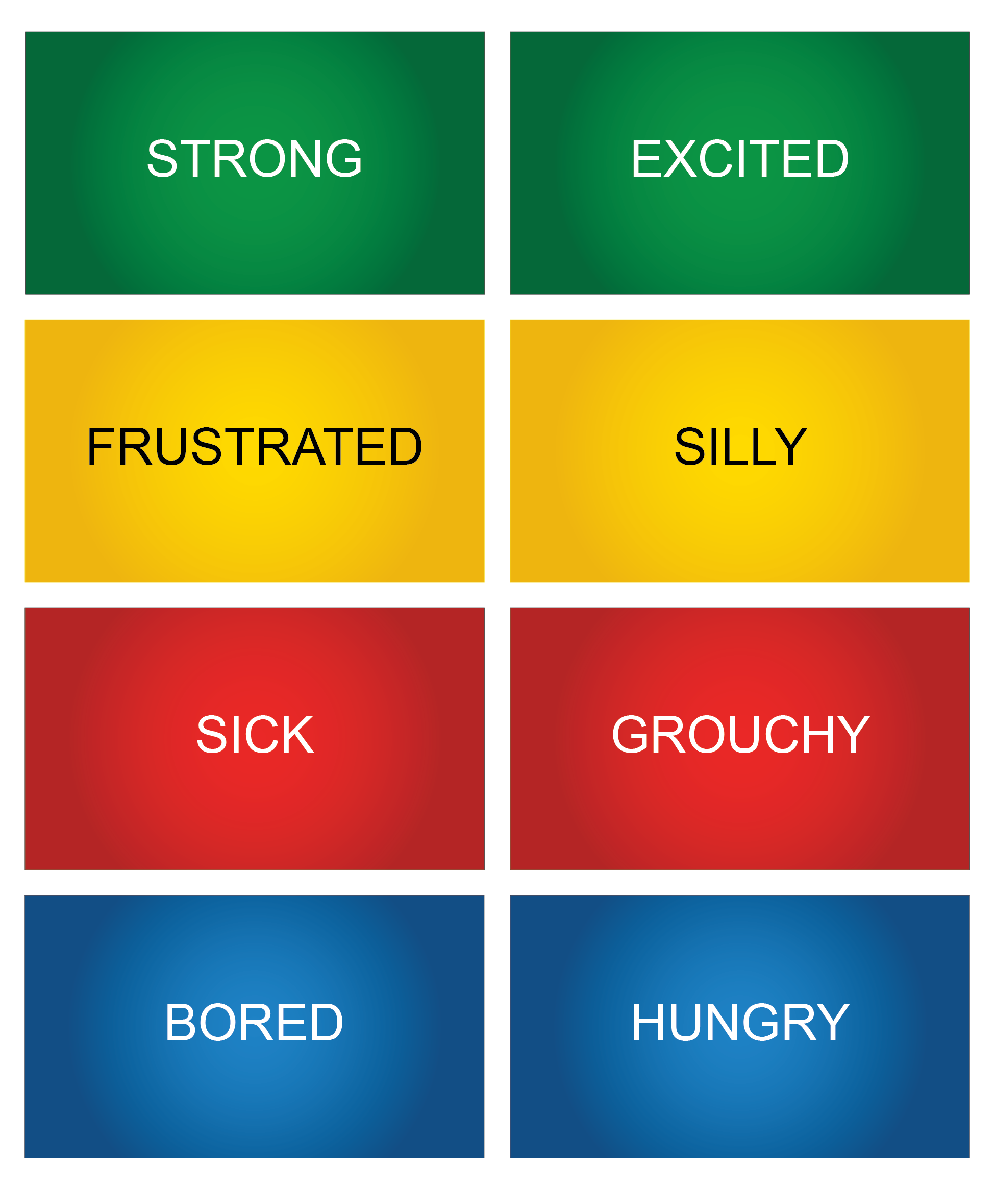

**Attachment 1.3: How would you feel?**

|  |  |  |  |
| --- | --- | --- | --- |
| **Green** | **Yellow** | **Blue** | **Red** |
|  |  |  |  |

**Attachment 1.4:** Activity for ME: Self-Assessment

I can demonstrate breathe like a dragon.

|  |  |
| --- | --- |
| Critical Elements | Check if Yes |
|  |  |
|  |  |
|  |  |

How do you feel when you breathe like a dragon?

|  |  |  |  |
| --- | --- | --- | --- |
| **Green** | **Yellow** | **Blue** | **Red** |
|  |  |  |  |

Would you use this activity again?

|  |  |  |
| --- | --- | --- |
| **Yes** | **Maybe** | **No** |