**Lesson 2: Awareness of ME: Feel, Think, and Act**

**Overview:** Students will recognize emotions and feelings. The lesson activities make the connection between feelings and how we think and act. Students will identify activities, strategies, and supports that can help them think and act in healthy and safe ways.

National Health Education Standards

**Standard 1:** Students will comprehend concepts related to health promotion and disease prevention to enhance health.

**Standard 3:** Students will demonstrate the ability to access valid information, products, and services to enhance health. The ability to find credible, accurate, and relevant information, services, and products concerning a specific health topic.

**Standard 7:** Students will demonstrate observable health and safety practices.

Healthy Behavior Outcome (HBO):

Students will engage in activities that are mentally and emotionally healthy.

**Lesson Objective** – Students will be able to:

|  |  |
| --- | --- |
| **Objective** | **Assessments** |
| 1. Describe feelings and reasons for the feelings. | Attachment 2.1 – Feel, think and act |
| 1. Describe the difference between everyday feelings and overwhelming feelings. | Attachment 2.1 – Feel, think and act |
| 1. Identify when a person is thinking and acting in safe and healthy ways using their upstairs brain. | Attachment 2.1 – Feel, think and act |
| 1. Identify resources, trusted adults, and activities that can support expressing emotions in healthy ways. | Attachment 2.1 – Feel, think and act |
| 1. Demonstrate a strategy to regulate or manage strong emotions. | Attachment 2.2 – Activities for ME |

Lesson Prerequisites or Assumptions:

This lesson examines emotions, feelings, and actions. Connect with your school’s behavioral health services and resources to identify how students can connect to those services and resources. It is also helpful to share parent education resources (see HELPs Parent Education Handout) for when students identify overwhelming feelings.

This lesson aligns with the concept of “overwhelming and everyday” feelings from Erika’s Lighthouse (<https://www.erikaslighthouse.org/portal/>). We suggest using Erika’s Lighthouse to support your students as part of a whole school, whole community approach to providing a safe, supportive culture around mental health.

ME Activity:

* EXPLAIN: “We are going to practice a calming or mindfulness activity to calm or regulate our body and brain/mind. First, I will show you what the tool looks like; then we will do it together, and then you will show me how to do it. Be slow and calm as we practice this tool.”

**Progressive Muscle Relaxation: Toes**

* Choose one muscle group to squeeze. It could be your making your fingers into a fist or curling your toes. We’re going to squeeze, count to five, and then release.
* How does your body feel when you squeeze? What’s the feeling when you let go of the squeeze? Remember to use “I feel _______ because ______________.”
* Let’s try it three more times. If you want, you can try another muscle group. Sometimes I work from my toes up.
* Can you describe how you feel after using this activity?
  + I feel __________ because _____________.
* When might you use this activity?
  + We might use it when we’re feeling anxious or stressed. It’s a good activity to feel the release of tension.

Teaching Steps:

Activity 1: Mental Health and Emotions

* Review of mental and emotional health.
* What is mental and emotional health? It is how we **feel, think,** and **act.**
* **Feel:** Everyone experiences feelings and emotions, but each person experiences and responds differently.
  + We feel emotions from inside ourselves. Feelings give us information to learn more about a situation. Feelings are not good or bad or positive or negative, but they can influence how we act. Feelings also change; they don’t remain the same for too long.
  + It’s important to understand emotions and feelings because they can impact how we think and act. We want act in ways that are healthy and safe.
* **Think:** Thinking occurs when our brain is at work to help us learn, progress, and navigate life and its decisions.
  + Our brain has an upstairs and a downstairs. Our upstairs brain is good at making thoughtful decisions. Our downstairs brain struggles to be thoughtful when making choices. When using our downstairs brain, we might think or act in ways that are unhealthy, unsafe, or unkind. Our feelings can influence whether we use our upstairs brain or our downstairs brain. We can use our resources to help us use our upstairs brain.
  + During Lesson 1, we recognized how strong we were feeling on a scale of 1 to 3. Remember that a Level 3 feeling is a strong feeling, and we need to use a resource or help from a trusted adult to think and act in healthy ways.
* **Act:** Our actions are how we behave and the choices we make. We need to make healthy and safe choices.

*Task 1: What am I feeling?*

* Emotions and feelings are not always easy to label or recognize, and you might not know what you are feeling or why you are feeling a certain way.
  + Being mentally and emotionally healthy does not mean always being happy. We all experience different emotions, including sadness, anger, and fear.
* If you are emotionally healthy, you can recognize your emotions and feelings, reach out and use your resources to think and act in healthy ways.
  + Manage emotions, feelings, and behaviors.
    - Managing means identifying and regulating. Today we’re going to learn how to regulate our emotions and feelings so we can express them in healthy ways.
    - Regulating means controlling or maintaining something so it operates properly.
  + Express with healthy actions.
    - Emotions can be expressed in healthy ways.
    - Emotions can also be expressed in unhealthy or unsafe ways.
* We are going to review how to describe our feelings (Attachment 2.1). We’re going to try our best to use our vocabulary and match different feelings to zones. A few things to remember:
  + Feelings are not good or bad or positive or negative, but they can influence how we act. Feelings also change; they don’t remain the same for too long.
    - Green – I’m ready to go. I’m feeling calm, ready, and focused.
    - Blue – I’m feeling sad, moving slowly, or need some help to get going.
    - Yellow – I’m feeling cautious or worried. I also need some help to accomplish what I want or need to do.
    - Red – I’m feeling frustrated, angry, or mad. I don’t feel in control, and I need some help getting control.
* Complete Attachment 2.1 and match the emotion words to the zones.

*Task 2. How big are my feelings?*

* We can also use levels to clarify how strong our emotions are.
* So far, we have talked about feelings you probably have every day. We also learned about big emotions and feelings that sometimes make it difficult to have control how we think and act. It’s important to know the difference between everyday feelings and overwhelming feelings.
* Everyday feelings come and go and are a normal reaction to what happens in our daily lives. Overwhelming feelings hang around for a long time, change the way we feel and behave, and may stop us from doing what we enjoy.
  + When we have big emotions or feelings, we have difficulty controlling or regulating the emotion. Small feelings are important feelings, but when we have them, we still feel in control of our thoughts and actions.
  + Reach out to a trusted adult when you recognize overwhelming feelings in yourself or others or if you notice threats or actions that could hurt or injure someone. You should also reach out to a trusted adult if your everyday feelings or big emotions need help or support. Trusted adults can help you, give support or give you helpful resources or tools.
  + *Erika’s Lighthouse (*[*LINK*](https://erikaslighthouse.org/)*) provides additional lessons for Grades 3-5 to understand everyday and overwhelming feelings.*
* Let’s practice recognizing our emotions with our four zones of emotions (Attachment 2.1, Part 2). Use the Feelings Wheel to recognize the emotion.
  + I got a new game that I can’t wait to play.
  + I forgot my math homework at home.
  + Another student in your class is calling you mean and hurtful names and has threatened to hit you.
  + I didn’t sleep much last night.
* When we experience overwhelming feelings, we need to reach out to a trusted adult for help.
* Identify a trusted adult who can help you at home, at school, or in the community. (*Note:* Follow up with your school’s behavioral health team if a student is struggling to recognize trusted adults at home and school.)

Activity 2: Think and Act

* Our mental health includes how we feel, think, and act. Our brain is the center that manages our thoughts and actions. We have an upstairs brain and a downstairs brain.
  + The upstairs brain (Level 1) is good at making thoughtful decisions.
  + Our downstairs brain (Level 3) struggles to be thoughtful when making choices. When using our downstairs brain, we might think or act in ways that are unhealthy, unsafe, or unkind because our downstairs brain is not designed to be thoughtful.
  + Our feelings can influence whether we’re using our upstairs brain or our downstairs brain. We can use our resources to help us use our upstairs brain. If we recognize that our downstairs brain is at work, we can use our resources to move upstairs to think and act in healthy ways.
    - Emotions are not good or bad, but emotions can influence how we act. Strong emotions can cause us to lose control or be unable to control how we think and act.
* We can use our tools and resources to think and act in ways that are healthy and safe.
* Let’s look at our zones of emotions first. Emotions can be small (Level 1) or big (Level 3). Deeper shades of colors show stronger levels.
  + When we are in Level 1, we are in our upstairs brain and can think about our actions. We are more likely to act in healthy ways.
  + In Level 2, we might have to stop and think or use a strategy to manage and express our emotions in healthy ways.
  + In Level 3, we have strong or big emotions. We need reach out for help or resources to help us regulate our emotions so we can use our upstairs brain to think and act in healthy ways.
* Let’s practice identifying how strong we are feeling (Level 1, 2, or 3).
  + I got a new game that I can’t wait to play.
  + I can’t seem to get this math problem correct.
  + Another student in your class is calling you mean and hurtful names and has threatened to hit you.
  + I didn’t sleep much last night.
* We have tools and resources to help our brains move upstairs so we can think and act in healthy ways.
* Activity 3: Recognize, Reach Out, and Use Resources
* We can learn about tools, resources, and trusted adults who can help us think and act in healthy and safe ways. We can learn skills and strategies to regulate our emotions by using the staircase to move to our upstairs brain.
  + Let’s think about a couple of resources or coping strategies to manage our emotions when we’re feeling big emotions or feelings.
    - Ask for help and support for the problem.
    - Calm and relax: Try using box breathing (Lesson 1) or find a calming space.
    - Think and be positive.
    - Distract yourself – doodle, fidget, or color.
    - Move – stand up and move around to energize your body.

Closure

* What did you learn about mental health?
  + It’s how we feel, think, and act.
* Tell me the difference between your upstairs brain and your downstairs brain?
  + When I use my upstairs brain, I am in control of how I think and act. My downstairs brain is not as good at thinking and acting in healthy ways.
* Why is important to know your feelings?
  + I can describe them and understand when I need to reach out and use my resources.
* What’s one strategy or tool you can use to help with what you’re feeling?
  + Answers vary. Ask for help; calm and relax; think and be positive; distract; and move.

Attachment 2.1a: Awareness of ME

*Part 1.* Write the feeling under the correct color and robot.

|  |  |  |  |
| --- | --- | --- | --- |
| Tense | Bored | Safe | Annoyed |
| **Blue** | **Green** | **Yellow** | **Red** |
|  |  |  |  |
|  |  |  |  |

1. _________________ feelings hang around, change the way we feel and behave, and may stop us from doing what we enjoy.
2. Everyday
3. Overwhelming

Write the names of trusted adults you can reach out to at home and at school.

|  |  |
| --- | --- |
| **Home** | **School** |
|  |  |

*Part 2.* Complete the table. Be sure to write a feeling word in the blank.

|  |  |  |  |
| --- | --- | --- | --- |
| **Situation** | **I am feeling** | **It feels** | **Upstairs or Downstairs Brain** |
| I got a new game that I can’t wait to play. |  |  |  |
| I can’t seem to get this math problem correct. |  |  |  |
| Another student in your class is calling you mean and hurtful names and has threatened to hit you. |  |  |  |
| I did not sleep much last night. |  |  |  |

**When I have strong feelings (Level 3) I can… (*Circle your choices*)**

|  |  |  |  |  |
| --- | --- | --- | --- | --- |
| **Be Calm** | **Move** | **Be Positive** | **Distract** | **Ask for Help** |
|  |  |  |  |  |

**Attachment 2.1b: Feelings Wheel**

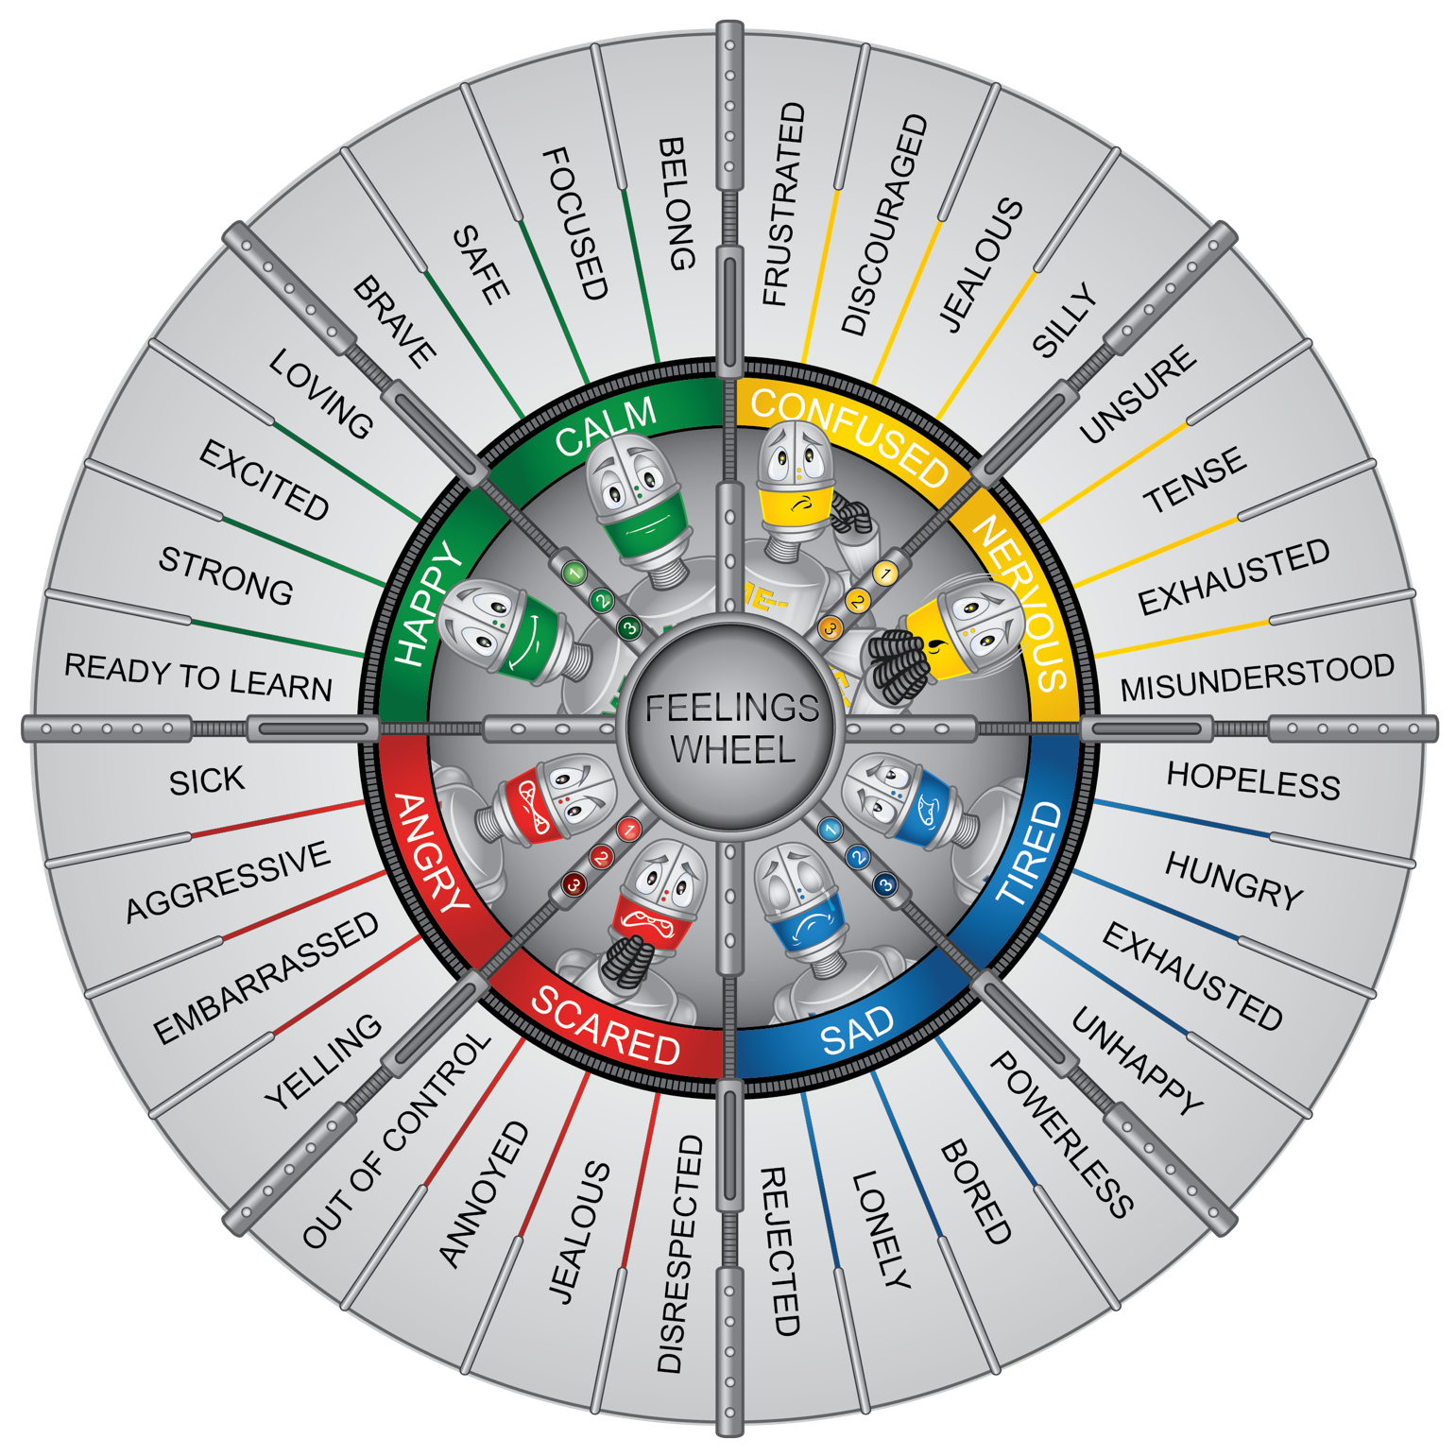

Attachment 2.2: Activity for ME: Self-Assessment

I can demonstrate the “Big Squeeze.”

|  |  |
| --- | --- |
| **Critical Elements** | **Check if Yes** |
| Squeeze |  |
| Count to 5 |  |
| Release |  |

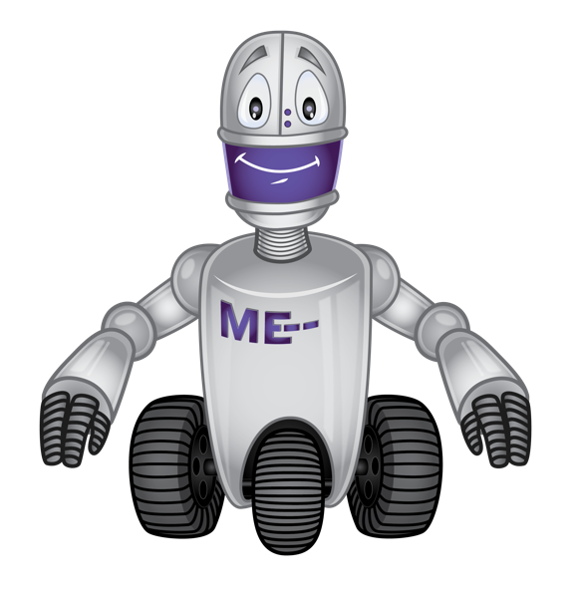

Circle how you feel when you do the Big Squeeze?

|  |  |  |  |
| --- | --- | --- | --- |
| **Green** | **Yellow** | **Blue** | **Red** |
|  |  |  |  |

Would you use this activity again?

|  |  |  |
| --- | --- | --- |
| **Yes** | **Maybe** | **No** |