Lesson 1: Getting to know ME: What is Mental and Emotional Health?
Overview: Students will learn about mental and emotional health, also known as “ME health”; explore the connections between ME health and other aspects of well-being; and identify helpful resources such as activities, information, and people.
National Health Education Standards
Standard 1: Students comprehend functional health knowledge to enhance health.
Standard 3: Students demonstrate health literacy by accessing valid and reliable health information, products, and services to enhance health.
Standard 7: Students demonstrate observable health and safety practices.
Healthy Behavior Outcome (HBO):
Students will engage in activities that are mentally and emotionally healthy.
Lesson Objective – Students will be able to:
Objective | Assessments
- Describe mental & emotional health. | Attachment 1.1 – All About ME
- Describe how mental and emotional health is connected and influenced by other aspects of health. | Attachment 1.1 – All About ME
- Describe emotions and feelings using “I feel _____ because __________________.” | Attachment 1.3 – How I Feel
- Identify a trusted adult who can support you if your feelings might lead to actions that are unsafe or unhealthy for you or someone else. | Attachment 1.3 – How I Feel  Attachment 1.4 – Feeling Scenarios
- Demonstrate a breathing strategy to enhance mental and emotional health. | Attachment 1.5 – Activity for ME

Behavioral HELPs Introduction:
- This lesson examines emotions, feelings, and actions. Connect with your school’s behavioral health services and resources to understand how students can connect to those services and resources. Ensure school mental health staff has set time aside to manage student self-referrals and any uncomfortable feelings students may have after this lesson.
- It is also helpful to share parent education resources (see HELPs Parent Education Handout) to have resources and support available when students identify overwhelming feelings.
- This lesson aligns with the concept of “feelings from Erika’s Lighthouse (https://www.erikaslighthouse.org/portal/). We suggest using Erika’s Lighthouse to support your students as part of a whole school, whole community approach to provide a safe, supportive culture around mental health.
Introduction:
- Show Slide 1 and then remind students of the classroom expectations for a safe and supportive environment.
- Today’s lesson addresses mental and emotional health. If you are having feelings, emotions, or thoughts you should feel comfortable to reach out to me or a trusted adult at school. (Remind students of your procedures if students need to use a regulation or mindfulness tool or strategy.)
- Remind students of your classroom expectations and norms to create a safe, supportive environment. (INSERT your classroom procedures here)
- Ensure school mental health staff has set time aside to manage student self-referrals and any uncomfortable feelings students may have after this lesson.
ME Activity:
- We’re starting a series of mental and emotional health lessons. You’ll hear me call these ME lessons, which stands for mental and emotional health, but it’s also because mental and emotional health is about ME because mental health is part of you. You’ll learn about what ME health is and how it connects to all aspects of your health. You’ll also learn strategies and activities that can enhance ME health. Each lesson about ME will have an activity you can use to strengthen ME health. Today’s activity is a breathing skill that will help us have a calm body and brain. First, I will show you what the tool looks like; then we will do it together, and then you will show me how to do it. Be slow and calm as we practice this tool.”
- Use the illustration in Attachment 1.5 to show the steps for box breathing
Teaching Steps:
Activity 1: Getting to know ME: What is mental and emotional health?
- What is mental and emotional health?
  - ME health includes our feelings, thoughts, and actions.
  - ME health affects how we think, feel, and act. It helps determine how we handle stress, relate to others, and make choices.
- ME health impacts our overall health. ME health helps us be happy, healthy, and productive.
  - ME health is connected to our physical health and social health. Your mental and emotional health impacts not only your thinking and mood, but also your physical health and behavior. Think of it this way:
  - Mental health = taking care of our minds
  - Physical health = taking care of our bodies
  - Social health = relationships with family, friends, peers, and others in your community
  - ME health is just as important as physical health. Just as we take care of our bodies by brushing our teeth, being physically active, and eating healthy, we’ll learn how to make healthy choices that strengthen and support our ME health.
  - While we learn about mental and emotional health, you’ll learn more about your strengths, abilities, and talents; you’ll also learn activities that support ME health.
    - Awareness of ME – Understanding ME health is connected to other aspects of my health.
      - Lesson 1 – Understanding ME and my feelings. We’ll learn about activities that can enhance ME health.
    - Strengthening ME – In Lessons 2 and 3, we’ll learn activities and strategies to strengthen and enhance ME health including regulating our emotions, making healthy choices, and using activities to support ME health.
    - Supporting ME – In Lessons 3 and 4, we’ll use tools and resources that support your ME health and the ME health of others. This section will include how to recognize or notice someone needs help; how to reach out and ask for help, and how to access resources that can support ME health.
- Task 1: What is mental and emotional (ME) health?
  - Draw a picture of yourself. Write three words or add more pictures that help to describe you. (See Attachment 1.1)
  - Think of things that make your happy or proud or that tell a story about you.
  - Write three feelings you have when you look at your picture. (Use Attachments 1.2a, 1.2b, and 1.2c if your students need support to think of feeling words.)
    - Attachment 1.2a is the Feelings Wheel and library where students can find a color and match it with a feeling word.
    - Attachments 1.2b and 1.2c are cards with feeling words and colors. They can be copied front to back and used as cards to share feelings.
  - Mental and emotional (ME) health is how we think, feel, and act. ME health impacts how we manage our emotions and actions.
- Task 2: ME Health is also connected to other aspects of health:
  - Diagram on dimensions of health: physical, mental, and social (see slides)
    - Mental health = taking care of our minds
    - Physical health = taking care of our bodies
    - Social health = relationships with family, friends, peers, and others in your community
  - Our dimensions of health are connected to each other. Can you think of a way mental health impacts another dimension of health?
    - You woke up with a stomachache. How might this physical feeling impact your mental and emotional health?
    - You were so excited for your birthday that you didn’t sleep much. How might you feel physically? Could it impact your social health?
  - Why is mental and emotional health important?
    - A healthy mind and body are connected. Both are important for overall health.
Activity 2 – Mental health: How we feel, think, and act
- Our mental and emotional health is how we feel, think, and act (Wisconsin Department of Public Instruction, 2024).
  - Feelings and emotions:
    - Everyone experiences emotions, but each person experiences them and responds to them differently.
    - People experience a wide range of feelings and emotions. Feelings are not good or bad, positive or negative, but they give us information that we can pay attention to.
    - It’s important to understand emotions and feelings because they can impact how we act. We want to act in ways that are healthy and safe.
  - Thoughts occur when our brain is at work to process information to help us learn, progress, and navigate life and its decisions.
  - Actions are behaviors or decisions using our mind and bodies.
- Task 1 – Let’s practice identifying and describing different emotions. The Feelings Wheel will help us describe our feelings. Awareness of our feelings and emotions will help us talk about them and understand how the people around us are feeling.
  - Step 1: Recognize feelings.
    - You can use Attachment 1.2a by itself or use Attachments 1.2b and 1.2c together to practice recognizing emotions. This activity suggests 1.2b and 1.2c.
  - Spread out the feeling cards (Attachment 1.2a) emoji side up and have students share what emotions they recognize. Sort the cards by the feelings they recognized and the ones they did not recognize.
    - Extension - You can also do the reverse – show a word and have the students draw a corresponding emoji face.
  - There are lots of different feelings. The wheel organizes them into categories.
    - Green – I’m ready to go. I feel calm, ready, and focused.
    - Blue – I’m feeling sad, moving slowly, or need some help to get going.
    - Yellow – I’m feeling cautious or worried. I need some help to accomplish what I want or need to do.
    - Red – I’m feeling frustrated, mean, or mad. I don’t feel in control, and I need some help getting control.
  - Organize the feeling cards into each color category. If you are unsure, we’ll stack them together and work together.

- Task 2: Describing Feelings
- We can use a scale to describe the strength or size of our emotions. The range is between 1 and 3. Level 1 feelings are smaller. With Level 1 feelings, I can think and act in healthy and safe ways. At the top of the scale is Level 3, for big feelings. With Level 3 feelings, I am unable to control how I think and act, or I need help to think and act in healthy ways. When I have Level 2 feelings, I need to use my tools, strategies, and resources to make sure I think and act in healthy and safe ways. Level 2 is a warning that my feelings could grow to Level 3.
  - When we are describing feelings, we use the following steps (see Attachment 1.3):
    - I feel _____ (using a feeling word and level).
      - For Level 3, a big or strong emotion, we need help and support from a resource. We can always tell a trusted adult how we are feeling.
    - I feel this way because ______________.
    - Think about tools you can use or people who could help you think and act in healthy ways.
- There are times when we recognize that our feelings or health are not at their best and that we need help making healthy and safe choices.
- What do we do when we need help with our physical health or when we need help making healthy choices? (Refer to Behavioral HELPs substance use prevention lessons.)
  - Reach out and seek help from a trusted adult, doctor, or other professional.
- What should we do if we recognize that our mental and emotional health is not at its best, that we’re not feeling OK, or that we might act in a way that is unhealthy or unsafe?
  - Reach out and seek help from a trusted adult, doctor, or another professional who can support ME health.
  - When we can recognize emotions and feelings, we can also be supportive of others. How could we help someone who isn’t feeling the best about their mental and emotional health?
    - Be kind and reach out; listen; and let them know a trusted adult can help them.
  - We can use activities and strategies to support our own ME health. We call them recharge or strengthen ME activities. We will learn more about reaching out and resources in future lessons.
- Task 3: Let’s see how much you remember as we practice recognizing our feelings.
- Syd is having a tough day at school. She woke up late and forgot her lunch on the counter, and her stomach is already growling. (See Attachment 1.4.)
  - Use the Feelings Wheel. How do you think Syd is feeling? Rate how strong the feelings might be.
  - Why did Syd feel this way?
    - Syd feels _______ because __________________.
  - What could you do to think and act in healthy ways?
- Your turn
  - You found out your class won an award for great attendance. You’ll get ice cream sandwiches at the end of the day.
    - Use the Feelings Wheel to select a feeling.
    - Rate how strong the feelings might be (Level 1, 2, or 3).
    - Why would you feel this way?
    - Complete the sentence. I feel _______ because __________________.
    - What could you do to think and act in healthy ways?
Activity 3
- Now that we’ve learned more about our feelings, thoughts, and actions, let’s think about how our actions can impact how we feel. We’re going to try our breathing activity again. This time, I want you to think about __________________.
  - How did you feel? (Show a feeling card or share, “I feel _______ because __________________.”)
  - When could you use this activity?
  - Can you think of other activities that can improve your feelings and your health?
Closure:
- What is mental and emotional health?
  - Our feelings, thoughts, and actions.
- Why is mental and emotional health important?
  - Our feelings and thoughts connect to our other dimensions of health. Our ME health can also influence how we act.
- Why is it important to recognize feelings?
  - We can describe our feelings to better understand them and tell someone if we’re not feeling mentally or emotionally well.
- What can you do strengthen mental and emotional health?
  - Answers vary – breathing exercise, physical activity, talking to a trusted adult.

Attachment 1.1: All about ME
Draw a picture of yourself. Label it with at least three words or pictures that describe you.

Write a feeling word next to the words or pictures that describe you.

Fill in the blanks:
I like to ____________________. It makes me feel ___________________.

Mental health is how I f_____, th______ and a_____.

Task 2: Write an example for mental health and physical health in the box.
Mental  (Mind) | Physical  (Body)
 | I get to play my favorite game with my friends at recess or PE.
I am feeling happy and excited. | (Describe how my body feels)
 | Your stomach hurt and you did not sleep much last night.

Attachment 1.2: Feelings Wheel

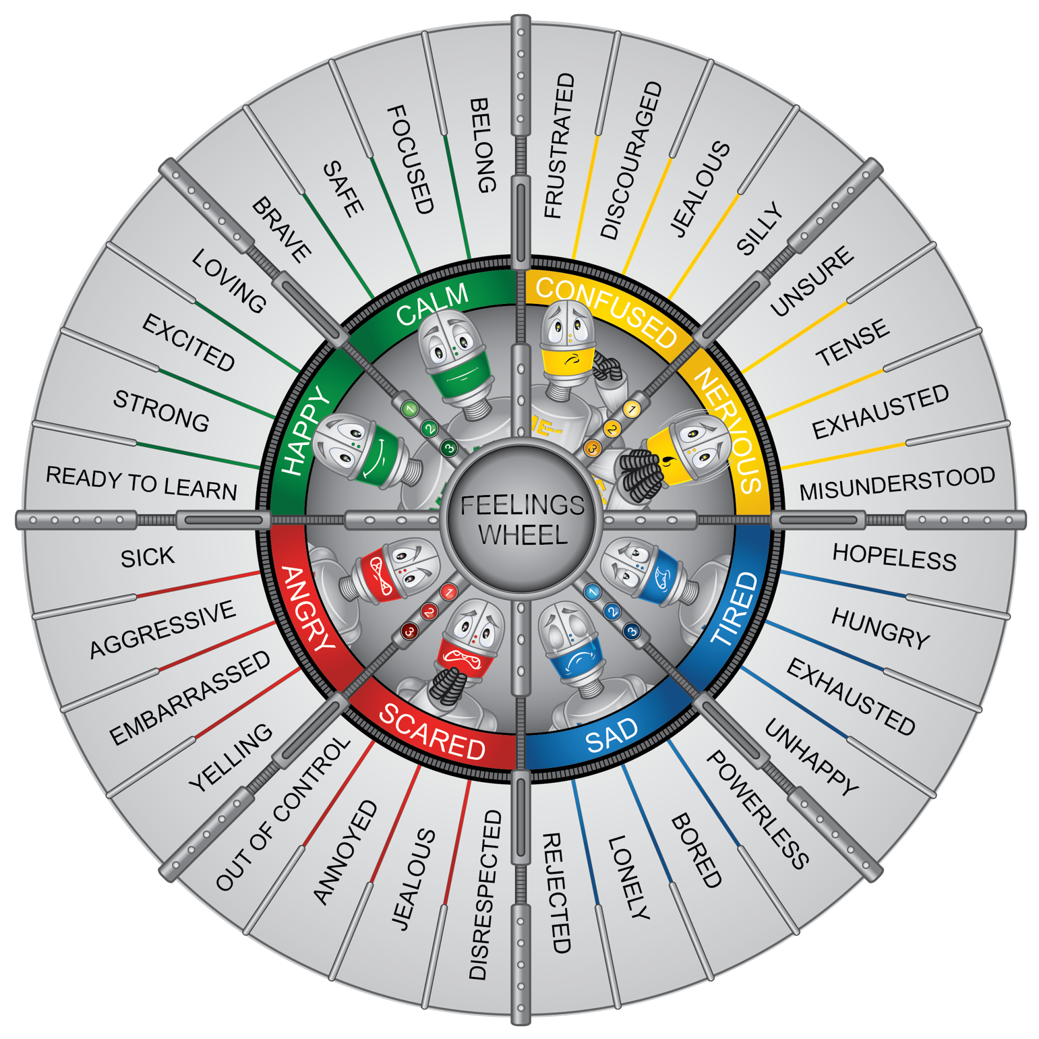

Attachment 1.3a: Robot Feelings

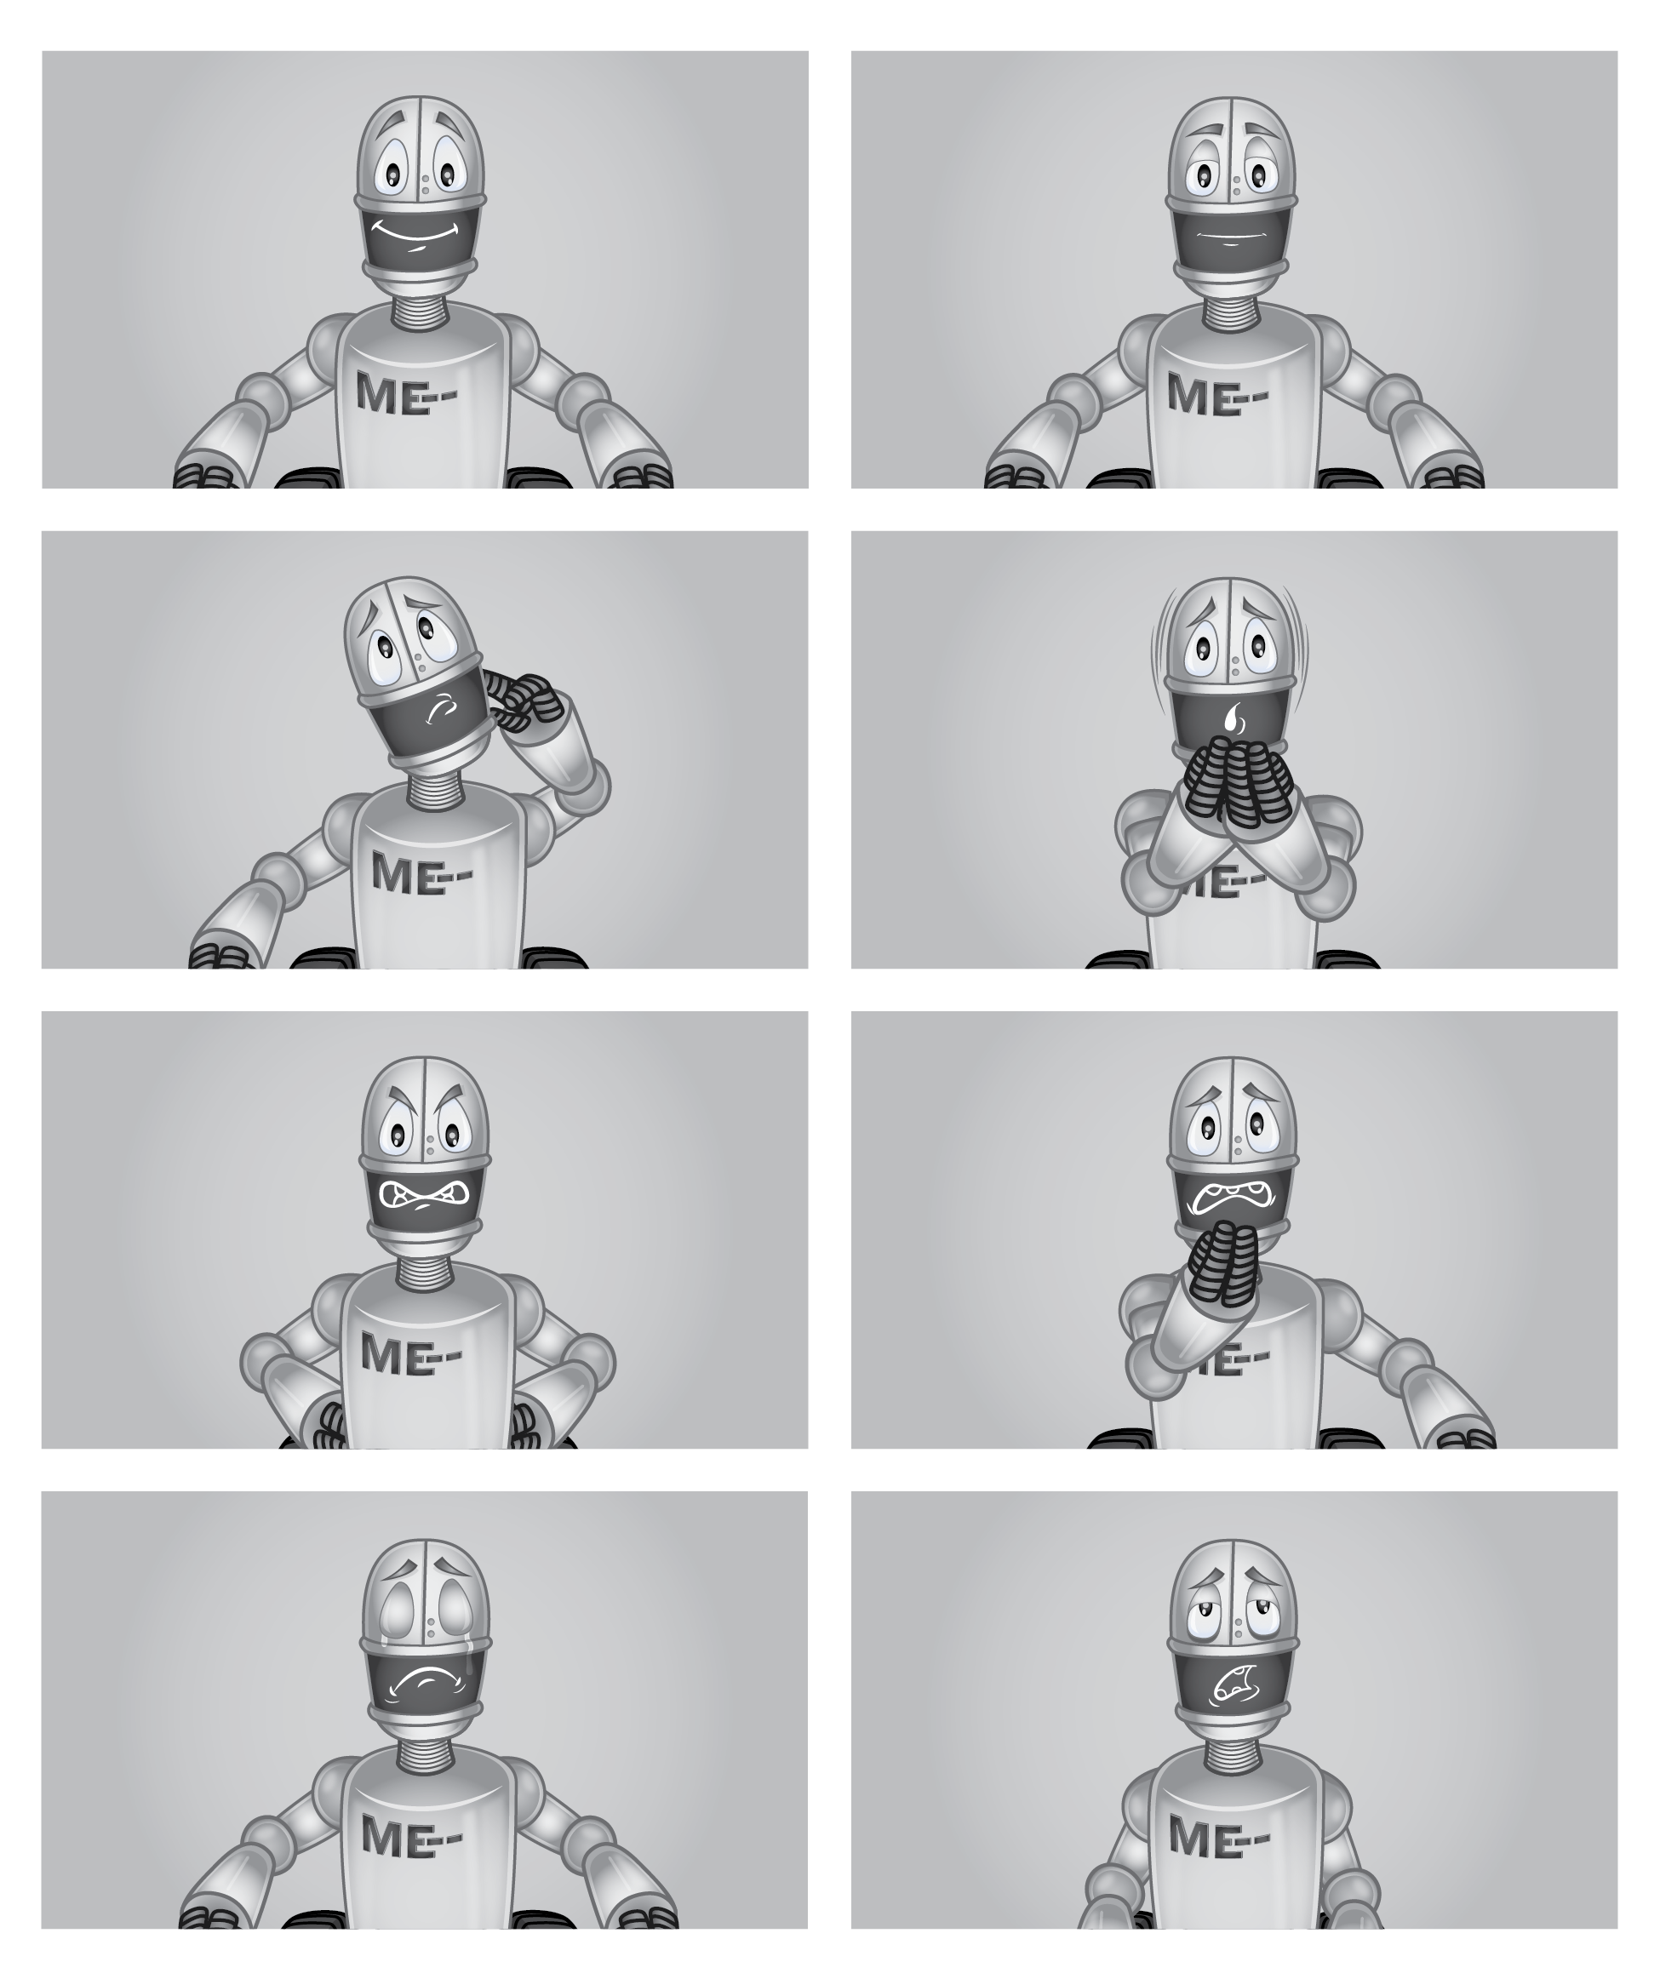

Attachment 1.3b: Feelings Cards

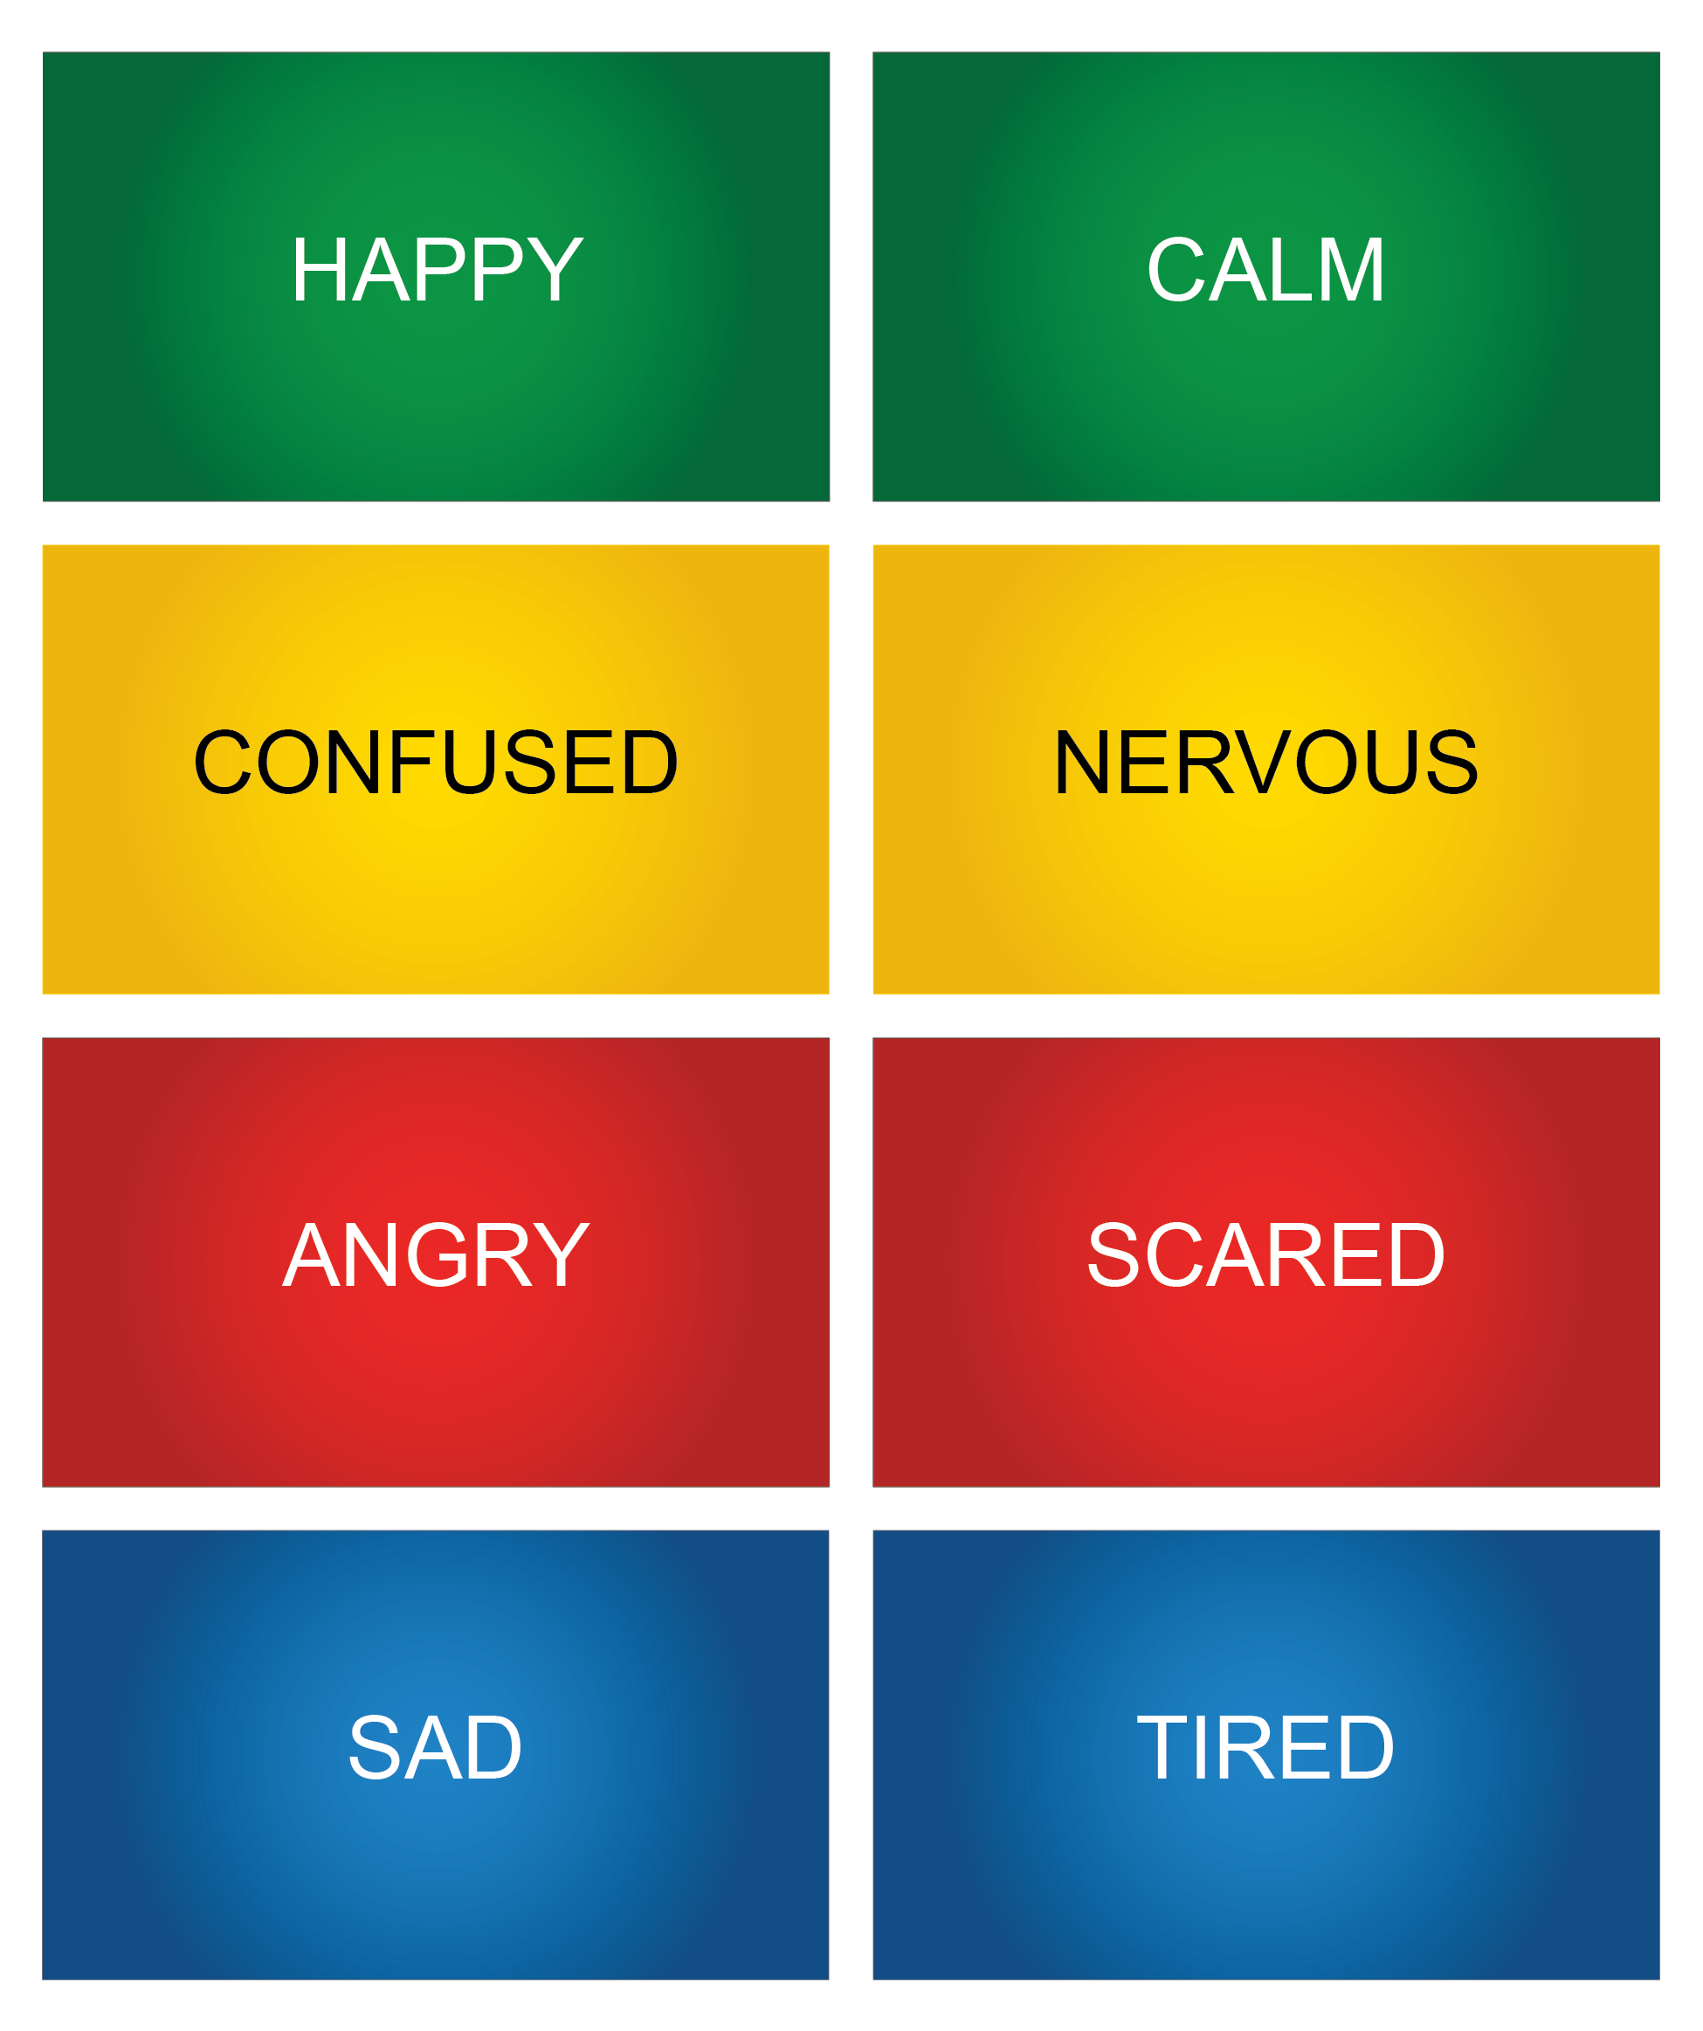

Attachment 1.3: How I Feel
Directions: Circle how you would feel and how strong the feeling would be.
Situation 1: Syd is having a tough day at school. She woke up late and forgot her lunch on the counter, and her stomach is already growling. (Use your feeling wheel to decide how you would feel.)
I feel |  |  |  | It feels
Green | Yellow | Blue | Red | Rate
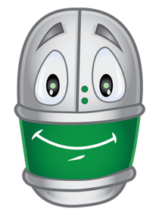 | 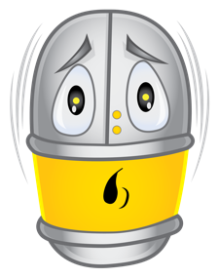 | 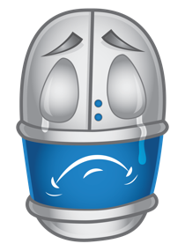 | 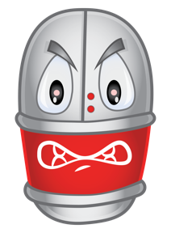 | 

What could you do to think and act in healthy ways?

Situation 2: You found out your class won an award for great attendance. You’ll get ice cream sandwiches at the end of the day. (Use your feeling wheel to decide how you would feel.)
I feel |  |  |  | It feels
Green | Yellow | Blue | Red | Rate

What could you do to think and act in healthy ways?

You can reach out to a ____________ adult when you need help with your feelings.
Attachment 1.4: Activity for ME: Self-Assessment
I can demonstrate square breathing.
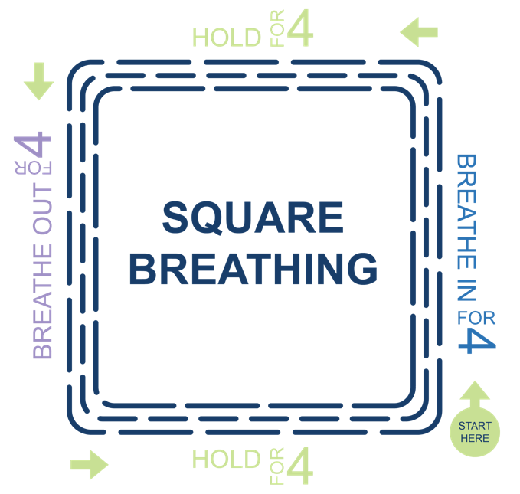
How do you feel when you do square breathing?
Green | Yellow | Blue | Red
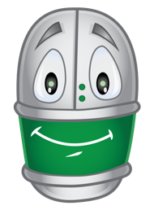 | 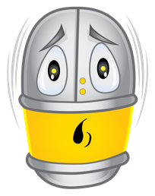 | 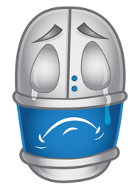 | 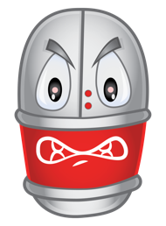

Would you use this activity again?
  Yes |   Maybe |   No
I can recognize my feelings.
Yes | Maybe | No

