**Lesson 4: Supporting ME: Resources and Recharge**

**Overview:** This lesson targets a collection of supports and resources that can support ME. Students will apply what they’ve learned in the first three lessons to share and awareness of ME, activities that strengthen ME, skills recognize, reach out and use resources that support ME.

**National Health Education Standards**

**Standard 1:** Students will comprehend concepts related to health promotion and disease prevention to enhance health.

**Standard 4:** Students will demonstrate the ability to use interpersonal communication skills to enhance health and avoid or reduce health risks.

**Healthy Behavior Outcome (HBO):**

|  |  |
| --- | --- |
| **MEH HBO 2** | Engage in activities that are mentally and emotionally healthy. |

**Lesson Objective**- Students will be able to:

|  |  |
| --- | --- |
| **Objective** | **Assessments** |
| 1. Use physical activity to enhance mental and emotional health. | Attachment 4.1: Physical Activity & ME |
| 1. Describe emotions and feelings to think and act in healthy ways. | Attachment 4.2: Toolkit for ME |
| 1. Identify resources that can help and support mental health at home and school | Attachment 4.2: Recognize, Reach Out, and Resources |
| 1. Describes a variety of activities and strategies to support mental and emotional health | Attachment 4.3: Resources Fortune Teller |

ME Activity:

* Physical Activity: Teacher selects an activity from a menu of physical activities that best fit your context and students’ needs. The menu includes raising your heart rate; coordination and rhythm; and flexibility.
* Explain: “We are going to practice using another tool to promote ME – physical activity. Did you know that moving your body improves your mood and that many people say they use movement or physical activity when they are stressed or need a boost of energy or a stress break? To start today’s lesson, we’re going to move. First, I will show you what the tool looks like; then we will do it together, and then you will show me how to do it.”
* Use Attachment 4.1a to check in after completing the activity.
  + *Note*. Attachment 4.1b. This is a collaborative activity you can do with your physical education teacher to support physical activity and mental health. Ask your physical education teacher for more physical activity ideas. Ask to collaborate on meeting Standard 5 (Identify multiple, specific health benefits as a reason to value physical activity). Your students will identify a favorite physical activity and how it benefits their health. This activity meets Standard 3A and Standard 5AB for the Ohio Physical Education Evaluation.

Introduction:

* We’ve developed an awareness of ME; how to strengthen ME by using strategies to enhance ME or by regulating our emotions and behaviors; and how to support ME by recognizing, reaching out, and using resources. In today’s lesson, you’re going to create a tool.

Teaching Steps:

Activity 1: Review what you know about ME- Recognize, reach out, and use resources

* Use Attachment 4.2 to review recognize, reach out, and use resources.
* Today I found out I got a bad grade on my science fair project. I tried to do my best, but I forgot to write the last paragraph.
* I feel ____________.
* Recognize
  + What are you feeling?
  + How strong is the feeling?
  + Is this an overwhelming feeling?
  + Do you need help? Who can help?
* Reach out and use resources:
  + Think: What can I do to support my mental and emotional health (ME)? What is a strategy or activity that might help?
  + Who would you talk to if you needed help with how you are feeling?
* Choose a healthy way to respond to this situation. Your resources include tools, skills, and trusted adults.
  + *If needed use Attachment 1.2a to review the Feelings Wheel.

Activity 2: Tools for ME

* We’re going to collect the tools we’ve learned during our lessons into a Toolkit for ME that can be used to strengthen our mental and emotional health.
  + Teachers – Attachment 4.2a or 4.2b collect the same information. You can use the table format (Attachment 4.3a) or the Fortune Teller (4.3b)
* Attachment 4.3a has four sections:
  + Step 1: Recognize – We can recognize feelings and emotions. Use the table to recognize an emotion for each color; think about how you might act; and then share a resources you can use to think and act in healthy ways.
  + Complete the first column with a feeling for each color.
  + Then list or describe the thoughts or actions that could happen when you feel that way. You can list any thoughts or actions because this is your toolkit.
  + Resources – These tools can be activities or people who can help me. Tools can be calming, moving, thinking positive or distracting. The activities can help me be positive or recharge my mental health.
  + Students will then identify trusted adults who are resources that can help me at home, at school, and in the community with my mental health.
  + Extension – Students could describe a feeling and a resource they would use to think and act in healthy ways.
  + Example: When I feel angry, I take deep breaths to calm myself down.
* Attachment 4.3b Fortune Teller. Follow directions on the page to identify 8 resources that can be used to support your mental and emotional health.
  + When the Fortune Teller is completed, students can share their resources with a partner using the Fortune Teller.

Activity 3: Show What You Know About ME

* Complete the Attachment 4.5 to show what you know about mental and emotional health.
* Remind students that when completing the skills check, the questions ask how confident they feel about each statement after the lessons.

Closure:

* What is mental and emotional health?
  + It is how we feel, think, and act.
* Why is mental and emotional health important to me?
  + It impacts our health and well-being. It is how we feel, think, and act.
* How can you support your mental and emotional health?
  + We can recognize, reach out and use our resources to feel, think, and act in ways that support our health.

Attachment 4.1: Activity for ME Self-Assessment

My favorite ways to move that improve my mental and emotional health

|  |  |
| --- | --- |
| **Movements** |  |
|  |
|  |
|  |

Circle how you feel when you move.

|  |  |  |  |
| --- | --- | --- | --- |
| **Green** | **Yellow** | **Blue** | **Red** |
|  |  |  |  |

Would you use this activity again?

|  |  |  |
| --- | --- | --- |
|   **Yes** |   **Maybe** |   **No** |

**Attachment 4.1b: Physical Education Connections – Physical Activity and Mental Health**

Write or draw activities that you like to do at home, at school, and in the community to move your body and improve your mental health.

|  |
| --- |
| **At school** |
| *In the classroom* |
| *At recess* |
| *In physical education* |
| **At home** |
|  |
| **In my community (parks, trails, etc.)** |
|  |

**List two reasons why it is important to be physically active.**

|  |
| --- |
|  |
|  |

**Attachment 4.2: Toolkit for me.**

I can recognize my feelings. Write two feelings words for each color.

|  |  |  |  |
| --- | --- | --- | --- |
| Green | Yellow | Blue | Red |
|  |  |  |  |
| Two feeling words: | Two feeling words: | Two feeling words: | Two feeling words: |
|  |  |  |  |
|  |  |  |  |

Choose one feeling word from any color and share how you feel.

I feel __________ because….

When I have big feeling, I can…. (Circle your answers)

|  |  |  |  |
| --- | --- | --- | --- |
| Take a Deep Breath | Move | Distract | Ask for help |
|  |  |  |  |

Draw or write the name of a trusted adult who can help you.

Attachment 4.3: Resources Fortune Teller

Directions:

*Answer these questions.*

|  |  |
| --- | --- |
| 1 | Trusted adult at home – Write or draw a trusted adult |
| 2 | Trusted adult at school – Write or draw a trusted adult |
| 3 | Stay calm – Write or draw a calming activity |
| 4 | Be positive – Write a positive thought |
| 5 | Distraction – Write or draw an activity |
| 6 | Move – Write or draw a movement |
| 7 | Move – Write or draw a movement |
| 8 | Your Choice – Write or draw another way to think and act in a healthy way |

**How to create a fortune teller.**

1. Fold each corner toward the center so the robots are in the center are up. Turn it over and fold each corner to the center again.
2. Fold the square in half so you can see the numbers.
3. Hold your feelings catcher with your thumb and finger so the numbers show.
4. Pick a number or have a friend pick a number. Use your catcher to practice sharing a feeling and a resource you can use.

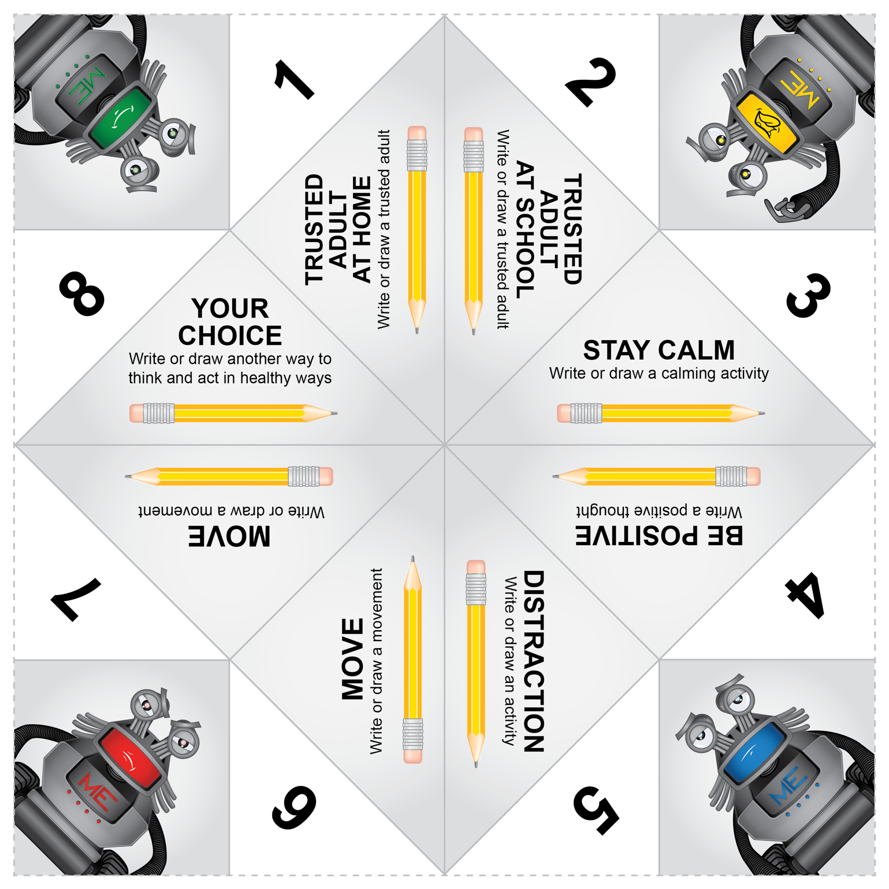

**Attachment 4.4: Show what you know about ME**

1. Can you recognize the feeling?

|  |  |  |  |
| --- | --- | --- | --- |
|  |  |  |  |
| Happy  Sad  Angry  Tired | Calm  Nervous  Mad  Hungry | Scared  Strong  Happy  Calm | Sad  Strong  Scared  Tired |

1. Mental health includes our …
2. Feelings
3. Thoughts
4. Actions
5. All of the above
6. I am using my _____________ brain when I can think and act in healthy ways.
7. Downstairs
8. Upstairs
9. Feelings that may stop us from doing what we enjoy, hang around for a long time, or change the way we feel and behave are ____________________.
10. Everyday feelings
11. Overwhelming feelings
12. Triggers
13. Coping skills

Can you list the three R’s to support mental health?

________________ our emotions and feelings.

________________: Ask for help or support.

________________: Tools or skills we can use to support mental health.

Scenario

|  |  |  |  |  |  |  |
| --- | --- | --- | --- | --- | --- | --- |
| **Situation** | **I feel…** | | | | **It feels…** | **Upstairs or Downstairs Brain** |
| Your class is singing a song to the entire school at today’s assembly. | **Green** | **Yellow** | **Blue** | **Red** |  |  |
|  |  |  |  |
| **Is it an overwhelming feeling?** | **Yes** | | **No** | | **Unsure** | |
|  | |  | |  | |
| **Do I need the help of a trusted adult?** | **Yes** | | **No** | | **Unsure** | |
|  | |  | |  | |
| **Who could help me?** |  | | | | | |

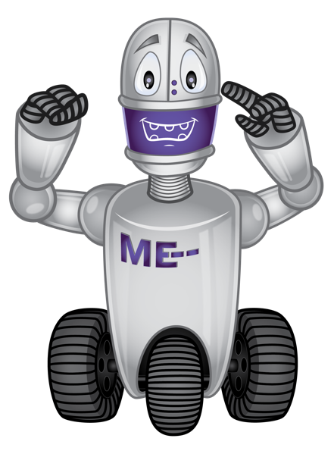

**Section II – Skills Check**

|  |  |  |  |
| --- | --- | --- | --- |
| **I can….** | **Always** | **Sometime** | **Never** |
| **Recognize** my feelings. |   **Yes** |   **Maybe** |   **No** |
| **Reach out** and share how I feel. |   **Yes** |   **Maybe** |   **No** |
| **Reach out** and ask for help. |   **Yes** | **Maybe** |   **No** |

|  |  |  |  |
| --- | --- | --- | --- |
| **Use resources.** | | | |
| I know a trusted adult who can help me. |   **Yes** |   **Maybe** |   **No** |
| I can use tools or resources to regulate my emotions. |   **Yes** |   **Maybe** |   **No** |
| I know at least 1 trusted adult who can help me. |   **Yes** |   **Maybe** |   **No** |
| I have activities, exercises and tools that can help my mental health. |   **Yes** |   **Maybe** |   **No** |