**Lesson 1: Getting to know ME: What is Mental and Emotional Health?**

**Overview:** Students will learn that mental and emotional health is how we feel, think, and act. Students will describe feelings using their feelings vocabulary and the rating scale.

**National Health Education Standards**

**Standard 1:** Students comprehend functional health knowledge to enhance health.

**Standard 3:** Students demonstrate health literacy by accessing valid and reliable health information, products, and services to enhance health.

**Standard 7:** Students demonstrate observable health and safety practices.

**Healthy Behavior Outcome (HBO):**

Students will engage in activities that are mentally and emotionally healthy.

**Lesson Objective**- Students will be able to:

|  |  |
| --- | --- |
| **Objective** | **Assessments** |
| 1. Describe mental & emotional health is how we feel think and act. | Attachment 1.1 – This is ME |
| 1. Describe how mental and emotional health is connected to other aspects of health. | Attachment 1.1 – This is ME |
| 1. Describe emotions and feelings using “I feel _____ because __________________.” | Attachment 1.3 – How I feel |
| 1. Identify a trusted adult who can support you if your feelings might lead to actions that are unsafe or unhealthy for you or someone else. | Attachment 1.3 – How I feel |
| 1. Demonstrate a breathing strategy to enhance mental and emotional health. | Attachment 1.4 – ME Activity Self-Assessment |

**Behavioral HELPs Introduction:**

* This lesson examines emotions, feelings, and actions. Connect with your school’s behavioral health services and resources to understand how students can connect to those services and resources. Ensure school mental health staff has set time aside to manage student self-referrals and any uncomfortable feelings students may have after this lesson.
* It is also helpful to share parent education resources (see HELPs Parent Education Handout) to have resources and support available when students identify overwhelming feelings.
* This lesson aligns with the concept of “feelings from Erika’s Lighthouse (<https://www.erikaslighthouse.org/portal/>). We suggest using Erika’s Lighthouse to support your students as part of a whole school, whole community approach to provide a safe, supportive culture around mental health.

ME Activity:

* We’re starting a series of mental and emotional health lessons. You’ll hear me call these ME lessons which stands for mental and emotional health but it’s also because mental and emotional health is about ME. You’ll learn that ME health is how we feel, think and act. You’ll understand how ME health connects your health. You’ll also learn strategies and activities that can enhance ME and your health. Each lesson about ME will have an activity or practice you can use to strengthen me. Today’s activity is a breathing skill that will help us have a calm body and brain. First, I will **show** you what the tool looks like, then we will **do** it together and finally you will **show me** how to do it. Be slow and calm as we practice this tool.”
* Use the illustration in Attachment 1.5 to show the steps for box breathing

Teaching Steps:

Activity 1: Getting to know ME: Defining Mental & Emotional (ME) Health

* What is mental and emotional health?
  + ME health is how we feel, think and act. ME health includes our *feelings, emotions, mood, thoughts, and actions*.
  + It affects how we think, feel, and act, and helps determine how we handle stress, relate to others, and make choices.
  + ME health impacts our overall health. ME health helps us be happy, healthy, and productive.
  + ME Health is connected to our physical health and social health. Your mental and emotional health impacts you, not only thinking and mood but also your physical health and behavior could be affected.
    - Think of Mental Health = taking care of our minds; Physical Health = taking care of our body; Social = relationships with family, friends, peers, and others in your community.
  + ME Health is just as important as physical health. Just as we take care of our bodies by brushing our teeth, being physically active, and eating healthy. We’ll learn how to take care of mental health.
    - Just like we make healthy choices for our body, we’ll make healthy choices that strengthen and support our ME health.
  + We’ll get to know more about ME health during our lessons and while we’re learning about mental and emotional health, you’ll learn more about your strengths, abilities, talents, and activities you can use that support ME. Your Toolkit for ME will include three areas:  Awareness of ME, Strengthening ME, and Supporting ME
* What is mental and emotional health?
  + Draw a picture of yourself. Write three words or add more pictures that help to describe you.
  + You can think of things that make your happy, proud, or like to share with others.
  + Look at the Picture of ME. How do you feel when you’re doing or playing an activity on the picture?
  + Can you draw an emoji or face that shows an emotion next to each of your three pictures.
  + Mental and Emotional (ME) Health is how we think, feel and act.
  + ME Health impacts how we manage our emotions and actions.
  + Let’s practice identifying feelings when you act in healthy and safe ways that benefit your social (friends), physical (your body), and mental (your mind).
* This mental and emotional health lessons will give you tools to enhance your mental and emotional health. We will create a Toolkit for ME that will include knowledge, skills, and resources. Your Toolkit for ME will include three areas:  Awareness of ME, Strengthening ME, and Supporting ME
  + Awareness of ME – Understanding ME and mental health is connected to other aspects of my health.
  + Lesson 1 – Understanding ME and my feelings. We’ll learn about activities that can enhance ME.
  + Strengthening ME – In Lesson 2 and 3 we’ll learn activities and strategies to strengthen and enhance ME including regulating our emotions and making health choices and using activities to help ME.
  + Supporting ME – In Lesson 3 and 4 we’ll use tools and resources that support your ME and the ME health of others. This section will include how to recognize or notice someone needs help with ME, how to reach out and ask for help, and knowing resources that can support ME.

Activity 2 – Awareness of ME: Feelings, Thoughts and Actions

* Our mental and emotional health is how we think, feel and act (Wisconsin, 2023).
  + *Feelings and emotions*
    - Everyone experiences emotions but how we experience them and respond to them are up to each person.
    - People experience a wide range of feelings and emotions. Feelings are not good or bad or positive or negative, but feelings give us information that we can pay attention to.
    - It’s important to understand emotions and feelings because they can impact how we act. We want to be sure we act in ways that are healthy and safe.
  + *Thoughts* occur when our brain is at work to process information to help us learn, progress, and navigate life and its decisions.
  + *Actions* are behaviors or decisions using our mind and bodies.
* Our feelings can influence our thoughts and actions. In this lesson we’re going to recognize our feelings and emotions so we can think and act in healthy and safe ways.
* *Task 1:* Describing Feelings
  + If we can label or describe how we’re feeling it can help us manage those feelings and think about how we can act in ways that are healthy and safe.
  + Let’s practice identifying and describing different emotions. The feelings wheel will help us describe our feelings to yourself and others. Describing our feelings and emotions will help us talk about them, share your feelings with others, and help us be aware of how the people around us are feeling.
  + Step 1: Recognize feelings - Spread out at your emotion cards (Attachment 1.2b and 1.2c). Show the emoji side and have students share what emotion they recognize. Sort the cards by the feelings you recognized and the ones they did not recognize.
    - *Extension* - You can also do the reverse, show a word, and have the students draw a corresponding emoji face. What are three emotions or feelings you have experienced recently.
  + There are lots of different feelings, but you can see the wheel organizes them into categories:
    - Green – I’m ready to go. Feeling calm, ready, and focused
    - Blue – I’m feeling sad, moving slow, or need some help to get going.
    - Yellow – I’m feeling cautious or worried. I also need some help to accomplish what I want or need to do.
    - Red – I’m feeling frustrated, angry, mad. I don’t feel in control, and I need some help getting control.
  + Let’s try to organize the feeling cards into each category. If you are unsure, we’ll stack them and work together
  + The categories might help us communicate our feelings when we’re not exactly sure how we’re feeling but we can help give valuable information.
* Describing Feelings
  + We can also use a scale to describe the strength or size of our emotions. The range is between 1 and 3. Level 1 are smaller, so I can think and act in healthy and safe ways. Level 3 are big feelings. Big feelings are when I am unable to control how I think and act. When I’m a 2 and 3 I should watch my feelings and use my tools, strategies, and resources to think and act in healthy and safe ways.
  + When we are describing feelings, we use the following steps (See Attachment 1.3)
    - I feel _____ using a feeling word and level.
    - I feel this way because……
    - Think about what tools or people who could help you think and act in healthy ways.
* There are times when we recognize our feelings or health are not at their best or we need help making choices that help us be healthy and safe.
* What do we do when we need help with our physical health or when we need help making healthy choices? (refer to Behavioral HELPs Substance Use Prevention Lessons)
  + Reach out and seek help from a trusted adult, doctor, or other professional who can support me.
* What should we do if recognize our feelings and thinking or our mental and emotional health is not at its best, we’re not feeling ok, or we might act in a way that is unhealthy or unsafe?
  + Reach out and seek help from a trusted adult, doctor, or another professional who can support ME.
* When we can recognize emotions and feelings, we can also be supportive of others. How could we help someone who isn’t feeling the best about their mental & emotional health?
  + Be kind and reach out, listen, and let them know a trusted adult can help them.
* We can also take steps to support ME. These might be activities or specific strategies for me. In our ME lessons we call them recharge or strengthen ME activities.
  + Example – Syd is having a tough day at school. She forgot lunch on the counter and their stomach is already growling. (See Attachment 1.3)
    1. How do you think Syd is feeling ______ (Use your feelings wheel.)
    2. Rate how strong the feelings might be______
    3. Finish this sentence – I feel _______ because……
    4. You can reach out to a trusted adult when you need help with your feelings.
  + Your turn – You found out your class won an award for great attendance. You’ll get a popcorn party this afternoon.
    1. I am feeling ________ (Use your feelings wheel.)
    2. Rate how strong the feelings might be______ (Scale of 1-5)
    3. Why did you feel this way?
    - What tools could Syd use to think and act in healthy ways?

Activity 3: Feel, think and Act

* Now that we’ve learned more about our feelings, thoughts, and actions. Let’s think about how our actions can impact how we feel. We’re going to try our breathing activity again this time I want you to think about……
  + How did you feel?
  + When could you use this activity?
  + Can you think of other activities that can improve how you feel and your health?

Closure:

* What is mental and emotional health?
  + *Our feelings, thoughts, and actions.*
* So why is mental and emotional health important?
  + *Our feelings and thoughts connect to our health. It can also influence how we act.*
* *Why is it also important to recognize feelings?* 
  + We can describe our feelings to better understand them, tell someone if we’re not
* Now what can you do strengthen mental and emotional health?
  + *Answers vary – breathing exercise, physical activity, talking to a trusted adult.*

Attachment 1.1: All about ME

Draw a picture of yourself. Label it with at least three words or pictures that describe you.

Write a feeling word next to the words or pictures that describe you.

Fill in the blanks:

I like to ____________________. It makes me feel ___________________.

Mental health is how I f_____, th______ and a_____.

**Task 2**: Write an example for mental health and physical health in the box.

|  |  |
| --- | --- |
| **Mental**  **(Mind)** | **Physical**  **(Body)** |
|  | I get to play my favorite game with my friends at recess or PE. |
| I am feeling happy and excited. | (Describe how my body feels) |
|  | Your stomach hurt and you did not sleep much last night. |

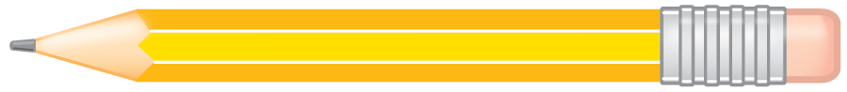

Attachment 1.2: Feelings Wheel

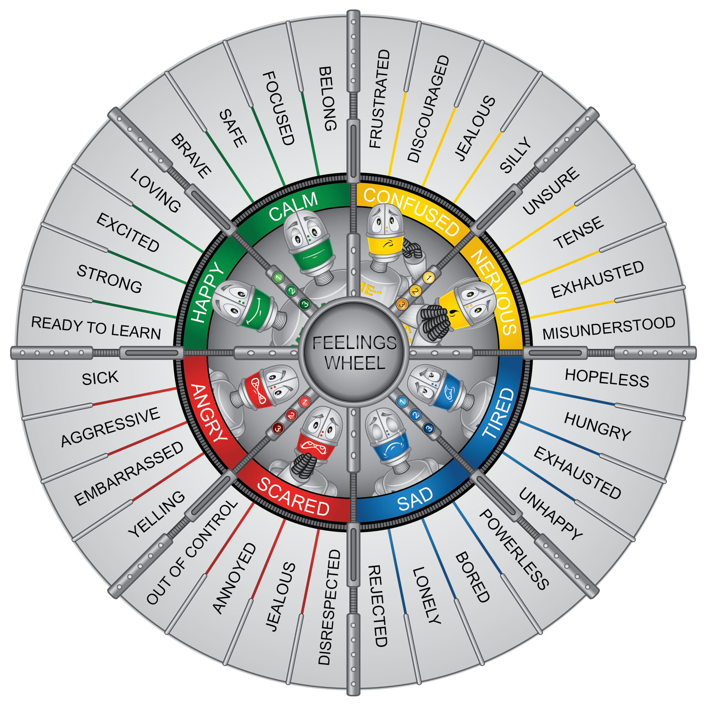

Attachment 1.3a: Robot Feelings

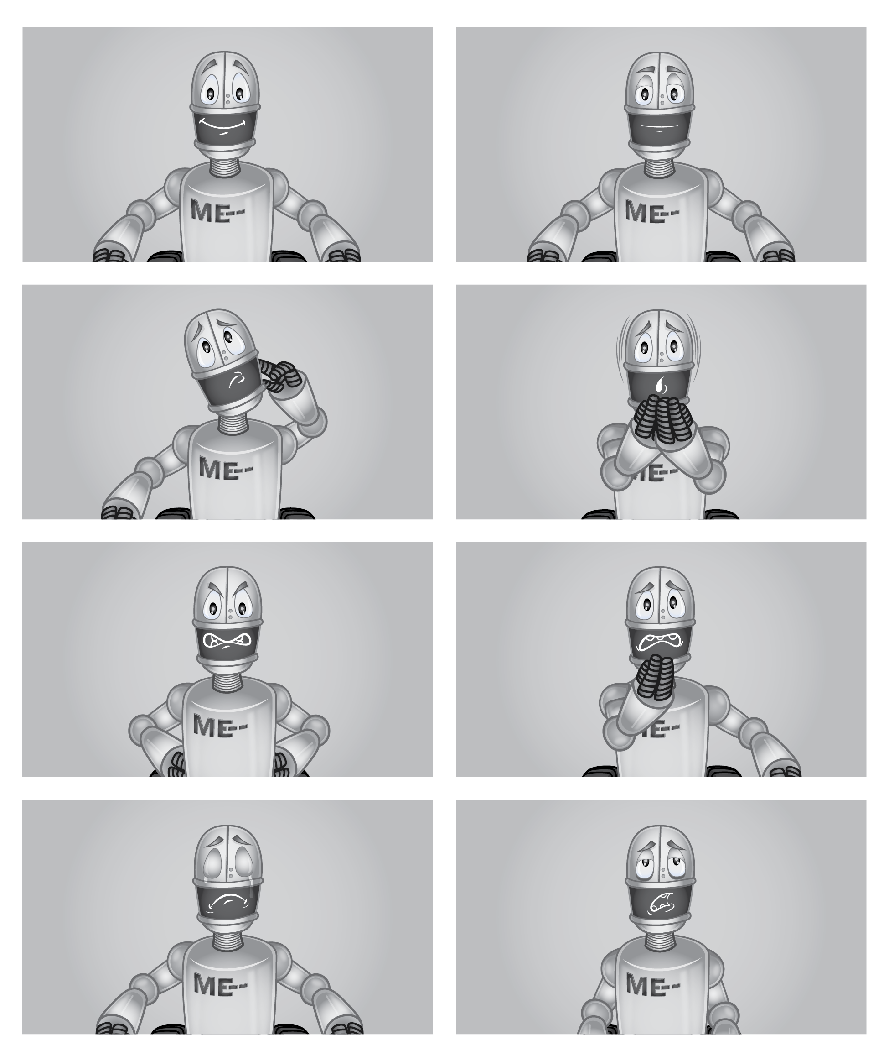

Attachment 1.3b: Feelings Cards

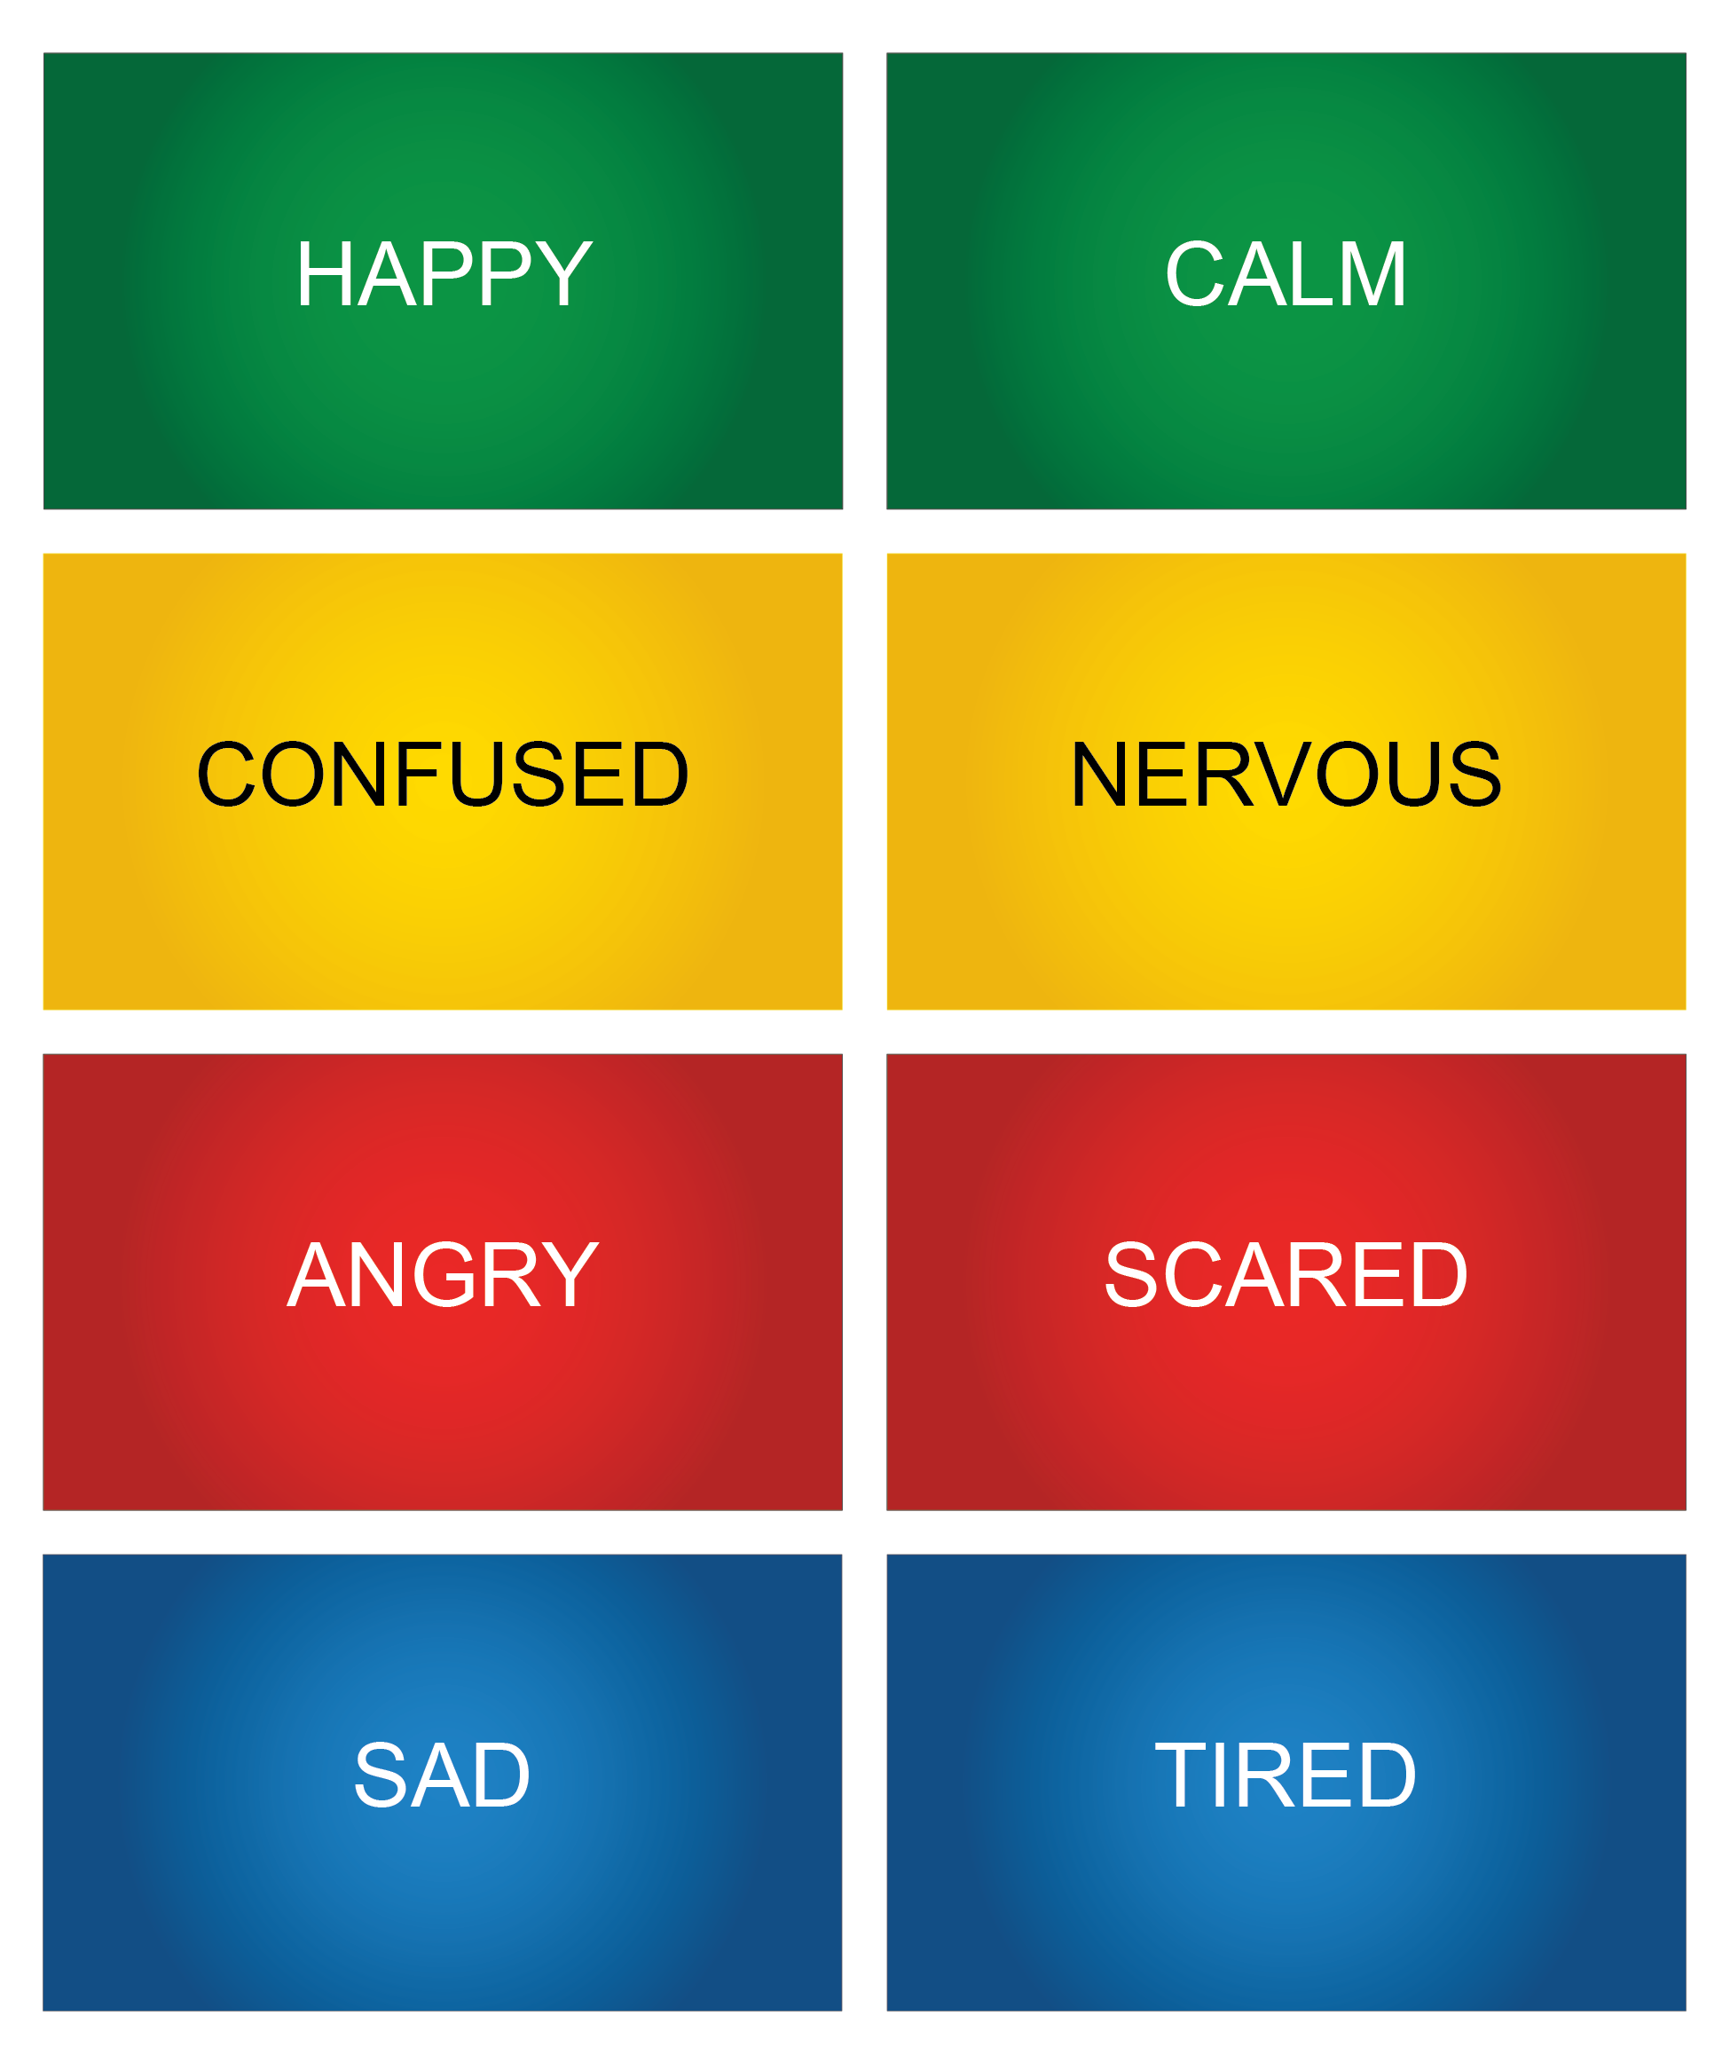

Attachment 1.3: How I Feel

*Directions:* Circle how you would feel and how strong the feeling would be.

*Situation 1:* Syd is having a tough day at school. She woke up late and forgot her lunch on the counter, and her stomach is already growling. (*Use your feeling wheel to decide how you would feel.*)

|  |  |  |  |  |
| --- | --- | --- | --- | --- |
| **I feel** | | | | **It feels** |
| **Green** | **Yellow** | **Blue** | **Red** | **Rate** |
|  |  |  |  |  |

What could you do to think and act in healthy ways?

*Situation 2:* You found out your class won an award for great attendance. You’ll get ice cream sandwiches at the end of the day. (*Use your feeling wheel to decide how you would feel.*)

|  |  |  |  |  |
| --- | --- | --- | --- | --- |
| **I feel** | | | | **It feels** |
| **Green** | **Yellow** | **Blue** | **Red** | **Rate** |
|  |  |  |  |  |

What could you do to think and act in healthy ways?

You can reach out to a ____________ adult when you need help with your feelings

Attachment 1.4: Activity for ME: Self-Assessment

I can demonstrate square breathing.

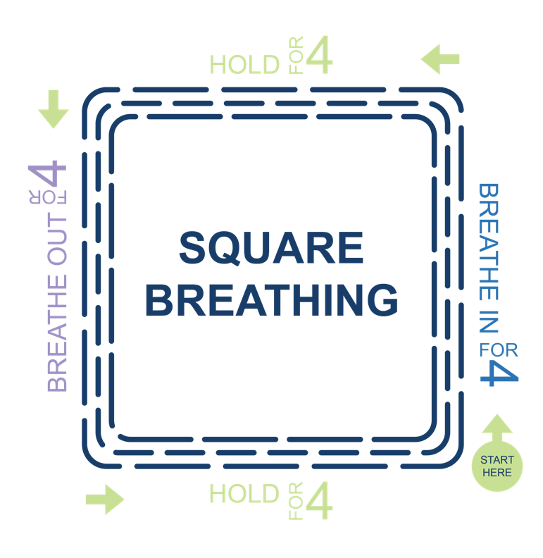

How do you feel when you do square breathing?

|  |  |  |  |
| --- | --- | --- | --- |
| **Green** | **Yellow** | **Blue** | **Red** |
|  |  |  |  |

Would you use this activity again?

|  |  |  |
| --- | --- | --- |
|   **Yes** | **Maybe** | **No** |

I can recognize my feelings.

|  |  |  |
| --- | --- | --- |
|   **Yes** |   **Maybe** |   **No** |