**Lesson 4: It’s ME**

**Overview:** Students will apply what they’ve learned in the first three lessons to share and awareness of ME, activities that strengthen ME, skills recognize, reach out and use resources that support ME.

National Health Education Standards

**Standard 1:** Students will comprehend concepts related to health promotion and disease prevention to enhance health.

**Standard 4:** Students will demonstrate the ability to use interpersonal communication skills to enhance health and avoid or reduce health risks.

Healthy Behavior Outcome (HBO):

|  |  |
| --- | --- |
| **MEH HBO 2** | Engage in activities that are mentally and emotionally healthy. |

Lesson Objective- Students will be able to:

|  |  |
| --- | --- |
| **Objective** | **Assessments** |
| Use positivity to enhance emotions and feelings. | Attachment 4.1: Positivity |
| Recognize different emotions and feelings | Attachment 4.2: Toolkit for ME |
| Describes how to recognize when help or resources are needed to support ME | Attachment 4.3: Show What you Know |
| Identify trusted adults that can support mental and emotional health. | Attachment 4.3: Show What you Know |
| Identify activities, resources, and strategies for each zone of emotions to support mental and emotional health | Attachment 4.2: Tools for ME |

ME Activity:

* Explain: “We are going to practice using another tool to promote ME – positivity. First, I will **show** you what the tool looks like. Then we will **do** it together, and then you will **show me** how to do it. Be slow and calm as we practice this tool.”
* **Positivity** helps kids to gain confidence and contributes to a growth mindset. Looking to the positive, even when faced with a challenge, can help ME health.
* Let’s practice positive self-talk by saying something positive instead of negative. Instead of “I can’t,” you can say ___________. (Example: “I can’t *yet.”)*
* We can also use positivity to take a negative thought and change it into a positive one. Let’s practice it in a new situation. Can you take this statement and make it positive?
  + “I can’t do that; it looks too hard.” (Try, ““It looks really hard, but I’ll do my best.”)
* We can also say something positive about ourselves (Attachment 4.1). “I am _______.” You might think about a talent, interest, or achievement that makes you proud.
* Great job of being positive! We’ll keep working on being positive and in this lesson. We’ll also practice using communication to enhance our mental health.

Introduction:

* We’ve learned a lot about ME — mental and emotional health. Our final lesson is going to show what you know about ME health and collect your tools and skills in a toolbox. We’re going to review how to recognize our feelings, reach out, and use our resources to support ME health.

Teaching Steps:

**Activity 1:** Tools for ME

* We’re going to collect the tools we’ve learned during our lessons into a toolkit to strengthen our mental and emotional health. Our toolkit has three sections:
* **Recognize** – One tool is to recognize my thoughts, feelings, and emotions.
  + Add two feelings you recognize for each color (e.g., green for happy, calm feelings).
  + Choose one feeling word and think about a situation or reason you felt that way. Then complete this sentence: I feel ________ because _______________.
    - Example: I feel happy because I played with my friends.
* **Reach out** – Use these tools to ask for help from trusted adults and resources.
* **Resources** – These tools can be sources of information, activities, or people who can help me. These can help me be positive, recharge my mental health, or help me at home, at school, and in the community.
  + We learned to:
    - Calm, move, think, and distract.
    - Students can share an example of each tool or resource.
* **Practice:** You have to read something to the entire school today for an assembly. Think about the following things:
  + I feel ____________.
  + **Recognize:** Is this an everyday feeling or an overwhelming feeling? Think: What can I do to support ME? Choose a strategy or activity that might help.
  + **Reach out:** Who would you talk to if you needed help with how you are feeling?
  + Use **resources**: Choose a healthy way to respond to this situation. Remember your resources that include tools, skills, and trusted adults.

**Activity 2:** Show what you know about ME health.

* Complete the knowledge check-in first and then review the answers.
* Have students complete the skill check. Review the answers.

Closure:

* What is mental and emotional health?
  + It is how we feel, think, and act.
* Why is mental and emotional health important to me?
  + It impacts our physical health, our behavior, and our well-being.
* How can you support your mental and emotional health?
  + Know about our feelings and emotions. Use activities that strengthen mental and emotional health. Recognize, reach out for help, and use resources to support mental and emotional health.

**Attachment 4.1: I can be positive!**

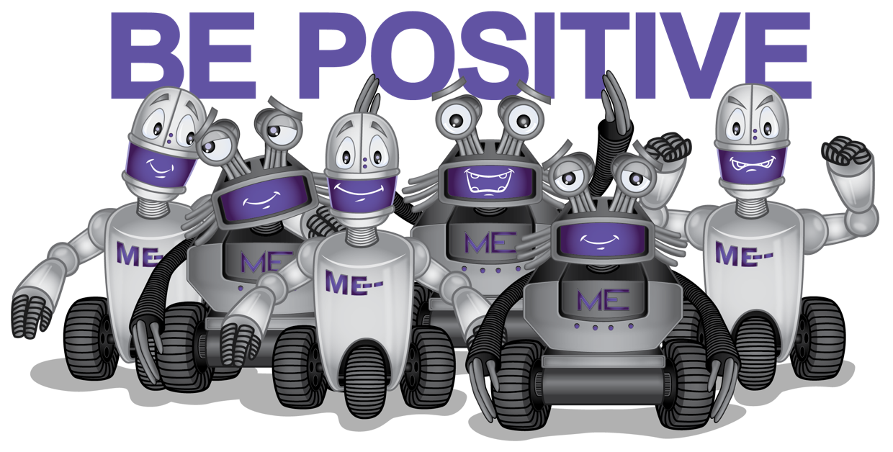

|  |  |
| --- | --- |
| Instead of | I will say… |
| I can’t | __ can |
| I am not good enough |  |
| Make your own positive affirmation |  |

When I am positive, I feel __________________ (Circle the color and write your feeling in the blank.)

|  |  |  |  |
| --- | --- | --- | --- |
| **Green** | **Yellow** | **Blue** | **Red** |
|  |  |  |  |

Attachment 4.2: Toolkit for ME.

I can recognize my feelings. Write two feelings words for each color.

|  |  |  |  |
| --- | --- | --- | --- |
| Green | Yellow | Blue | Red |
|  |  |  |  |
| Two feeling words: | Two feeling words: | Two feeling words: | Two feeling words: |
|  |  |  |  |
|  |  |  |  |

Choose one feeling word from any color and share how you feel.

I feel __________ because….

When I have big feeling, I can…. (Circle your answers)

|  |  |  |  |
| --- | --- | --- | --- |
| Take a Deep Breath | Move | Distract | Ask for help |
|  |  |  |  |

Draw or write the name of a trusted adult who can help you.

Attachment 4.3: Show What You Know

**Part I. What Did We Learn?**

1. **True** or **Fals**e. Everyone has emotions and feelings.
2. **True** or **Fals**e. My downstairs brain is good at thinking and making decisions.
3. **True** or **False** All emotions and feelings are okay.

**Write the number under each category of feeling.**

|  |  |  |  |  |  |  |  |
| --- | --- | --- | --- | --- | --- | --- | --- |
| 1. Happy | | 1. Sad | | 1. Angry | | 1. Nervous | |
| **Green** | | **Yellow** | | **Blue** | | **Red** | |
|  | |  | |  | |  | |
|  | |  | |  | |  | |

**Part 2. Skills Check**

|  |  |  |  |
| --- | --- | --- | --- |
| **I can….** | **Always** | **Sometime** | **Never** |
| **Recognize** my feelings. | **Yes** | **Maybe** | **No** |
| **Reach out** and share how I feel. | **Yes** | **Maybe** | **No** |
| **Reach out** and ask for help. | **Yes** | **Maybe** | **No** |
| **Use resources.** | | | |
| I know at least one trusted adult who can help me with ME health. | **Yes** | **Maybe** | **No** |
| I can use tools or resources to regulate my emotions. | **Yes** | **Maybe** | **No** |