**Lesson 2: It’s ME: Feel, Think, & Act**

**Overview:** Students apply their knowledge of feelings and emotions to recognize feeling and understand how feelings are linked to how we think and act. When we recognize big feelings and emotions, we can reach out to resources to be sure we think and act in healthy ways.

National Health Education Standards

**Standard 1:** Students comprehend functional health knowledge to enhance health.

**Standard 3:** Students demonstrate health literacy by accessing valid and reliable health information, products, and services to enhance health.

**Standard 7:** Students demonstrate observable health and safety practices.

Healthy Behavior Outcome (HBO):

Students will engage in activities that are mentally and emotionally healthy.

Lesson Objective – Students will be able to:

|  |  |
| --- | --- |
| **Objective** | **Assessments** |
| 1. Describe emotions and feelings. | Attachment 2.2 – How Do You Feel, Think, and Act? |
| 1. Recognize when help is needed with emotions and feelings. | Attachment 2.2 – How Do You Feel, Think, and Act? |
| 1. Analyze whether emotions and feelings are expressed with healthy or unhealthy actions. | Attachment 2.2 – How Do You Feel, Think, and Act? |
| 1. Identify trusted adults who can help with emotions and feelings. | Attachment 2.2 – How Do You Feel, Think, and Act? |
| 1. Demonstrate a strategy that enhances mental health and recognize the feelings after completing the skill. | Attachment 2.3 – The Big Squeeze |

Behavioral HELPs Reminders

This lesson examines emotions, feelings, and actions. Connect with your school’s behavioral health services and resources to identify how students can connect to those services and resources. It is also helpful to share parent education resources (see HELPs Parent Education Handout in the Teacher Guide) for when students identify overwhelming feelings.

ME Activity:

* **EXPLAIN:** “We are going to practice a calming or regulating activity to calm body and brain/mind. First, I will **show** you what the tool looks like. Then we will **do** it together, and then you will **show me** how to do it. Be slow and calm as we practice this tool.”
* **The Big Squeeze (Attachment 2.3)**
* Choose one muscle group to squeeze. It could be your making your fingers into a fist or curling your toes. We’re going to squeeze, count to five, and then release.
* How does your body feel when you squeeze? What’s the feeling when you let go of the squeeze? Remember to use “I feel _______ because ______________.”
* Let’s try it three more times. If you want, you can try another muscle group. Sometimes I work from my toes up.
* Can you describe how you feel after using this activity?
  + I feel __________ because _____________.
* When might you use this activity?
  + We might use it when we’re feeling anxious or stressed. It’s a good activity to feel the release of tension.

Teaching Steps:

Activity 1: Recognize, Reach Out, and Use Resources

* Review mental and emotional health. Mental and emotional health is how we **feel, think**, and **act.**
* Everyone experiences feelings and emotions, but how we experience them and respond to them is different for each person. People experience a wide range of feelings and emotions.
* **Feelings** give us information that we can pay attention to and learn more about a situation. Feelings are not good or bad or positive or negative.
  + It’s important to recognize and understand emotions and feelings because they can impact how we think and act. We want to be sure we act in ways that are healthy and safe.
* **Thinking** is the work our brains do to help us learn and make good decisions.
* **Actions** are when we make decisions or are how we behave. We need to act in ways that are healthy and safe to help our minds and bodies.
* We’re going to learn how to **recognize** our emotions, **reach out** for help when needed, and use **resources** to help us think and act in healthy and safe ways.
* Let’s review the Feelings Wheel and practice recognizing emotions (see Attachment 2.1).

*Part 1:* Recognize Emotions and Feelings

* Teacher - Select one robot emoji from each color (Attachment 2.1). Show the emoji and have the students tell you what color then use a feelings vocabulary word. Teacher model how to share feelings – “I feel_____.
  + Option – You can integrate math by rolling two dice, adding the numbers together and then sharing the robot emoji.
* Emotions are not always easy to label or recognize with a vocabulary word, and you might not know what you are feeling or why you are feeling a certain way. If you can’t find the feeling word, then you can use the color (e.g., red, blue, yellow or green). We can also use the scale to describe how strong we’re feeling. The scale includes Level 1 (small), Level 2 (medium), Level 3 (big feelings). Sometimes feelings are big when they seem to be difficult to control; you might feel like you are unable to think or act in healthy and safe ways.
  + When our feelings are Level 2 or 3, we need to think about how we can be healthy and safe.
* Practice recognizing emotions using the following steps. Practice recognizing emotions using the following steps. Have the students only complete the first three columns.

1. Read the scenario (Column 1) and identify the feeling and strength (Column 2).

2. Then ask students to show a thumbs up (upstairs brain – 1), sideways (middle-2), down (downstairs brain – 3). (Column 3)

* + My birthday is today.
    - I feel really excited about my birthday. Rate the feeling (1-3)
  + I forgot my lunch on the bus.
    - Examples – “I feel unsure (yellow) because I don’t know how I will eat today.”
    - “I feel frustrated (red) and hungry (blue) because I want to eat.
    - Rate the feeling (1-3)
  + I spent recess arguing with my friends about what game to play.
    - I feel angry because we argued instead of playing.
    - I feel frustrated because we did not play much today.
    - I feel sad because we were arguing. Rate the feeling (1-3)
* If you have felt a Level 3, you should reach out to a resource like a trusted adult and tell them how you feel so you can think and act in healthy ways.
  + Can you remember who is a trusted adult you can ask for help?
    - Parents, grandparents, teachers, counselors, and other adults
  + Let’s learn more about how we can think and act in healthy ways when we recognize our emotions.

*Part 2: How do you feel, think and act?*

* Now we’re going to practice recognizing how feelings and emotions impact how we think and Now we’re going to practice recognizing how feelings and emotions impact how we think and act.
* Our brain has an upstairs and downstairs. Our upstairs brain is working when our brain is in control, and we can think and play. Our downstairs brain controls our body functions like breathing and heart rate without thinking. The downstairs brain takes over when we experience big emotions, so we might not be in control, or we must work to think and act in healthy ways.
  + We can rate our feelings from big (3) to small (1). Big feelings mean our downstairs brain is working hard, while in a Level 1, our upstairs brain is working hard.
  + Some feelings and colors — like red and blue — are more likely to feel big.
* Fortunately, we can use the “stairs” between our upstairs and downstairs brain. We can use a two-step process to be sure we think and act in healthy ways. We can:

1. Stop and think — recognize our feelings.

* + - I feel ________ because __________.
    - How strong is the feeling? (1, 2, or 3)

1. Manage and express emotions, feelings, and behaviors with healthy actions.
   * + Manage also means to identify and regulate. Today we’re going to learn how to regulate our emotions and feelings so we can express them in healthy ways.
     + Express with healthy actions. We can control how we think and act.

* Practice:
  + I spent my recess arguing with my friends about what game to play.
    - Recognize my feelings.
      * I feel angry (Level 2) because we argued instead of playing.
  + How can I think and act in healthy ways? Can I manage and express my emotions?
  + I can take a breath and think about how we can compromise.
  + I can share how I am feeling.
* We can learn skills and strategies to manage our feelings, thoughts, and actions. Let’s learn about tools, activities, and strategies that we can practice to regulate our emotions and behavior.
  + Let’s think about a couple of ways we can manage our emotions.
    - Calm: I can take a breath or find a calming, relaxing space.
    - Move: I can move my body
    - Distract: I can doodle, draw, or use a fidget to distract how I’m feeling.
    - Think: I can be positive.
    - Reach Out: I can share how I am feeling with someone.
    - Ask: Ask for help.
* Who can help you?
  + Trusted adults. Trusted adults are adults who care about you and are willing to help you. Some of the trusted adults in our building include teachers, the school counselor, and many others. Health professionals like doctors, nurses, and counselors are also trusted adults; they are trained and ready to help you be healthy and safe.

*More Practice*

* Example 1 – You lost a video game right before winning the level. You slam the controller down.
  + Stop and think: What am I feeling? I feel ____________.
  + Are my thoughts and actions healthy and safe?
  + What could I do to be healthy and safe?
* Example 2 – When you were playing tag, you didn’t feel a tag, but the tagger said they got you. You’re frustrated, but you say, “OK, I’ll be it.”
  + Stop and think: What am I feeling? I feel ____________.
  + Are my thoughts and actions healthy and safe?
  + What could I do to be healthy and safe?

Closure:

* Great job today recognizing your emotions, thinking about how we can act in healthy and safe ways. Let’s review how to recognize our feelings
* What are feelings ___________? (Select one robot from each color of the wheel. Ask students to share a feeling from that color)
  + Recognize my feelings and if my brain is upstairs or downstairs.
* What can you do to act in healthy ways?
  + I can reach out and use resources like staying calm, thinking positive, or taking a breath.
  + I can share how I am feeling with a trusted adult.
  + I can ask a trusted adult for help.
* Who can you reach out to?
  + Trusted adults at home or school.
  + Recognize your emotions, reach out for help, and use your resources to think and act in healthy ways.

Attachment 2.1: Feelings Wheel

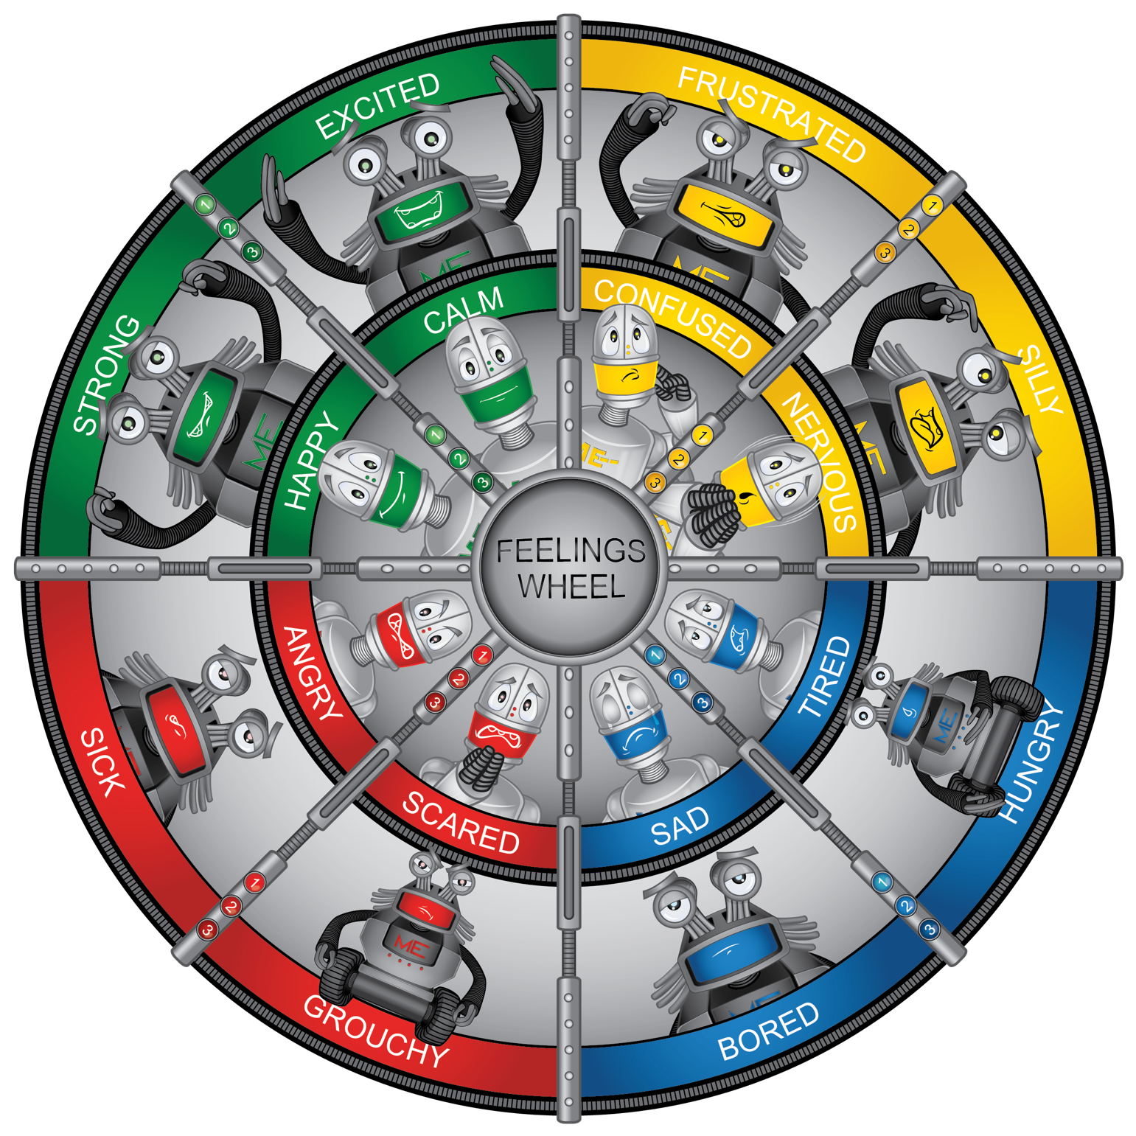

Attachment 2.2: Name that feeling

Directions: Roll two dice and count the number. Show the robot. Students respond with the color, then the word.

|  |  |  |
| --- | --- | --- |
| 1 | 2 | 3 |
| 4 | 5 | 6 |

Show these robots

|  |  |  |
| --- | --- | --- |
| 1 | 2 |  |
| 4 | 5 | 6 |

Answer Key:

|  |  |  |
| --- | --- | --- |
| Angry (1) | Confused (2) | Scared (3) |
| Happy (4) | Nervous (5) | Sad (6) |

Attachment 2.3: How do you feel?

|  |  |  |  |  |  |  |
| --- | --- | --- | --- | --- | --- | --- |
| **Story** | **Feeling** | | | | **Size** | **Upstairs or Downstairs** |
| **Column 1** | **2** | | | | **3** | **4** |
| **Green** | **Yellow** | **Blue** | **Red** |
| My birthday is today. |  |  |  |  |  |  |
| I spent recess arguing with my friends about what game to play. |  |  |  |  |  |  |
| I forgot my lunch on the bus. |  |  |  |  |  |  |

Draw or write the name of a trusted adult who can help you be healthy and safe.

Attachment 2.4: Activity for ME: Self-Assessment

I can demonstrate the “Big Squeeze.”

|  |  |
| --- | --- |
| **Critical Elements** | **Check if Yes** |
|  |  |
| Count to 5 |  |
| Release |  |

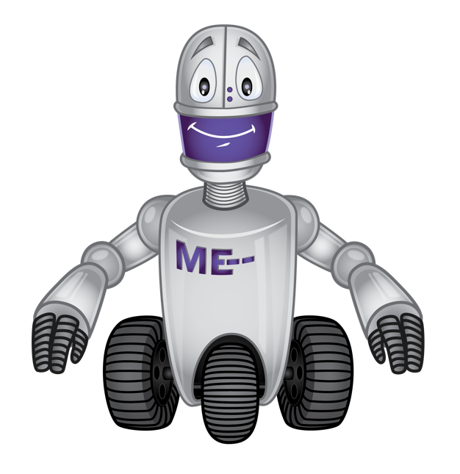

Circle how you feel when you do the Big Squeeze?

|  |  |  |  |
| --- | --- | --- | --- |
| **Green** | **Yellow** | **Blue** | **Red** |
|  |  |  |  |

Would you use this activity again?

|  |  |  |
| --- | --- | --- |
| **Yes** | **Maybe** | **No** |