Lesson 1: Me and My Feelings
Overview: Students will learn that mental and emotional health is how we feel, think and act. Students will describe feelings using their feelings vocabulary and the rating scale.
National Health Education Standards
Standard 1: Students comprehend functional health knowledge to enhance health.
Standard 3: Students demonstrate health literacy by accessing valid and reliable health information, products, and services to enhance health.
Standard 7: Students demonstrate observable health and safety practices.
Healthy Behavior Outcome (HBO):
Students will engage in activities that are mentally and emotionally healthy.
Lesson Objective- Students will be able to:
Objective | Assessments
- Describe mental and emotional health. | Attachment 1.1 – Feelings Wheel
- Identify different emotions and feelings. | Attachment 1.2 – Recognize Feelings  Attachment 1.3 – How Are You Feeling?
- Describe emotions and feelings using vocabulary words and descriptors. | Attachment 1.2 – Recognize Feelings  Attachment 1.3 – How Are You Feeling?
- Analyze a situation to recognize the emotion or feeling present. | Attachment 1.3 – How Are You Feeling?
- Demonstrate a breathing activity that promotes mental and emotional health. | Attachment 1.4 – Feelings Wheel
Behavioral HELPs Introduction:
- This lesson examines emotions, feelings, and actions. Connect with your school’s behavioral health services and resources to understand how students can connect to those services and resources. Ensure school mental health staff has set time aside to manage student self-referrals and any uncomfortable feelings students may have after this lesson.
- It is also helpful to share parent education resources (see HELPs Parent Education Handout) to have resources and support available when students identify overwhelming feelings.
- This lesson aligns with the concept of “feelings from Erika’s Lighthouse (https://www.erikaslighthouse.org/portal/). We suggest using Erika’s Lighthouse to support your students as part of a whole school, whole community approach to provide a safe, supportive culture around mental health.

Lesson Introduction:
- Today’s lesson addresses mental and emotional health. If you are recognize feelings, emotions, or thoughts that you think need help or support, you can reach out to me or a trusted adult at school. (Remind students of your procedures if students need to use a regulation or mindfulness tool or strategy.)
- Remind students of your classroom expectations and norms to create a safe, supportive environment. (INSERT your procedures here)
ME Activity: Take a Breath
- We’re starting a series of mental and emotional health lessons. You’ll hear me call these ME lessons, which stands for mental and emotional health, but it’s also because mental and emotional health is about ME. You’ll learn about what ME health is and how it connects to all aspects of your health. You’ll also learn strategies and activities that can enhance ME and your health. Each lesson about ME will have an activity or practice you can use to strengthen your own ME health. Today’s activity is a breathing skill that will help us have a calm body and brain. First, I will show you what the tool looks like. Then we will do it together, and finally you will show me how to do it. Be slow and calm as we practice this tool.
- Blow Out the Candles
  - Inhale deeply into your chest and belly; breathe out to blow out the candles.
  - They didn’t go out the first time. These might be special candles that take at least three tries to blow them out. Let’s try again. Remember: It’s breathe in deep in the chest and blow out through the mouth.
  - Repeat at the end of class and complete Attachment 1.4.
Teaching Steps:
Activity 1: Getting to know ME: Defining Mental and Emotional (ME) Health
- What is mental and emotional health?
  - ME health is how we think, feel, and act.
  - ME health helps us be happy, healthy, and productive. ME health impacts our overall health. It is also connected to our physical health and social health.
  - Think of mental health as taking care of our minds; think of physical health as taking care of our bodies; think of social health as taking care of relationships with family, friends, peers, and others in your community.
  - ME Health is just as important as physical health. Just as we take care of our bodies by brushing our teeth, being physically active, and eating healthy, we’ll learn how to take care of mental health. Your mental and emotional health impacts not only your thinking and mood; it can also affect your physical health and behavior.
  - While we get to know more about ME health, you’ll learn more about your strengths, abilities, talents, and activities that support ME.
Activity 2: Matching Emotions
- Our mental and emotional health is made up of feelings, thoughts, and actions.
  - Feelings and emotions are within or inside ourselves.
    - Everyone experiences emotions, but how we experience them and respond to them are up to each person.
    - People experience a wide range of feelings and emotions. Feelings are not good or bad, positive, or negative, but they can give us information that we can pay attention to.
    - Feelings change; they don’t remain the same for too long.
    - It’s important to understand emotions and feelings because they can impact how we act. We want to be sure we act in ways that are healthy and safe.
  - Thinking occurs when our brain is working and processing information to help us learn and make decisions.
  - Actions are behaviors.
- If we can label or describe how we’re feeling, it can help us manage those feelings and think about how we can act in ways that are healthy and safe.
  - We’re going to practice matching feeling with the word. Show students the Feelings Wheel (Attachment 1.1). Read through the feelings listed on the Feelings Wheel. Remember if you cannot find the exact word it can be helpful to share what color or category you are feeling.
  - Let’s practice identifying and describing different emotions. The Feelings Wheel (Attachment 1.1) will help us describe our feelings to yourself and others. Describing our feelings and emotions will help us talk about them, share your feelings with others, and help us be aware of how the people around us are feeling.
- There are lots of different feelings, but you can see the wheel organizes them into categories. The categories are helpful if we cannot find the exact word to match how we are feeling.
  - Green – I’m ready to go. Feeling calm, ready, and focused
  - Blue – I’m feeling sad, moving slow, or need some help to get going.
  - Yellow – I’m feeling cautious or worried. I also need some help to accomplish what I want or need to do.
  - Red – I’m feeling frustrated, angry, mad. I don’t feel in control, and I need some help getting control.
  - Step 1: Recognize feelings – Spread out at your emotion picture cards (Attachment 1.2a). Show the pictures (robot side) and have students share what emotions they recognize.
    - Sort the cards by the feelings they recognized and the ones they did not recognize.
  - Step 2: Take the cards the students did not recognize and match them with a color. Remind students that when we can’t find the specific word to describe our feelings, we can use the category to help describe how we are feeling.
    - The categories might help us communicate our feelings when we’re not exactly sure how we’re feeling, but we can help give valuable information.
  - For extra practice, you can have partners play match-up. One partner shows a picture while the other partner tries to match it with a feeling word (Attachment 1.2b).
- Activity 3: Describing my feelings
  - We can use a scale to describe the strength or size of our emotions. The range is between 1 and 3. Level 1 is smaller, so I can think and act in healthy and safe ways. In the middle is Level 2, when my feelings are bigger, but I am still able to stay calm. At the top of the scale is 3 for big feelings. Big feelings are when I am unable to control how I think and act.
    - When I’m at Level 2, I should watch my feelings and use my tools, strategies, and resources to think and act in healthy and safe ways
    - Level 3 is a warning that I might think and act in ways that are unhealthy or unsafe. I should reach out for help from a trusted adult or use my tools to think and act in healthy ways.
- When we are describing feelings, we use the following statements (See Attachment 1.3)
  - I feel _____ (using a feeling word and level).
  - I feel this way because ___________________.
  - In Lesson 2, we will think about tools we can use or people we could ask to help us think and act in healthy ways.
- Attachment 1.1 has pictures of different faces displaying different emotions. We’re going to try to link the emotions to how we might feel in certain situations. (In Lesson 2, we will talk about big emotions; Lesson 1 is just to identify, describe, or label feelings.)
  - How would you feel if:
    - It’s your birthday, and you can’t wait to open your presents.
    - You fell on the way to school.
    - A teacher gave you a big high five on the way into school.
    - The fire alarm went off at school.
    - You got a question wrong on your test.
- You can use the Feelings Wheel (Attachment 1.1) or use your feeling cards (Attachment 1.2a and 1.2b) to describe your feelings for each situation.
- Debrief: Everyone has different emotions for each situation. We can all think about how we’re feeling, and we can act to be healthy and safe.
- Activity 4: Catch Your Breath
- Now that we’ve learned more about our mental health by learning about feelings, thoughts, and actions, let’s think about how our actions can also impact how we feel. We’re going to try our breathing activity again. This time, I want you to think about:
  - When I take a breath, I feel __________ (vocabulary and descriptor) because ____________.
  - Would you use this activity again? (Yes, Maybe, or No)
Closure:
- What do you know about mental health?
  - (Our feelings, thoughts, and actions)
- Why is mental and emotional health important?
  - (Our feelings and thoughts connect to our health. ME health can also influence how we act.)
- How can you share your feelings?
  - I feel ___________ (feelings word and size) because _____________.

Attachment 1.1: Feelings Wheel

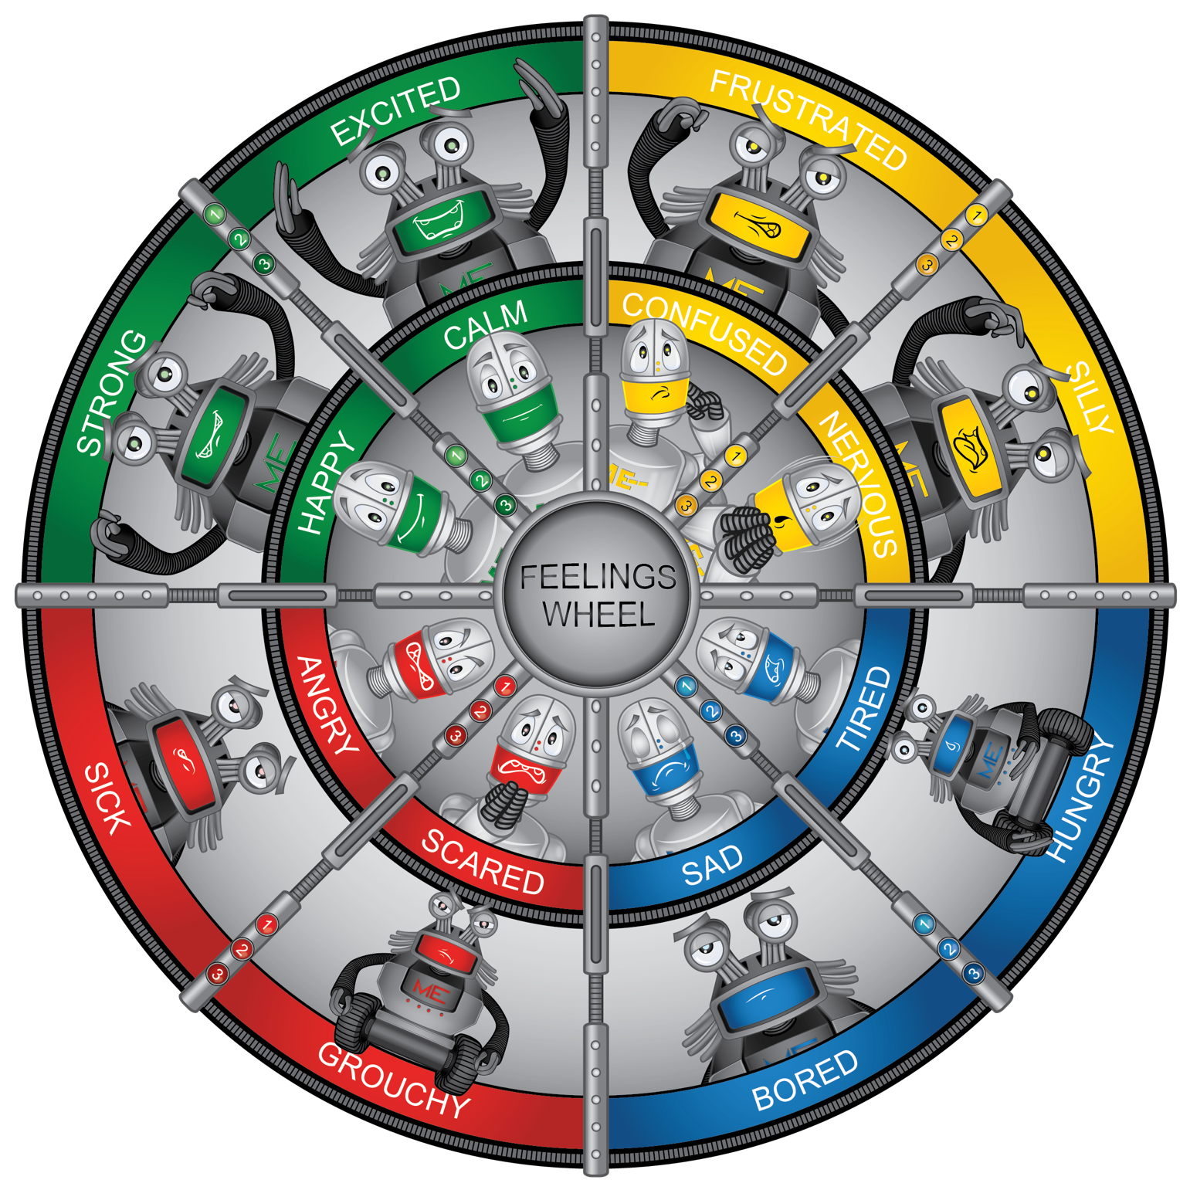

Attachment 1.2a: Robot Feelings
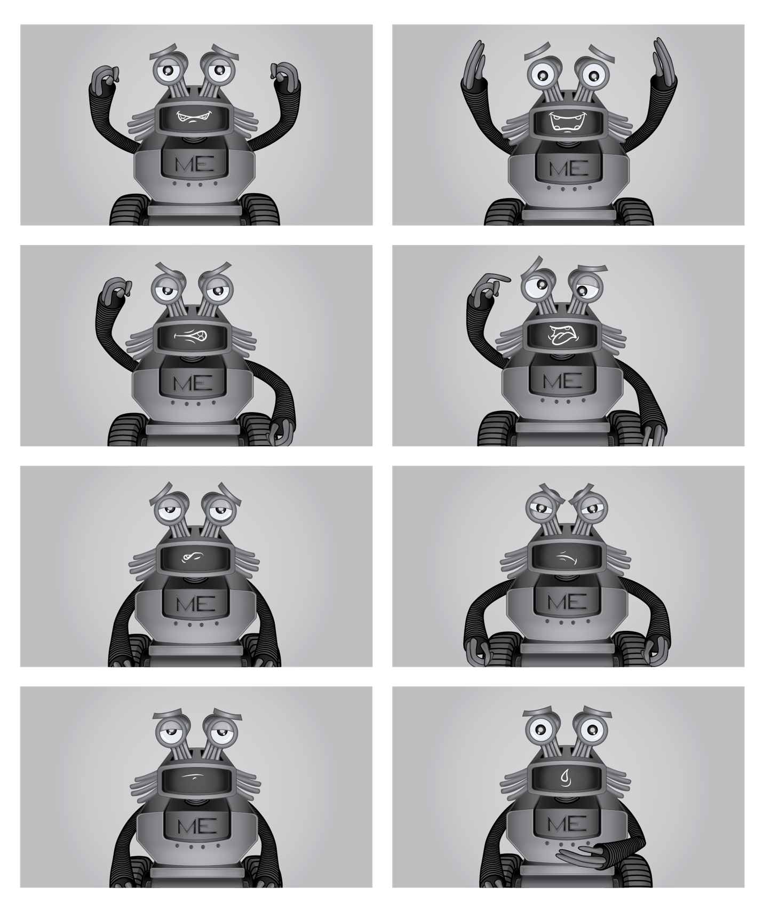

Attachment 1.2b: Feelings Cards
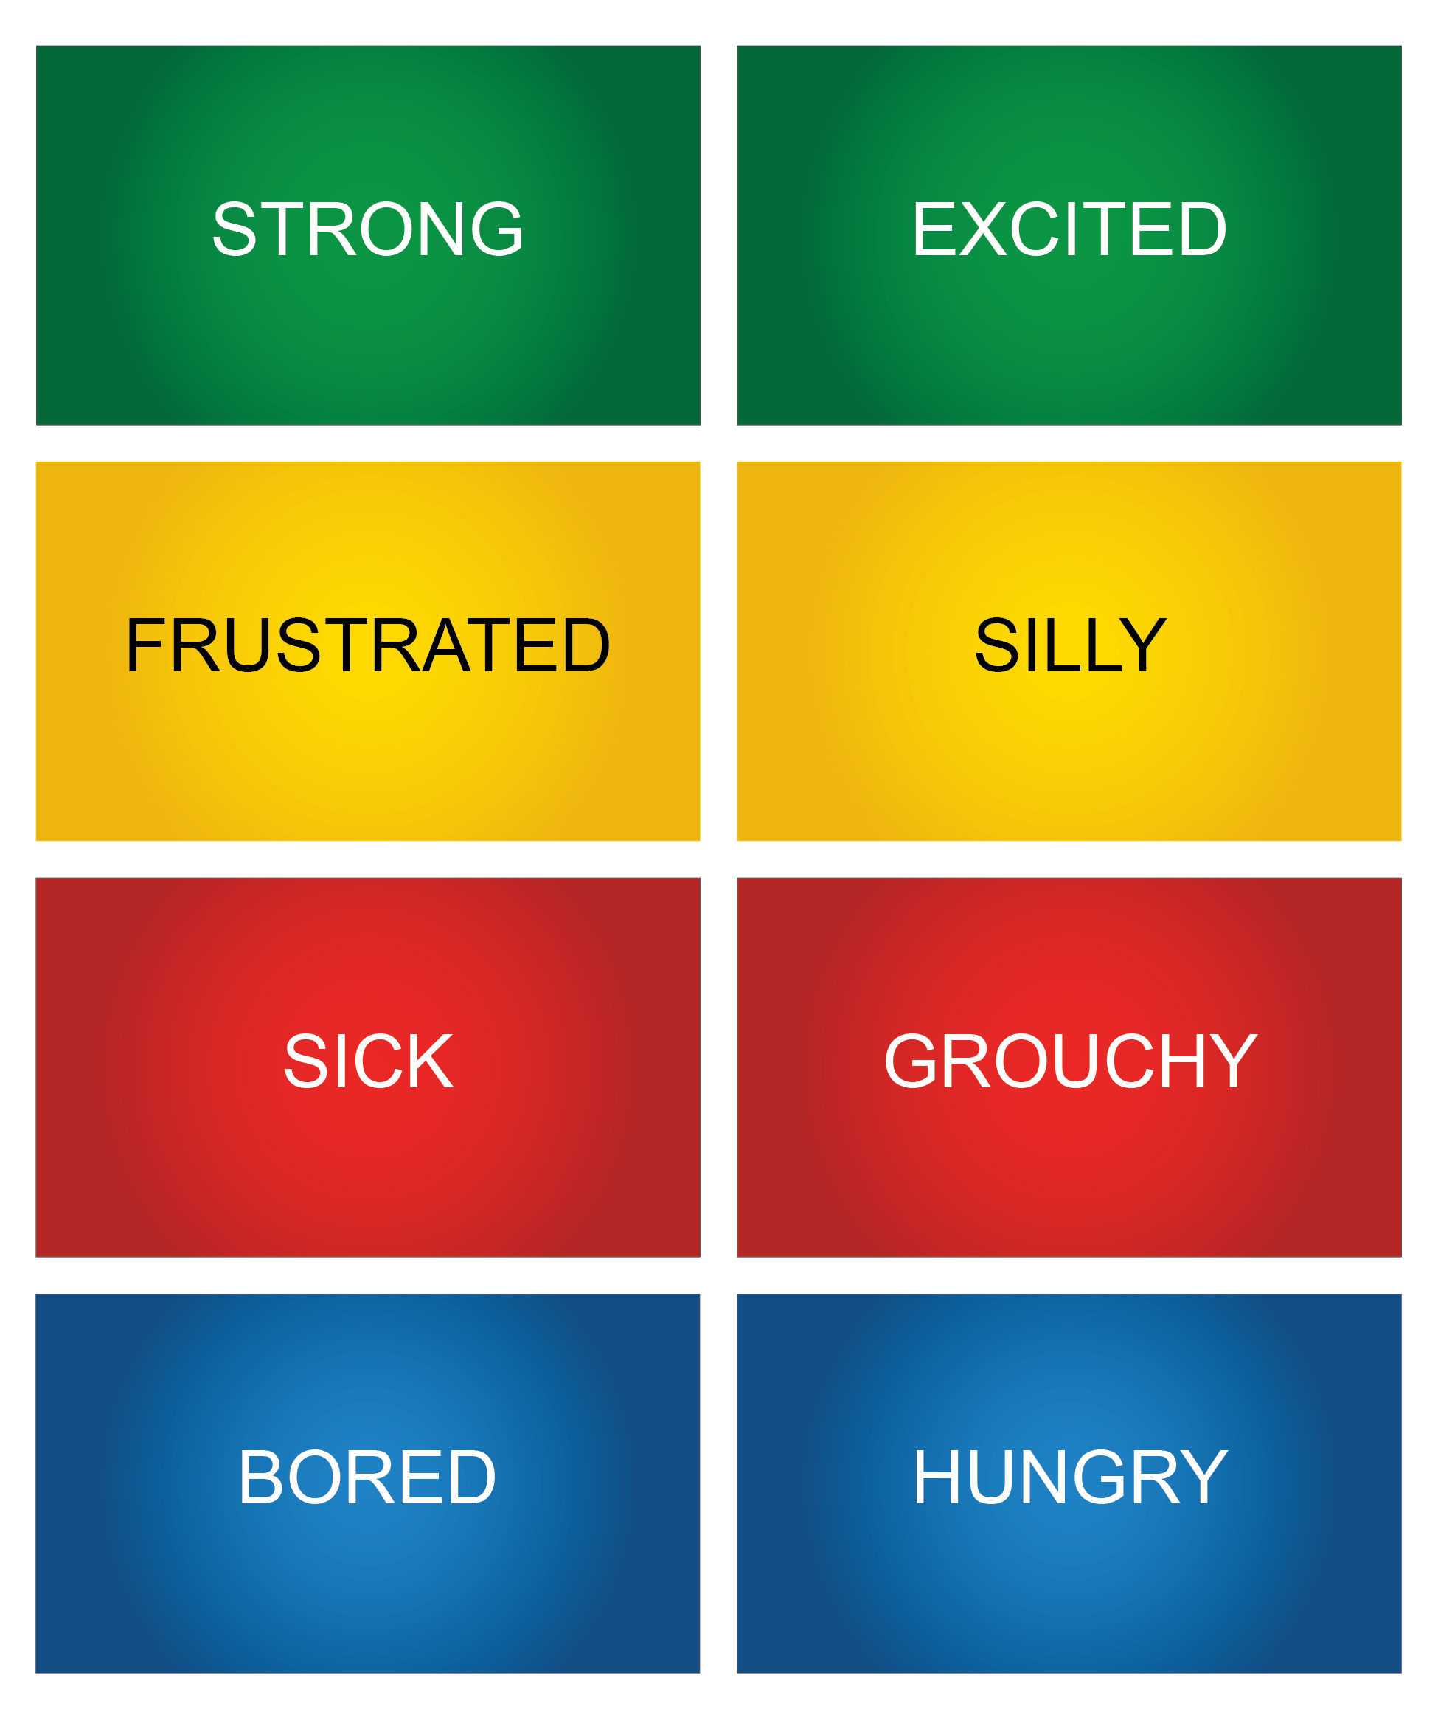

Attachment 1.3: How Are You Feeling?
Directions: Circle how you would feel and how strong the feeling would be.
It’s your birthday, and you can’t wait to open your presents.
I feel |  |  |  | It feels
Green | Yellow | Blue | Red | Rate
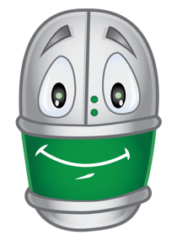 | 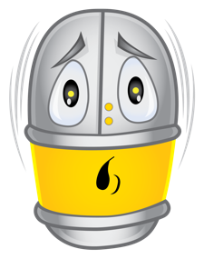 | 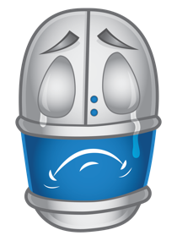 | 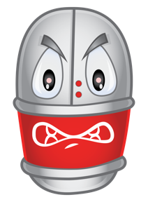 | 

You fell on the way to school.
I feel |  |  |  | It feels
Green | Yellow | Blue | Red | Rate

A teacher gave you a big high five on the way into school.
I feel |  |  |  | It feels
Green | Yellow | Blue | Red | Rate

The fire alarm went off at school.
I feel |  |  |  | It feels
Green | Yellow | Blue | Red | Rate

You can’t figure out the answer to the math problem.
I feel |  |  |  | It feels
Green | Yellow | Blue | Red | Rate

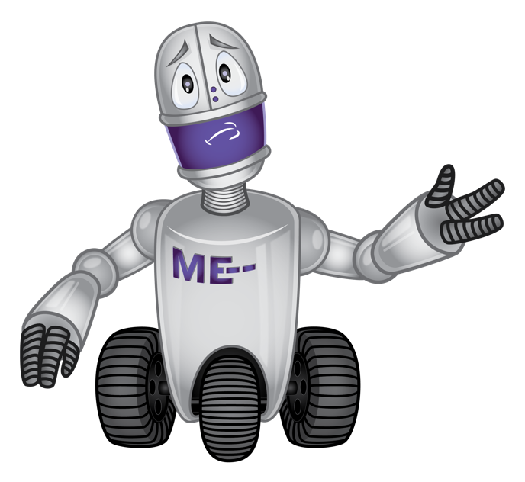
Attachment 1.4: Activity for ME: Self-Assessment
I can blow out the candles.
Critical Elements | Check if Yes
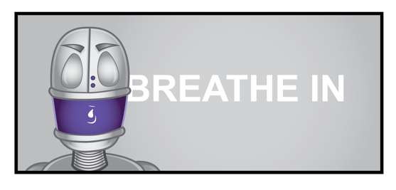

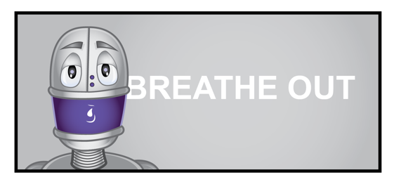

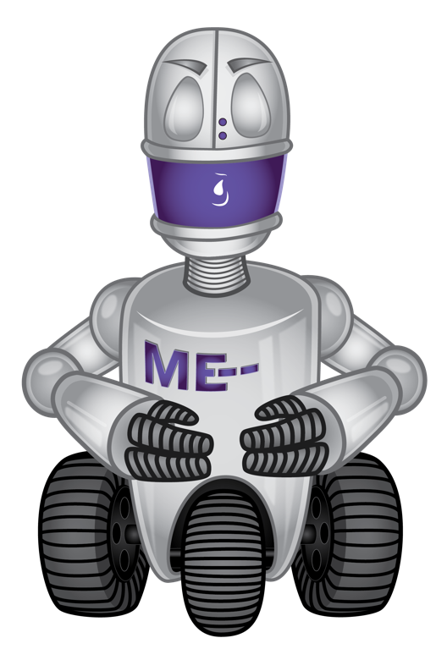

How do you feel when you take a deep breath?
Green | Yellow | Blue | Red
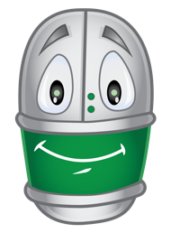 | 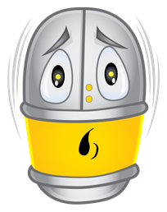 | 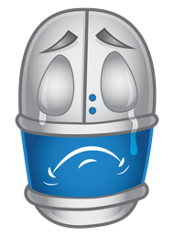 | 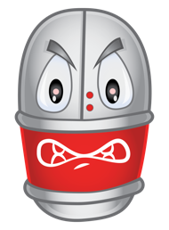

Would you use this activity again?
  Yes |   Maybe |   No

