Tips for the Beginning Nursing Student

Pre-Licensure Students
Welcome to the College of Nursing and Health! You have chosen to embark on a challenging, yet rewarding career! As a professional nurse in training, you must have the tools necessary to learn assessment skills and perform your job.

For your first nursing course, you will be required to purchase the following equipment:

You will need to bring these items with you during lab:
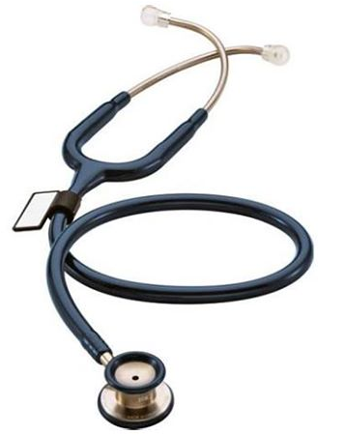
You will need a watch with a second hand for accurate assessment of vital signs.
  - You will be learning how/practicing blood pressures, and you will be required to have your own stethoscope and manual blood pressure cuff. Manual blood pressure cuffs can be purchased at a Medical Supply store, as well as at Affordable Uniforms.
  - A stethoscope is one of the most important items you will need for NUR 2100 and any future clinical experiences.
  - Qualities to look for when purchasing a stethoscope:
    - Single tube
    - Bell and diaphragm, a.k.a. double-sided (for both low and high pitched sounds)
    - Attached name tag (you can also purchase this separately)
  - We suggest you look at the college bookstore, Affordable Uniforms, or order directly from several safe websites. Some safe sites / distributors:
Affordable Uniforms: http://www.affuniforms.com; All Heart: http://www.allheart.com/
Littmann: www.littmann.com
  - You do not need to spend hundreds of dollars on a stethoscope, but do NOT buy the bargain basement variety—like everything else; you get what you pay for. Littmann is a very good brand of stethoscope. Please see the enclosed information from Littman. (The Classic II and the Classic III are both good choices).
- Littman stethoscopes can be purchased at the WSU bookstore. By doing this, the CONH benefits.
MDF and ADC Adscope are reliable brands of stethoscopes for reasonable prices.
    - The MD One Stethoscope (MDF 777) at Affordable Uniforms: Cost is around $69 and you can choose from 12 colors of tubing.
    - The MDF 747XP Stethoscope is also a good quality and costs around $29 at Affordable Uniforms. You can also choose from 12 tubing colors.
    - All MDF Stethoscopes have a lifetime warranty (including the tubing), and come with free replacement parts through the “Free Parts for Life Program.”
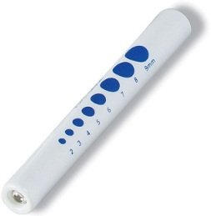
      - *If you purchase an MDF stethoscope, register your stethoscope at www.MDFinstruments.com to qualify for the Lifetime Warranty and the Free-Parts-For-Life Program.
  - You will need a penlight. You can purchase penlights either in the WSU bookstore or in a uniform store. I would suggest purchasing a penlight that also includes a gauge for pupil measurement.

WSU College of Nursing and Health Uniforms:
Students will be required to wear the WSU Nursing Uniform for all clinical experiences and when performing the PE Competency. Students are required to purchase WSU Nursing Uniforms through Affordable Uniforms. You will need to purchase hunter green scrubs with WSU-MV CONH embroidered on the chest. You may also purchase an optional hunter green long-sleeve warm-up jacket with the WSU-MV CONH patch sewn on the left sleeve. You must be fitted and order your uniforms at the Affordable Uniform store before your start to the nursing program.
Information for Affordable Uniforms can be found on the Student Life and Recourses tab: https://nursing.wright.edu/student-life-and-resources
- Uniforms must be clean and in good repair.
- Female students may purchase a skirt or pants uniform.
- The pants and skirts are to be of proper length and fit. If the student is wearing a skirt, the hemline is to be below the knee and worn with white hose.
  - Students who choose to wear ankle-length skirts must purchase the same hunter-green fabric directly from Landau. This will ensure that the color of skirt matches the uniform top.
- Shoes are to be white or black (minimal colored markings), made of leather or vinyl, not canvas.
  - Open toes or heels are not permitted.
  - It is preferred to wear white hose/socks with white shoes, black hose/socks with black shoes.
  - Shoestrings must be white for white shoes, black for black shoes.
  - Shoes are expected to be clean and in good repair and worn only for clinical experiences.
  - Affordable Uniforms also has white shoes at reasonable prices.
- Official Wright State University nursing student photo ID must be worn on the right chest area.
  - This ID can be purchased on campus at Wright 1 Card Services: 055 Student Union.
The full uniform policy can be found as part of the student handbook: https://nursing.wright.edu/sites/nursing.wright.edu/files/page/attachments/Undergraduate-Student-Handbook_0.pdf

WSU College of Nursing and Health Uniform Policy highlights:
- Hair is to be above the neckline. Long hair is to be worn so it does not fall below the base of the neck.
- A plain wedding band may be worn. A watch with a second hand and one pair of stud earrings (one in each ear LOBE) may be worn. No other jewelry may be worn.
- Visible body piercing must be removed. Tattoos must be covered by clothing or Band-Aids as appropriate.
- No make-up should be worn.
- No nail polish is allowed.
- No perfume or aftershave is to be worn.
- Chewing gum is not permissible in the clinical setting.

