GENERAL
• I don’t have a Castle Branch account and never received instructions on how to create an account, what do I do?
Please refer the Castle Branch tab under your degree for instructions on how to create an account.

• Something on my Castle Branch account was rejected and I am unsure why?
If you received a notification that you have something rejected on your profile, you must log into your account using a laptop or desktop computer. The app on mobile devices does not provide you the reason why. Once you have reviewed the reason, if you are still unsure what to do, please contact your clinical coordinator.
• I had a Castle Branch account before, but it is not showing my to-do list?
Your account has been archived due to inactivity for several months. Please email cehs-opfe@wright.edu to report the issue. This process takes up to 3 business days.

• My clinical faculty wants me to print off proof of my compliance from Castle Branch, how can I print off a copy of my profile in PDF format?
Here are instructions to access your Castle Branch (CB) report:
• Log into Castle Branch (https://mycb.castlebranch.com/), select “Document Center,” then select “My Documents”
• Click on “Clinical Requirements” and a list will come up of PDF files.
• Click on the PDF file that starts with "Results…” then select “Download.” The file will download to your computer.
• This file is a 2-3 page document that includes all of your CB results.
• Submit this file to your instructor as instructed. Some may want a printed copy, but others only need an electronic copy.
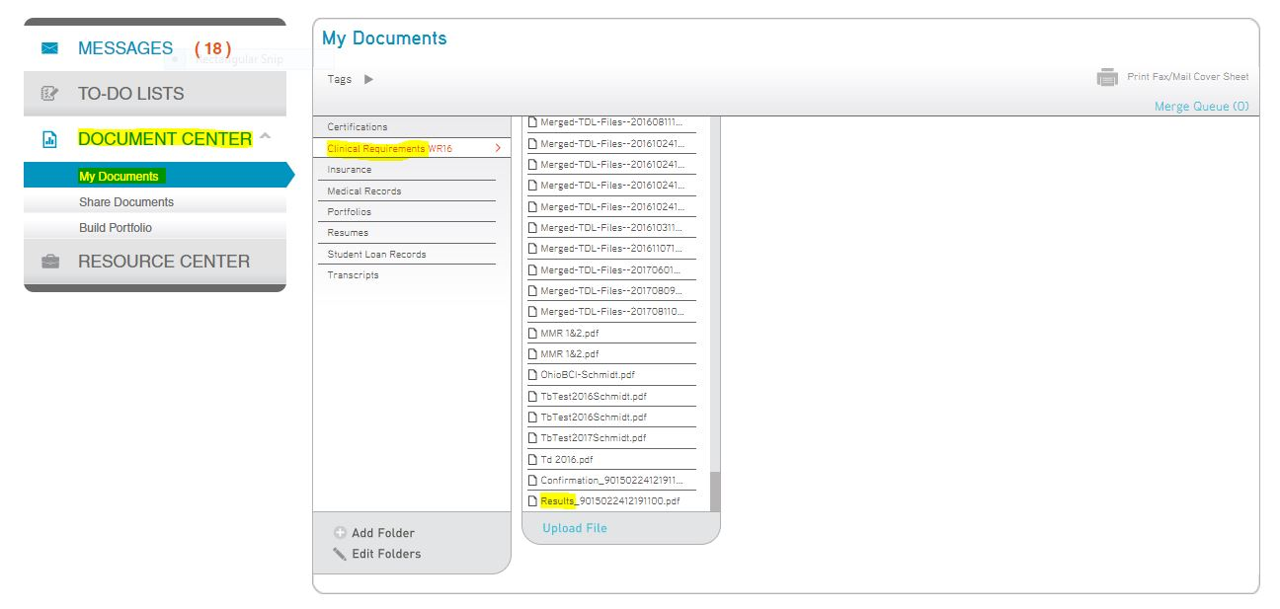

MEDICAL AND IMMUNIZATION REQUIRMENTS

• How recent must my immunizations and other medical records be?
You must show proof of one TdaP during your lifetime, then proof of either a Tdap or TD within the last 10 years. The MMR, Varicella, Hep B vaccines do not have a limit, but you must show proof of immunity through a titer. The only items that must be completed at least within the last year is a 2- step TB test, physical, and flu shot. Please watch deadlines for these immunizations.

• I recently had a TB test done for work; Can I upload this?
Yes, as long as it is within the last year and is a 2- step, then you must complete an annual 1 step on the “anniversary” date of your first test. You will need to upload the 2 step to your Castle Branch account and then when your annual test comes due, you need to upload that test.

• I won’t have my Hep B series completed by the time clinical starts, is this okay?
Yes, this is okay. As long as you keep up to date with the due dates for each shot in that series.
Please upload documentation of your shots to your Castle Branch profile, as you receive them, so that we know you are in process. (It is recommended to receive a final titer at the end of your repeat series. If you choose not to receive the final titer, you will need to sign the Hep B Titer Declination form located on the Student Life and Resource webpage.

• I received a negative results for my Hep B Titer, what should I do?
You will either need to repeat the series or do a booster with another titer. This decision is up to you and your provider. So long as you are in the process of this, you will not be penalized.

• My insurance card doesn’t have my name on it or is only an ID card (military only)?
If your insurance card has your parents, significant other, maiden name, etc. you will need to get a letter from your insurance company stating that you are on the policy and upload that with a copy of your card.
Military students will need to get a letter from Tricare stating proof of coverage.

• I have only received the Rubella and not the Rubeola (or vice versa) for my MMR, is this okay?
No, you must complete both immunizations or have documentation of a positive titer for Rubeola & Rubella and Mumps.

• Where can I go to get the TB, Flu Shot, Hep B, etc?
You can contact the student health services M-F at Wright State Physicians: https://www.wright.edu/student-health-services
Hours may vary during breaks and appointments may be needed. All services require presentation of a student ID. Students may use cash, check, Visa, MasterCard, or Discover or charge their Bursar’s account. Additional services and a current price list are available in the Health Services Office.

• I’m entering classes for the Fall, when should I get my flu shot completed by?
Flu shots are approved each year for the current flu season. (Fall term by October 1 and Spring term by December 15th)

CPR

⇒ I just completed a CPR class, but I do not have the card, what should I do?
Only the official CPR card is approved. A letter or certificate is not accepted.

REQUIRED TRAINING PROGRAMS
* How do I access the required training programs (Blood Borne Pathogen and Clinical Passport)?
Please go to the Student Life and Resource tab and select your degree pathway. The training programs will show as a sub-tab. Once you complete each of the two (2) programs and successfully pass the quiz for each training, your Certificate of Completion will generate and you can then save and download into your Castle Branch account.
If you receive an “Error” message, please contact Julie Hunt at julie.hunt@wright.edu
You will need to provide your W#. She will enter you into the Pilot training course and you will receive an enrollment email from Pilot.
Note: this is an annual requirement

